**ASSIGNMENT 1 :**

**STEP 1:- CREATE A SAMPLE “HELLO WORLD” APPLICATION USING FOLLOWING.**

<https://pythonspot.com/flask-hello-world/>

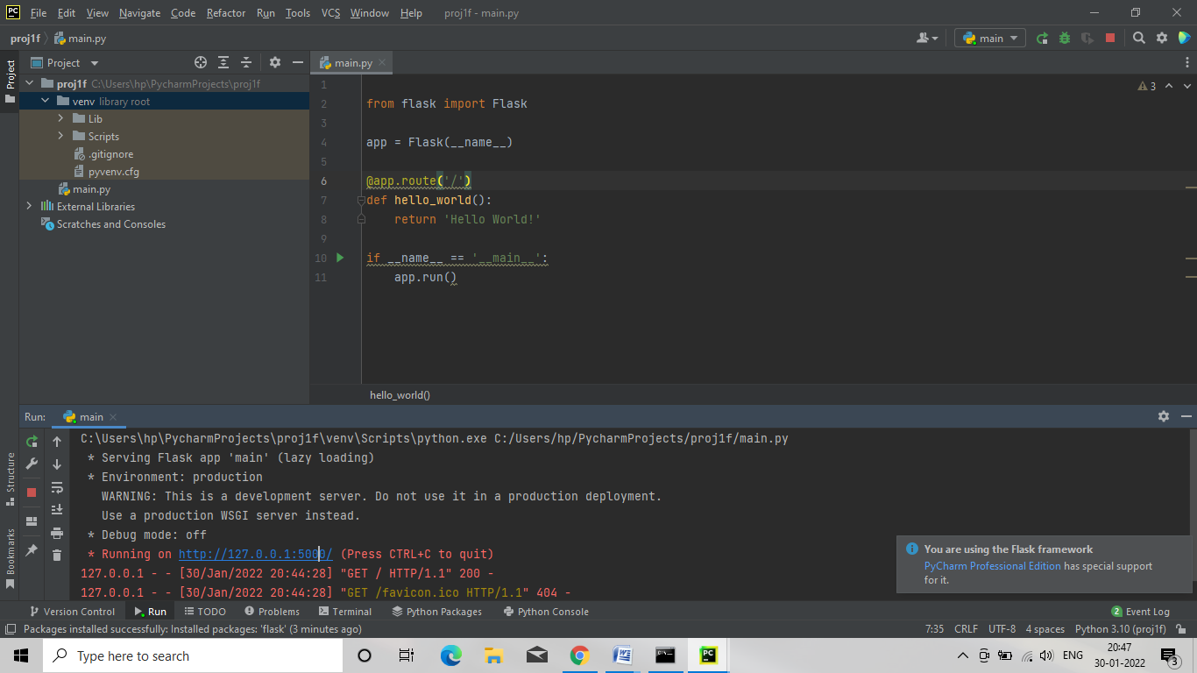

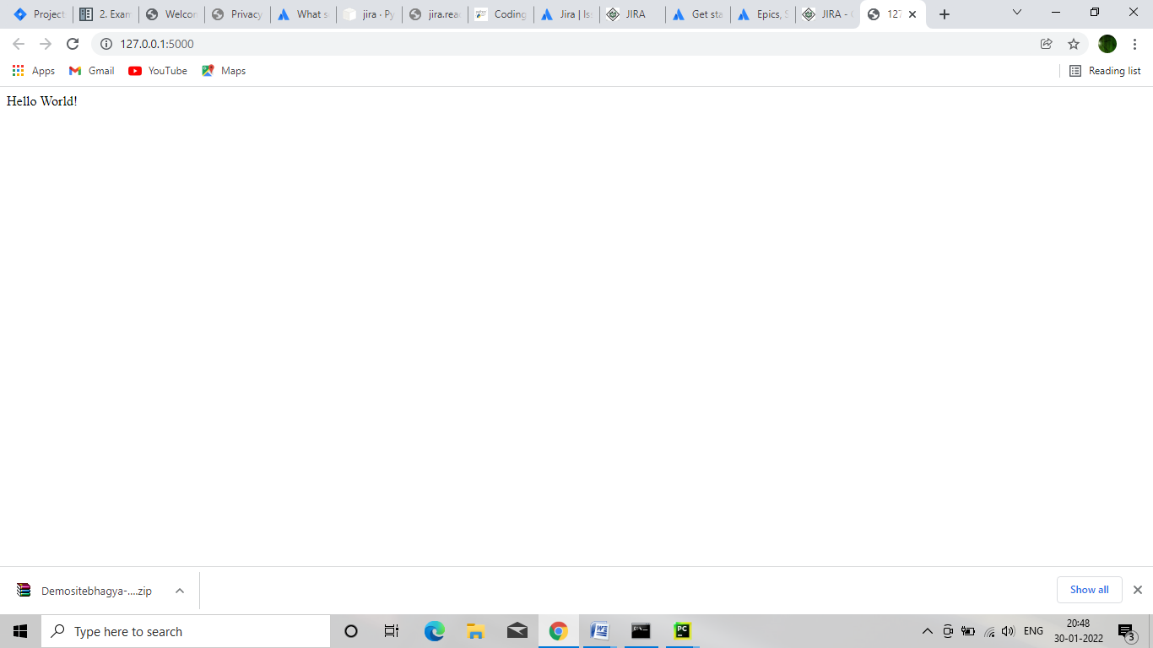

**STEP2 :- STORE THE CODE ON GITHUB IN A PUBLIC REPOSITORY  
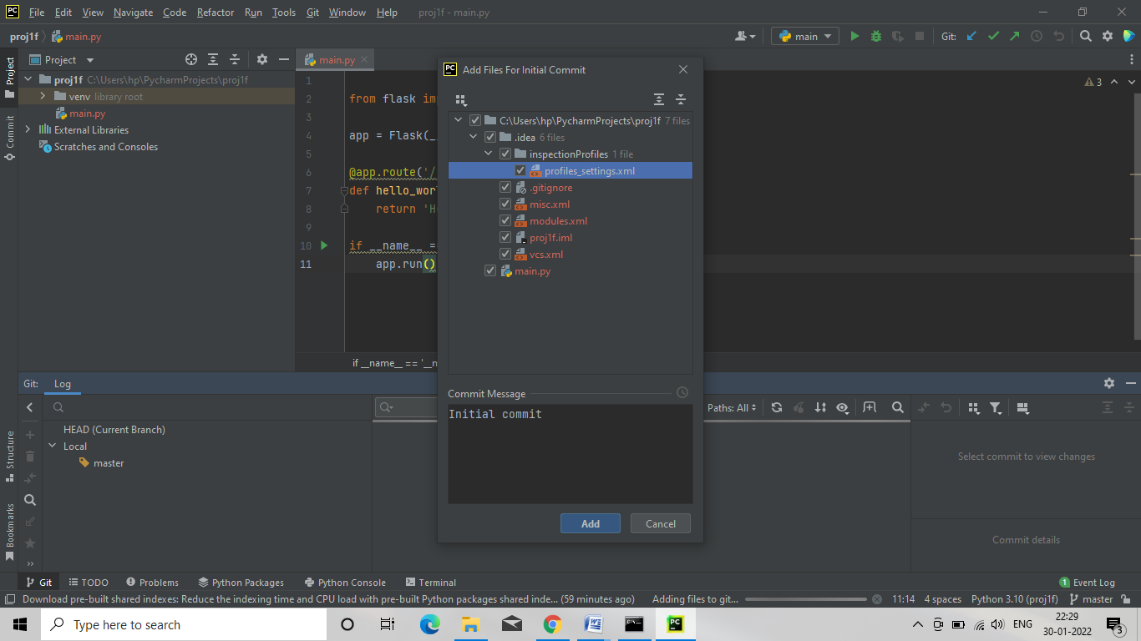**

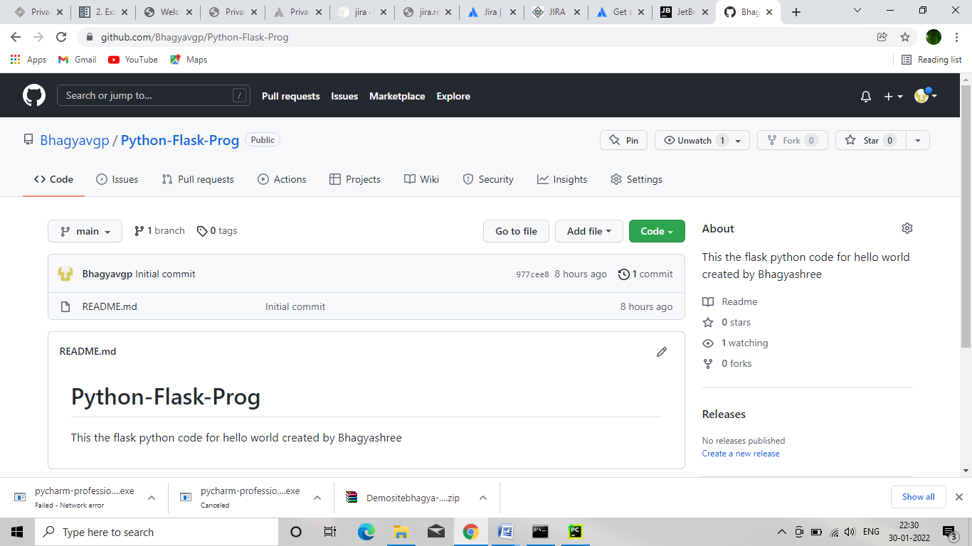

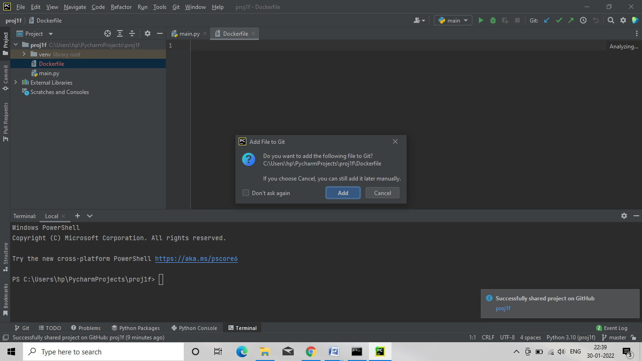

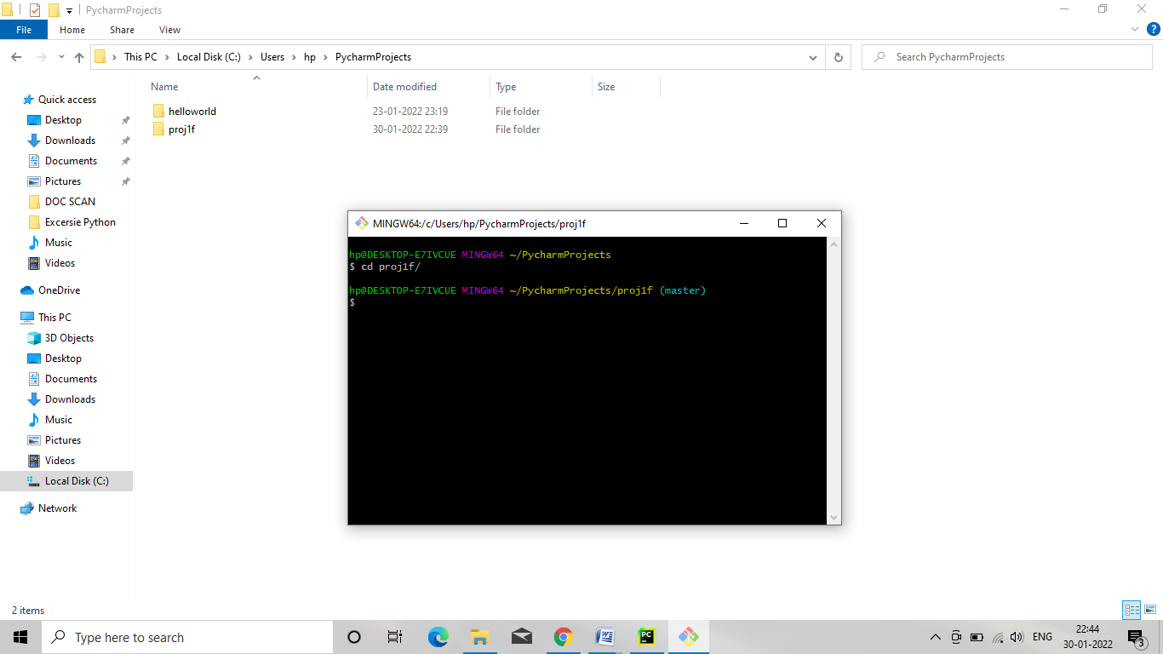

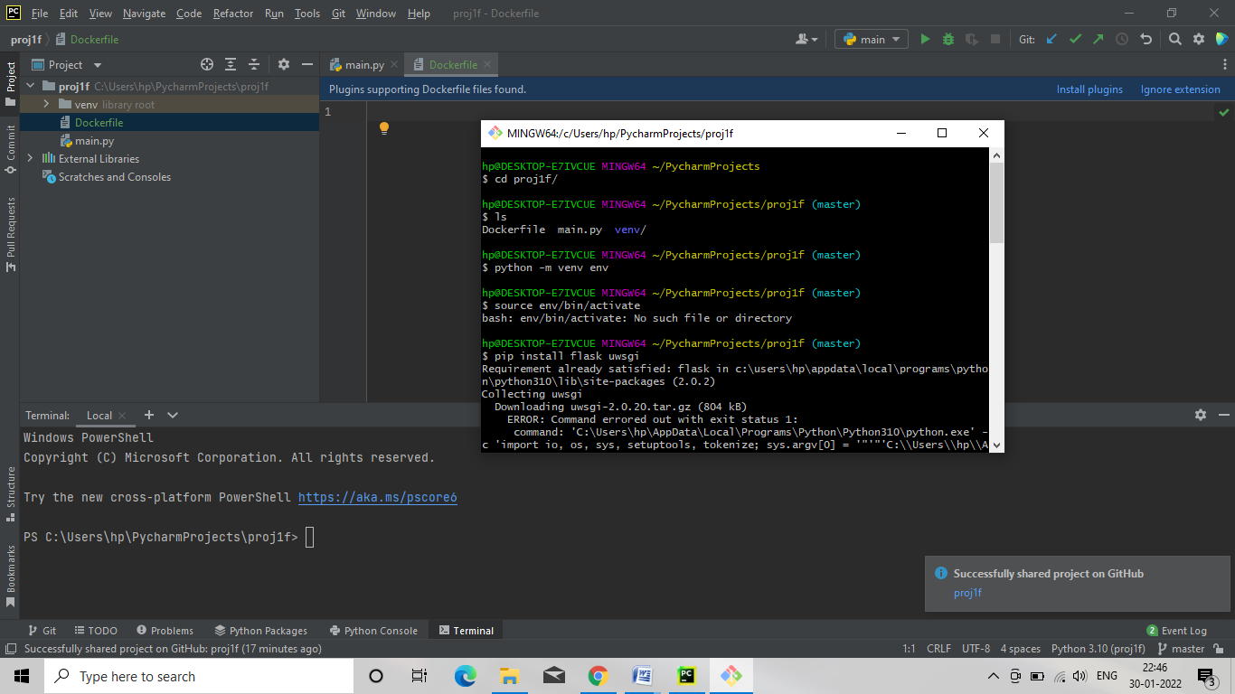

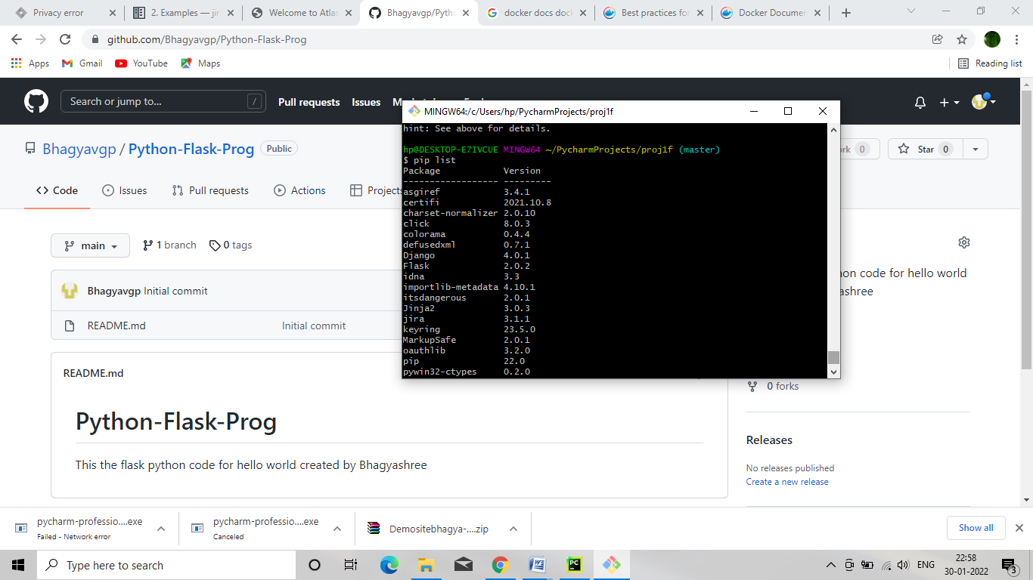

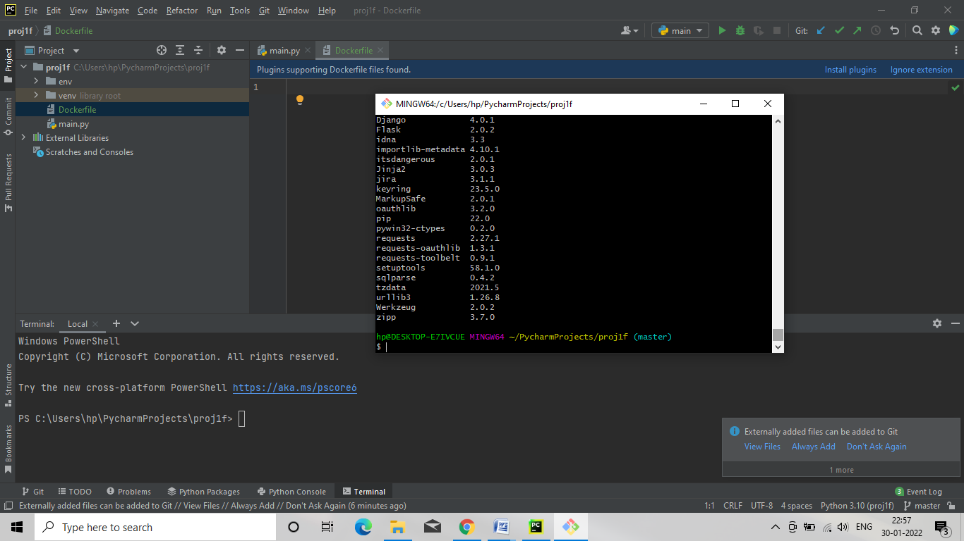

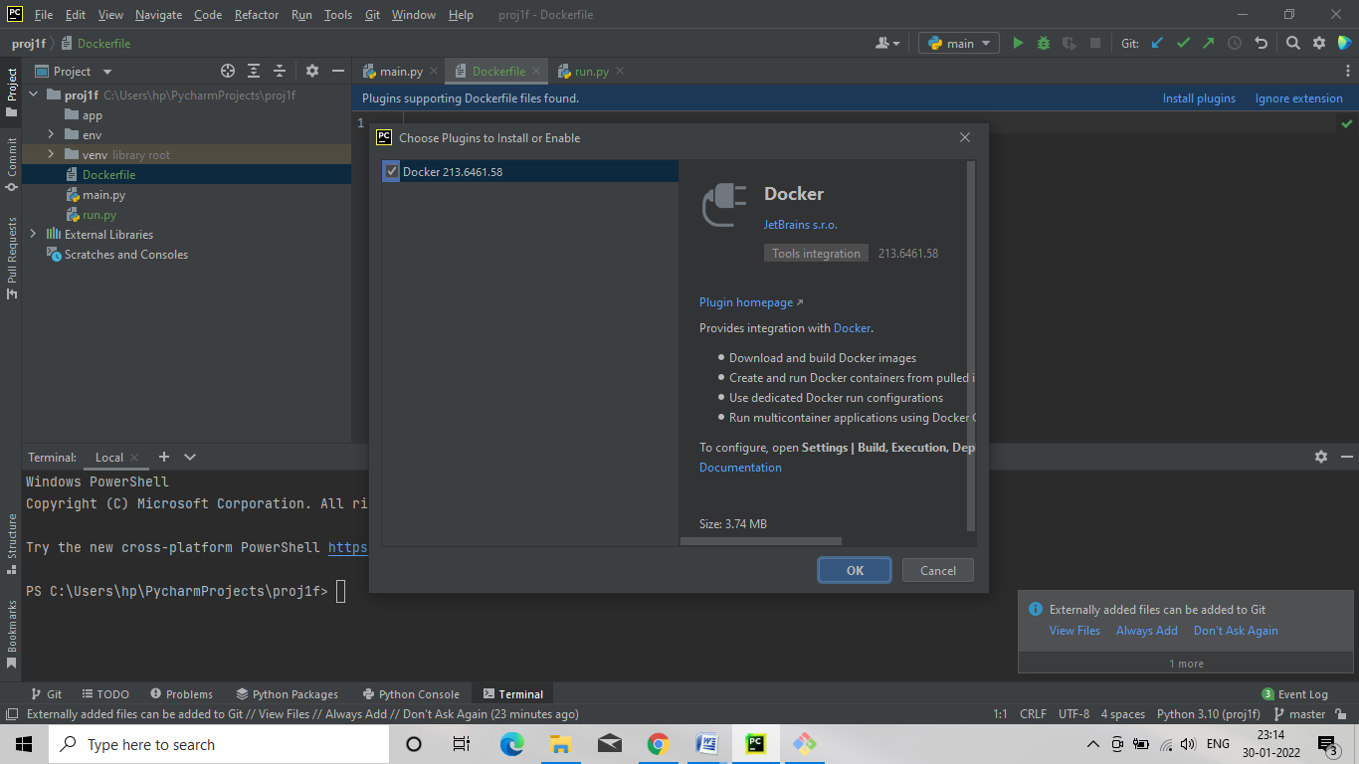

**Dockerfile**

# use the python 3.10.2 container image  
FROM python:3.10.2-stretch   
  
#Set the working directory to /app  
WORKDIR /app  
  
#Copy the current directory contents into the container at /app  
ADD . /app  
  
# Install the dependencies  
RUN pip install -r requirements.txt  
  
# run the command to start uWSGI  
CMD ["uwsgi", "app.ini"]

**--init--.py**

from flask import Flask  
  
app = Flask(__name__)  
  
from app import views

**run.py**

from app import app  
  
if __name__=="__main__":  
 app.run()

**.dockerignore**

env/  
__pycache__/