**DTE: Power Restore Notification and Power Outage Notification**

Low Level Design Document Specification: DataPower

Prepared By: Prolifics

Contents

1.1 Reference Documents 2

1.2 Document Revision History 2

2 Overview 3

Document Purpose 3

2.1 Audience 3

2.2 Assumptions 3

2.3 Out of Scope 3

Scope 3

3 Architectural view of Power Outage Notification & Power Restore Notification 4

3.1 Power Outage Notification 4

3.2 Power Restore Notification 4

3.3 List of Services 6

4 Interface Specification Details 6

4.1 DataPower - mcep_MeterAlarmSendToOms 6

4.1.1 Prerequisites 7

4.1.2 Service Overview 7

4.1.3 Objects 7

4.1.4 Backend 15

4.1.5 Request-Response Type 15

4.1.6 XML Manager 15

4.2 DataPower - OMS_ConfigurationProperties 16

4.2.1 Prerequisites 16

4.2.2 Service Overview 17

4.2.3 Objects 17

4.2.4 Backend 19

4.2.5 Request-Response Type 19

## Reference Documents

|  |  |  |  |  |
| --- | --- | --- | --- | --- |
| **S.No.** | **DOCUMENT NAME** | **AUTHOR** | **VERSION** | **REMARK / NOTE** |
| 1 | Interface Specification Document | Interface Specification ESB Meter Management Power Restore Notification | 1.0 | [Link](https://dteenergy.sharepoint.com/:w:/r/sites/MEP/ADMS2/Prolifics/Shared%20Documents/03-DISCOVERY%20+%20ANALYSIS%20%26%20ARCHITECTURE/INTERFACE%20SPECIFICATION/ADMS%20Integration%20Interface%20Specification%20Power%20Restore%20Notification-29.2%20_v1.docx?d=w5b37969a7128489eb80dc0f1a150d30c&csf=1) |
| 2 | Interface Specification Document | Interface Specification ESB Meter Management Power Outage Notification | 1.0 | [Link](https://dteenergy.sharepoint.com/:w:/r/sites/MEP/ADMS2/Prolifics/Shared%20Documents/03-DISCOVERY%20+%20ANALYSIS%20%26%20ARCHITECTURE/INTERFACE%20SPECIFICATION/ADMS%20Intgeration%20Interface%20Specification%20Power%20Outage%20Notification-29.1%20_v1.docx?d=we53b1cf278e148b3be8fb8f56679d4ce&csf=1) |

## Document Revision History

|  |  |  |  |  |
| --- | --- | --- | --- | --- |
| Release | Date | Document Name | Revised By | Description of Change |
| 0.1 | 30th August, 2019 | DTE – Power Restore Notification and Power Outage integration Project | Prolifics | * Initial Draft |

# Overview

## Document Purpose

The aim of this document is to provide technical design details for DTE – Power Restore Notification and Power Outage Notification Project. This document will focus on DataPower part of the solution.

*Note: Acronyms and new terms introduced by this project are in the Glossary section*

## Audience

This document should be read and understood by all system stakeholders with an interest in the detailed architecture of the services. Most importantly, this applies to those who will use it to carry out their business responsibilities and those who are building the service.

Designers and Developers will use this document as input into design and develop applications/services.

Intended Audience [Including but not limited to]

1. Project Managers
2. Architects
3. TechLeads
4. Consultants
5. Developers

## Assumptions

## Out of Scope

## Scope

1. Scope of this document is specific to DTE – Power Restore Notification and Power Outage Notification integration project.
2. It covers DataPower related details only.

# Architectural view of Power Outage Notification & Power Restore Notification

With reference to the above requirement documents, below are the architectural diagrams where the new services are incorporated.

As a part of development, a new common DataPower interface is developed for point 7 in the flow of Power Outage Notification and for point 8 in the below flow of Power Outage Notification.

## Power Outage Notification

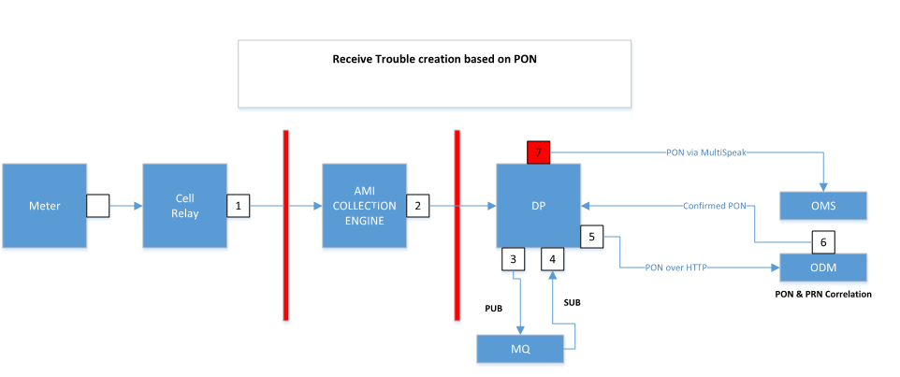

**Power Outage Notification Integration Diagram**

## Power Restore Notification

As a part of development, a new DataPower interface is developed at point 8 in the below flow of Power Outage Notification.

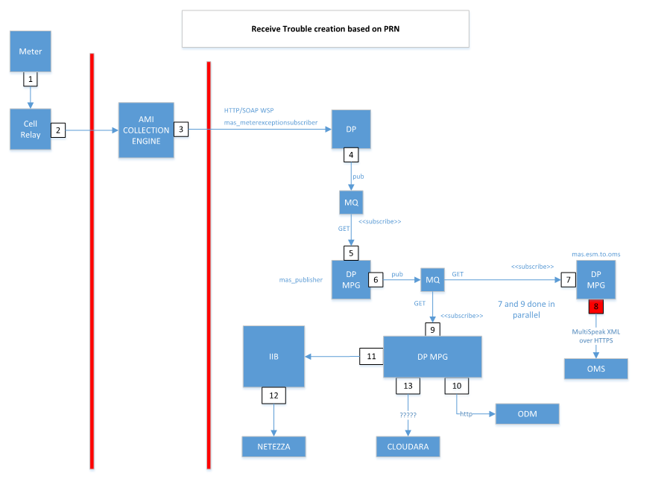

**Power Restore Notification Integration Diagram**

## List of Services

|  |  |  |
| --- | --- | --- |
| **Services** | **Type** | **Front Side Hander** |
| [mcep_MeterAlarmSendToOms](https://10.0.10.228:9090/servicelist/MPGateway?popup=false&navFrame=false) | Multi-Protocol Gateway | MQ services |
| OMS_ConfigurationProperties | Multi-Protocol Gateway | HTTP Services |

# Interface Specification Details

## DataPower - [mcep_MeterAlarmSendToOms](https://10.0.10.228:9090/servicelist/MPGateway?popup=false&navFrame=false)

With reference to the requirement of message transformation stated in the section 2.21 in the requirement document, the MPGW ([mcep_MeterAlarmSendToOms](https://10.0.10.228:9090/servicelist/MPGateway?popup=false&navFrame=false)) is created which picks the message from the GET queue. After picking up the message, the message is transformed as per the OMS request structure and is then triggered to OMS. If the transaction is successful, the response message is placed in the MQ FSH PUT queue and if the OMS is running down the message is sent for retry to IIB as per the requirement stated in section 2.28. During the down time of OMS the message reaches to error rule of DataPower and in this rule MQRFH2 headers (Sleep, RetryTime, OutputDestinationQueueName, LoggingQueueName, Service details of DataPower) are added along with the incoming payload to DataPower and sent to IIB.

|  |  |
| --- | --- |
| **Actors** | |
| **Producer/Provider** | OMS |
| **Middleware/Integration** | IIB, DataPower |
| **Consumer** | MQ Services |

|  |  |
| --- | --- |
| **Key Service Information** | |
| **Protocols** | MQ  Middleware/Integration:    DataPower receive request from MQ.  Posts the request to the OMS.  Send acknowledgement back to MQ services in the success scenario and in case of failure, it sends the message to IIB for retry mechanism via MQ.    Consumers:  MQ Services |
| **Port** | 1418 and 1420 |
| **Message Format** | SOAP |
| **Messaging pattern** | Request Response |



### Prerequisites

1. MQ details such as Get Queue, Put Queue, Backout Queue need to be configured in DataPower.
2. Public Certificate and private key of DataPower appliance.
3. OMS endpoints [HOST:PORT /axis2/services/OMS_MultiSpeak_v41]

### Service Overview

1. In this service, DataPower act as a Client.
2. In order to consume DataPower service, MQ need to place the message in Get Queue that is configured in DataPower service Front side handler.
3. Backend will be HTTPS handler, which contain OMS certificate to establish SSL.

### Objects

#### Multi -Protocol Gateway Policy

**Object Name – mcep_MeterAlarmSendToOms**

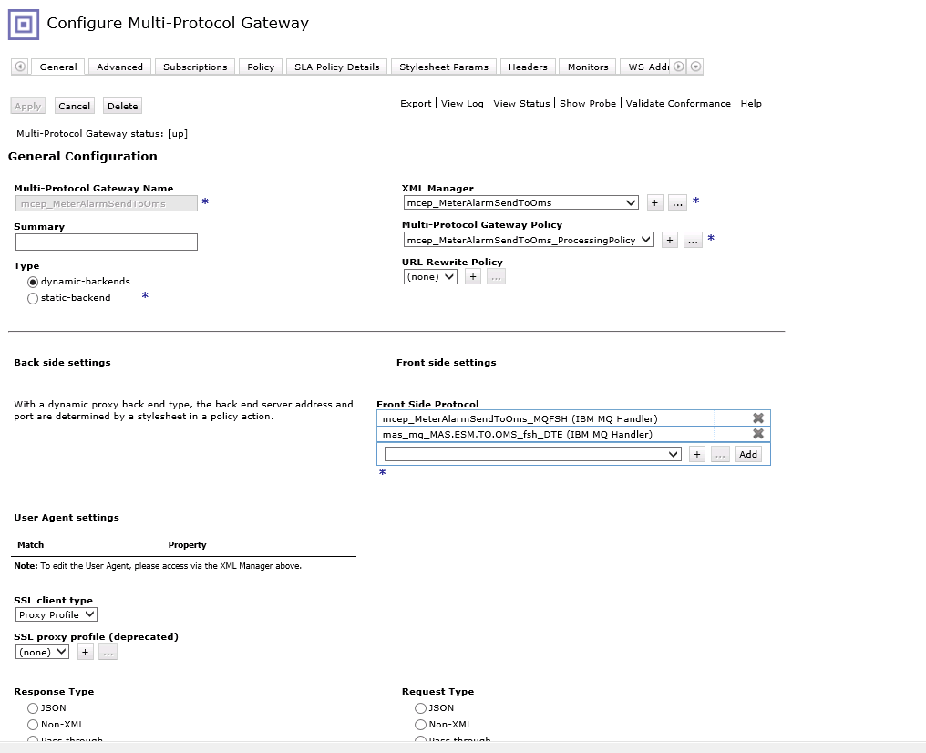

Consists of below Rules –

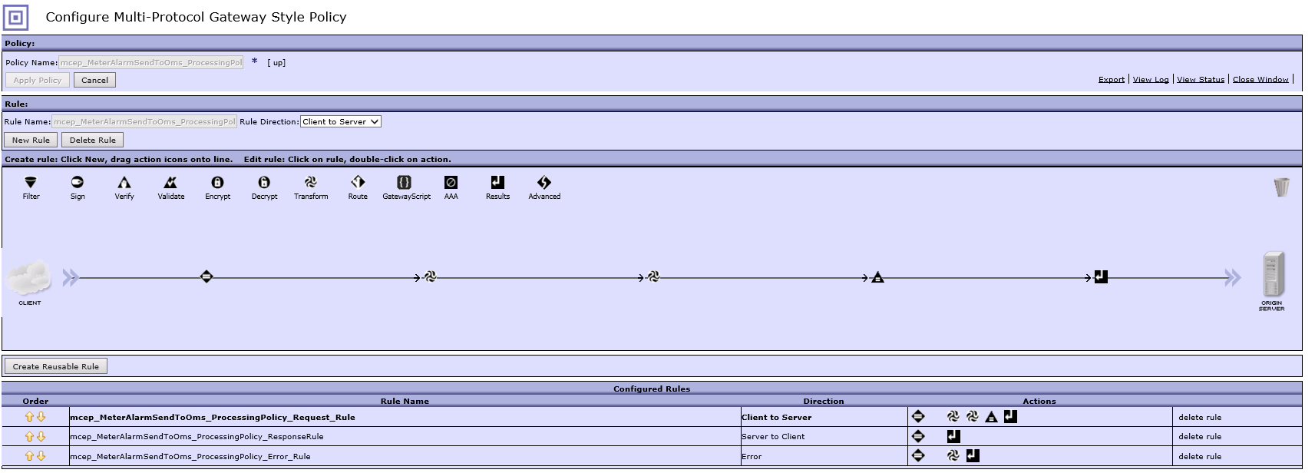

|  |  |
| --- | --- |
| ProcessingRules | Name |
| Client_to_Server | mcep_MeterAlarmSendToOms_ProcessingPolicy_Request_Rule |
| Server_to_Client | mcep_MeterAlarmSendToOms_ProcessingPolicy_ResponseRule |
| Error | mcep_MeterAlarmSendToOms_ProcessingPolicy_Error_Rule |

1. **Client_to_Server –**

mcep_MeterAlarmSendToOms_ProcessingPolicy_Request_Rule – This rule is responsible to transform the incoming SOAP message and send the request to OMS.

Match Action – Match_All

XSLT’s –

* mcep_MeterAlarmSendToOms_SettingContextRequestHeaders.xslt
* ODEvenODEventNotification_DP_To_OMS.xslt

1. **Server_to_Client –**

mcep_MeterAlarmSendToOms_ProcessingPolicy_ResponseRule – This rule capture response from OMS.

Match Action – Match_All

1. **Error –**

mcep_MeterAlarmSendToOms_ProcessingPolicy_Error_Rule – This rule is responsible for Error-handling, whenever any error occurs during the connectivity to OMS the request message is sent to IIB through a Queue along with the sleep, retry time headers.

#### Front-Side Handler

**Power Outage Notification**

1. Front Side Handler – mcep_MeterAlarmSendToOms_MQFSH

|  |  |  |
| --- | --- | --- |
| DP box | IP URL | MQ Service Details |
| 10.0.10.228 | https://10.0.10.228:9090 | Queue Manger Object: mcep_ESBMQ  Host: 10.0.10.160  Port: 1418  Queue Manger Name: mcep_ESBMQ  Channel Name : mcep_ESBMQ_SrvrChnl  Backout Queue Name : METERALARMS.OMS.IIBQM  Get Queue: METERALARMS.OMS.CEP  Put Queue: METERALARMS.OMS.DP |
|  |  |  |

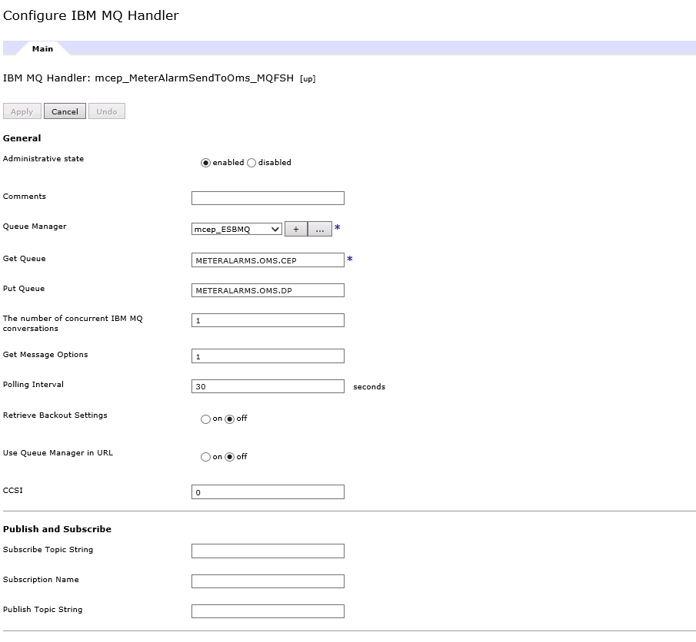

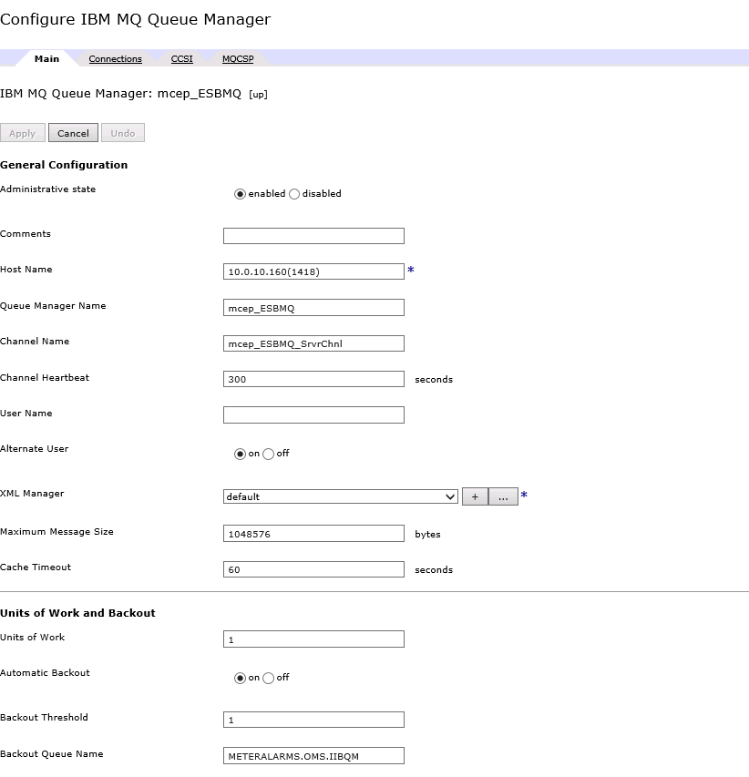

**Power Restore Notification**

1. Front Side Handler – mas_mq_MAS.ESM.TO.OMS_fsh_DTE

|  |  |  |
| --- | --- | --- |
| DP box | IP URL | MQ Service Details |
| 10.0.10.228 | https://10.0.10.228:9090 | Queue Manger Object: mas_ESBMQ_DTE  Host: 10.0.10.160  Port: 1420  Queue Manger Name: mas_ESBMQ_DTE  Channel Name : mas_ESBMQ_SrvrChnl  Backout Queue Name : MAS.ESM.TO.IIBQM  Get Queue: MAS.ESM.TO.OMS  Put Queue: MAS.ESM.TO.DP |
|  |  |  |

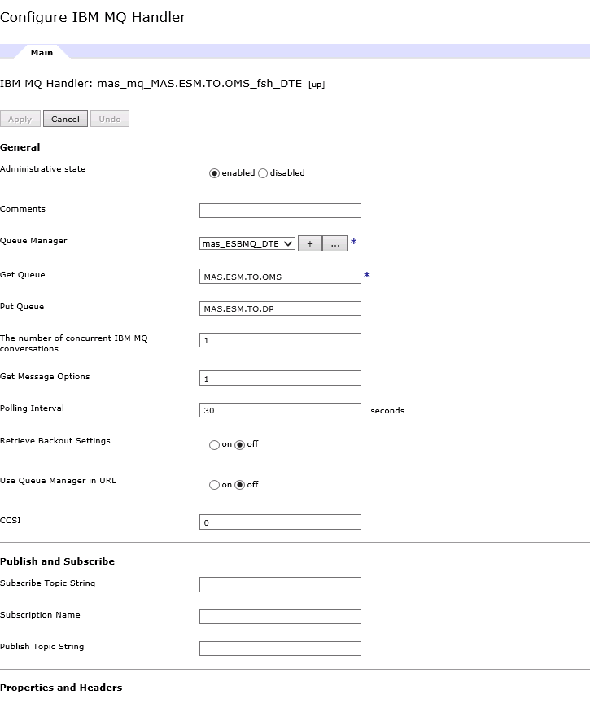

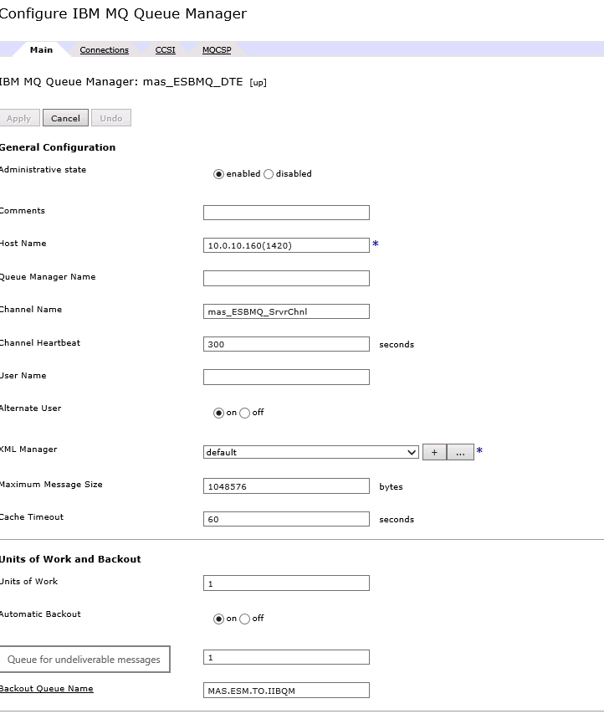

#### SSL-Server Profile –TBD

### Backend

OMS – Outage management systems

OMS provides SOAP based web services to DTE

### Request-Response Type

Request type – SOAP

Response type – SOAP

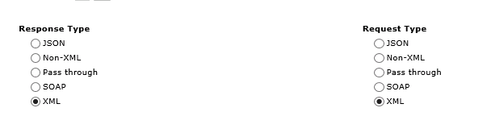

### XML Manager

**XML Manager: mcep_MeterAlarmSendToOms**

Document cache and Document cache policy are defined in the XML Manager to cache the documents that are being used in the transformations in the DataPower policy.

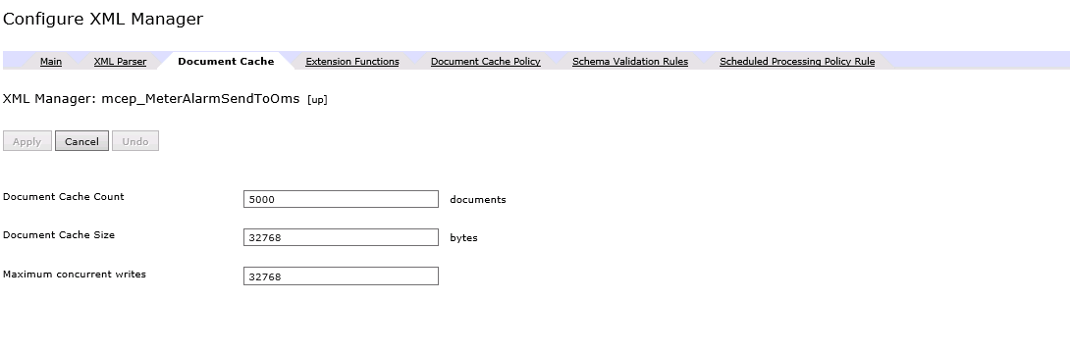

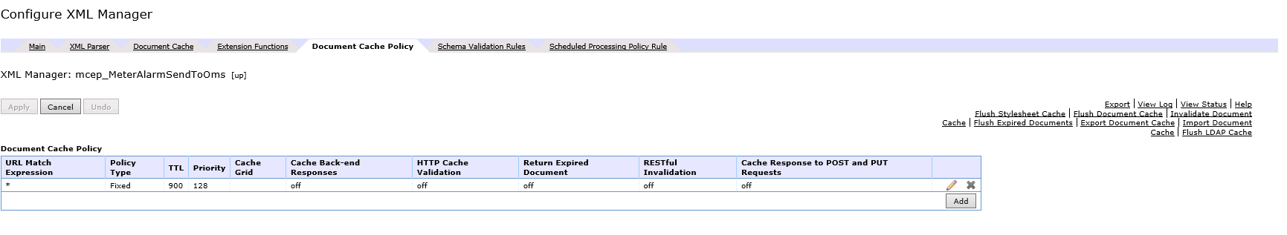

## DataPower - OMS_ConfigurationProperties

With reference to the requirement of creation of configuration and password files stated in the section 2.21 in the requirement document, the MPGW (OMS_ConfigurationProperties) is created which authenticates and authorizes the incoming message through AAA action and encrypts the incoming password in the payload and places the configuration details and password details in the local file management which is used by the MPGW ([mcep_MeterAlarmSendToOms](https://10.0.10.228:9090/servicelist/MPGateway?popup=false&navFrame=false)) to incorporate the userID and password details in the request sent to OMS.

|  |  |
| --- | --- |
| **Actors** | |
| **Producer/Provider** | DataPower |
| **Middleware/Integration** | DataPower |
| **Consumer** | Testing Tools |

|  |  |
| --- | --- |
| **Key Service Information** | |
| **Protocols** | HTTP  Middleware/Integration:    DataPower receive request from Testing Tools.  Authenticating and authorizing the message with AAA and a loop back service is created at DataPower end.  Creates [Configuration.xml](https://10.0.10.228:9090/webguiapp/fileAccess/Configuration.xml?filename=local%3A%2FOMS_ConfigurationProperties%2FXML%2FConfiguration.xml) and [Password.xml](https://10.0.10.228:9090/webguiapp/fileAccess/Password.xml?filename=local%3A%2FOMS_ConfigurationProperties%2FXML%2FPassword.xml) files in the local:///[OMS_ConfigurationProperties](https://10.0.10.228:9090/system/FileMaintenance?navFrame=false)/XML location.    Consumers:  LoopBack |
| **Port** | 7002 |
| **Message Format** | XML |
| **Messaging pattern** | Request Response |



### Prerequisites

1. The service need to be configured as a loopback in DataPower.
2. AAA info file is created in the local file folder location.

### Service Overview

1. In this service, DataPower act as a Client.
2. In order to consume DataPower service, HTTP URL need to be fired from testing tools such as postman, SOAPUI that is configured in DataPower service Front side handler.
3. A SOAP-call is made to the DataPower appliance through xslt to place the files in the file folder location.

### Objects

#### Multi -Protocol Gateway Policy

Object Name – OMS_ConfigurationProperties

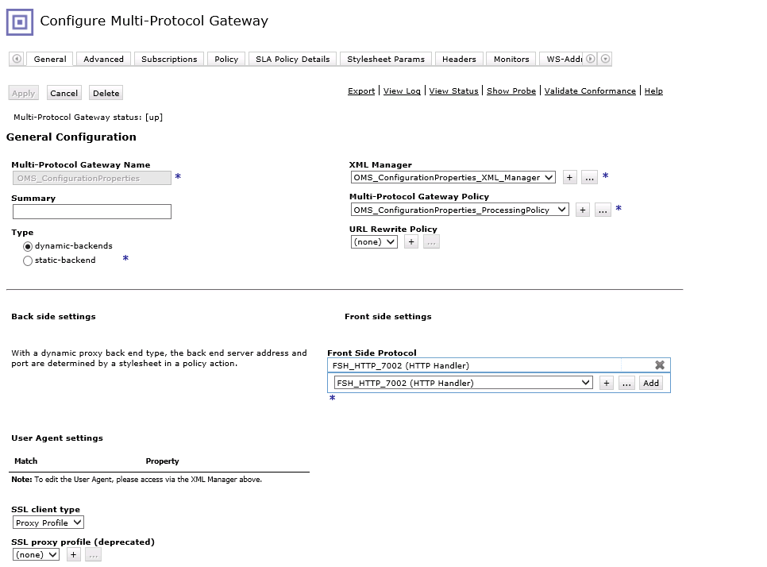

**Consist of below Rules –**

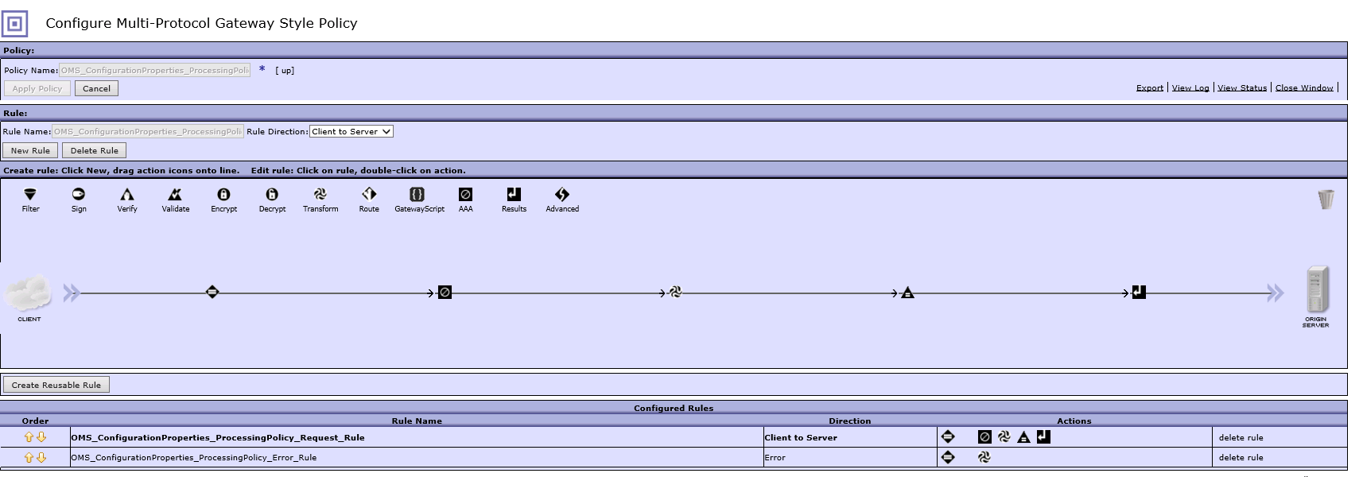

|  |  |
| --- | --- |
| ProcessingRules | Name |
| Client_to_Server | OMS_ConfigurationProperties_ProcessingPolicy_Request_Rule |
| Error | OMS_ConfigurationProperties_ProcessingPolicy_Error_Rule |

1. **Client_to_Server –**

OMS_ConfigurationProperties_ProcessingPolicy_Request_Rule– This rule is responsible to authenticate and authorize the user and the data is fetched from the headers through AAA action. If the user is authenticated and authorized, a SOAP call is made to DataPower default Domain to place the required files in the local file location. Else, the message is reject from DataPower and not processed for further action to place the files.

Match Action – Match_All

XSLT’s –

* OMS_ConfigurationProperties_CreateFile.xslt

1. **Error –**

OMS_ConfigurationProperties_ProcessingPolicy_Error_Rule– This rule is responsible for Error-handling, whenever any error occurs a SOAP fault is built and send to the consumer.

#### Front-Side Handler

Front Side Handler – FSH_HTTP_7002

|  |  |  |
| --- | --- | --- |
| DP box | IP URL | Port |
| 10.0.10.228 | https://10.0.10.228:9090 | 7002 |
|  |  |  |

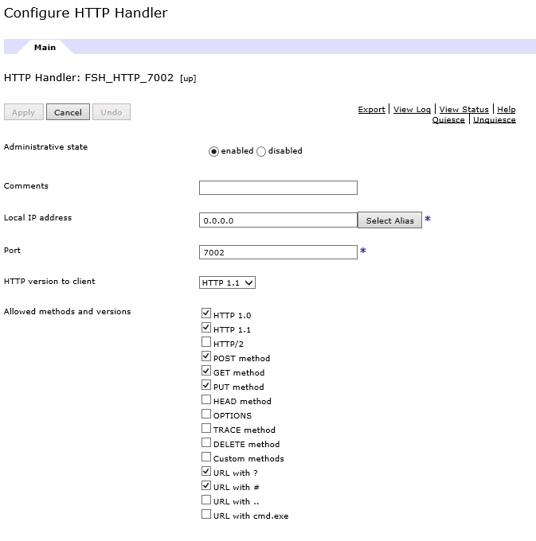

#### SSL-Server Profile –TBD

### Backend

It is a loop back service ,the DataPower service itself acts as a backend

### Request-Response Type

Request type – XML

Response type – XML

