

**Retry Mechanism**

**IIB – Low Level Design**

Prepared by: Prolifics

Date: 6st Sep 2019

Contents

Document Information 3

1. Purpose 4

2. Solution Architecture 4

2.1 Service Interaction: Low Level Diagram 4

3. Technical Design 5

3.1 Requirements 5

3.2 Assumptions 5

3.3 Application Details: 5

3.3.1 Application Description 5

3.3.2 Message Flow Diagram 5

3.3.3 Message Flow Description 5

3.4 Message Format Specifications 6

3.4.1 Input Message Format Specifications 6

3.4.2 Output Message Format Specification 6

3.5 Logging and Error Handling 6

3.5.1 Repository Details 7

3.5.2 IIB Configuration Details 7

3.6 Unit Test Case. 8

Document Information

|  |  |  |  |  |
| --- | --- | --- | --- | --- |
| **Version Number** | **Date** | **Version By** | **Summary of Changes** | **Changes marked** |
| Initial | 09/6/2019 | Akanksha | Initial Draft | No |
|  |  |  |  |  |

Approvals

This document requires following approvals.

|  |  |
| --- | --- |
| **Name** | **Changes marked** |
|  |  |
|  |  |
|  |  |

Acronyms

|  |  |
| --- | --- |
| **Acronym** | **Description** |
| IIB | IBM Integration Bus |
| MQ | Message Queue |
| XML | eXtensible Markup Language |
| MQRFH2 | MQRFH2 Headers |

# Purpose

This document provides in depth design details of the Integration service mcep_OmsRetryApp. It captures high level and low level details of the service with IIB as integration component. It also captures logging, error handling and other configuration details involved in this integration.

# Solution Architecture

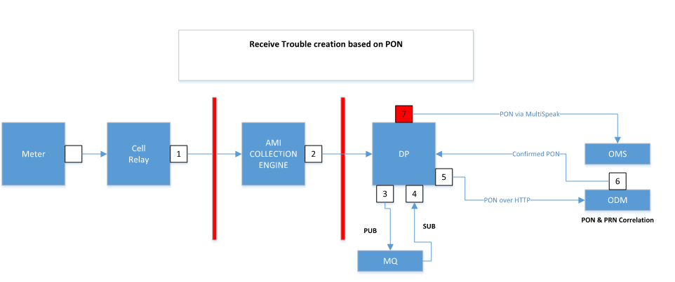

## Service Interaction: Low Level Diagram

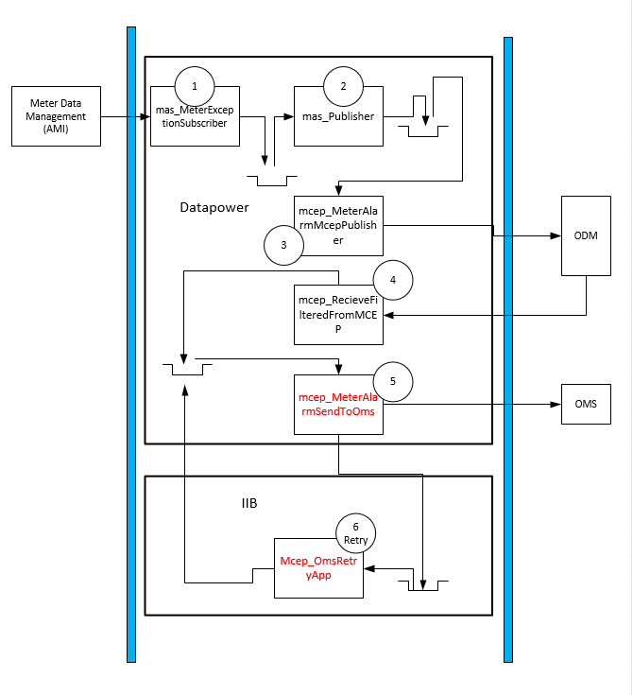

# Technical Design

## Requirements

The purpose of this flow is to perform the Retry Mechanism. In the service, considering the time difference of current time and createdDateTime. If the time difference is less than 30 minute then the message will be picked by ‘METERALARMS.OMS.CEP’to do the retry otherwise the message will be route to the ‘METERALARMS.OMS.LOGGING’. This Service also uses the common subflow ‘PRO_COMMON_UTIL_SF’. Which will be use to generate the logs on the basis of Log Levels. i.e DEBUG,INFO. This logging can be enabled or disabled on run time.

## Assumptions

* The Input Message should be in XML Format.
* Every message should have a unique Msg id.

## Application Details:

Application Name: RetryApplication

### Application Description

The RetryApplication receives input message in XML Format.The message will also contain meta data as part of MQRFH2 headers that contains details like, RetryTime for that message, SleepTime, Timestamp, DestinationQueue and LoggingQueue.

The exception will be handled while sending the payload to OMS Messages to OMS should be held for delivery for some time (1000ms) once the number of tries has been exhausted, the metadata and payload will be logged to the LoggingQueue. RetryTime is 30 minute.

### Message Flow Diagram

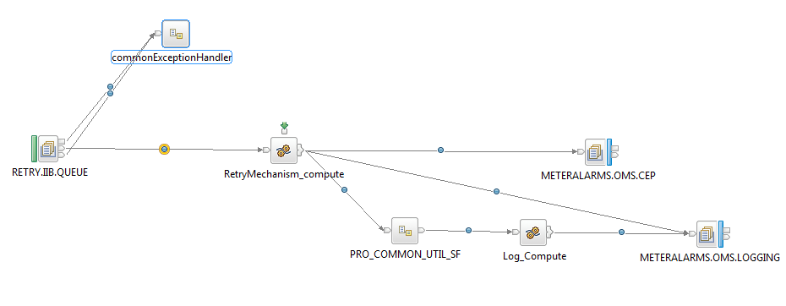

### Message Flow Description

|  |  |  |
| --- | --- | --- |
| Node Name | Node Type | Node Description |
| RETRY.IIB.QUEUE | MQInput Node | IIB will pick the input message which is placed by Datapower. The message also contains meta data in MQRFH2.usr headers. |
| RetryMechanism_compute | Compute Node | This node will perform the RetryMechanism for 30 minute and the conditional logging. |
| METERALARMS.OMS.CEP | MQOutput Node | Datapower will pick the message to try the retry mechanism within 30 min from the OutputDestinationQueue. |
| METERALARMS.OMS.LOGGING | MQOutput Node | after the retry time exhausted , the message will be logged in the LoggingQueue. |
| commonExceptionHandler | Error subflow | This node will receive the error occurred at MQInput Node and will route it to the commonExceptionHandler subflow for further processing. |
| PRO_COMMON_UTIL_SF | Logging subflow | This node receives the output message after the retry time got exhausted and will route to the logging subflow for logging. |
| Log_Compute | Compute Node | This Node sets the Log Levels. i.e DEBUG,INFO. |

## Message Format Specifications

### Input Message Format Specifications

|  |  |
| --- | --- |
| Attribute Name | Description |
| Message Format | XML Format |
| File Name |  |
| Schema |  |
| Sample File/Message |  |

### Output Message Format Specification

|  |  |
| --- | --- |
| Attribute Name | Description |
| Message Format | XML Format |
| Schema |  |
| Sample File/Message |  |

## Logging and Error Handling

IIB will make use of the Prolifics Common Framework for Logging ‘PRO_COMMON_UTIL_SF’ and Error handling framework ‘commonExceptionHandler’.



### Repository Details

|  |  |  |  |
| --- | --- | --- | --- |
| Artifact | Version | Repository Location | |
| RetryApplication | 1 |  |

### 

### IIB Configuration Details

|  |  |  |
| --- | --- | --- |
| Parameter Name | Environment | Parameter Value |
| Additional Instances | DEV | 1 |

## Unit Test Case.

