Software Engineering (CS401)

Assignment 1

**U19CS012**

Q1.) From the Errors listed below, Design a C program Fragment to compare the outputs of **Splint** and the **Standard C** Compiler.

A.) **Dereferencing** a Possibly NULL Pointer.

**Code**

*#include* <stdio.h>

int main()

{

    int number = 10;

    int *ptr = &number;

*// Mark this Flag as true when you want to dereference a NULL pointer*

    bool deref_null_pointer = false;

*if* (deref_null_pointer)

        ptr = NULL;

*// ! Dereferencing a null pointer always results in undefined behavior and can cause crashes.*

    printf("%d", *ptr);

*return* 0;

}

**Output**

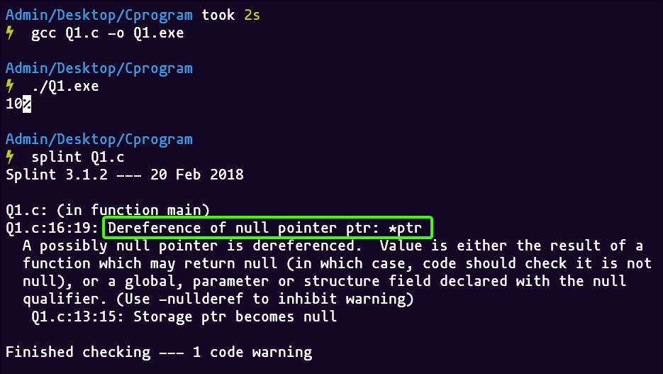

B.) Using possibly undefined storage or returning storage that is not properly defined.

**Code**

*#include* <stdio.h>

extern void set_value(*/*@out@*/* int \**x*);

extern int get_value(*/*@in@*/* int \**x*);

int get_value(int \**x*)

{

*return* 12;

}

int compute(*/*@out@*/* int \**x*, int *id*)

{

*if* (*id* > 1)

*return* \**x*;

*else* *if* (*id* > 5)

*return* get_value(*x*);

*else*

    {

        set_value(*x*);

*return* \**x*;

    }

}

int main()

{

    int k = 10;

    int *p = &k;

    int ans = compute(p, k);

*return* 0;

}

**Output**

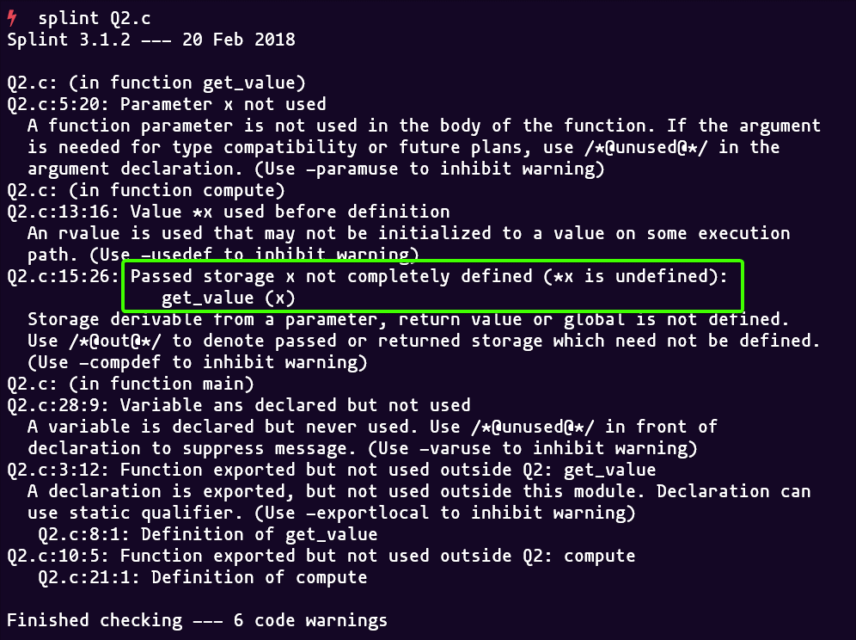

C.) Type mismatches, with greater precision and flexibility than provided by C compilers.

**Code**

*#include* <stdio.h>

*#include* <stdbool.h>

bool type_mismatch(int *val*)

{

*// int comparison with bool*

*if* (*val* == true)

    {

*return* true;

    }

*// Instead of False, returned 0*

*return* 0;

}

int main()

{

    type_mismatch(1);

*return* 0;

}

**Output**

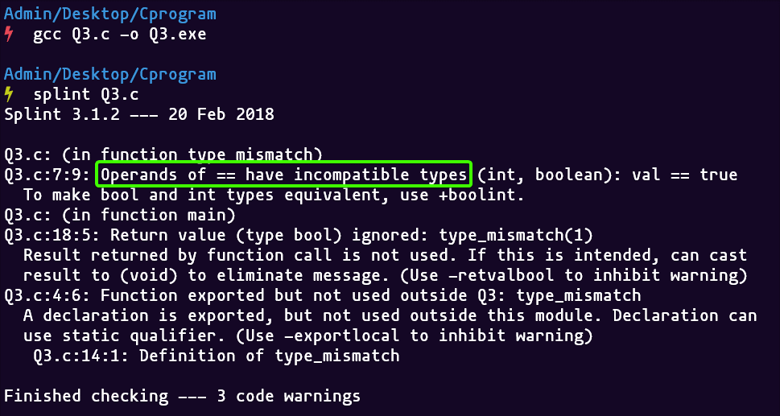

D.) Violations of Information Hiding.

**Code**

*#include* <stdio.h>

*#include* <stdbool.h>

*#include* <string.h>

*// Added this Header file*

*#include* "mystrings.h"

bool isPalindrome(mystring *s*)

{

    char *current = (char *)*s*;

    int i, len = (int)strlen(*s*);

*for* (i = 0; i <= (len + 1) / 2; i++)

    {

*if* (current[i] != *s*[len - i - 1])

*return* false;

    }

*return* true;

}

bool callPal(void)

{

*return* (isPalindrome("bob"));

}

int main()

{

    printf("Checking Information Abstractions\n");

*// callPal();*

*return* 0;

}

**Output**

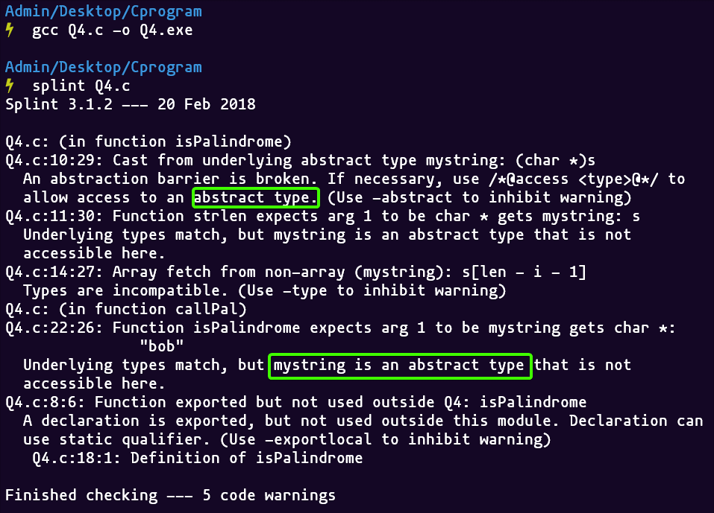

E.) Memory management errors including uses of dangling references and memory leaks.

**Code**

*#include* <stdio.h>

*#include* <stdlib.h>

*// Deallocating a memory pointed by ptr causes dangling pointer*

void dangling_pointer()

{

    int *ptr = (int *)malloc(sizeof(int));

*// After below free call, ptr becomes a dangling pointer*

    free(ptr);

*// No more a dangling pointer*

    ptr = NULL;

}

*// F(x) with memory leak*

void func_to_show_mem_leak()

{

    int *ptr2 = (int *)malloc(sizeof(int));

*// return without deallocating ptr2*

*return*;

}

int main()

{

    dangling_pointer();

    func_to_show_mem_leak();

*return* 0;

}

**Output**

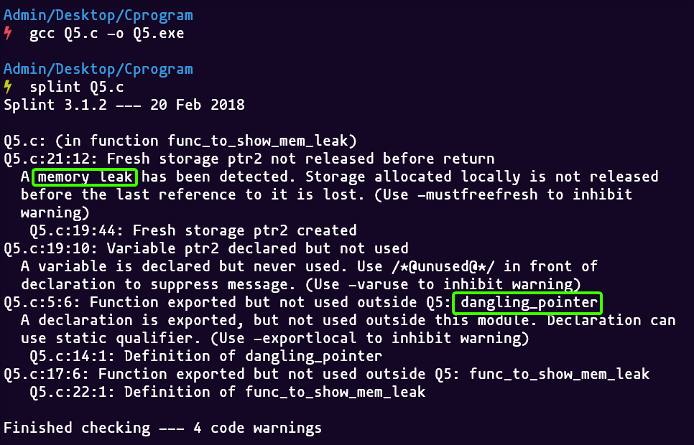

F.) Dangerous Aliasing.

**Code**

*#include* <stdio.h>

*#include* <ctype.h>

*#include* <string.h>

*// Aliasing refers to the situation where the same memory location can be accessed using different names.*

void dangerous_alias(char \**s*, char \**t*)

{

*// Copying t to s*

    strcpy(*s*, *t*);

    \**s* = toupper(\**s*);

}

int main()

{

    char *x = "hello";

    char *y = "world";

    dangerous_alias(x, y);

    printf("x = %c", *x);

    printf("y = %c", *y);

*return* 0;

}

**Output**

