Software Engineering (CS401)

Lab Assignment 5

**U19CS012**

Q1.) Classical Synchronization Problem

**Dining Philosophers Problem**

* There are **Four** **Philosophers** sitting around a **Round Table**.
* There are **Forks** on the Table, One between each Pair of Philosophers.
* The Philosophers want to eat Spaghetti from a large bowl in the Center of the Table. Unfortunately, the spaghetti is particularly ***slippery***, and a Philosopher needs **both forks** to eat it.

The philosophers have agreed on the following protocol to obtain the forks:

Initially, philosophers think about **Philosophy**, when they get **Hungry** they do the following:

* Take the **left fork**
* Take the **right fork** and start eating
* Return both forks simultaneously, and repeat from the beginning.

Build a SPIN model for this scenario.

**Code**

*/*Dining Philosophers Problem [U19CS012]*/*

#define NUM_PHIL 4

int forks[NUM_PHIL];

proctype phil(int id)

{

end:

*/*The philosopher is allowed to be in any state*/*

*do*

    :: printf("Philosopher %d is thinking\n", id);

*/*Deduce which forks are ours*/*

       int leftfork = id;

       int rightfork = id+1;

*/*Since it is Round Table*/*

*if*

         :: id+1 >= NUM_PHIL -> rightfork = 0;

         :: *else* -> rightfork = id+1;

*fi*

*assert*(rightfork < NUM_PHIL);

*/*Start Acquiring Forks*/*

       bool leftforkacquired = false;

       bool rightforkacquired = false;

*do*

          :: leftforkacquired && rightforkacquired -> *break*

          :: !leftforkacquired || !rightforkacquired ->

*/*Acquire Left Fork first*/*

*atomic* {

*do*

                :: forks[leftfork] == 0 ->

                   forks[leftfork]++;

                   leftforkacquired = true;

                :: leftforkacquired -> *break*

*od*

            }

*/*Acquire Right Fork*/*

*atomic* {

*if*

*/*Right fork is usable*/*

                :: forks[rightfork] == 0 ->

                   forks[rightfork]++;

                   rightforkacquired = true;

*/*Right fork is unusable, release left for and restart*/*

                :: *else* ->

                   forks[leftfork]--;

                   leftforkacquired = false;

*fi*

            }

*od*

*assert*(leftforkacquired && rightforkacquired);

*assert*(forks[leftfork] == 1 && forks[rightfork] == 1);

*/*Eat*/*

       printf("Philosopher %d is eating with forks %d and %d\n", id, leftfork, rightfork);

progress:

*/*Consider passing eat as progress*/*

*/*Return forks*/*

       forks[rightfork]--;

       forks[leftfork]--;

*od*

}

init

{

  int i = 0;

*do*

    :: i >= NUM_PHIL -> *break*

    :: *else* -> run phil(i);

               i++

*od*

}

ltl verify {

  [](

    forks[0] <= 1 &&

    forks[1] <= 1 &&

    forks[2] <= 1 &&

    forks[3] <= 1 &&

    forks[4] <= 1

  )

}

**Output**

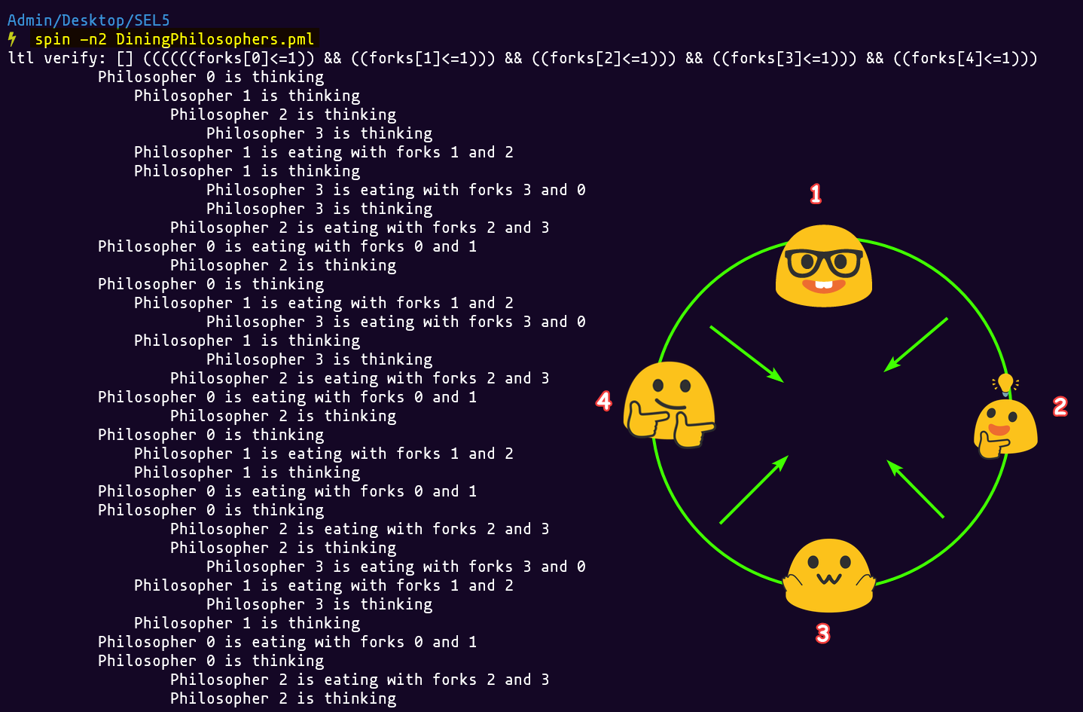

**SUBMITTED BY**: U19CS012 BHAGYA VINOD RANA