Software Engineering (CS401)

Lab Assignment 6

**U19CS012**

Q1.)

Below are the given elements you have to **Design User Interface (U.I.)**

* Some challenges are **intentionally high-level**, so it's up to you to interpret how to design it (i.e. mobile vs web, full page vs one component, etc.)
* You can use **Any Tool** of your choice for UI design.

A1.)



Tool Used – **Figma**

Figma is a modern, streamlined design tool that makes the developer handoff [the stage when the *UI is at a point where the* ***developer*** *can finally start* ***implementing*** *it in code*] process **smooth and seamless**.

Developers now have better **access** to the designs and have the ability to **extract information** about typography, redlines, colors, measurement and more.

1. Sign up

Graphic Design

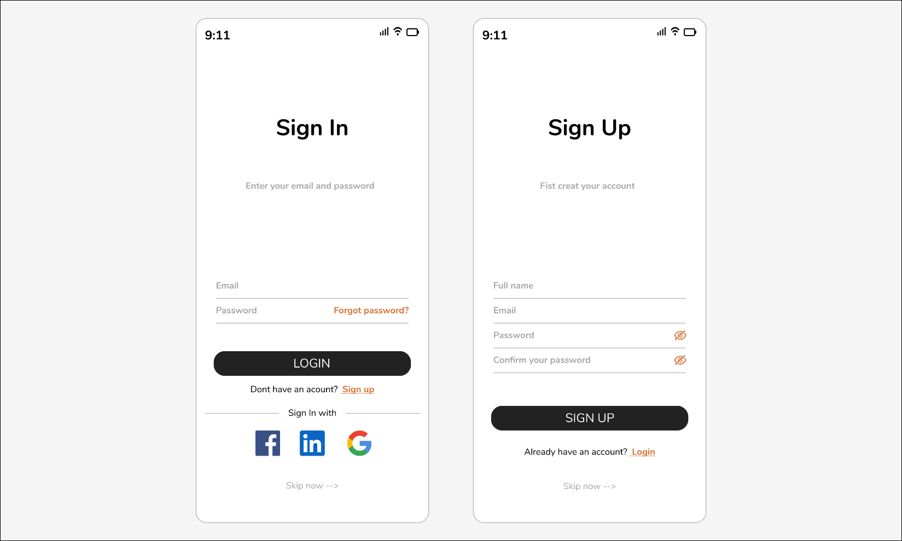

Figma File

<https://www.figma.com/file/h9ebuBHsZz8qPDDcr1m23c/SE_Lab_6_1>

2. Checkout **Flow**

Graphic Design

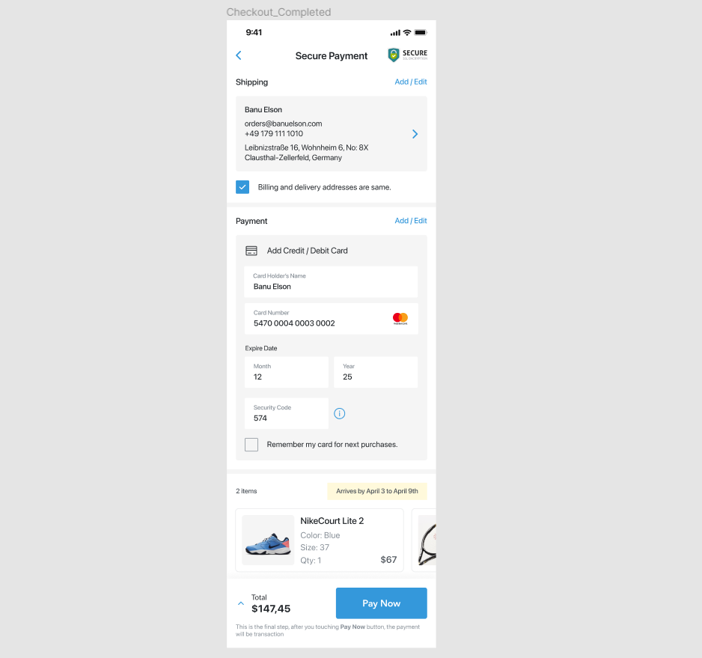

Figma File

<https://www.figma.com/file/QRyBXjSiHpKFdJFQW8ugnB/SE_Lab_6_2>

3. Calculator

Graphic Design

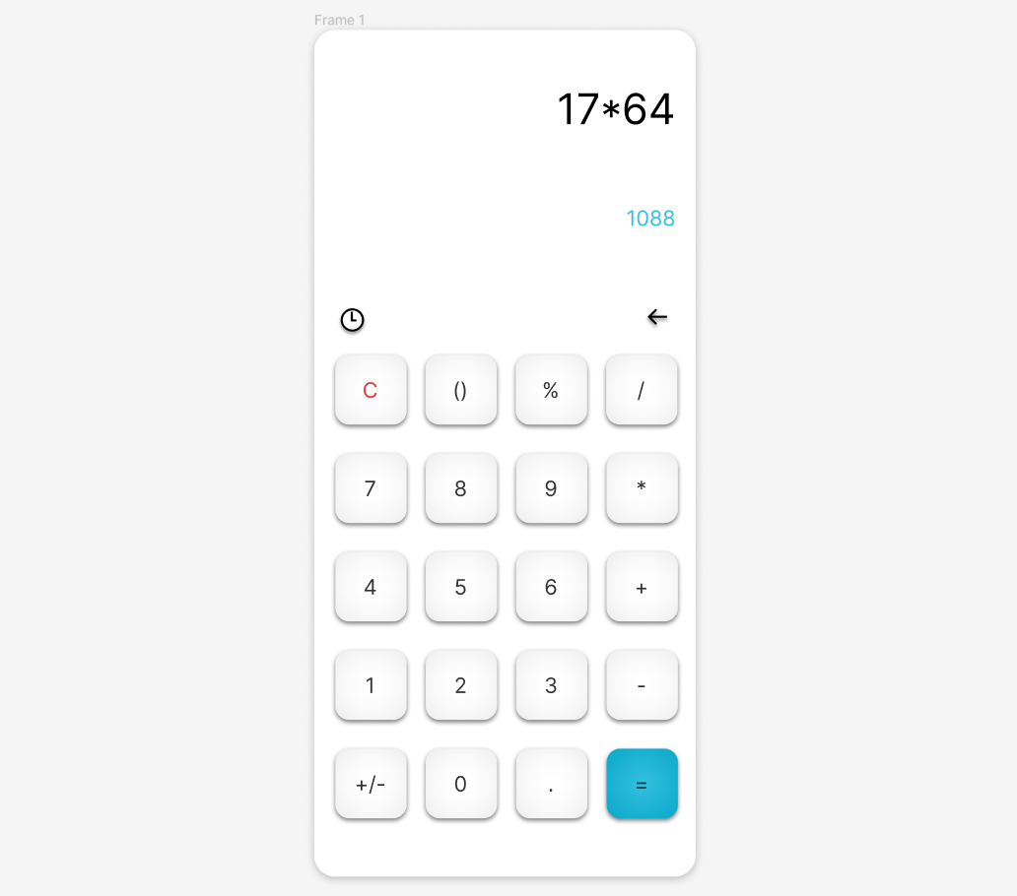

Figma File

<https://www.figma.com/file/SpgS8DGMgJK3Yaf0kkq46p/SE_Lab_6_3>

4. App icon

Graphic Design

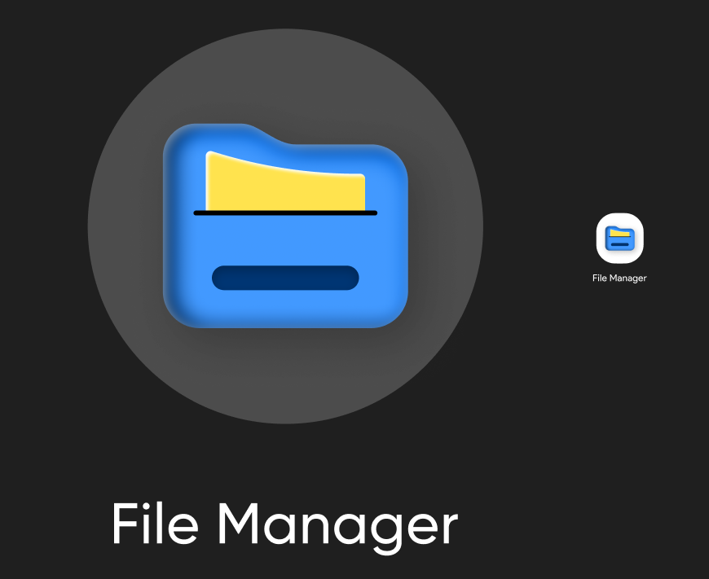

Figma File

<https://www.figma.com/file/2Aw4cxeyguBs5OddYJCM4D/SE_Lab_6_4>

5. Profile

Graphic Design

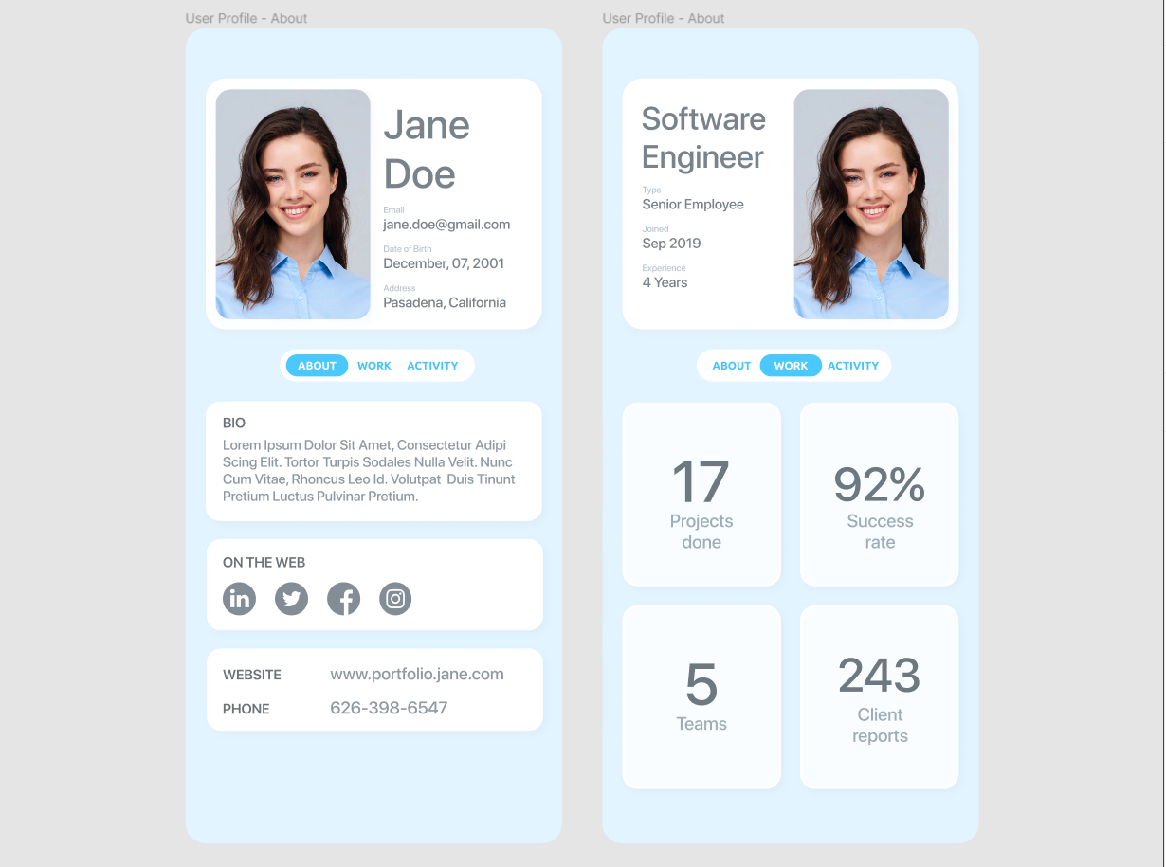

Figma File

<https://www.figma.com/file/pPDj8q83QGWiavRR9MCVJF/SE_Lab_6_5>

6. Settings

Graphic Design

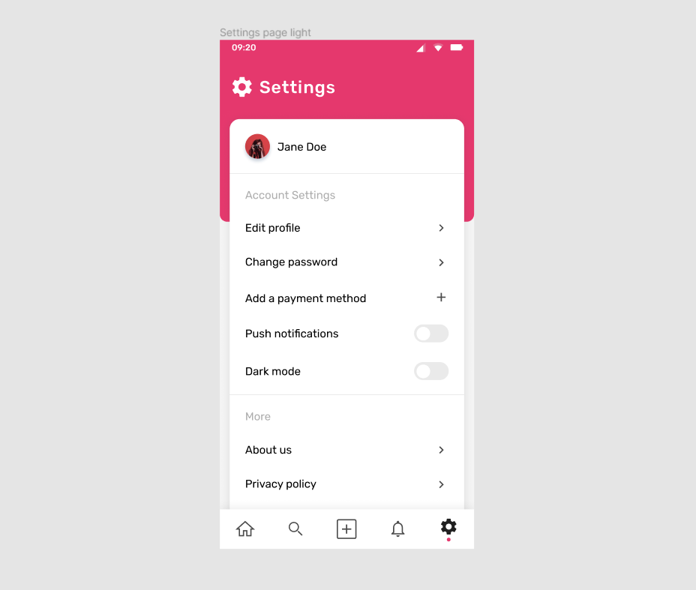

Figma File

<https://www.figma.com/file/m2HXR0Hu6Ypgp0YLAhO0pb/SE_Lab_6_6>

7. Error page

Graphic Design

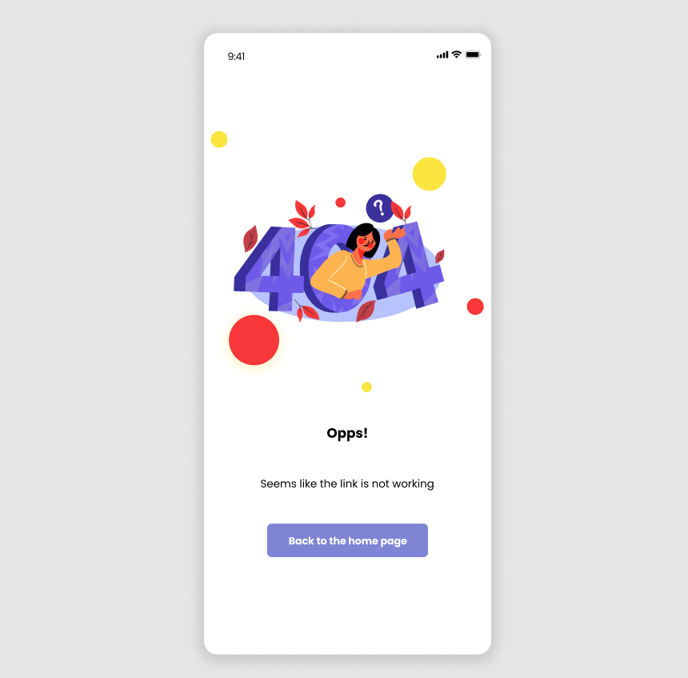

Figma File

<https://www.figma.com/file/qot68b1x36IOFOPVHi6lpl/SE_Lab_6_7>

8. Music player

Graphic Design

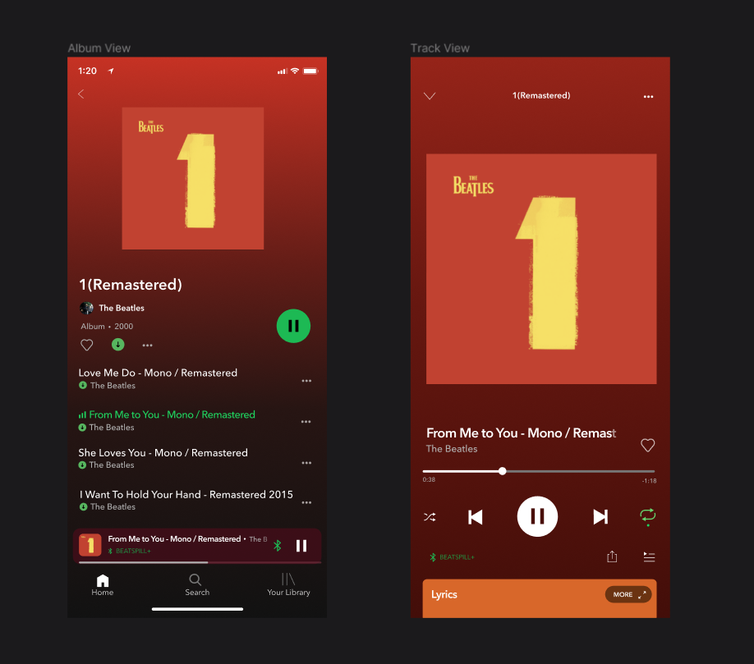

Figma File

<https://www.figma.com/file/QIERUMVbsxFIHGgr80ENmc/SE_Lab_6_8>

9. Flash Messages

Graphic Design

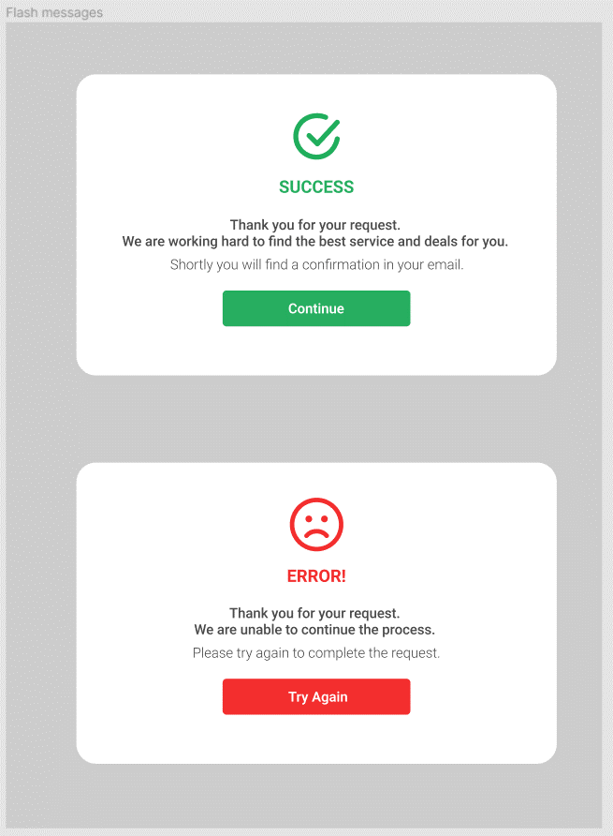

Figma File

<https://www.figma.com/file/6sFZBdaXVR3qG83M8abkPh/SE_Lab_6_9>

10. Single Product

Graphic Design

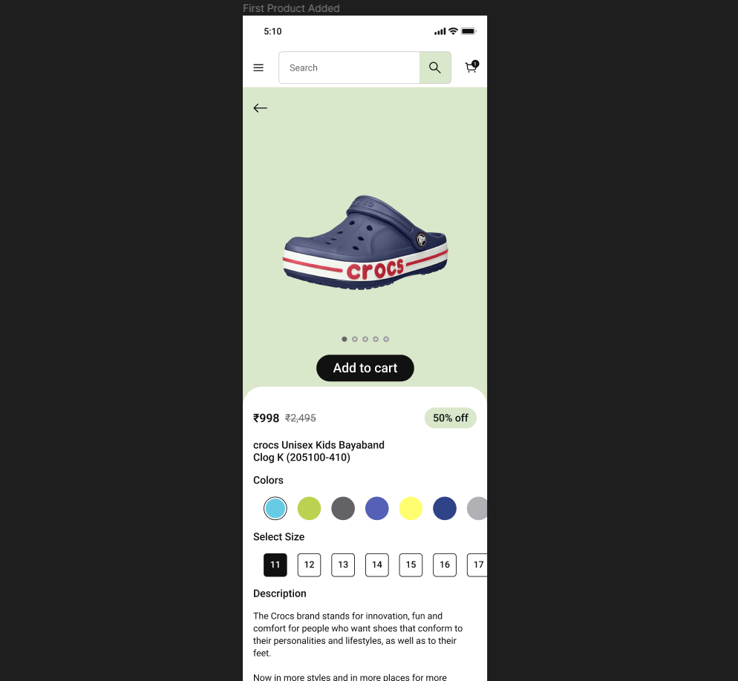

Figma File

<https://www.figma.com/file/SOZnJrOvGdYvO4YD7MTy55/SE_Lab_6_10>

11. Direct messaging

Graphic Design

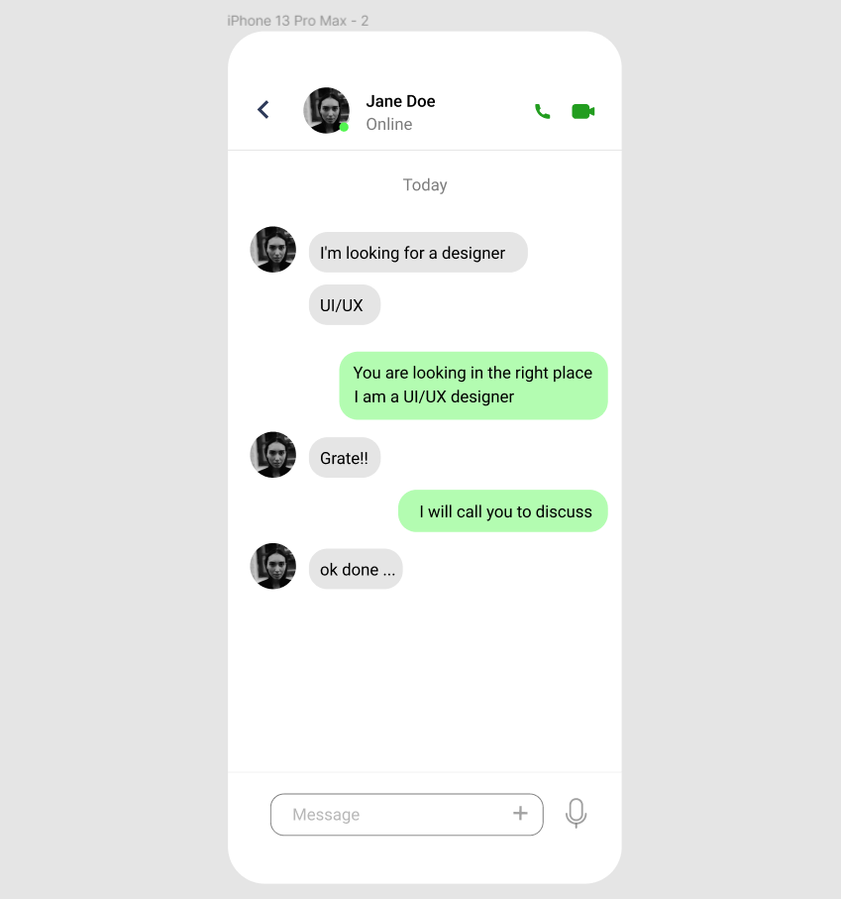

Figma File

<https://www.figma.com/file/ocaGfLZAra18NGghB6yAq6/SE_Lab_6_11>

12. Countdown

Graphic Design

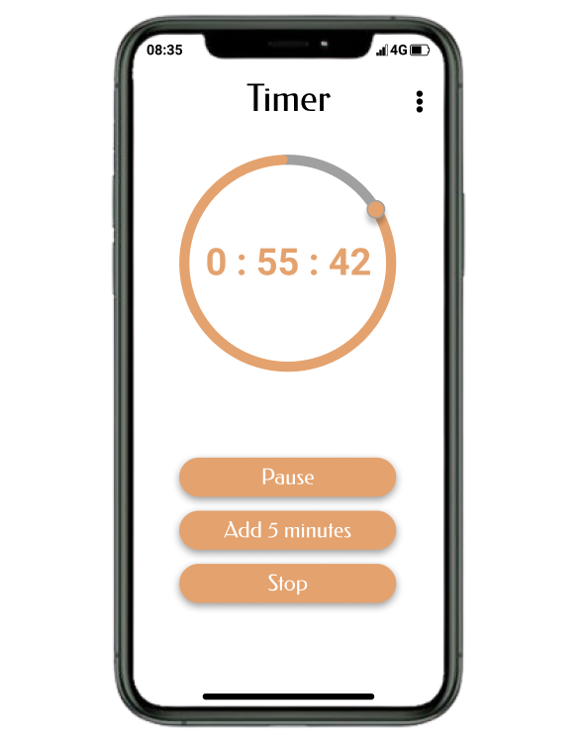

Figma File

<https://www.figma.com/file/ePvRoWzoSmJCdMLbzIZvOn/SE_Lab_6_12>

13. On/Off Switch

Graphic Design

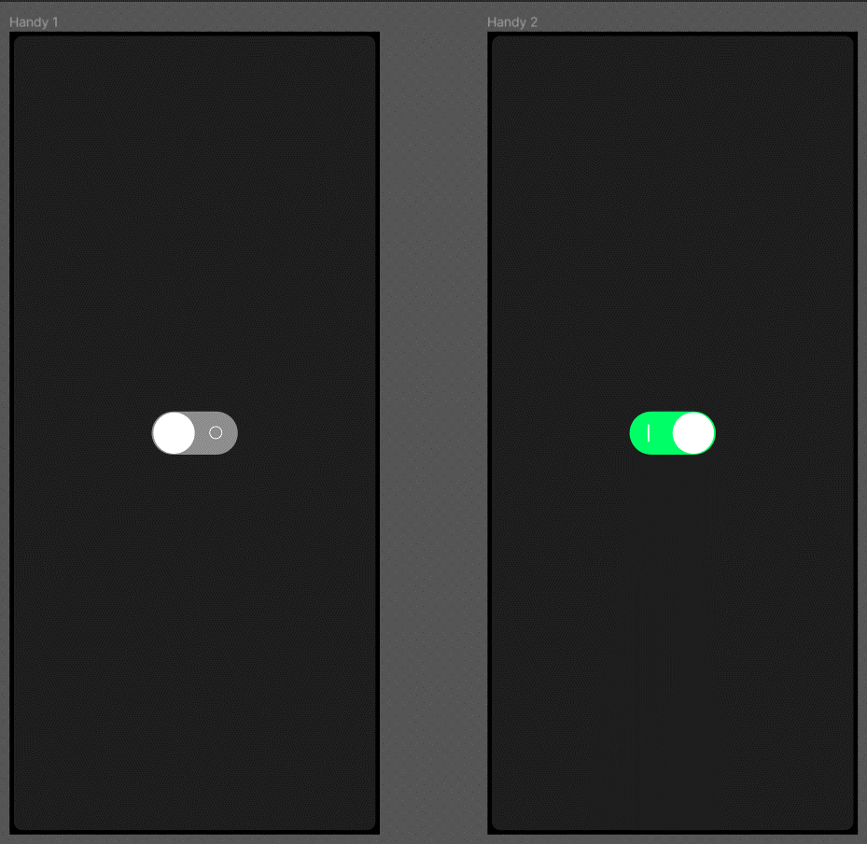

Figma File

<https://www.figma.com/file/wgfdGdfSY3U5U7efwFwX1X/SE_Lab_6_13>

14. Email receipt

Graphic Design

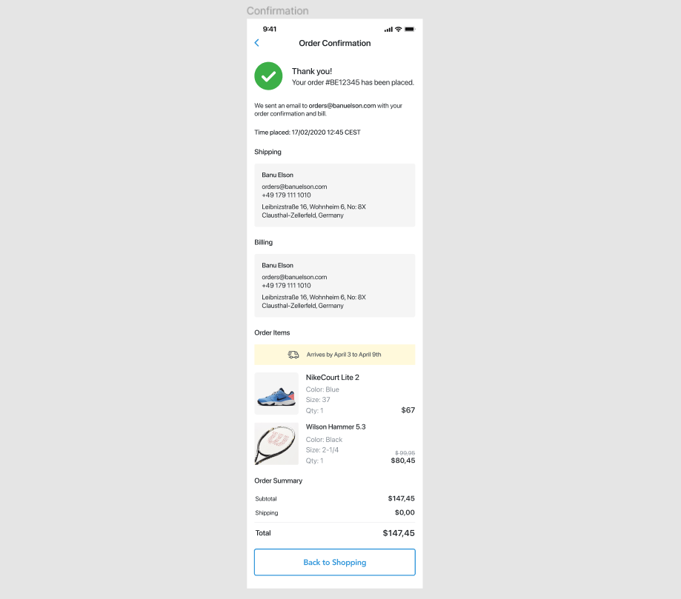

Figma File

<https://www.figma.com/file/QRyBXjSiHpKFdJFQW8ugnB/SE_Lab_6_2>

15. Dashboard

Graphic Design

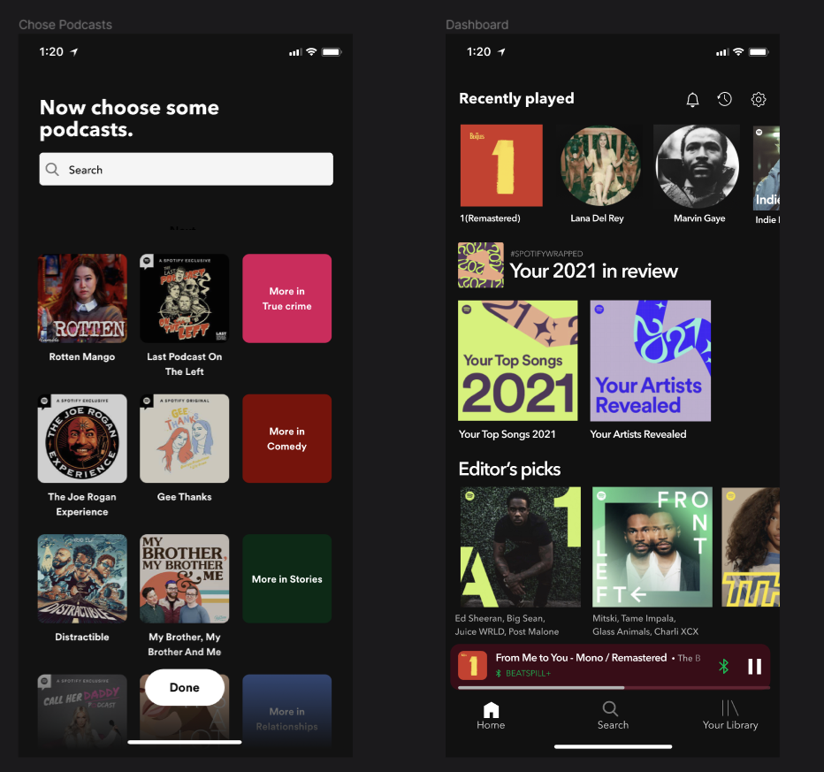

Figma File

<https://www.figma.com/file/QIERUMVbsxFIHGgr80ENmc/SE_Lab_6_8>

16. Search

Graphic Design

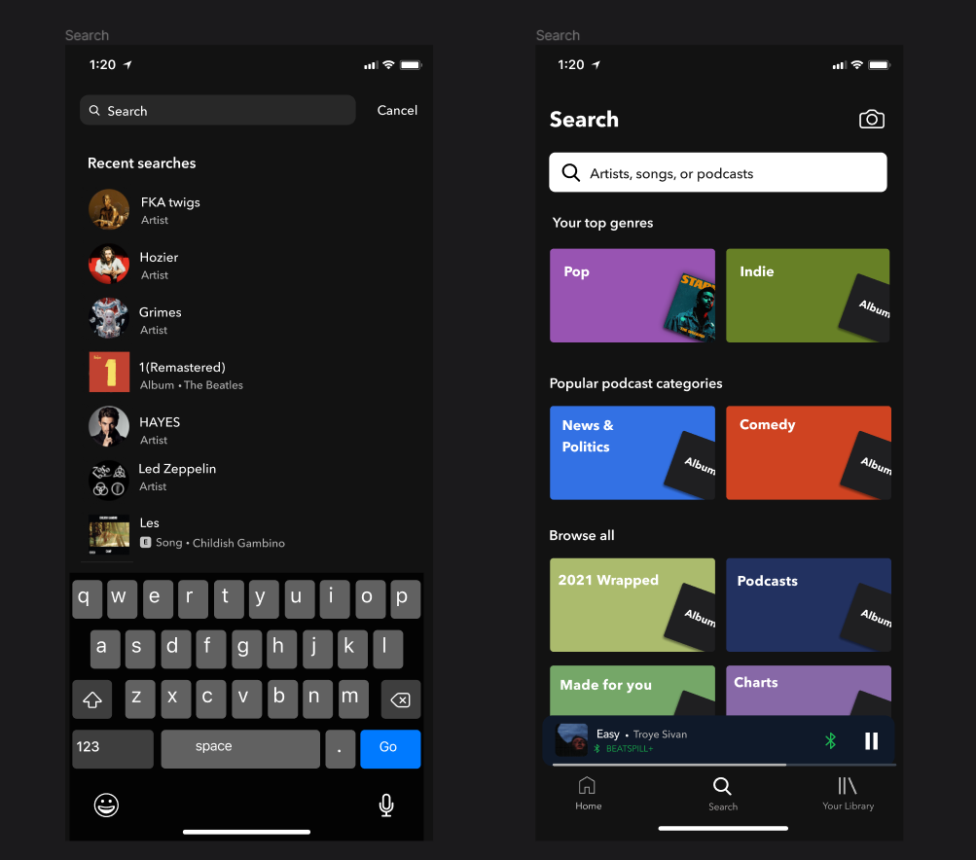

Figma File

<https://www.figma.com/file/QIERUMVbsxFIHGgr80ENmc/SE_Lab_6_8>

17. Boarding Pass

Graphic Design

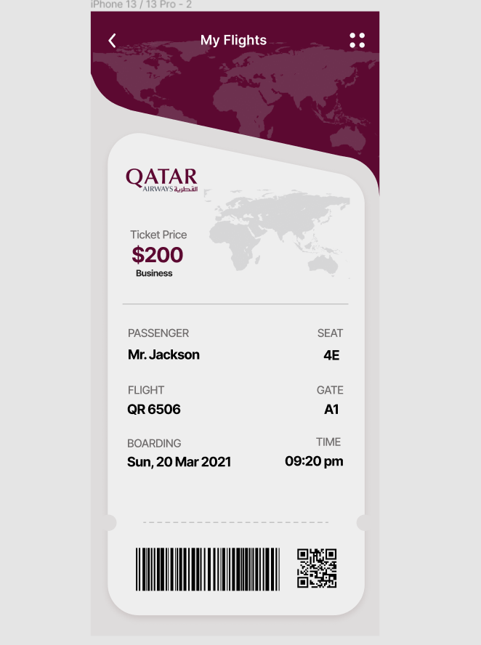

Figma File

<https://www.figma.com/file/qGsg4W12mrhyXYFM5ywxET/SE_Lab_6_17>

18. Subscribe

Graphic Design

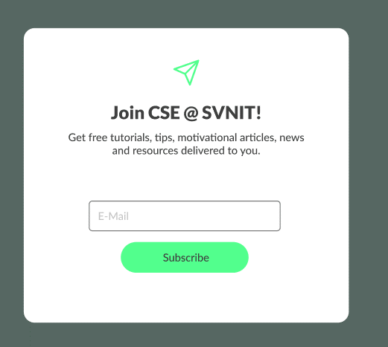

Figma File

<https://www.figma.com/file/QxUhEEW6Gl8PqZdRTKvHme/SE_Lab_6_18>

19. Contact Us

Graphic Design

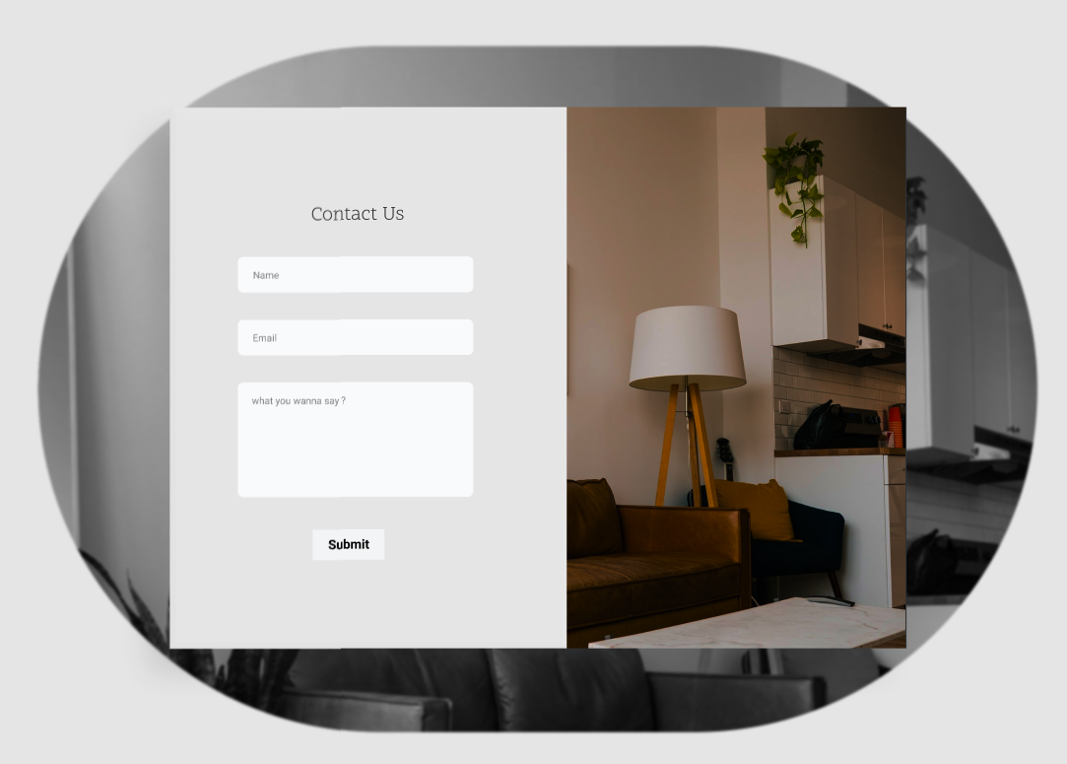

Figma File

<https://www.figma.com/file/XTqDlWDH0PpMCrI5EttnH0/SE_Lab_6_19>

20. Pricing

Graphic Design

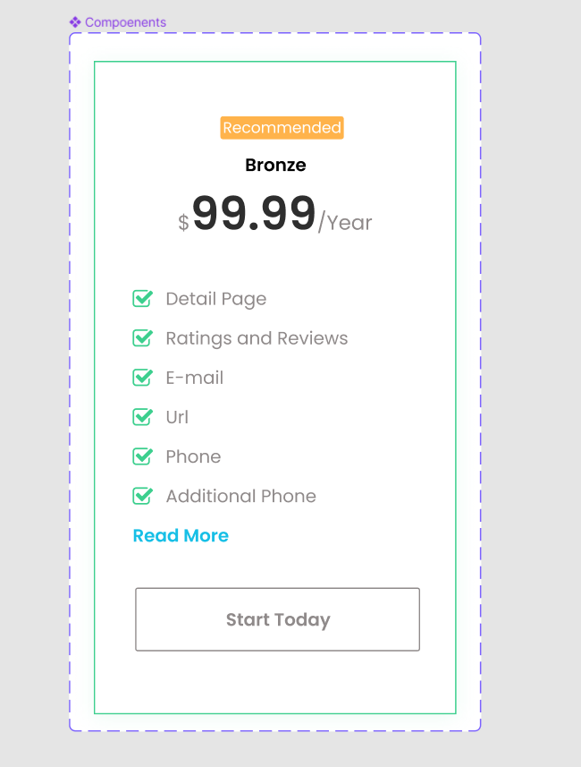

Figma File

<https://www.figma.com/file/NWUNviX40CiSn7HEPk3glg/SE_Lab_6_20>

21. File upload

Graphic Design

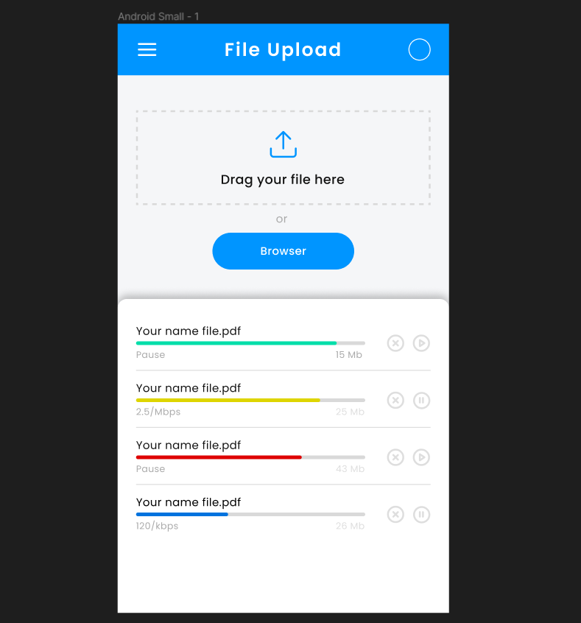

Figma File

<https://www.figma.com/file/R00KfTginlW0rvadOLQP2x/SE_Lab_6_21>

22. Crowdfunding campaign

Graphic Design

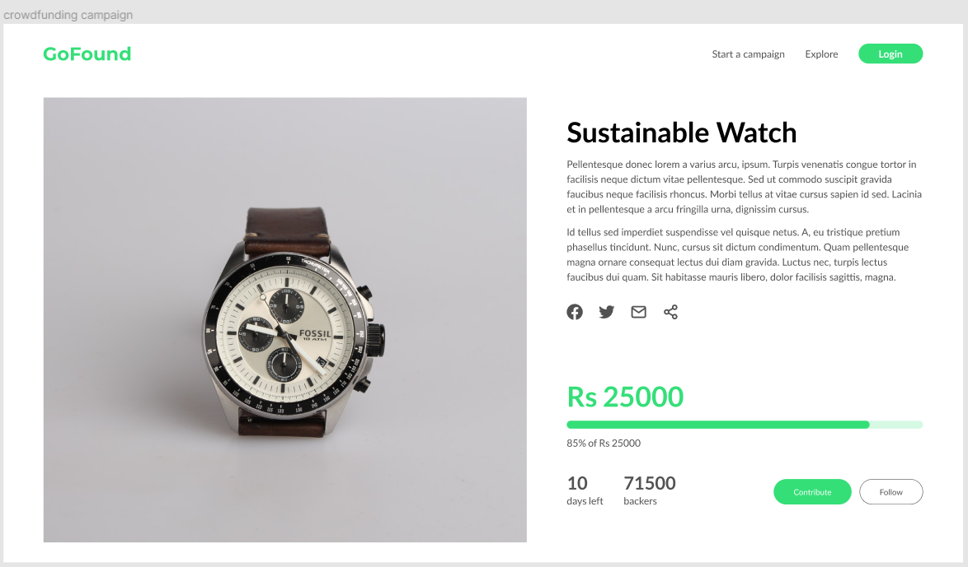

Figma File

<https://www.figma.com/file/0V90vkQKsDypDUJlaZuOgQ/SE_Lab_6_22>

23. Special offer

Graphic Design

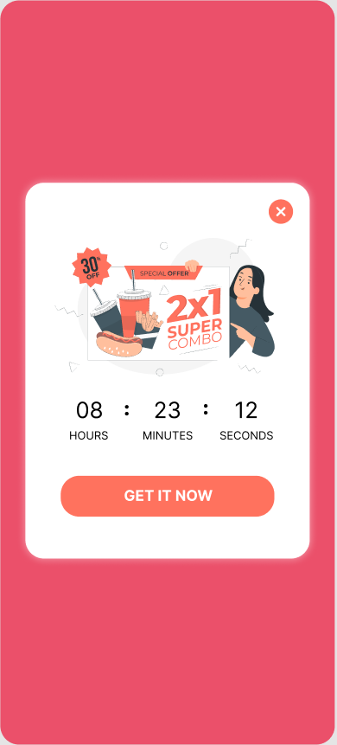

Figma File

<https://www.figma.com/file/iNiF1JOIZCzezBygs0S9ah/SE_Lab_6_23>

24. Calendar

Graphic Design

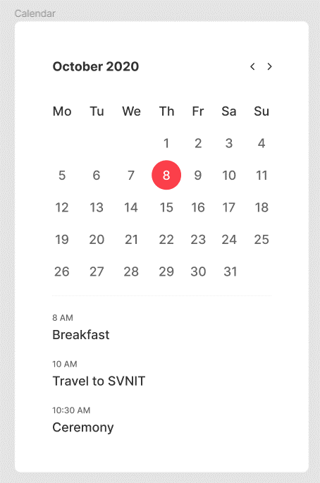

Figma File

<https://www.figma.com/file/M0lgqpz3Ag0IdDDGrpi9IP/SE_Lab_6_24>

25. Testimonials

Graphic Design



Figma File

[https://www.figma.com/file/nPkiDbJ3sSTtCyZ976b6cW/SE_Lab_6_25](https://www.figma.com/file/nPkiDbJ3sSTtCyZ976b6cW/SE_Lab_6_25?node-id=0%3A1)

26. ToDo List

Graphic Design

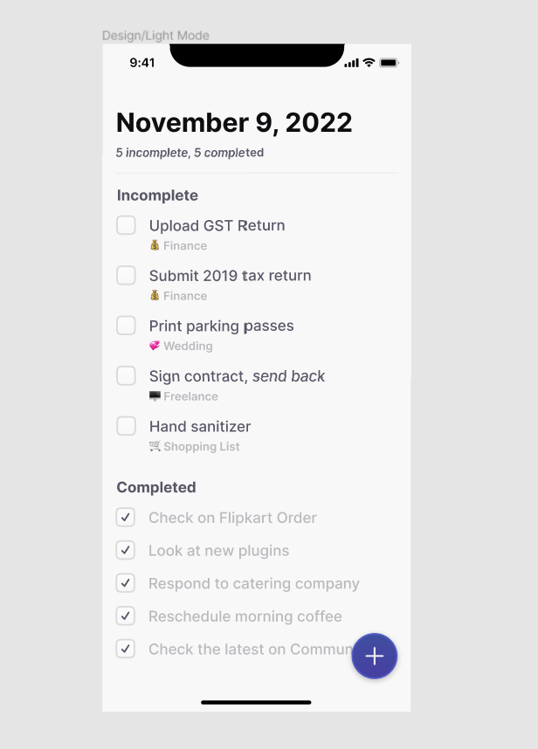

Figma File

<https://www.figma.com/file/HEFNY0h8WtiNUNMtcBSCNm/SE_Lab_6_26>

27. Invoice

Graphic Design

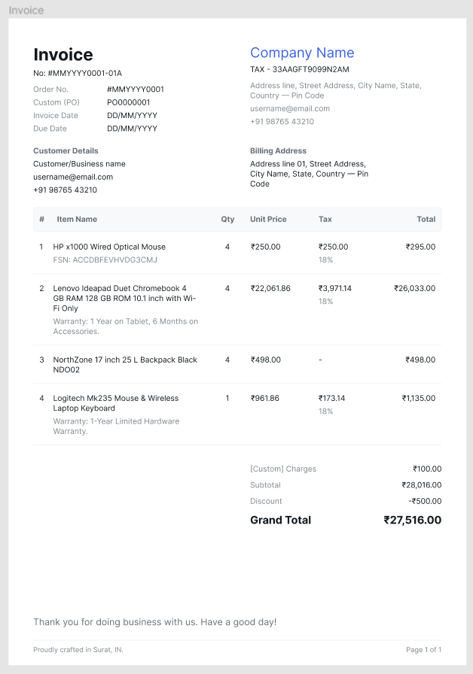

Figma File

<https://www.figma.com/file/2dz72PweRwvKbl2LMUXHIv/SE_Lab_6_27>

28. Activity feed

Graphic Design

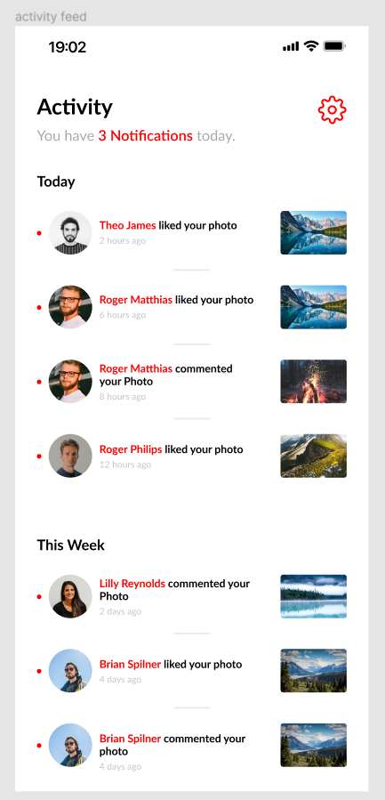

Figma File

<https://www.figma.com/file/sT8muVYYqZbM2l7soz8SPf/SE_Lab_6_28>

29. Redeem coupon

Graphic Design

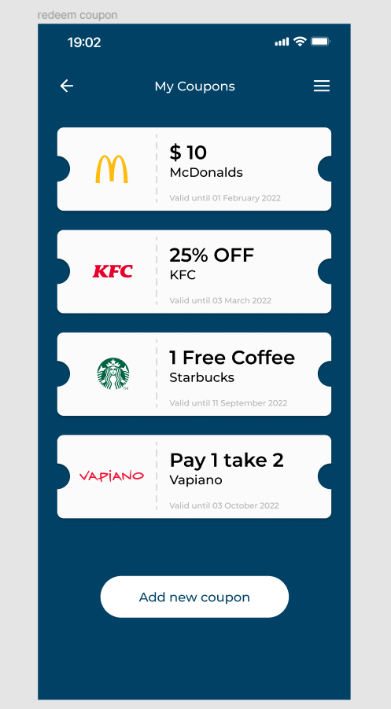

Figma File

[https://www.figma.com/file/1NAmOZxdUdmzOuKdm6rilk/SE_Lab_6_29](https://www.figma.com/file/1NAmOZxdUdmzOuKdm6rilk/SE_Lab_6_29?node-id=0%3A1)

30. Trending

Graphic Design



Figma File

[https://www.figma.com/file/GXkyycnRZE3aiJ3tJYVZxn/SE_Lab_6_30](https://www.figma.com/file/GXkyycnRZE3aiJ3tJYVZxn/SE_Lab_6_30?node-id=37%3A197)

**SUBMITTED BY**: U19CS012

BHAGYA VINOD RANA