**----------------------------------------------------------------**

**DL**

**MID SEMESTER EXAM ANSWERS**

**Date: 7th March, 2023**

**----------------------------------------------------------------**

Q1.) Answer the following (Any Two)

A.) Consider the following Scenario: A child was asked to sing a song in the school annual function. He started with good pace, however due to nervousness he was unable to continue; after a minute of his pause, some children among the audience cheered him up and finally he was able to perform very well in every such kind of program. Above scenario is an example of which type of Human learning to that child? Write briefly about different types of human learning.

Answer: **Operant Conditioning**

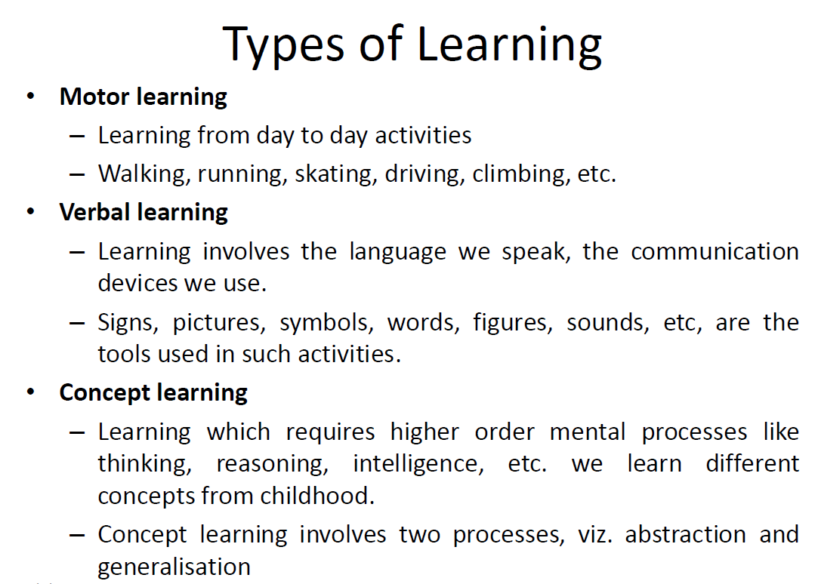

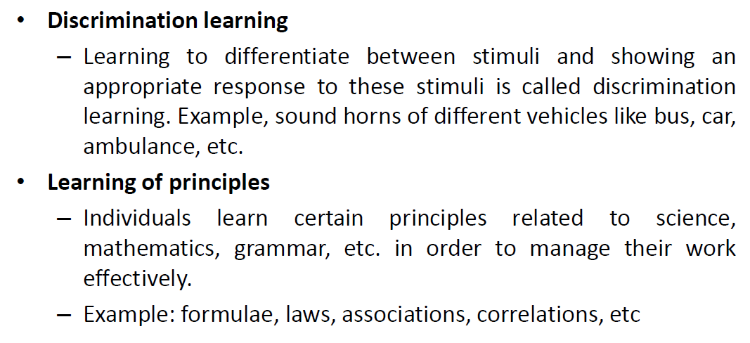

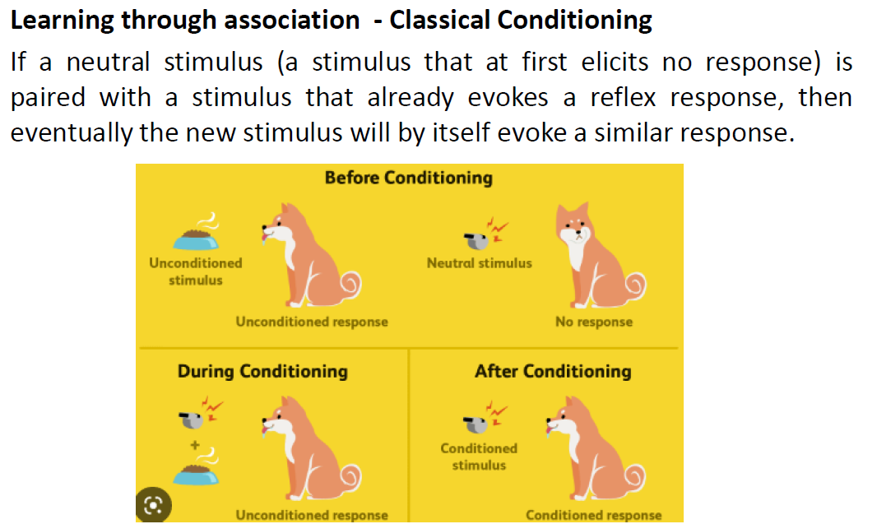

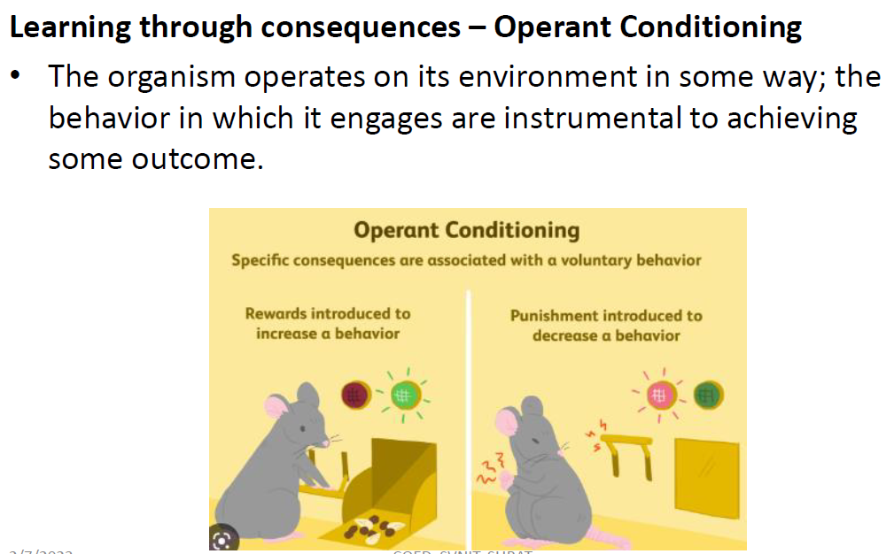

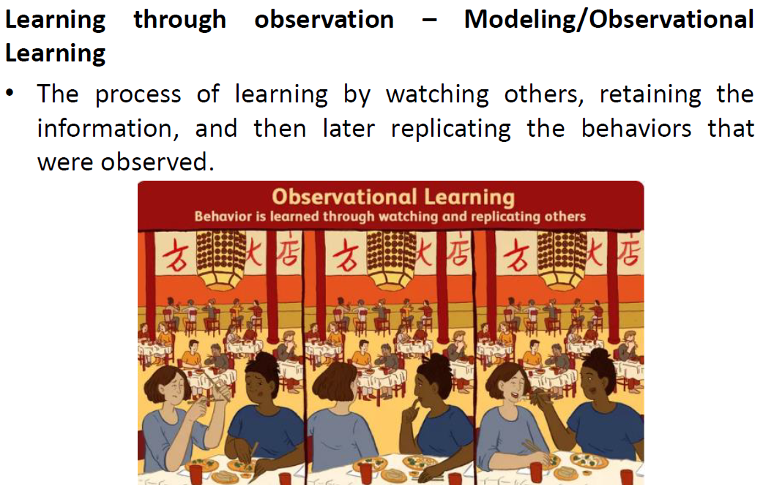

B.) Given the following Customized AC System: System works on the fact that Customized AC will be turned OFF if the Room door is open and the temperature is low. Given the following situations: S1: Room door is closed, temperature is high; S2: Room is closed, temperature is low; S3: Room is open, temperature is high, S4: Room is open, temperature is low. Design an appropriate McCulloch O Pitts Neuron model for above system.

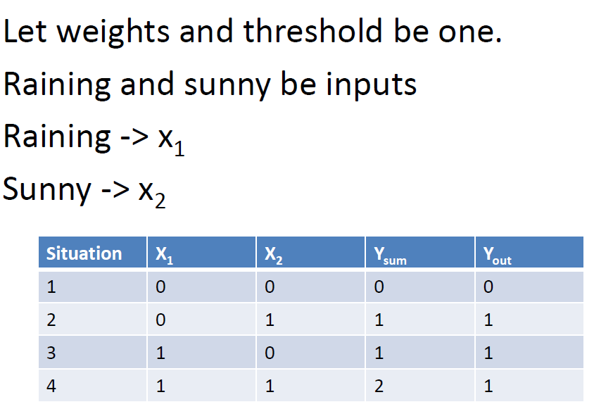

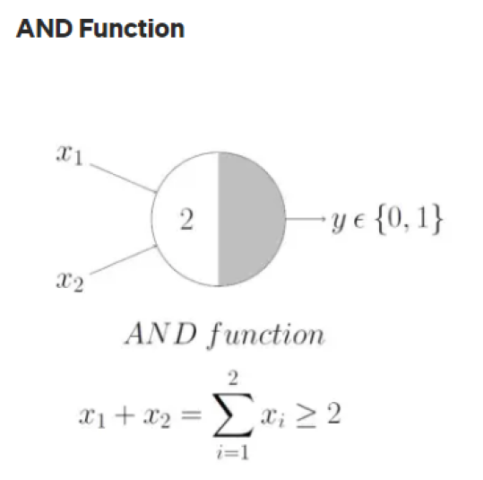

C.) Refer to the neural network given below: List and calculate learnable parameters at each layer and for overall network. List and comment on hyper-parameters of the deep neural networks in brief.

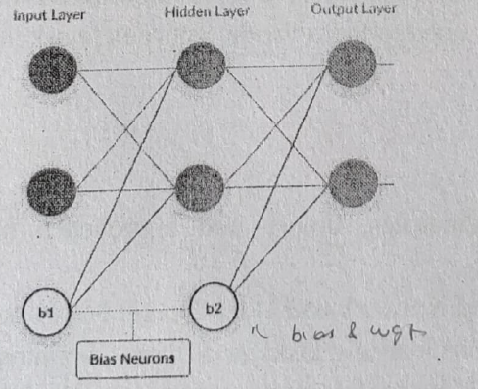

Answer: inputs * outputs + biases

Learnable Parameters: Weights & Biases

I/P & Hidden = 2*2 + 2 = 6

Hidden & O/P = 2*2 + 2 = 6

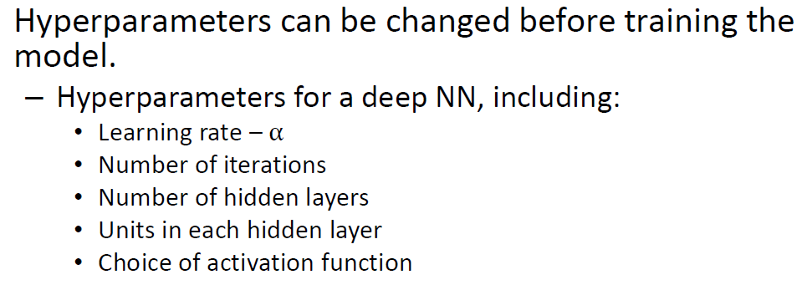

Q2.) Answer the following.

A.) What do you mean by dead neurons in deep neural networks? By using which activation function/s issue of dead neurons can occur? How to overcome them?

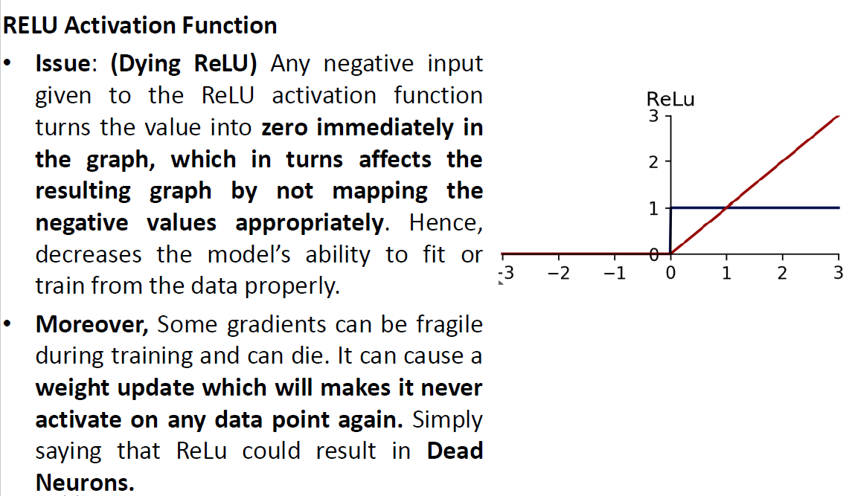

Overcome : Leaky ReLU & ELU

B.) Assume a dataset has multiple outliers and we need to design a deep neural network for the same; which loss function will be optimum for such a dataset? Explain the same in brief.

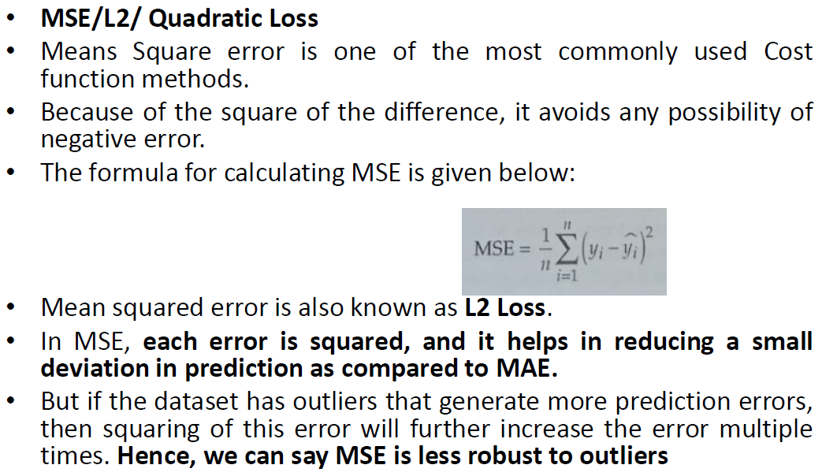

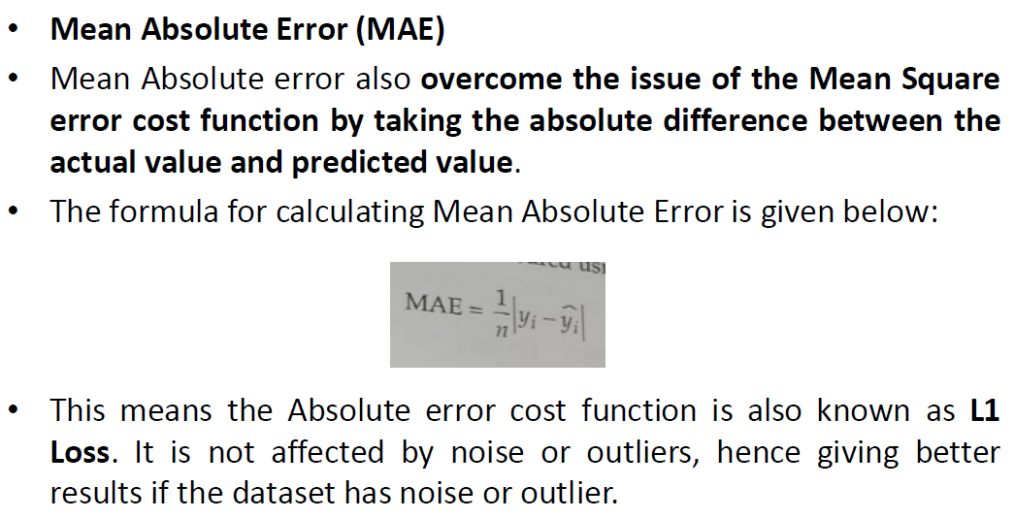

C.) "In Deep neural networks, as and when the weights increase, the gradient increases". Above mentioned statement gives the implication of which problem? List and brief possible way/s to mitigate the same?

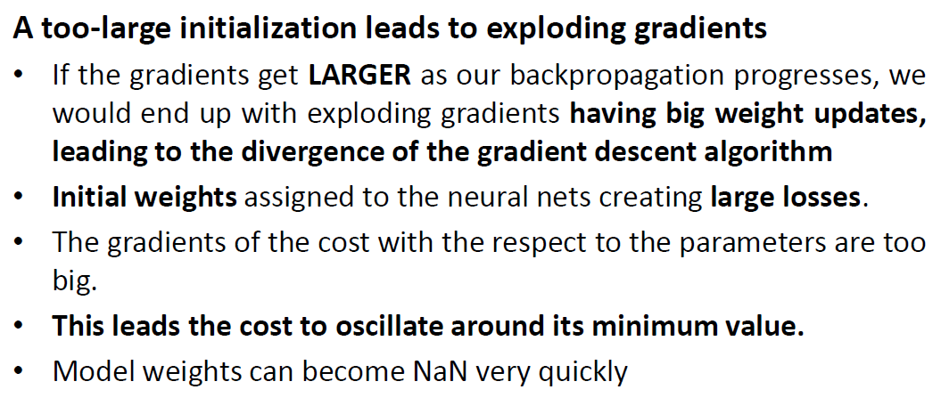

Mitigation: Gradient Clipping & Backpropagation through Time

Q3.) Answer the following

A.) Consider an input image of size 13x13 and 64 filters of size 3x3. Discuss whether it is possible to perform convolutions with strides 2, 3, 4, and 5. Justify your answer in each case.

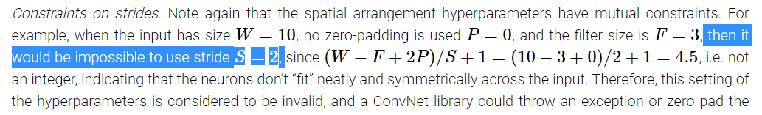

For 2,4,5 -> Possible, 3 -> Not Possible

B.) Differentiate between CNN and RNN with suitable examples.

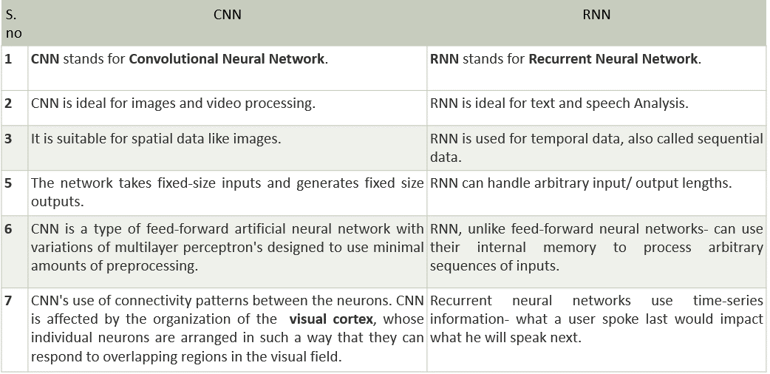

C.) What are the major issues in RNN? Discuss the methods to address these issues.

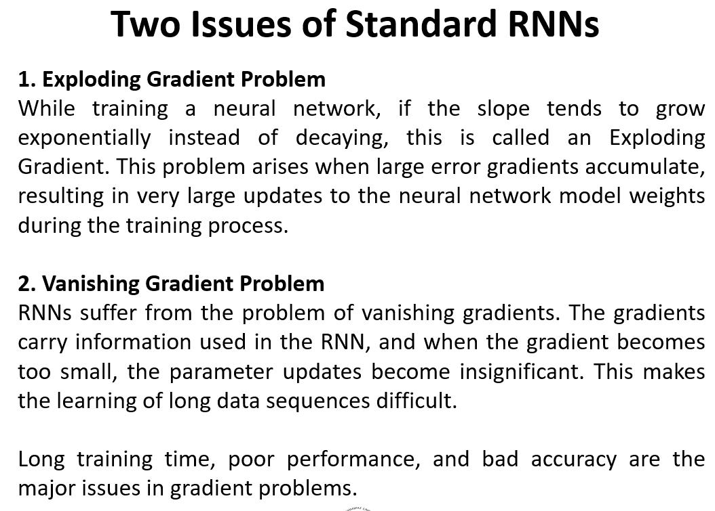

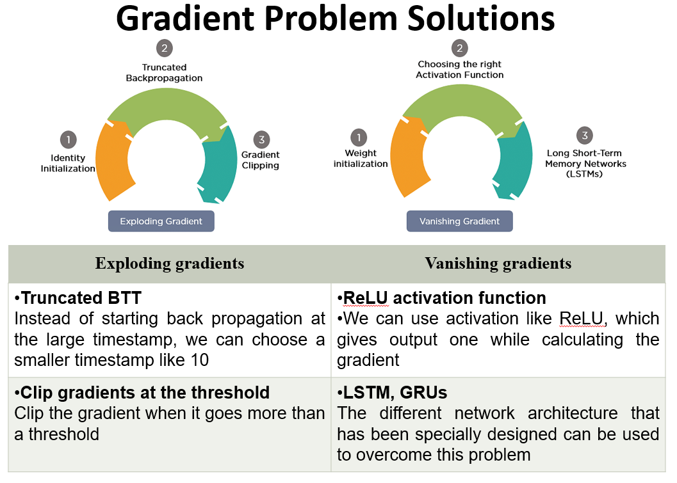

D.) What is the difference between the workflow of LSTM and GRU? Give the examples where LSTM should be used over GRU.

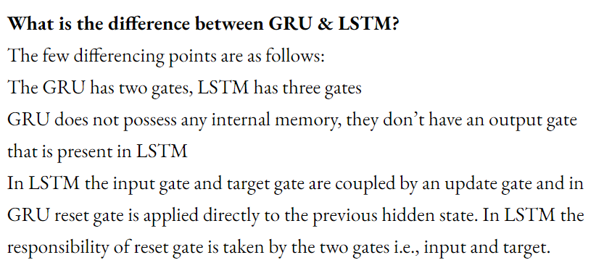

One can choose LSTM if you are dealing with large sequences and accuracy is concerned, GRU is used when you have less memory consumption and want faster results

E.)

