Original Code Size :

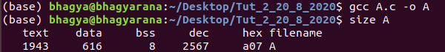
Q1 Initialized Size:

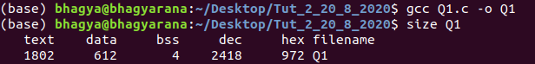
Q1 Unintialized Size:

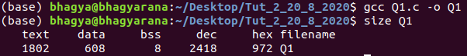
Q2 Initialized Size:

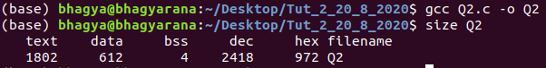

Q2 Unintialized Size:

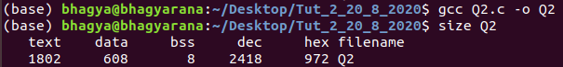

Q3 Initialized Size:

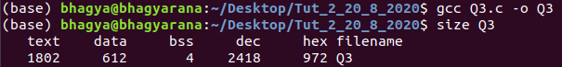

Q3 Unintialized Size:

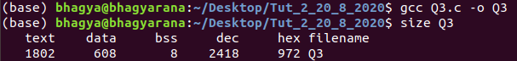

Q4 Initialized Size:

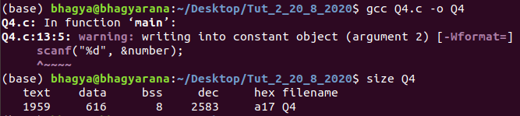
Q5 Initialized Size:

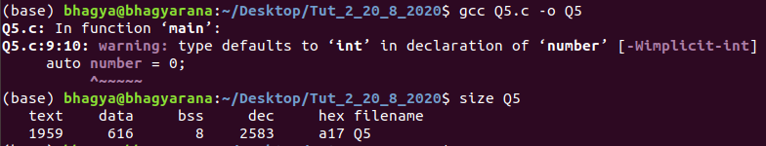

Q6 Initialized Size:

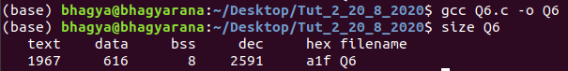

Q6 Unintialized Size:

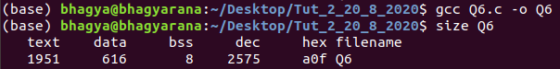

Q7 Initialized Size:

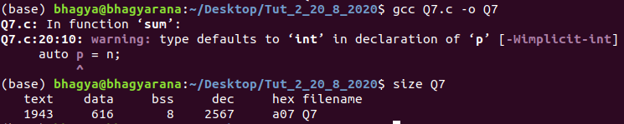

Q8 Initialized Size:

