**PPL Previous Year Question Papers Solution**

**[2022] [Mid] [12 March]**

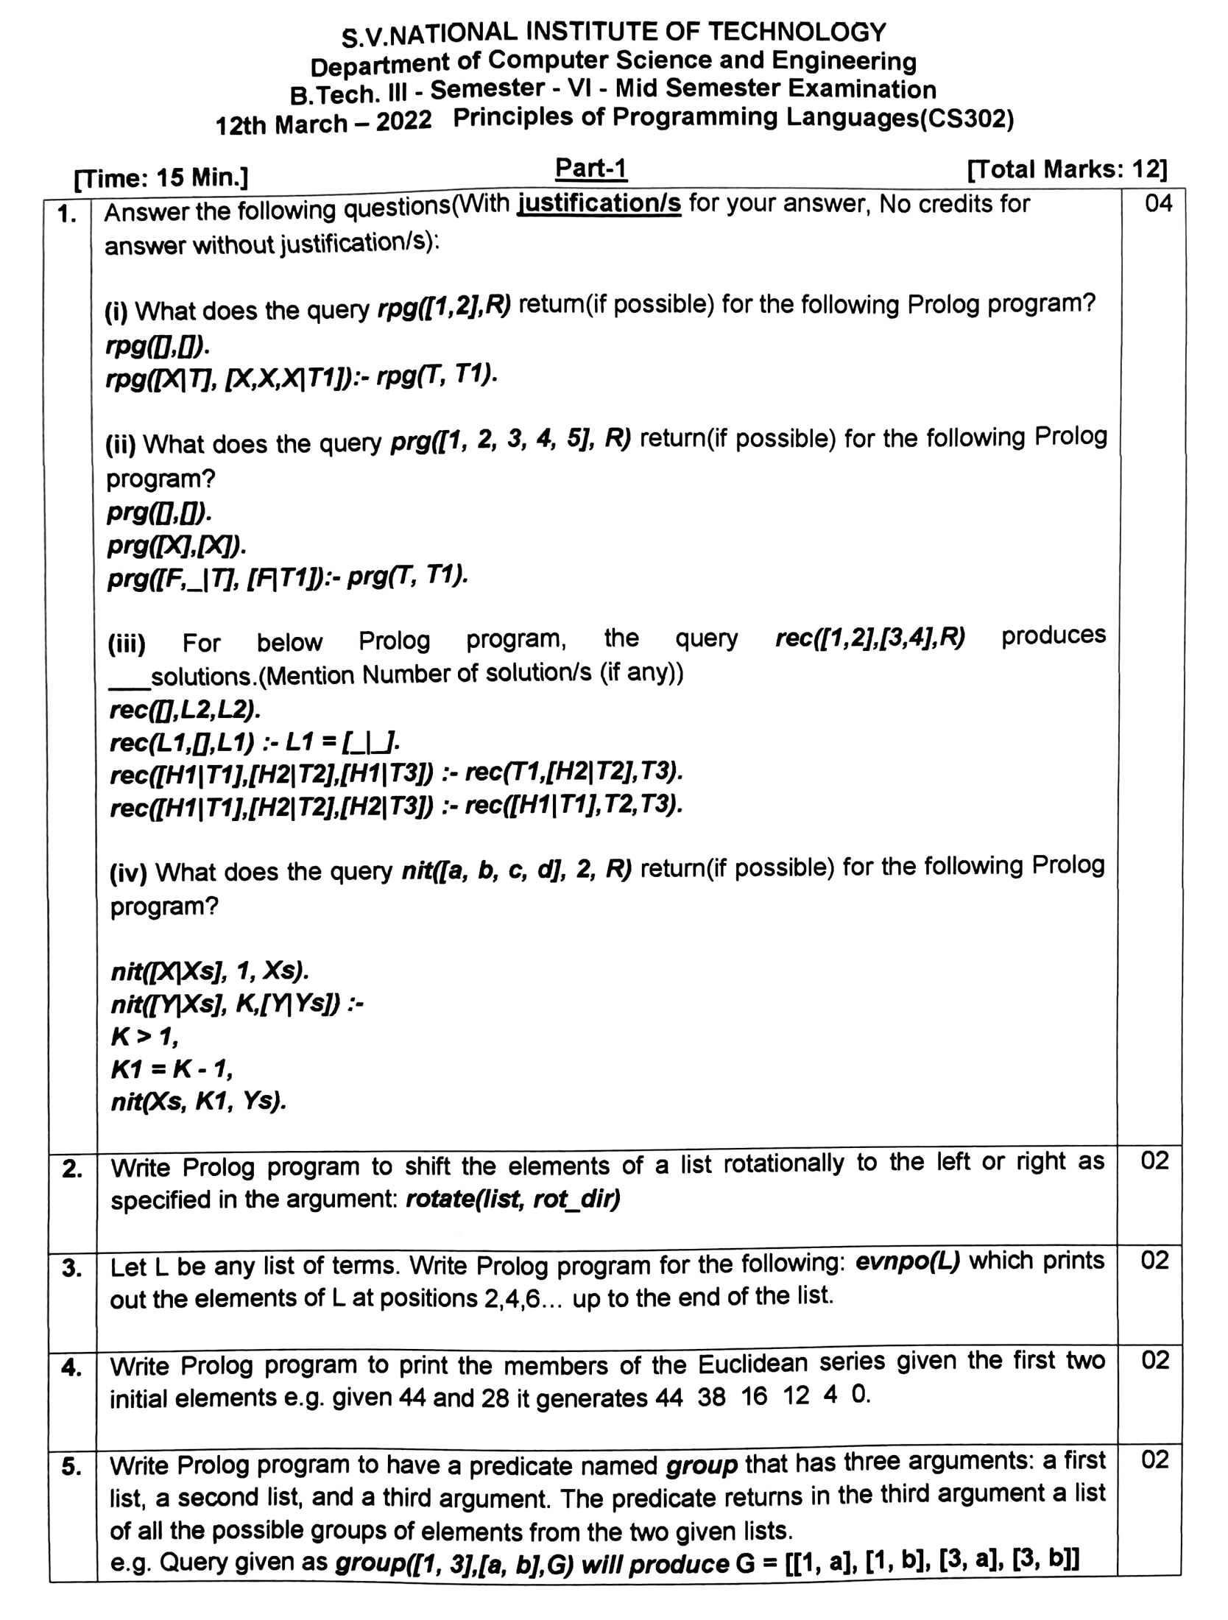

**1.)**

**(i)**

**rpg([],[]).**

**rpg([X|T],[X,X,X|T1]):-rpg(T,T1).**

**rpg([1,2],R).**

**R = [1, 1, 1, 2, 2, 2].**

**(ii)**

**prg([],[]).**

**prg([X],[X]).**

**prg([F,_|T],[F|T1]):-prg(T,T1).**

**prg([1,2,3,4,5],R).**

**R = [1, 3, 5].**

**(iii)**

**rec([],L2,L2).**

**rec(L1,[],L1):-L1=[_|_].**

**rec([H1|T1],[H2|T2],[H1|T3]):-rec(T1,[H2|T2],T3).**

**rec([H1|T1],[H2|T2],[H2|T3]):-rec([H1|T1],T2,T3).**

**rec([1,2],[3,4],R).**

**R = [1, 2, 3, 4] ;**

**R = [1, 3, 2, 4] ;**

**R = [1, 3, 4, 2] ;**

**R = [3, 1, 2, 4] ;**

**R = [3, 1, 4, 2] ;**

**R = [3, 4, 1, 2] ;**

**false.**

**(iv)**

**nit([X|Xs],1,Xs).**

**nit([Y|Xs],K,[Y|Ys]):-**

**K>1,**

**K1=K-1,**

**nit(Xs,K1,Ys).**

**nit([a,b,c,d],2,R).**

**You Would have Thought [a,c,d] as Output, But in Base Case, its Infinite Loop.**

**Therefore, False it the Real Output.**

2.)

shift(L1, N, L2) *:-*

    N < 0, *!*,             *% this is the case for negative N*

    length(L1, Len),

    N1 is Len + N,

    shift(L1, N1, L2)*.*

shift(L1, N, L2) *:-*

    append(Lx, Ly, L1), *% L1 is Lx || Ly*

    append(Ly, Lx, L2), *% L2 is Ly || Lx*

    length(Lx, N)*.*      *% The length of Lx is N*

?- shift([1,2,3,4,5],1,R).

R = [2, 3, 4, 5, 1] ;

false.

?- shift([1,2,3,4,5],4,R).

R = [5, 1, 2, 3, 4] ;

false.

?- shift([1,2,3,4,5],-1,R).

R = [5, 1, 2, 3, 4] ;

false.

3.)

evenpo(L):-

    evenpos(L,Ans),

    print_list(Ans)*.*

evenpos([X],[])*.*

evenpos([X,X2],[X2])*.*

evenpos([H,H2|T],[H2|R])*:-*

    evenpos(T,R)*.*

print_list([])*.*

print_list([H|T])*:-*

    write(H),

    write(" "),

    print_list(T)*.*

?- evenpo([a,b,c,d,e,f,g,h]).

b d f h

true ;

false.

4.) There is Error in Question Series should be [44 **28** 16 12 4 0]

*% Print the Element of Euclidean Series [44 28 16 12 4 0]*

go(X1,X2)*:-*

    write(X1),

    write(' '),

    write(X2),

    write(' '),

    euclid(X1,X2)*.*

euclid(_,0)*.*

euclid(X1,X2)*:-*

    R is X1 mod X2,

    write(R),

    write(' '),

    R > 0,      *% Mod by Zero Error*

    euclid(X2,R)*.*

?- go(44,28).

44 28 16 12 4 0

false.

5.)

1.)

2.)

3.)

4.)

5.)

6.)

7.)

**[2021] [End] [1 December]**

**[2021] [Mid] [29 September]**

**[2019] [End] [4 December]**

**[2019] [Mid] [3 October]**

**[2020] [Supplementary] [11 Feb]**

**[2019] [Supplementary] [12 Feb]**