Principles of Programming Language (CS302)

Assignment - 4

**U19CS012**

1.) Write a program in C++ that **Calls** both

* **Dynamically Bound** method
* **Statically Bound** method

Large number of times, timing the calls to both of the two. Compare the **Timing results** and Compute the difference of the time required by the Two. Explain the Results.

**Binding** - Mapping of one thing to another

[In Context of **Compiled Languages** - Link between a **Function Call** and **Function Definition**.] When a function is called in C++, the Program Control binds to the Memory Address where that Function is defined.

|  |  |  |
| --- | --- | --- |
|  | Static Binding | Dynamic Binding |
| Happens at | **Compile** Time | **Run**time |
| Happens when | all information needed to call a function is available at the compile-time. | Happens when the compiler cannot determine all information needed for a function call at compile-time. |
| Achieved Using | Normal Function Calls, Function & Operator Overloading | Virtual functions |
| Execution Time | **Faster** {Since all info is Available before runtime} | **Slower** { Function call is not resolved until runtime for later binding} |
| Code Size | **Large** | **Small & Flexible** Code { single function can handle different types of objects at runtime} |

**Code**

*// For Basic IO*

*#include* <iostream>

*// For setprecision*

*#include* <iomanip>

*// For Time Calculation*

*#include* <chrono>

using namespace std;

using namespace std::chrono;

*// [U19CS012] BHAGYA VINOD RANA*

*// Maximum Number of Calls*

const int MAX_CALLS = 1000000;

*// Complex Calculation*

void complex_calc()

{

    long long int sum = 0;

*for* (int i = 0; i < 1000; i++)

        sum += i;

}

*// Base Class*

class base

{

public:

*// Statically Bound*

    void fun_1() { complex_calc(); }

*// Dynamically Bound*

    virtual void fun_2() { complex_calc(); }

};

*// Derived Class*

class derived : public base

{

public:

*// This was Just to Confuse*

    void fun_1() { cout << "derived-1\n"; }

    void fun_2() { complex_calc(); }

};

void menu()

{

    cout << "------------------------------------------------------------\n";

    cout << "1 -> Statically Bound Method\n";

    cout << "2 -> Dynamically Bound Method\n";

    cout << "3 -> Exit\n";

    cout << "------------------------------------------------------------\n";

}

int main()

{

    base *p;

    base t;

    derived obj1;

    p = &obj1;

    auto start = high_resolution_clock::now();

    auto end = high_resolution_clock::now();

    double time_taken = duration_cast<nanoseconds>(end - start).count();

    int choice = 1;

*while* (true)

    {

        menu();

        cout << "Enter you Choice [1/2/3] : ";

        cin >> choice;

*switch* (choice)

        {

*case* 1:

*// Static Bind*

            start = high_resolution_clock::now();

*for* (int i = 0; i < MAX_CALLS; i++)

                p->fun_1();

            end = high_resolution_clock::now();

*// Calculating total time taken by the Static Bind.*

            time_taken = duration_cast<nanoseconds>(end - start).count();

            time_taken *= 1e-9;

            cout << "Time taken by Statically Bound Method is : " << fixed << time_taken << setprecision(9);

            cout << " sec" << endl;

*break*;

*case* 2:

*// Dynamic Bind*

            start = high_resolution_clock::now();

*for* (int i = 0; i < MAX_CALLS; i++)

            {

                p->fun_2();

            }

            end = high_resolution_clock::now();

*// Calculating total time taken by the Static Bind.*

            time_taken = duration_cast<nanoseconds>(end - start).count();

            time_taken *= 1e-9;

            cout << "Time taken by Dynamically Bound Method is : " << fixed << time_taken << setprecision(9);

            cout << " sec" << endl;

*break*;

*case* 3:

            cout << "\nStatic Vs Dynamic Bind Comparision Done Successfully!\n";

*return* 0;

*break*;

*default*:

            cout << "Enter Valid Input! Please Try Again!\n";

        }

    }

*return* 0;

}

**Output**

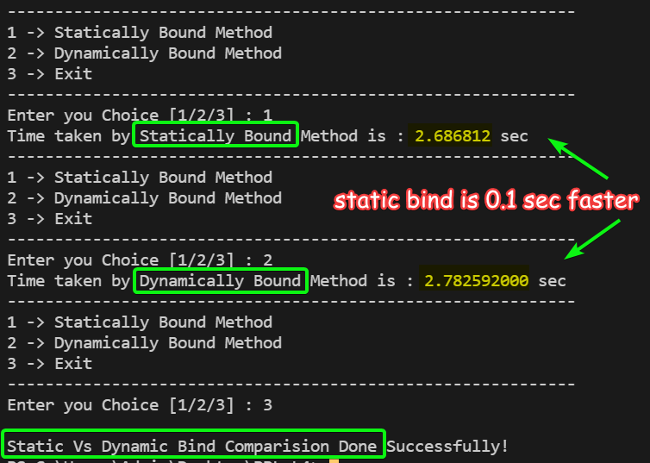

We Observer that {Time Taken by **Dynamic Bind** takes More (>) time than **Static Bind,** Since in Dynamic Bind, the Function Call is Resolved at the **Run Time**}.

2.) Design and implement a C++ program that defines a base class A, which has a subclass B, which itself has a subclass C. The A class must implement a method, which is overridden in both B and C.

You must also write a test class that instantiates A, B, and C and includes three calls to the method.

* One of the calls must be **statically bound to A’s** method.
* One call must be **dynamically bound to B’s** method
* One must be **dynamically bound to C’s** method.

All of the method calls must be through a pointer to class A.

**Code**

*#include* <iostream>

using namespace std;

class A

{

public:

    virtual void method()

    {

        cout << "Method From -> class A\n";

    }

*// Constructor*

    A()

    {

        method();

    }

};

*// B class is derived from base class A.*

class B : public A

{

public:

    void method()

    {

        cout << "Method From -> class B\n";

    }

};

*// C class is derived from base class B.*

class C : public B

{

public:

    void method()

    {

        cout << "Method From -> class C\n";

    }

};

int main()

{

    A *a;

    cout << "\nCall that is Statically Bound to A's Method\n";

    A tmp;

    a = &tmp;

    cout << "\nCall Dynamically Bound to B's Method\n";

    B b;

    a = &b;

    a->method();

    cout << "\nCall Dynamically Bound to C's Method\n";

    C c;

    a = &c;

    a->method();

*return* 0;

}

**Output**

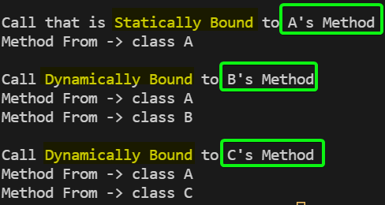

3.) Consider the following C++ skeletal program [Question in Assignment had Errors]:

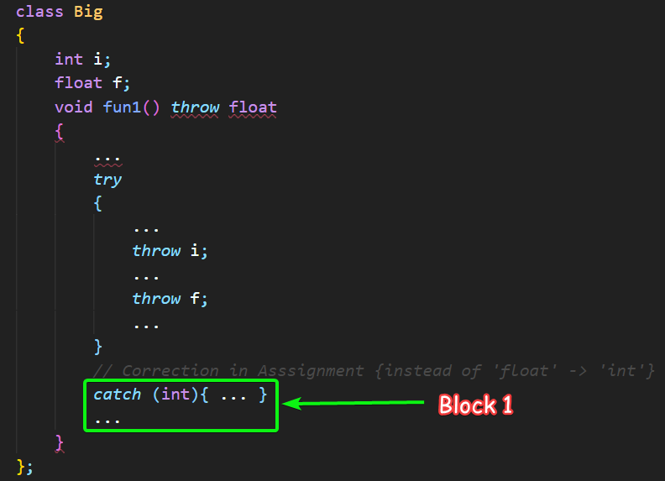

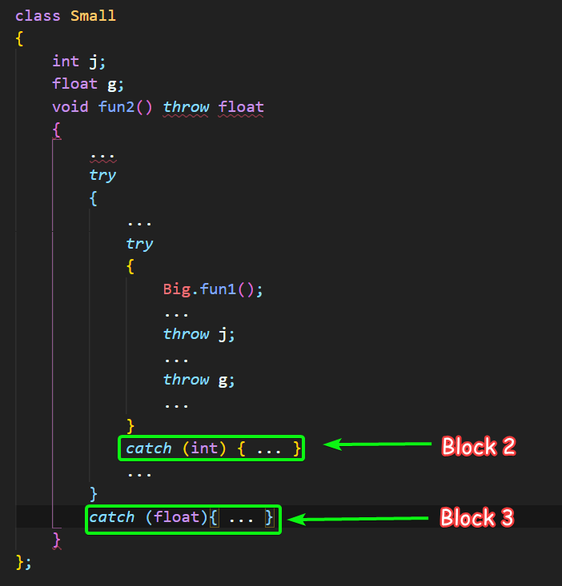

In each of the four throw statements, where is the **exception handled**?

[**Note**: fun1() is called from fun2() in class **Small**.]

|  |  |  |
| --- | --- | --- |
| Throw Statement | Catch Block [1/2/3] | Reason |
| throw i; | 1 | Since 'i' is an **int** variable.  The nearest matching - 'int' catch block after throw i catches the error.  So, **Block 1** handles **throw** i. |
| throw f; | 3 | Since 'f' is **float** variable.  The nearest matching – ‘float’ catch block after throw ‘f’ will catch the error because there is **no matching catch** available in fun1() and also fun1() is called by fun2(). So, it will catch by it.  So, **Block 3** handles **throw** f. |
| throw j; | 2 | 'j' is an **int** variable.  The nearest matching - int catch block after throw j catches the error.  So, **Block 2** handles **throw** j. |
| throw g; | 3 | Since 'g' is **float** variable.  The nearest matching - float catch block after throw g will catch the error.  So, **Block 3** handles throw g. |

4.) Write a C++ program that takes a set of inputs.

The type of input governs the kind of operation to be performed, i.e. **concatenation for strings and addition for int or float**.

You need to write the class template **AddElements** which has a functions:

* **add()** for giving the sum of int or float elements.
* **concatenate()** to concatenate the second string to the first string.

**Code**

*#include* <bits/stdc++.h>

using namespace std;

*// [U19CS012] BHAGYA VINOD RANA*

struct fast

{

    fast()

    {

        ios_base::sync_with_stdio(false);

        cin.tie(NULL);

    }

};

fast f;

*/*Write the class AddElements here*/*

template <class T>

class AddElements

{

private:

    T a;

public:

*// Constructor*

    AddElements(T val)

    {

        a = val;

    }

*// Add for int and float*

    T add(T &n)

    {

*return* a + n;

    }

*// String Concatanation*

    T concatenate(T b)

    {

*return* a + b;

    }

};

int main()

{

    int n, i;

    cin >> n;

*for* (i = 0; i < n; i++)

    {

        string type;

        cin >> type;

*if* (type == "float")

        {

            double element1, element2;

            cin >> element1 >> element2;

            AddElements<double> myfloat(element1);

            cout << myfloat.add(element2) << endl;

        }

*else* *if* (type == "int")

        {

            int element1, element2;

            cin >> element1 >> element2;

            AddElements<int> myint(element1);

            cout << myint.add(element2) << endl;

        }

*else* *if* (type == "string")

        {

            string element1, element2;

            cin >> element1 >> element2;

            AddElements<string> mystring(element1);

            cout << mystring.concatenate(element2) << endl;

        }

    }

*return* 0;

}

**Output**

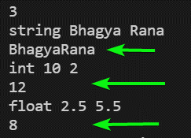

Also Tested the Code on **Hacker-Rank** Website.

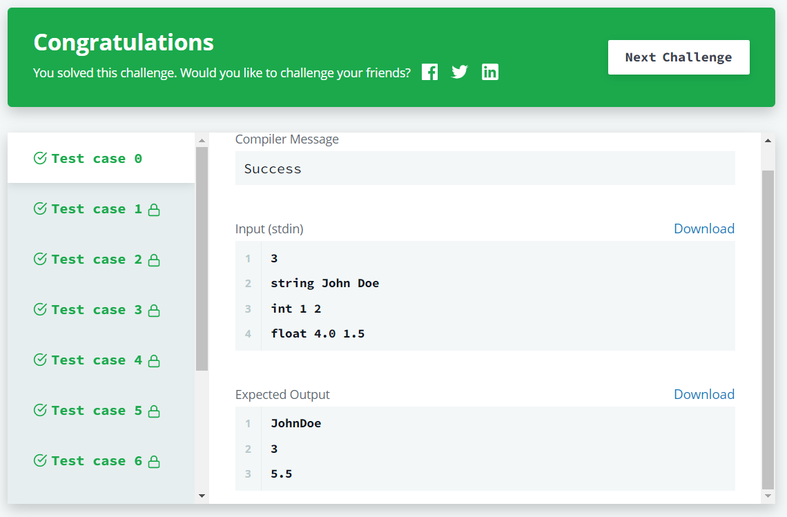

[Problem Link - <https://www.hackerrank.com/challenges/c-class-templates/problem>]

**SUBMITTED BY**: U19CS012

BHAGYA VINOD RANA