Principles of Programming Language (CS302)

Practical Exam

**U19CS012**

1.) A **book shop** maintains the inventory of books that are being sold at the shop. The list includes details such as author, title, price, publisher and stock position.

Whenever a customer wants a book, the sales person inputs **the title and author** and the system searches the list and displays whether it is available or not.

* If it is not, an appropriate message is displayed.
* If it is, then the system displays the **book details** and requests for the **number of copies** required.
* If the requested copies are **available**, the total cost of the requested copies is displayed; otherwise the message “Required copies not in stock” is displayed.

Design a system using a class called **books** with suitable member functions and constructors. Use **new** operators in constructors to allocate memory space required. Implement **C++ program** for the system.

Improve the system design to incorporate the following features:

* The **price of the books should be updated** as and when required. Use a member function to implement this.
* The **stock value of each book should be automatically** updated as soon as a transaction is completed.
* The number of **successful and unsuccessful transactions** should be recorded for the purpose of statistical analysis. Use **static data members** to keep count of transactions.
* Also demonstrate the use of pointers to access the members.

**Code**

*#include* <bits/stdc++.h>

using namespace std;

*// For Statistical Analysis of Transactions*

static int success = 0;

static int failure = 0;

*// Book Class*

class book

{

public:

    string author, title, publisher;

    int price, stock;

*// Book Constructor*

    book() {}

    book(string author, string title, string publisher, int price, int stock)

    {

*this*->author = author;

*this*->title = title;

*this*->publisher = publisher;

*this*->price = price;

*this*->stock = stock;

    }

*// To Check if Stock is Available or Not*

    bool is_available()

    {

*return* stock > 0;

    }

*// Function to Check if Match is Found or Not*

    bool match(string title, string author)

    {

*return* *this*->title == title and *this*->author == author;

    }

*// Returns the Price if Stock is Available*

    float available(int copies)

    {

*if* (stock >= copies)

        {

            stock -= copies;

*return* (copies * price);

        }

*else*

        {

*return* -1;

        }

    }

*// F(x) to Update the Price*

    void update_price(int price)

    {

*this*->price = price;

    }

*// F(x) to Update the Stock*

    void update_stock(int stock)

    {

*this*->stock += stock;

    }

};

*// Inventory Class*

class inventory

{

    vector<book *> books;

public:

*// F(x) to add Book*

    void add_book(book *b)

    {

        books.push_back(b);

        success++;

    }

*// F(x) to Search for Particular Book [Linear Search]*

    bool search_book(string title, string author)

    {

*for* (int i = 0; i < books.size(); i++)

        {

*if* (books[i]->match(title, author))

            {

*return* true;

            }

        }

*return* false;

    }

*// F(x) to issue Book*

    bool issue_book(string title, string author, int copies)

    {

*for* (int i = 0; i < books.size(); i++)

        {

*if* (books[i]->match(title, author))

            {

*if* (books[i]->is_available())

                {

                    float cost = books[i]->available(copies);

*if* (cost != -1)

                    {

                        cout << "Book issued successfully. Cost : " << cost << endl;

                        success++;

*return* true;

                    }

*else*

                    {

                        cout << "Not Enough Copies Available. No Book Issued!" << endl;

                        failure++;

*return* false;

                    }

                }

*else*

                {

                    cout << "Book Not Available." << endl;

                    failure++;

*return* false;

                }

            }

        }

        failure++;

        cout << "Book Not Found." << endl;

*return* false;

    }

*// F(x) to Update the Price*

    void update_price(string title, string author, int price)

    {

*for* (int i = 0; i < books.size(); i++)

        {

*if* (books[i]->match(title, author))

            {

                books[i]->update_price(price);

                cout << "Price Updated." << endl;

                success++;

*return*;

            }

        }

        failure++;

        cout << "Book Not Found." << endl;

    }

*// F(x) to Update the Stock of Book*

    void update_stock(string title, string author, int stock)

    {

*for* (int i = 0; i < books.size(); i++)

        {

*if* (books[i]->match(title, author))

            {

                books[i]->update_stock(stock);

                cout << "Stock Updated." << endl;

                success++;

*return*;

            }

        }

        failure++;

        cout << "Book Not Found." << endl;

    }

};

*// F(x) to Print the Menu Options*

void menu()

{

    cout << "~~~~~~~~~~~~~~~~~~~~~~~~~~~~~~~~~~~~~~~~~~~~~~~~~~~~~~~~~~~~\n";

    cout << "1 -> Add Book" << endl;

    cout << "2 -> Search Book" << endl;

    cout << "3 -> Issue Book" << endl;

    cout << "4 -> Update Book Price" << endl;

    cout << "5 -> Update Book Stock" << endl;

    cout << "6 -> Statistical Analysis" << endl;

    cout << "7 -> Exit" << endl;

    cout << "~~~~~~~~~~~~~~~~~~~~~~~~~~~~~~~~~~~~~~~~~~~~~~~~~~~~~~~~~~~~\n";

}

int main()

{

    inventory store;

    book tmp_book;

    string author, title, publisher;

    int price, stock, copies;

    int cost, choice = 0;

*while* (choice != 7)

    {

        menu();

        cout << "Enter your Choice : ";

        cin >> choice;

*switch* (choice)

        {

*case* 1:

        {

            cout << "Enter Author : ";

            cin >> author;

            cout << "Enter Title : ";

            cin >> title;

            cout << "Enter Publisher : ";

            cin >> publisher;

            cout << "Enter Price : ";

            cin >> price;

            cout << "Enter Stock : ";

            cin >> stock;

            tmp_book = book(author, title, publisher, price, stock);

            store.add_book(new book(tmp_book));

            cout << "Book Added Successfully." << endl;

*break*;

        }

*case* 2:

        {

            cout << "Enter Author : ";

            cin >> author;

            cout << "Enter Title : ";

            cin >> title;

*if* (store.search_book(title, author))

            {

                cout << "Book Found." << endl;

            }

*else*

            {

                cout << "Book Not Found." << endl;

            }

*break*;

        }

*case* 3:

        {

            cout << "Enter Author : ";

            cin >> author;

            cout << "Enter Title : ";

            cin >> title;

            cout << "Enter No. of Copies: ";

            cin >> copies;

            store.issue_book(title, author, copies);

*break*;

        }

*case* 4:

        {

            cout << "Enter Author : ";

            cin >> author;

            cout << "Enter Title : ";

            cin >> title;

            cout << "Enter New Price : ";

            cin >> price;

            store.update_price(title, author, price);

*break*;

        }

*case* 5:

        {

            cout << "Enter Author : ";

            cin >> author;

            cout << "Enter Title : ";

            cin >> title;

            cout << "Enter Stock to be Added : ";

            cin >> stock;

            store.update_stock(title, author, stock);

*break*;

        }

*case* 6:

        {

            cout << "Successful Transactions : " << success << endl;

            cout << "Failure Transactions    : " << failure << endl;

*break*;

        }

*case* 7:

        {

            cout << "Thank You for Visiting Our Book Shop!" << endl;

*break*;

        }

*default*:

        {

            cout << "Invalid Choice Entered." << endl;

*break*;

        }

        }

    }

    cout << "~~~~~~~~~~~~~~~~~~~~~~~~~~~~~~~~~~~~~~~~~~~~~~~~~~~~~~~~~~~~\n";

*return* 0;

}

**Output**

Task 1: Adding a Book

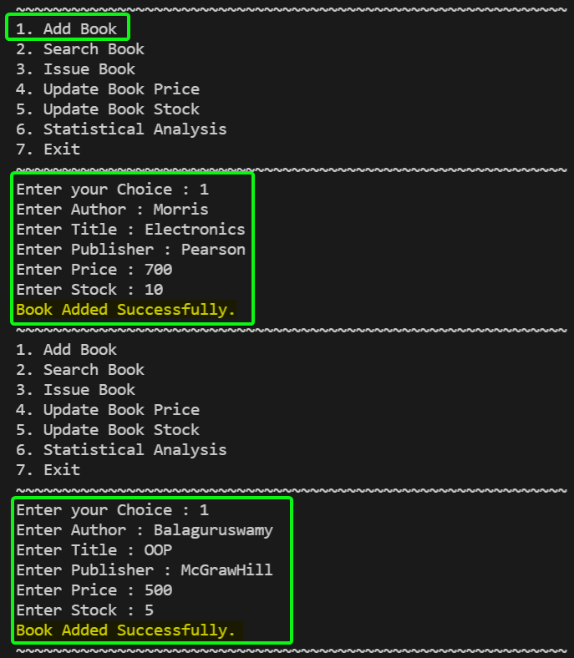

Task 2: Searching a Book

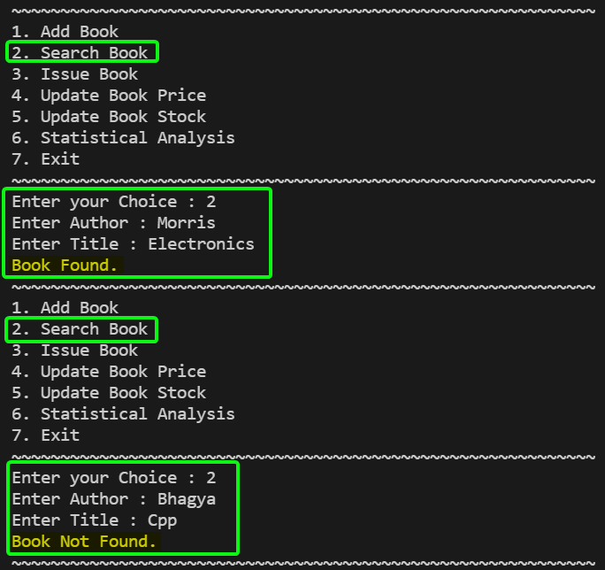

Task 3: Issuing a Book

We will first Try to Issue a Book with Larger than Stock Available.

Secondly, We will Check with Quantity within Stock Available and get the Cost after issuing the Book.

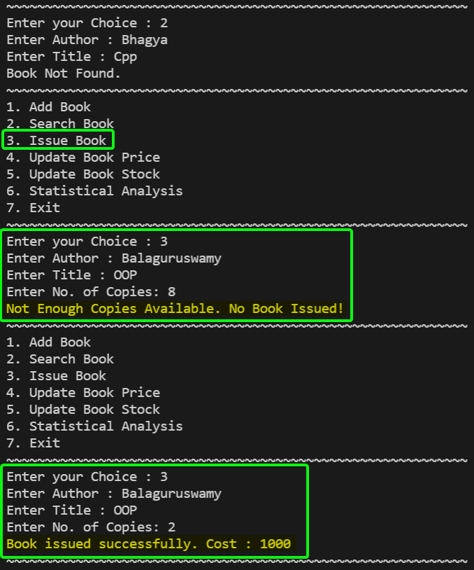

Task 4: Updating Book Price

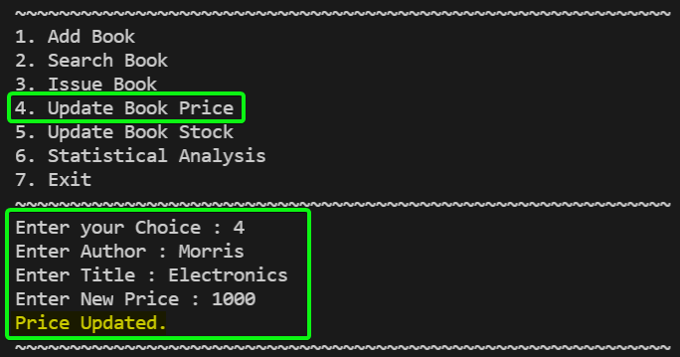

Task 5: Updating Stocks

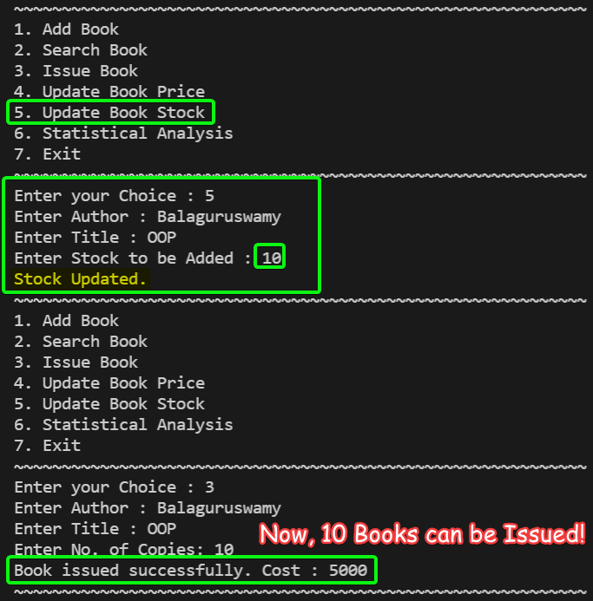

Task 6: Statistical Analysis

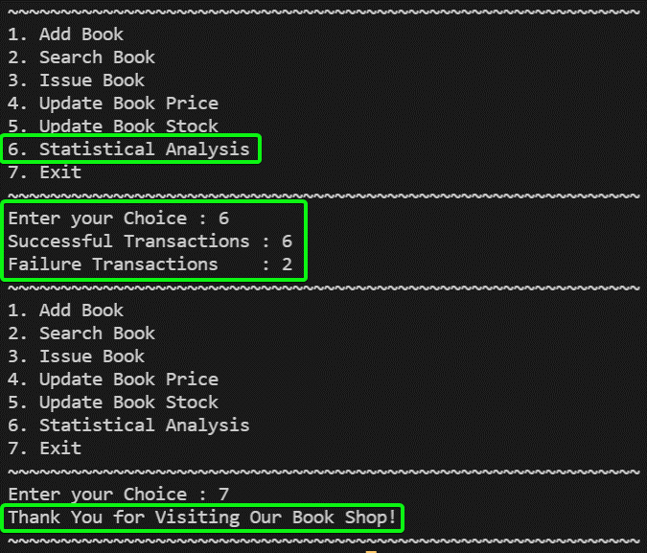

2.) Define a predicate memCount (AList, BList, Count) that is true if AList occurs Count times within BList. Define without using an accumulator.

**Example**: memCount( [a,b] , [ a, [a,b,c], **[a,b]**, [d,e,f], **[a,b]** ] , 2).

**Code**

*% U19CS012 - BHAGYA VINOD RANA*

*% What I Understood from Question*

*% You are Given List Blist and You need to Check the Frequency of Alist in Blist*

*% and Check it is Equal to Count*

*% Prolog F(x) to Check if Two Lists are Equal*

same([], [])*.*

same([H1|R1], [H2|R2])*:-*

    H1 = H2,

    same(R1, R2)*.*

*% Code to Get the Frequency of Alist in Blist*

freq(Alist,[],0)*.*

freq(Alist,[H|T], C)*:-*

    (same(Alist,H)) *->*

    (

        freq(Alist,T,Cnt),

        C is Cnt+1

    )

    ;

    (

        freq(Alist,T, C)

    )*.*

*% Main Function*

memCount(Alist, Blist, Count)*:-*

*% Function to Iterate the Blist and Count the Occurance of Alist in Ans*

    freq(Alist,Blist,Ans),

*% Compare the Frequency Calculated with Count*

    Ans = Count*.*

**Output**

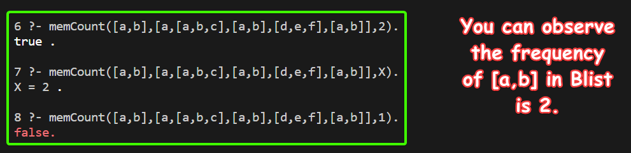

**SUBMITTED BY**: U19CS012

BHAGYA VINOD RANA