Distributed System (CS304)

Assignment - 1

**U19CS012**

1) To Study the Basics of **Connection Oriented Protocol** and **Connectionless protocol**. Also explain the difference between them.

Both these **Services** are used for the **connection establishment** between two or more than two devices.

A.) Connection Oriented Protocol

Connection oriented service is a **data transfer method** between two computers in a **different network**, which is designed after the **telephone system**. Like, in telephone system if we want to talk to someone, we just pick up the phone, dial the number of whom we want to talk with; after the connection is established we talk and lastly, we hang up the call.

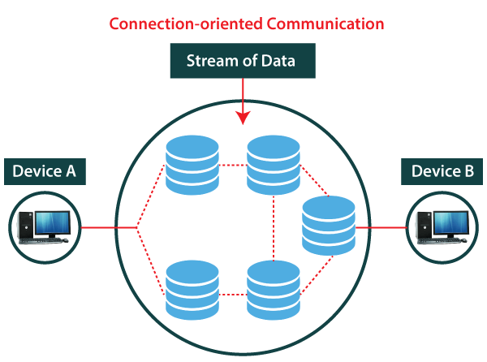

Similarly, the **connection oriented** service first establishes the virtual connection between the source and the destination, then transfers all data packets belonging to the same message through same dedicated established connection and after all packets of a message is transferred it releases the connection.

To establish a connection a source sends a **request** packet to the destination. In response to which destination sends the **acknowledgement** packet to the source confirming that the destination is ready to accept the data from the source.

Meanwhile, the **routers** involved in the exchange of request and acknowledgement packet between source and destination, define the **virtual path** that will be **followed by all packets** belonging to the same message. So, we say that the **resources** involved in data transfer are **reserved** before transferring all packet in a message.

As all the data packets in a message follow the same path their **order** is preserved as they reach the destination. After sending all data packets the source sends a special packet to **terminate** the connection. To which destination sends an acknowledgement confirming the termination of connection and all the router delete the path entry from routing table.

As connection oriented service provide acknowledgement at each action it provides **reliability** in the service. There are **fewer** chances of **packet loss** as they travel a predefined path. The connection oriented services are preferred over a **long and steady** conversation.

As the virtual path is predefined there are rare or no chances of **congestion**. If we talk about the delay in data transmission, there is no delay in the transmission of packets as there is a dedicated path for it. But, a substantial **delay** is introduced due to the acknowledgement process during connection establishment and termination.

The **TCP** protocol is a **connection oriented** protocol.

The connection oriented service works the same at both, the network layer and transport layer i.e. first it establishes a connection, exchanges data and terminates the connection. But, it’s behaviour slightly differs at both the layer. Let’s see how?

**At Network Layer:** At the network layer, the connection oriented service is concerned regarding the **coordination** of **source**, **destination** and **routers** involved in between the source and destination.

As there is coordination between source, destination and all the routers in between and all packet belonging to the same message follow a dedicated established connection. So, we **can** implement **flow control, error control and congestion control** in connection oriented services.

**At Transport Layer:** At the transport layer, the connection oriented service is **concerned** only about the **source** and the **destination**. Here, the packets show **dependency** on each other. As all packets will go around the same allocated route.

B.) **Connectionless Service**

Connectionless service is a method of data transmission between two computers in a different network. Connectionless service is also termed as **datagram service**. This service look-alike the **postal system** where each letter carries its source & destination address and each one of them is **routed** through a **different path.**

The source divides the message into small acceptable packets these packets known as a **datagram**. These datagrams are individually pushed into the network; each datagram may travel a **different path**. The network considers each datagram or data packet as an **independent entity** i.e. **no relationship** is considered between the packets belonging to the same message.

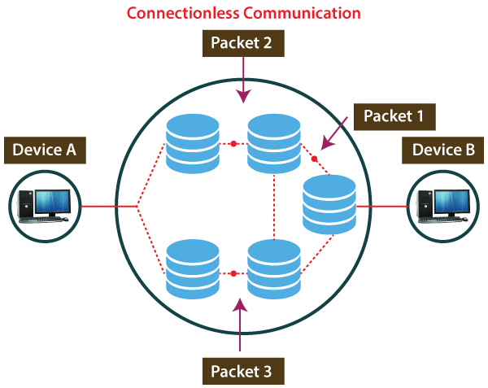

Each datagram carries its **source** and **destination** address. The **router** uses the **destination** address to route the datagram to its destination. The packets received at the destination may be received **out of order**. Hence, the datagrams are assembled to recreate the original message.

The **UDP** protocol is a **connectionless** protocol.

The connectionless service is provided by the protocols of both network layer as well as the transport layer. Though its basic function is the same, i.e. it routes each packet independently over the network may be through different data paths. But still, it behaves slightly different at both the network layer and the transport layer. Let us see how?

**At Network Layer:** The connectionless service at network layer **signifies** **different path** for **different data packets** belonging to the same message.

**At Transport Layer:** The connectionless service at transport layer exhibits **independency between the packets** rather than the different paths that different packets belonging to the same message will follow.

As the data packets belonging to the same message follow the different path it may happen that they are received at the destination out of order. It can also be the case that one of the packets is lost.

At the transport layer, each packet is considered as an independent entity and packets show no relationship with each other. The destination transport layer will not even know that a packet has been lost. Here, we can conclude that we **cannot** implement **flow control, error control, or congestion control** in connectionless service.

C.) Comparison between **Connection-Oriented & Connectionless Service.**

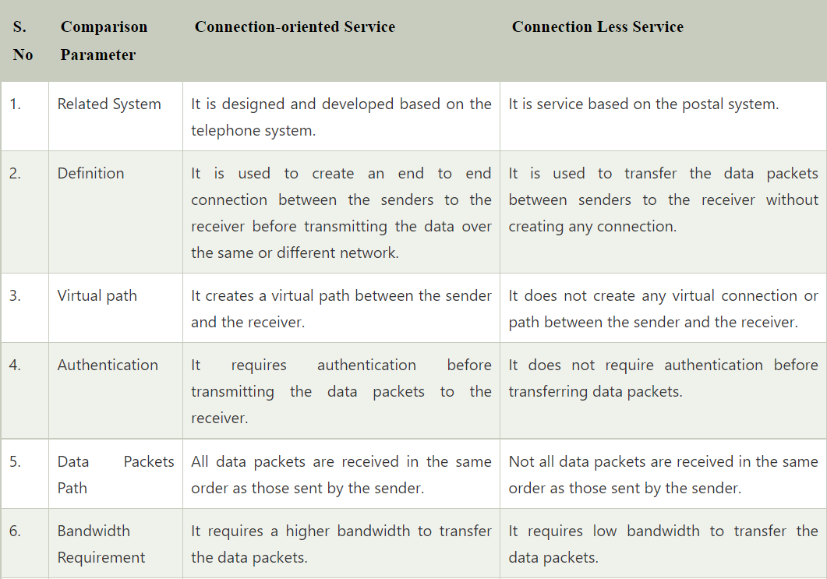

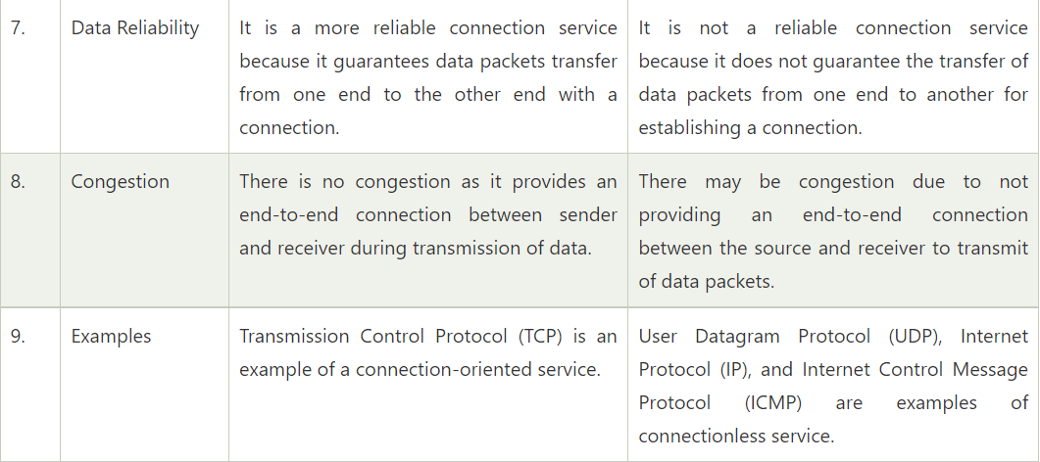

**SUBMITTED BY**: U19CS012

BHAGYA VINOD RANA