Distributed Systems (CS304)

Assignment - 3

**U19CS012**

1. Calculate the **CPU Load** for your machine and **Identify the State** (under loaded or overloaded) of your machine. You have to find out the CPU usage of your computer using some Unix command.

**Hint**: With the help of **grep** Unix command, you can extract CPU usage. If CPU load is greater than 70% than it is overloaded, if it is between the range of 30% to 70% than it is moderately loaded and if it is less than 30% than it is lightly-loaded.

Unix Command for CPU Utilization - **top**

* The **top** program provides a dynamic real-time view of a running system.
* It can display **system summary information** as well as a list of tasks currently being managed by the Linux kernel.
* The top command monitors CPU utilization, process statistics, and memory utilization.

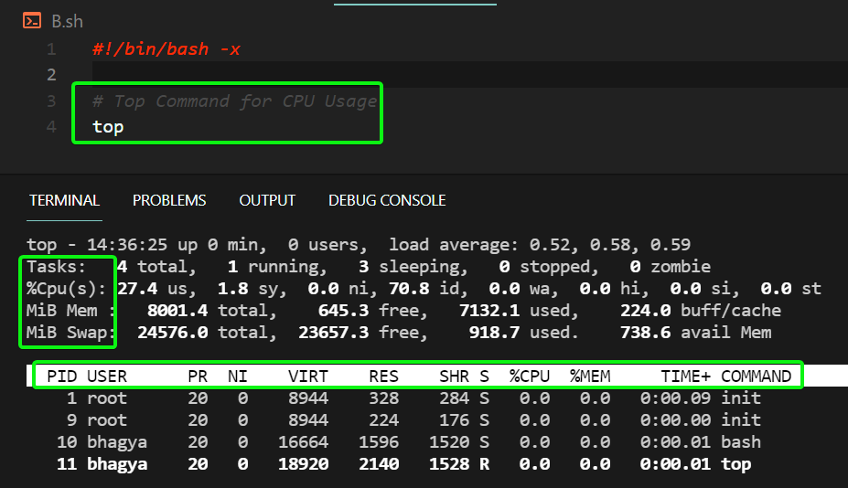

We will run it in Batch Mode and Read Single Byte.

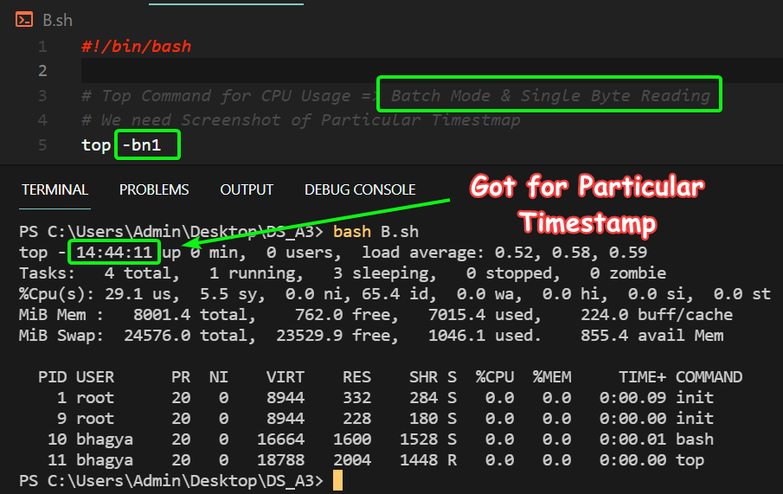

Now, For CPU Load, We require the Line with %**Cpu(s),** So we use **grep** to filter our results.

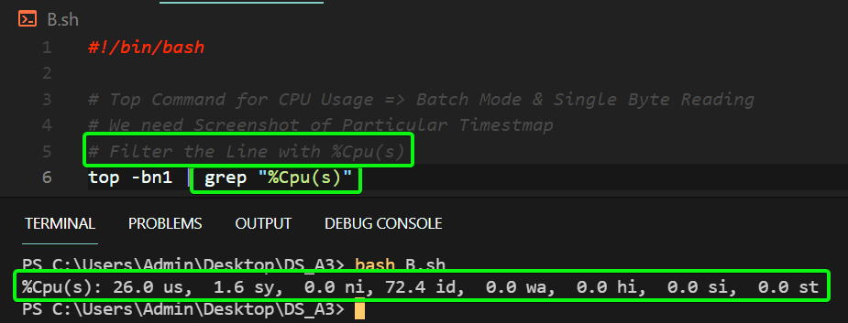

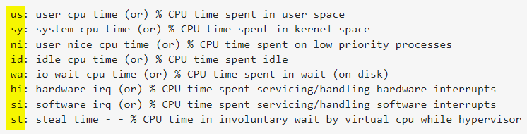

We need to store Output in **Array** and add the User and System CPU Time.

**Code**

*#!/bin/bash*

*# [U19CS012 BHAGYA VINOD RANA]*

*# read -a => Array which will have the Output of top.. command*

read -a arr <<< `top -bn1 | grep "%Cpu(s)"`

User_CPU_Time=${arr[1]}

*# arr[2] => us, Which is of no use*

System_CPU_Time=${arr[3]}

*# bc is used for inline calculator in linux*

Total_CPU_Time=`echo $User_CPU_Time + $System_CPU_Time | bc`

echo "Total_CPU_Usage : $Total_CPU_Time%"

*# Set the Limits for Demarcation of States*

upper_limit=70.0

lower_limit=30.0

*# If the Total Usage is Greater than 70%, then its Overloaded*

*if* [ $(echo "$Total_CPU_Time > $upper_limit" | bc) -eq 1 ]; *then*

    echo "Your System State :  Overloaded"

*# Else if Total Usage is Less than 30%, then its Lightly Loaded*

*elif* [ $(echo "$Total_CPU_Time < $lower_limit" | bc ) -eq 1 ]; *then*

    echo "Your System State :  Lightly-Loaded"

*# Else Moderately Loaded*

*else*

    echo "Your System State : Moderately Loaded"

*fi*

**Output**

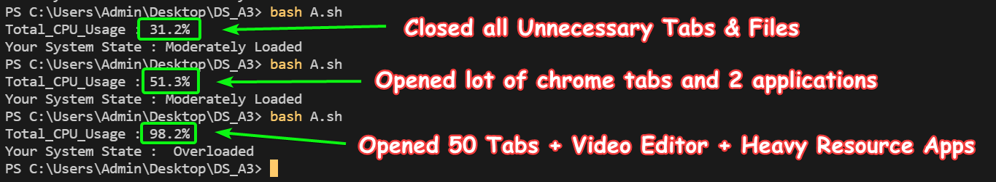

**SUBMITTED BY**: U19CS012

BHAGYA VINOD RANA