Distributed Systems (CS304)

Assignment - 4

**U19CS012**

1. Implement **echo client-server** message passing application. Message sent from **client** should be displayed on server and then program should terminate.

1. Write a **Server** (TCP) C Program that opens a listening socket and **waits** to serve client.
2. Write a **Client** (TCP) C Program that connects with the server program knowing IP address and port number.
3. Get the **Input** string from console on client and send it to server, server displays the same string.

**Code**

**[server.c]**

*// TCP SERVER {Opens a Listening Socket and Waits for Client}*

*#include* <stdio.h>

*// For strlen*

*#include* <string.h>

*// For sockets*

*#include* <sys/socket.h>

*// For inet_addr*

*#include* <arpa/inet.h>

*// For write*

*#include* <unistd.h>

*#define* MAX_SIZE 2000

*// [U19CS012] BHAGYA VINOD RANA*

int main(int argc, char *argv[])

{

    int socket_desc, client_sock, c, read_size;

    struct sockaddr_in server, client;

    char client_message[MAX_SIZE];

*// Create socket*

    socket_desc = socket(AF_INET, SOCK_STREAM, 0);

*if* (socket_desc == -1)

    {

        printf("Could Not Create Socket!\n");

    }

    printf("Socket Created!\n");

*// Prepare the sockaddr_in structure*

    server.sin_family = AF_INET;

    server.sin_addr.s_addr = INADDR_ANY;

    server.sin_port = htons(8888);

*// Bind*

*if* (bind(socket_desc, (struct sockaddr *)&server, sizeof(server)) < 0)

    {

*// print the error message*

        perror("Bind Failed! Error Occured!");

*return* 1;

    }

    printf("Bind Done!\n");

*// Listen*

    listen(socket_desc, 3);

*// Accept and incoming connection*

    puts("Waiting for Incoming Clients Connections ...");

    c = sizeof(struct sockaddr_in);

*// Accept connection from an incoming client*

    client_sock = accept(socket_desc, (struct sockaddr *)&client, (socklen_t *)&c);

*if* (client_sock < 0)

    {

        perror("Accept Failed");

*return* 1;

    }

    printf("Connection Accepted!\n");

*// Receive a Message from client*

*while* ((read_size = recv(client_sock, client_message, MAX_SIZE, 0)) > 0)

    {

*// Send the message Back to client [Echo]*

        write(client_sock, client_message, strlen(client_message));

    }

*if* (read_size == 0)

    {

        printf("Client Disconnected!\n");

        fflush(stdout);

    }

*else* *if* (read_size == -1)

    {

        perror("recv() failed");

    }

*return* 0;

}

**[client.c]**

*// TCP CLIENT {Connects with the server program knowing IP address and port number.}*

*// For printf*

*#include* <stdio.h>

*// For strlen*

*#include* <string.h>

*// For socket*

*#include* <sys/socket.h>

*// For inet_addr*

*#include* <arpa/inet.h>

*// For write*

*#include* <unistd.h>

*#define* MAX_SIZE 2000

*// [U19CS012] BHAGYA VINOD RANA*

int main(int argc, char *argv[])

{

    int sock;

    struct sockaddr_in server;

*// Create socket*

    sock = socket(AF_INET, SOCK_STREAM, 0);

*if* (sock == -1)

    {

        printf("Could Not Create Socket!\n");

    }

    printf("Socket Created Successfully!\n");

*// IP Address*

    server.sin_addr.s_addr = inet_addr("127.0.0.1");

    server.sin_family = AF_INET;

*// Port Number*

    server.sin_port = htons(8888);

*// Connect to remote server*

*if* (connect(sock, (struct sockaddr *)&server, sizeof(server)) < 0)

    {

        perror("Connection Failed! Error Occured!");

*return* 1;

    }

    printf("Client Connected!\n");

*// keep communicating with server*

*while* (1)

    {

        char message[MAX_SIZE], server_reply[MAX_SIZE];

        printf("Enter Message [to be Echoed by Server] : ");

        scanf("%s", message);

*// Send Message to the Server*

*if* (send(sock, message, strlen(message), 0) < 0)

        {

            printf("Send Failed\n");

*return* 1;

        }

*// Receive Reply from Server*

*if* (recv(sock, server_reply, MAX_SIZE, 0) < 0)

        {

            printf("recv() Failed!\n");

*break*;

        }

        printf("Server Reply [Echo] : %s \n\n", server_reply);

    }

    close(sock);

*return* 0;

}

**Output**

**Step 1-2-3**: Compile both server.c and client.c to generate the executable Files.

Start the **Server by executing** the server.exe

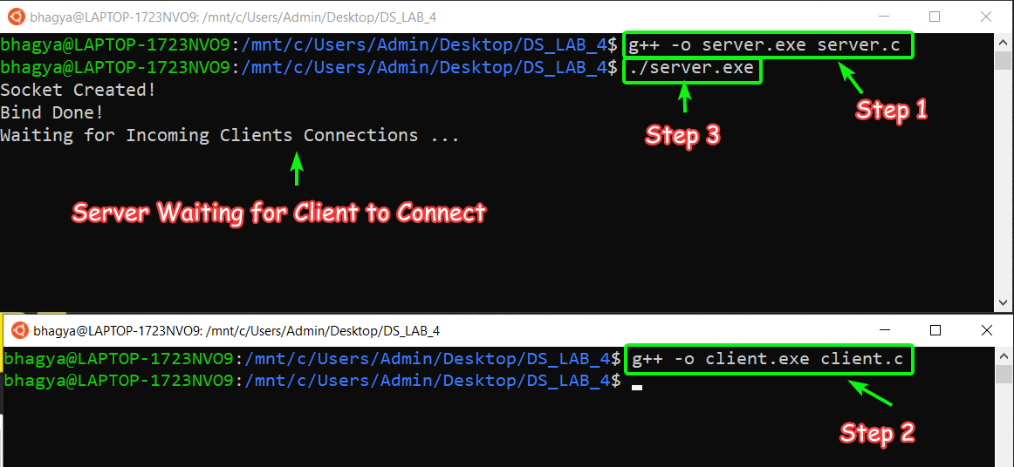

**Step 4**: Run the Client, So Server gets the Client Connected and Ready to **Echo the Message** from the Client.

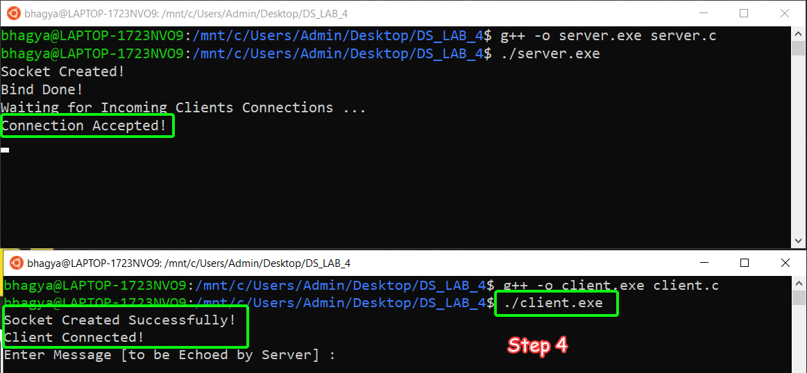

**Step 5**: Enter “String” and Server will Echo it!

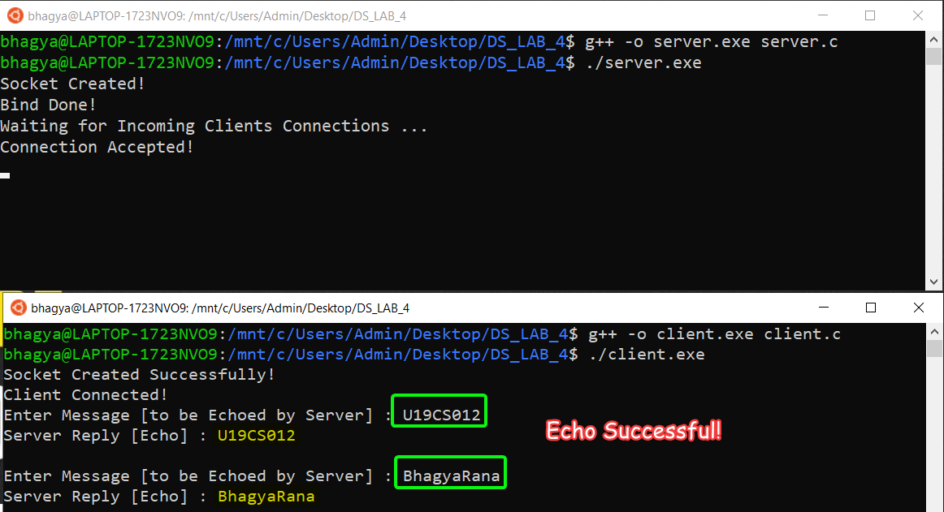

**SUBMITTED BY**: U19CS012

BHAGYA VINOD RANA