Distributed Systems (CS304)

Assignment - 6

**U19CS012**

Simulate RPC (Create any one procedure on remote machine and call it from local machine)

**List of Programs for RPC**

1.) Find out the **Factorial** of given Number.

**[factorial.x]**

program factorial_PROG{

    version factorial_VERS{

        int factorial(int)=1;

    }=1;

}=0x4562877;

**Run Command** : rpcgen –a –C factorial.x

* All required files will be created.
* The factorial_client.c and factorial_server.c files would be modified as following:

**[factorial_client.c]**

*/\**

*\* This is sample code generated by rpcgen.*

*\* These are only templates and you can use them*

*\* as a guideline for developing your own functions.*

*\*/*

*#include* "factorial.h"

void

factorial_prog_1(char *host, int x)

{

    CLIENT *clnt;

    int  *result_1;

    int  factorial_1_arg;

*#ifndef* DEBUG

    clnt = clnt_create (host, factorial_PROG, factorial_VERS, "udp");

*if* (clnt == NULL) {

        clnt_pcreateerror (host);

        exit (1);

    }

*#endif*  */* DEBUG */*

    factorial_1_arg = x;

    result_1 = factorial_1(&factorial_1_arg, clnt);

*if* (result_1 == (int *) NULL) {

        clnt_perror (clnt, "call failed");

    }*else*{

        printf("Result : %d! = %d\n",x,*result_1);

    }

*#ifndef* DEBUG

    clnt_destroy (clnt);

*#endif*   */* DEBUG */*

}

int

main (int argc, char *argv[])

{

    char *host;

*if* (argc < 3) {

        printf ("usage: %s server_host\n", argv[0]);

        exit (1);

    }

    host = argv[1];

    factorial_prog_1 (host,atoi(argv[2]));

exit (0);

}

**[factorial_server.c]**

*/\**

*\* This is sample code generated by rpcgen.*

*\* These are only templates and you can use them*

*\* as a guideline for developing your own functions.*

*\*/*

*#include* "factorial.h"

int *

factorial_1_svc(int *argp, struct svc_req *rqstp)

{

    static int  result;

*/\**

*\* insert server code here*

*\*/*

    int  temp = 1;

*for*(int i = 1; i <= *argp; i++)

    {

        temp *= i;

    }

    printf("Factorial of %d is called\n",*argp);

    result = temp;

*return* &result;

}

**Run Command** : make –f Makefile.factorial

Very IMP Step – **Run Command** : sudo rpcbind

[**Output**]

Server:

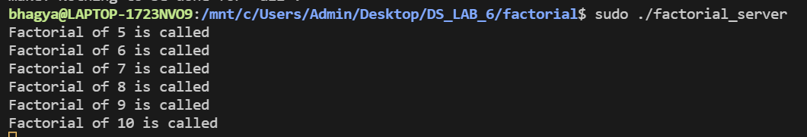

Client:

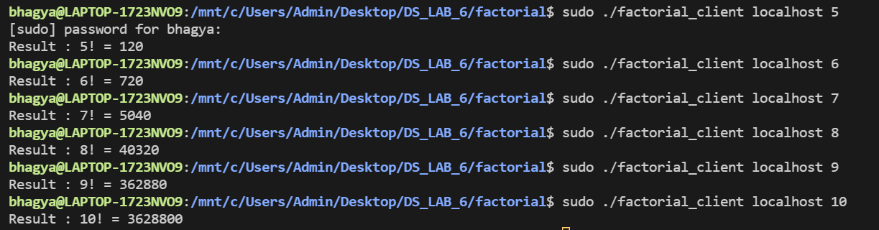

2.) Implement **Calculator** (Basic operation).

**[calc.x]**

struct numbers{

    int a;

    int b;

    char op;

};

program calc_PROG{

    version calc_VERS{

        int calc(numbers)=1;

    }=1;

}=0x4562877;

**Run Command** : rpcgen –a –C calc.x

* All required files will be created.
* The calc_client.c and calc_server.c files would be modified as following:

**[calc_client.c]**

*/\**

*\* This is sample code generated by rpcgen.*

*\* These are only templates and you can use them*

*\* as a guideline for developing your own functions.*

*\*/*

*#include* "calc.h"

void calc_prog_1(char *host)

{

    CLIENT *clnt;

    int *result_1;

    numbers calc_1_arg;

    char temp;

*#ifndef* DEBUG

    clnt = clnt_create(host, calc_PROG, calc_VERS, "udp");

*if* (clnt == NULL)

    {

        clnt_pcreateerror(host);

        exit(1);

    }

*#endif* */* DEBUG */*

    printf("Enter 2 numbers: ");

    scanf("%d%d", &(calc_1_arg.a), &(calc_1_arg.b));

    scanf("%c", &temp);

    printf("Press\n a for addition\n s for subtraction\n m for multiplication\n d for division\n r for modulus\n Choice : ");

    scanf("%c", &(calc_1_arg.op));

    result_1 = calc_1(&calc_1_arg, clnt);

*if* (result_1 == (int *)NULL)

    {

        clnt_perror(clnt, "call failed");

    }

*else*

    {

*if* (*result_1 == INT_MIN && calc_1_arg.op == 'd')

        {

            printf("Division by zero is not allowed\n");

        }

*else*

        {

            printf("Result = %d\n", *result_1);

        }

    }

*#ifndef* DEBUG

    clnt_destroy(clnt);

*#endif* */* DEBUG */*

}

int main(int argc, char *argv[])

{

    char *host;

*if* (argc < 2)

    {

        printf("usage: %s server_host\n", argv[0]);

        exit(1);

    }

    host = argv[1];

    calc_prog_1(host);

    exit(0);

}

**[calc_server.c]**

*/\**

*\* This is sample code generated by rpcgen.*

*\* These are only templates and you can use them*

*\* as a guideline for developing your own functions.*

*\*/*

*#include* "calc.h"

int *calc_1_svc(numbers *argp, struct svc_req *rqstp)

{

    static int result;

*if* (argp->op == 'a')

    {

        printf("add(%d,%d)is called\n", argp->a, argp->b);

        result = (argp->a) + (argp->b);

    }

*else* *if* (argp->op == 's')

    {

        printf("sub(%d,%d)is called\n", argp->a, argp->b);

        result = (argp->a) - (argp->b);

    }

*else* *if* (argp->op == 'm')

    {

        printf("mul(%d,%d)is called\n", argp->a, argp->b);

        result = (argp->a) * (argp->b);

    }

*else* *if* (argp->op == 'r')

    {

        printf("mod(%d,%d)is called\n", argp->a, argp->b);

        result = (argp->a) % (argp->b);

    }

*else*

    {

        printf("div(%d,%d)is called\n", argp->a, argp->b);

*if* (argp->b != 0)

        {

            result = (argp->a) / (argp->b);

        }

*else*

        {

            result = INT_MIN;

        }

    }

*return* &result;

}

**Run Command** : make –f Makefile.calc

[**Output**]

Server:

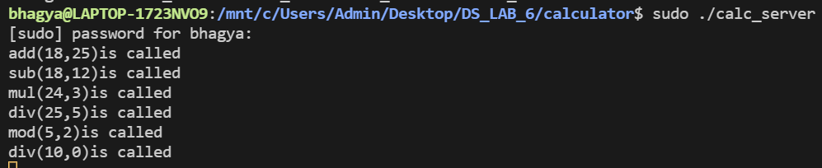

Client:

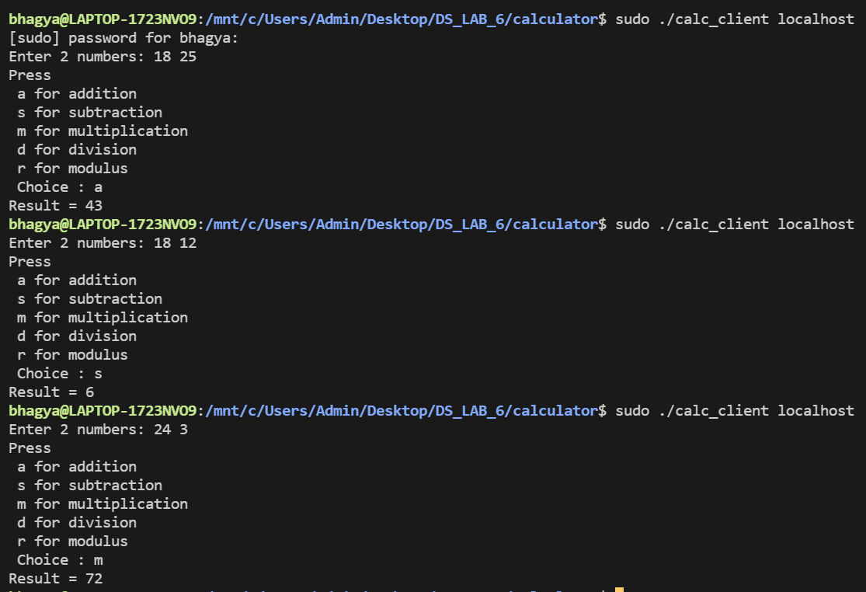

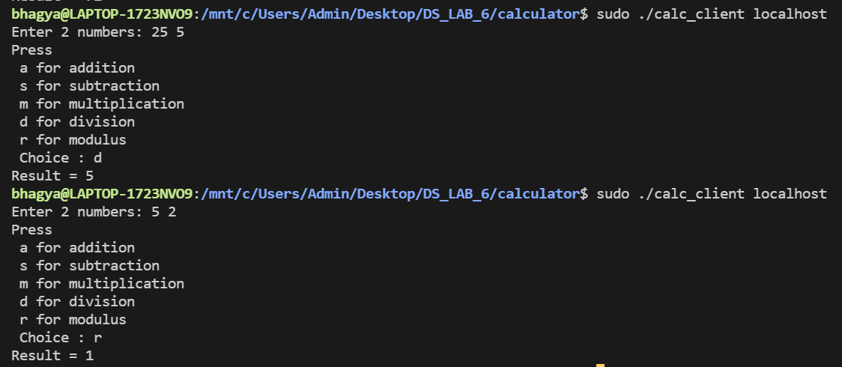

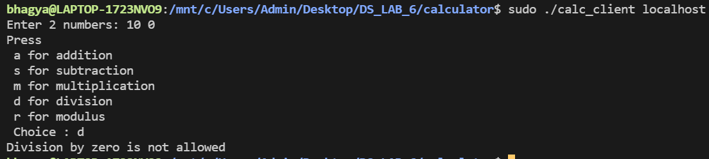

3.) Find out whether given number is **Prime** Number or not.

**[prime.x]**

program prime_PROG{

    version prime_VERS{

        int prime(int)=1;

    }=1;

}=0x4562877;

**Run Command** : rpcgen –a –C prime.x

* All required files will be created.
* The prime_client.c and prime_server.c files would be modified as following:

**[prime_client.c]**

*/\**

*\* This is sample code generated by rpcgen.*

*\* These are only templates and you can use them*

*\* as a guideline for developing your own functions.*

*\*/*

*#include* "prime.h"

void prime_prog_1(char *host)

{

    CLIENT *clnt;

    int *result_1;

    int prime_1_arg;

*#ifndef* DEBUG

    clnt = clnt_create(host, prime_PROG, prime_VERS, "udp");

*if* (clnt == NULL)

    {

        clnt_pcreateerror(host);

        exit(1);

    }

*#endif* */* DEBUG */*

*do*

    {

        printf("Enter a non-zero postive number: ");

        scanf("%d", &prime_1_arg);

    } *while* (prime_1_arg < 1);

    result_1 = prime_1(&prime_1_arg, clnt);

*if* (result_1 == (int *)NULL)

    {

        clnt_perror(clnt, "call failed");

    }

*else*

    {

*if* (*result_1 == 0)

            printf("%d is not prime\n", prime_1_arg);

*else* *if* (*result_1 == 1)

            printf("%d is prime\n", prime_1_arg);

*else*

            printf("%d is neither prime nor composite\n", prime_1_arg);

    }

*#ifndef* DEBUG

    clnt_destroy(clnt);

*#endif* */* DEBUG */*

}

int main(int argc, char *argv[])

{

    char *host;

*if* (argc < 2)

    {

        printf("usage: %s server_host\n", argv[0]);

        exit(1);

    }

    host = argv[1];

    prime_prog_1(host);

    exit(0);

}

**[prime_server.c]**

*/\**

*\* This is sample code generated by rpcgen.*

*\* These are only templates and you can use them*

*\* as a guideline for developing your own functions.*

*\*/*

*#include* "prime.h"

int *prime_1_svc(int *argp, struct svc_req *rqstp)

{

    static int result;

    int n = *argp;

    printf("prime(%d) is called\n", n);

*if* (n == 1)

    {

        result = 2;

*return* &result;

    }

    result = 1;

*for* (int i = 2; i <= n / 2; i++)

    {

*if* (n % i == 0)

        {

            result = 0;

*break*;

        }

    }

*return* &result;

}

**Run Command** : make –f Makefile.prime

[**Output**]

Server:

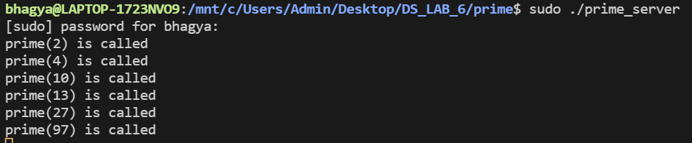

Client:

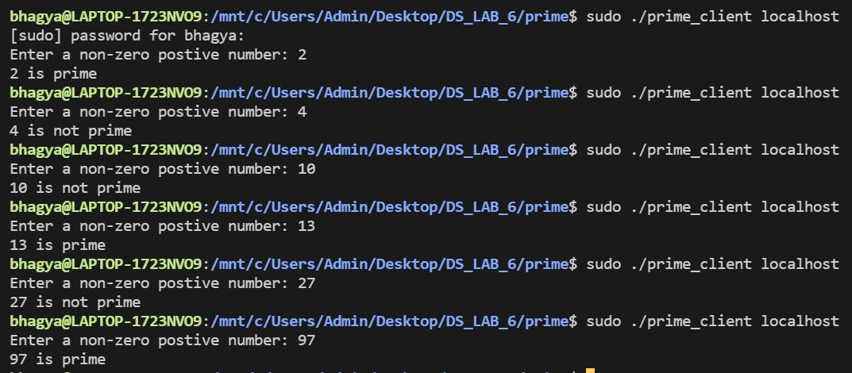

4.) Print out the **Fibonacci** series till the given number.

**[fib.x]**

struct sequence{

    int a[50];

};

program FIB_PROG{

    version FIB_VERS{

        sequence fib(int)=1;

    }=1;

}=0x4562877;

**Run Command** : rpcgen –a –C fib.x

* All required files will be created.
* The prime_client.c and prime_server.c files would be modified as following:

**[fib_client.c]**

*/\**

*\* This is sample code generated by rpcgen.*

*\* These are only templates and you can use them*

*\* as a guideline for developing your own functions.*

*\*/*

*#include* "fib.h"

void fib_prog_1(char *host, int x)

{

    CLIENT *clnt;

    sequence *result_1;

    int fib_1_arg;

*#ifndef* DEBUG

    clnt = clnt_create(host, FIB_PROG, FIB_VERS, "udp");

*if* (clnt == NULL)

    {

        clnt_pcreateerror(host);

        exit(1);

    }

*#endif* */* DEBUG */*

    fib_1_arg = x;

    result_1 = fib_1(&fib_1_arg, clnt);

*if* (result_1 == (sequence *)NULL)

    {

        clnt_perror(clnt, "call failed");

    }

*else*

    {

        printf("Fib series upto %d: ", fib_1_arg);

        int i = 0;

*while* (1)

        {

*if* (result_1->a[i] < fib_1_arg)

                printf("%d ", result_1->a[i++]);

*else*

*break*;

        }

        printf("\n");

    }

*#ifndef* DEBUG

    clnt_destroy(clnt);

*#endif* */* DEBUG */*

}

int main(int argc, char *argv[])

{

    char *host;

*if* (argc < 3)

    {

        printf("usage: %s server_host\n", argv[0]);

        exit(1);

    }

    host = argv[1];

    fib_prog_1(host, atoi(argv[2]));

    exit(0);

}

**[fib_server.c]**

*/\**

*\* This is sample code generated by rpcgen.*

*\* These are only templates and you can use them*

*\* as a guideline for developing your own functions.*

*\*/*

*#include* "fib.h"

sequence *

fib_1_svc(int *argp, struct svc_req *rqstp)

{

    static sequence result;

    result.a[0] = 0;

    result.a[1] = 1;

    int i = 2;

    printf("Fib upto %d is called\n", *argp);

*while* (result.a[i - 1] < (*argp))

    {

        result.a[i] = result.a[i - 1] + result.a[i - 2];

        i++;

    }

*return* &result;

}

**Run Command** : make –f Makefile.fib

[**Output**]

Server:

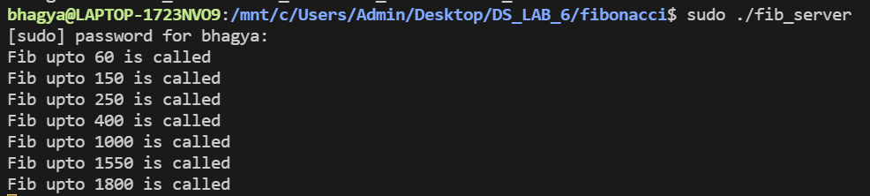

Client:

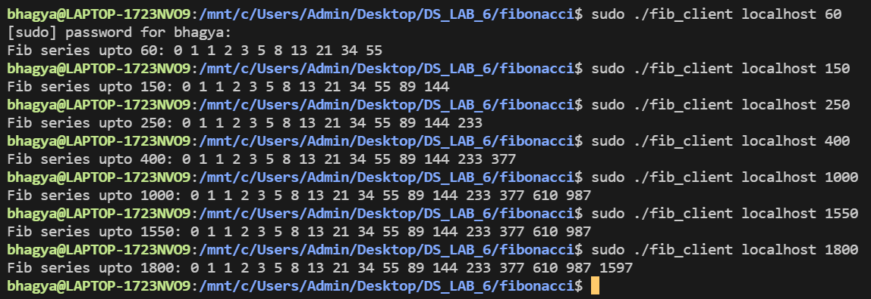

5.) Find the **Maximum** value of an array of integers using RPC.

**[maxArray.x]**

struct numbers{

    int array[100];

    int size;

};

program maxArray_PROG{

    version maxArray_VERS{

        int maxArray(numbers)=1;

    }=1;

}=0x4562877;

**Run Command** : rpcgen –a –C **maxArray**.x

* All required files will be created.
* The maxArray_client.c and maxArray _server.c files would be modified as following:

**[maxArray_client.c]**

*#include* "maxArray.h"

void maxarray_prog_1(char *host)

{

    CLIENT *clnt;

    int *result_1;

    numbers maxarray_1_arg;

*#ifndef* DEBUG

    clnt = clnt_create(host, maxArray_PROG, maxArray_VERS, "udp");

*if* (clnt == NULL)

    {

        clnt_pcreateerror(host);

        exit(1);

    }

*#endif* */* DEBUG */*

    printf("Enter the number of elements in the array : ");

    scanf("%d", &maxarray_1_arg.size);

    printf("Enter the elements of the array : \n");

*for* (int i = 0; i < maxarray_1_arg.size; i++)

    {

        scanf("%d", &maxarray_1_arg.array[i]);

    }

    result_1 = maxarray_1(&maxarray_1_arg, clnt);

*if* (result_1 == (int *)NULL)

    {

        clnt_perror(clnt, "call failed");

    }

*else*

    {

        printf("The maximum element in the array is : %d\n", *result_1);

    }

*#ifndef* DEBUG

    clnt_destroy(clnt);

*#endif* */* DEBUG */*

}

int main(int argc, char *argv[])

{

    char *host;

*if* (argc < 2)

    {

        printf("usage: %s server_host\n", argv[0]);

        exit(1);

    }

    host = argv[1];

    maxarray_prog_1(host);

    exit(0);

}

**[maxArray_server.c]**

*/\**

*\* This is sample code generated by rpcgen.*

*\* These are only templates and you can use them*

*\* as a guideline for developing your own functions.*

*\*/*

*#include* "maxArray.h"

int *maxarray_1_svc(numbers *argp, struct svc_req *rqstp)

{

    static int result;

    printf("The maximum of the array : (");

*for* (int i = 0; i < argp->size; i++)

    {

        printf("%d ", argp->array[i]);

    }

    printf(") is required\n");

    int n = argp->size;

    int *arr = argp->array;

    int max = arr[0];

*for* (int i = 1; i < n; i++)

    {

*if* (arr[i] > max)

        {

            max = arr[i];

        }

    }

    result = max;

*return* &result;

}

**Run Command** : make –f Makefile.maxArray

[**Output**]

Server:

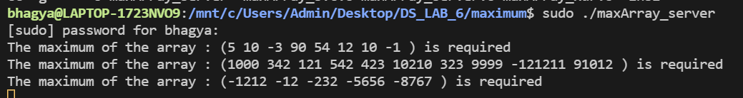

Client:

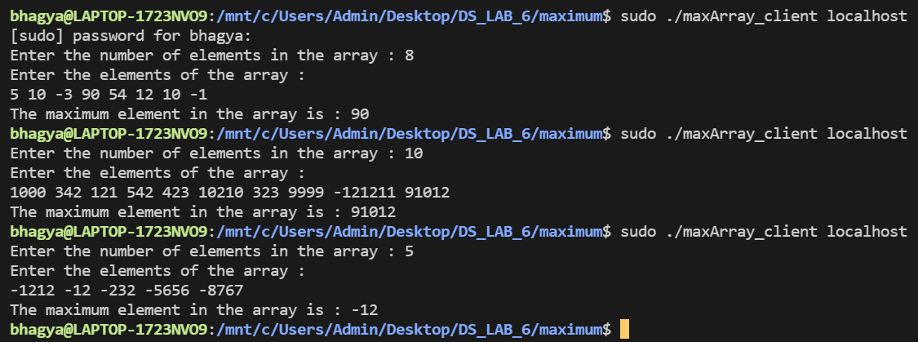

**SUBMITTED BY**: U19CS012

BHAGYA VINOD RANA