Distributed Systems (CS304)

Assignment - 7

**U19CS012**

Simulate RPC (Create any one procedure on remote machine and call it from local machine)

**List of Programs for RPC**

1.) String is **Palindrome or Not.**

**[q1.x]**

program PALINDROME_PROG{

    version VERSION1 {

        int palindrome(string s)=1;

    }=1;

}=0x4562877;

**Run Command** : rpcgen –a –C q1.x

* All required files will be created.
* The q1_client.c and q1_server.c files would be modified as following:

**[q1_client.c]**

*/\**

*\* This is sample code generated by rpcgen.*

*\* These are only templates and you can use them*

*\* as a guideline for developing your own functions.*

*\*/*

*#include* "q1.h"

void

palindrome_prog_1(char *host, char* str)

{

    CLIENT *clnt;

    int  *result_1;

    char * palindrome_1_arg = str;

*#ifndef* DEBUG

    clnt = clnt_create (host, PALINDROME_PROG, VERSION1, "udp");

*if* (clnt == NULL) {

        clnt_pcreateerror (host);

        exit (1);

    }

*#endif*  */* DEBUG */*

    result_1 = palindrome_1(&palindrome_1_arg, clnt);

*if* (result_1 == (int *) NULL) {

        clnt_perror (clnt, "call failed");

    }

*if*(*result_1 == 1){

        printf("Paildrome\n");

    }

*else*{

        printf("Not Palindrome\n");

    }

*#ifndef* DEBUG

    clnt_destroy (clnt);

*#endif*   */* DEBUG */*

}

int

main (int argc, char *argv[])

{

    char *host;

*if* (argc < 3) {

        printf ("usage: %s server_host\n", argv[0]);

        exit (1);

    }

    host = argv[1];

    palindrome_prog_1 (host,argv[2]);

exit (0);

}

**[q1_server.c]**

*/\**

*\* This is sample code generated by rpcgen.*

*\* These are only templates and you can use them*

*\* as a guideline for developing your own functions.*

*\*/*

*#include* "q1.h"

int *

palindrome_1_svc(char **argp, struct svc_req *rqstp)

{

    static int  result;

    printf("Palindrome check for %s is called\n",*argp);

    result = 1;

    int len = strlen(*argp);

*for*(int i=0;i<len;i++){

*if*((*argp)[i] != (*argp)[len-i-1]){

            result = 0;*break*;

        }

    }

*return* &result;

}

**Run Command** : make –f Makefile.q1

[**Output**]

Server:

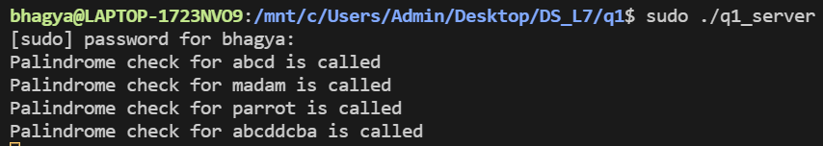

Client:

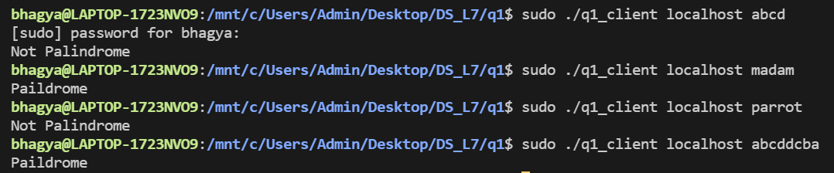

2.) Find out if a given year is a **Lear Year** or not.

**[q2.x]**

program LEAPYEAR_PROG{

    version VERSION1 {

        int leapyear(int year) = 1;

    } = 1;

} =  0x4562877;

**Run Command** : rpcgen –a –C q2.x

* All required files will be created.
* The q2_client.c and q2_server.c files would be modified as following:

**[q2_client.c]**

*/\**

*\* This is sample code generated by rpcgen.*

*\* These are only templates and you can use them*

*\* as a guideline for developing your own functions.*

*\*/*

*#include* "q2.h"

void

leapyear_prog_1(char *host,int year)

{

    CLIENT *clnt;

    int  *result_1;

    int  leapyear_1_arg = year;

*#ifndef* DEBUG

    clnt = clnt_create (host, LEAPYEAR_PROG, VERSION1, "udp");

*if* (clnt == NULL) {

        clnt_pcreateerror (host);

        exit (1);

    }

*#endif*  */* DEBUG */*

    result_1 = leapyear_1(&leapyear_1_arg, clnt);

*if* (result_1 == (int *) NULL) {

        clnt_perror (clnt, "call failed");

    }

*if*(*result_1 == 1){

        printf("Leap Year\n");

    }*else*{

        printf("Not Leap Year\n");

    }

*#ifndef* DEBUG

    clnt_destroy (clnt);

*#endif*   */* DEBUG */*

}

int

main (int argc, char *argv[])

{

    char *host;

*if* (argc < 3) {

        printf ("usage: %s server_host\n", argv[0]);

        exit (1);

    }

    host = argv[1];

    int year = atoi(argv[2]);

    leapyear_prog_1 (host,year);

exit (0);

}

**[q2_server.c]**

*/\**

*\* This is sample code generated by rpcgen.*

*\* These are only templates and you can use them*

*\* as a guideline for developing your own functions.*

*\*/*

*#include* "q2.h"

int *

leapyear_1_svc(int *argp, struct svc_req *rqstp)

{

    static int  result;

    printf("Leap year check for %d is called\n",*argp);

    result = 0;

*if*(*argp % 4 == 0){

        result = 1;

    }

*if*(*argp % 100 == 0){

        result = 0;

    }

*if*(*argp % 400 == 0){

        result = 1;

    }

*return* &result;

}

**Run Command** : make –f Makefile.q2

[**Output**]

Server:

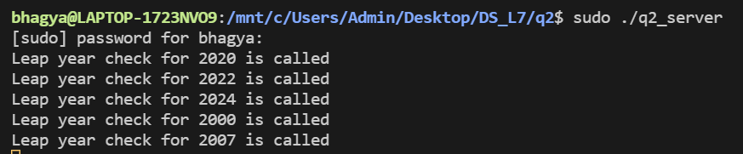

Client:

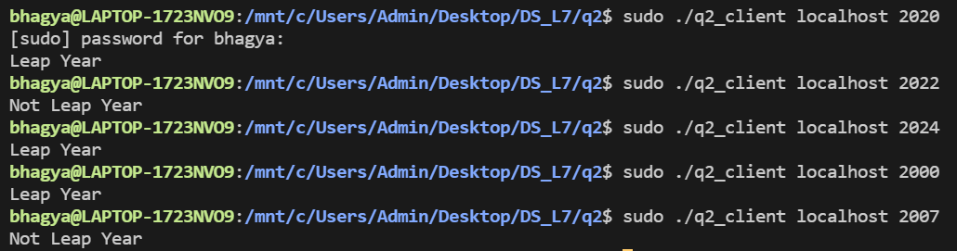

3.) Find out the **GCD** of a given number.

**[q3.x]**

struct intpair{

    int a;

    int b;

};

program GCD_PROG{

    version VERSION1 {

        int gcd(intpair p) = 1;

    } = 1;

} =  0x4562877;

**Run Command** : rpcgen –a –C q3.x

* All required files will be created.
* The q3_client.c and q3_server.c files would be modified as following:

**[q3_client.c]**

*/\**

*\* This is sample code generated by rpcgen.*

*\* These are only templates and you can use them*

*\* as a guideline for developing your own functions.*

*\*/*

*#include* "q3.h"

void

gcd_prog_1(char *host,int a,int b)

{

    CLIENT *clnt;

    int  *result_1;

    intpair  gcd_1_arg = {a,b};

*#ifndef* DEBUG

    clnt = clnt_create (host, GCD_PROG, VERSION1, "udp");

*if* (clnt == NULL) {

        clnt_pcreateerror (host);

        exit (1);

    }

*#endif*  */* DEBUG */*

    result_1 = gcd_1(&gcd_1_arg, clnt);

*if* (result_1 == (int *) NULL) {

        clnt_perror (clnt, "call failed");

    }

    printf("gcd : %d\n",*result_1);

*#ifndef* DEBUG

    clnt_destroy (clnt);

*#endif*   */* DEBUG */*

}

int

main (int argc, char *argv[])

{

    char *host;

*if* (argc < 4) {

        printf ("usage: %s server_host\n", argv[0]);

        exit (1);

    }

    host = argv[1];

    int a = atoi(argv[2]);

    int b = atoi(argv[3]);

    gcd_prog_1 (host,a,b);

exit (0);

}

**[q3_server.c]**

*/\**

*\* This is sample code generated by rpcgen.*

*\* These are only templates and you can use them*

*\* as a guideline for developing your own functions.*

*\*/*

*#include* "q3.h"

int gcd_s(int a,int b){

*if*(a==0){

*return* b;

    }

*if*(a>b){

        gcd_s(a%b,b);

    }

*else*{

        gcd_s(b%a,a);

    }

}

int *

gcd_1_svc(intpair *argp, struct svc_req *rqstp)

{

    static int  result;

    printf("GCD for %d and %d is called\n",argp->a,argp->b);

    result = gcd_s(argp->a,argp->b);

*return* &result;

}

**Run Command** : make –f Makefile.q3

[**Output**]

Server:

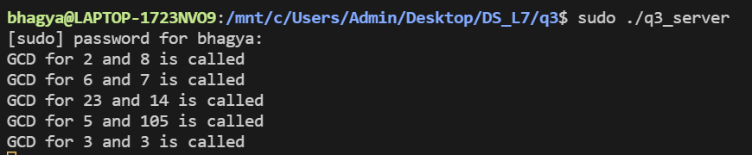

Client:

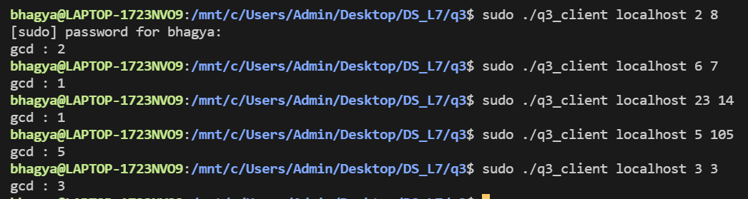

4.) Find out the **Square root** of a given number.

**[q4.x]**

program SQRT_PROG{

    version VERSION1 {

        float sqrt(float n) = 1;

    } = 1;

} =  0x4562877;

**Run Command** : rpcgen –a –C q4.x

* All required files will be created.
* The q4_client.c and q4_server.c files would be modified as following:

**[q4_client.c]**

*/\**

*\* This is sample code generated by rpcgen.*

*\* These are only templates and you can use them*

*\* as a guideline for developing your own functions.*

*\*/*

*#include* "q4.h"

void

sqrt_prog_1(char *host,float n)

{

    CLIENT *clnt;

    float  *result_1;

    float  sqrt_1_arg=n;

*#ifndef* DEBUG

    clnt = clnt_create (host, SQRT_PROG, VERSION1, "udp");

*if* (clnt == NULL) {

        clnt_pcreateerror (host);

        exit (1);

    }

*#endif*  */* DEBUG */*

    result_1 = sqrt_1(&sqrt_1_arg, clnt);

*if* (result_1 == (float *) NULL) {

        clnt_perror (clnt, "call failed");

    }

    printf("sqrt : %f\n",*result_1);

*#ifndef* DEBUG

    clnt_destroy (clnt);

*#endif*   */* DEBUG */*

}

int

main (int argc, char *argv[])

{

    char *host;

*if* (argc < 3) {

        printf ("usage: %s server_host\n", argv[0]);

        exit (1);

    }

    host = argv[1];

    float n = atof(argv[2]);

    sqrt_prog_1 (host,n);

exit (0);

}

**[q4_server.c]**

*/\**

*\* This is sample code generated by rpcgen.*

*\* These are only templates and you can use them*

*\* as a guideline for developing your own functions.*

*\*/*

*#include* "q4.h"

float *

sqrt_1_svc(float *argp, struct svc_req *rqstp)

{

    static float  result;

*/\**

*\* insert server code here*

*\*/*

    printf("Sqrt for %f is called\n",*argp);

    float err = 0.00001f;

    float a = *argp;

    float b = 2.0f;

*if*(abs(b-a)<=err) b = 1.5f;

*while*((b-a)>err || (a-b)>err){

        a = *argp/b;

        b = (a+b)/2;

    }

    result = a;

*return* &result;

}

**Run Command** : make –f Makefile.q4

[**Output**]

Server:

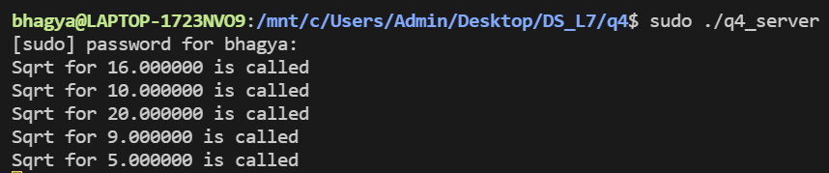

Client:

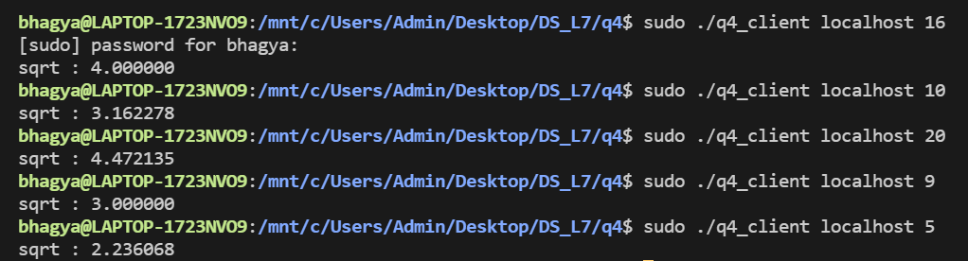

5.) **Swap two variables** without using the 3rd variable.

**[q5.x]**

struct intpair{

    int a;

    int b;

};

program SWAP_PROG{

    version VERSION1 {

        intpair swap(intpair p) = 1;

    } = 1;

} =  0x4562877;

**Run Command** : rpcgen –a –C q5.x

* All required files will be created.
* The swap_client.c and swap_server.c files would be modified as following:

**[q5_client.c]**

*/\**

*\* This is sample code generated by rpcgen.*

*\* These are only templates and you can use them*

*\* as a guideline for developing your own functions.*

*\*/*

*#include* "q5.h"

void

swap_prog_1(char *host,int a,int b)

{

    CLIENT *clnt;

    intpair  *result_1;

    intpair  swap_1_arg = {a,b};

*#ifndef* DEBUG

    clnt = clnt_create (host, SWAP_PROG, VERSION1, "udp");

*if* (clnt == NULL) {

        clnt_pcreateerror (host);

        exit (1);

    }

*#endif*  */* DEBUG */*

    result_1 = swap_1(&swap_1_arg, clnt);

*if* (result_1 == (intpair *) NULL) {

        clnt_perror (clnt, "call failed");

    }

    printf("a: %d , b: %d \n",result_1->a,result_1->b);

*#ifndef* DEBUG

    clnt_destroy (clnt);

*#endif*   */* DEBUG */*

}

int

main (int argc, char *argv[])

{

    char *host;

*if* (argc < 4) {

        printf ("usage: %s server_host\n", argv[0]);

        exit (1);

    }

    host = argv[1];

    int a = atoi(argv[2]);

    int b = atoi(argv[3]);

    swap_prog_1 (host,a,b);

exit (0);

}

**[q5_server.c]**

*/\**

*\* This is sample code generated by rpcgen.*

*\* These are only templates and you can use them*

*\* as a guideline for developing your own functions.*

*\*/*

*#include* "q5.h"

intpair *

swap_1_svc(intpair *argp, struct svc_req *rqstp)

{

    static intpair  result;

*/\**

*\* insert server code here*

*\*/*

    printf("Swap called\n");

    result.a = argp->b;

    result.b = argp->a;

*return* &result;

}

**Run Command** : make –f Makefile.q5

[**Output**]

Server:

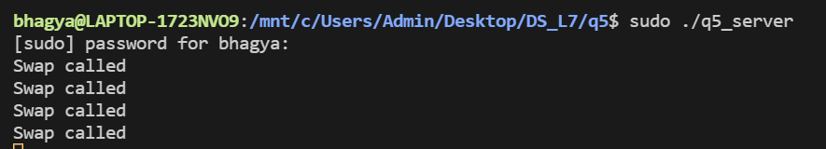

Client:

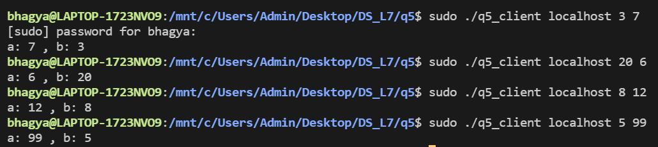

6.) Calculate **Maximum, Minimum, average** of given array.

**[q6.x]**

struct arraysize{

    int* arr;

    int size;

};

program ARR_PROG{

    version VERSION1 {

        arraysize arrop(arraysize arr) = 1;

    } = 2;

} =  0x20000005;

**Run Command** : rpcgen –a –C q6.x

* All required files will be created.
* The q6_client.c and q6_server.c files would be modified as following:

**[q6_client.c]**

*/\**

*\* This is sample code generated by rpcgen.*

*\* These are only templates and you can use them*

*\* as a guideline for developing your own functions.*

*\*/*

*#include* "q6.h"

void

arr_prog_2(char *host,int n,int* arr)

{

    CLIENT *clnt;

    arraysize  *result_1;

    arraysize  arrop_2_arg = {arr,n};

*#ifndef* DEBUG

    clnt = clnt_create (host, ARR_PROG, VERSION1, "udp");

*if* (clnt == NULL) {

        clnt_pcreateerror (host);

        exit (1);

    }

*#endif*  */* DEBUG */*

    result_1 = arrop_2(&arrop_2_arg, clnt);

*if* (result_1 == (arraysize *) NULL) {

        clnt_perror (clnt, "call failed");

    }

    printf("Min:%d\nMax:%d\nAvg:%d\n",result_1->arr[0],result_1->arr[1],result_1->arr[2]);

*#ifndef* DEBUG

    clnt_destroy (clnt);

*#endif*   */* DEBUG */*

}

int

main (int argc, char *argv[])

{

    char *host;

*if* (argc < 2) {

        printf ("usage: %s server_host\n", argv[0]);

        exit (1);

    }

    host = argv[1];

    int n = atoi(argv[2]);

    int arr[n];

*for*(int i=0;i<n;i++)arr[i] = atoi(argv[i+3]);

    arr_prog_2 (host,n,arr);

exit (0);

}

**[q6_server.c]**

*/\**

*\* This is sample code generated by rpcgen.*

*\* These are only templates and you can use them*

*\* as a guideline for developing your own functions.*

*\*/*

*#include* "q6.h"

arraysize *

arrop_2_svc(arraysize *argp, struct svc_req *rqstp)

{

    static arraysize  result;

    printf("Maximum,Minimum,Average called for an array\n");

    result.size = 3;

    static int arr[3];

    arr[0] = INT_MAX;

    arr[1] = INT_MIN;

    arr[2] = 0;

*for*(int i=0;i<argp->size;i++){

*if*(arr[0] > argp->arr[i]){

            arr[0] = argp->arr[i];

        }

*if*(arr[1] < argp->arr[i]){

            arr[1] = argp->arr[i];

        }

        arr[2] += argp->arr[i];

    }

    arr[2] /= argp->size;

    result.arr = arr;

*return* &result;

}

**Run Command** : make –f Makefile.q6

[**Output**]

Server:

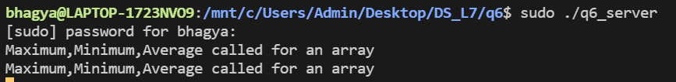

Client:

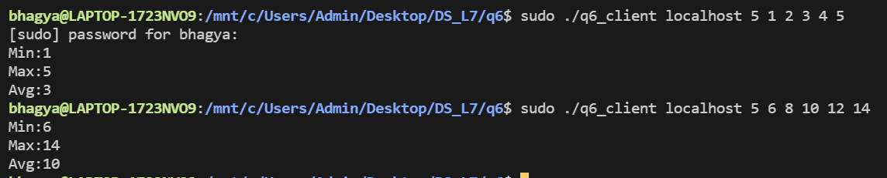

7.) Compare the given two strings.

**[q7.x]**

struct strpair{

    int len1;

    char* a;

    int len2;

    char* b;

};

program ARR_PROG{

    version VERSION1 {

        int cmp(strpair p) = 1;

    } = 2;

} =  0x20000007;

**Run Command** : rpcgen –a –C q7.x

* All required files will be created.
* The compare_client.c and compare_server.c files would be modified as following:

**[q7_client.c]**

*/\**

*\* This is sample code generated by rpcgen.*

*\* These are only templates and you can use them*

*\* as a guideline for developing your own functions.*

*\*/*

*#include* "q7.h"

void

arr_prog_2(char *host,char* a,char* b)

{

    CLIENT *clnt;

    int  *result_1;

    strpair  cmp_2_arg={strlen(a)+1,a,strlen(b)+1,b};

*#ifndef* DEBUG

    clnt = clnt_create (host, ARR_PROG, VERSION1, "udp");

*if* (clnt == NULL) {

        clnt_pcreateerror (host);

        exit (1);

    }

*#endif*  */* DEBUG */*

    result_1 = cmp_2(&cmp_2_arg, clnt);

*if* (result_1 == (int *) NULL) {

        clnt_perror (clnt, "call failed");

    }

    printf("%d\n",*result_1);

*#ifndef* DEBUG

    clnt_destroy (clnt);

*#endif*   */* DEBUG */*

}

int

main (int argc, char *argv[])

{

    char *host;

*if* (argc < 2) {

        printf ("usage: %s server_host\n", argv[0]);

        exit (1);

    }

    host = argv[1];

    arr_prog_2 (host,argv[2],argv[3]);

exit (0);

}

**[q7_server.c]**

*/\**

*\* This is sample code generated by rpcgen.*

*\* These are only templates and you can use them*

*\* as a guideline for developing your own functions.*

*\*/*

*#include* "q7.h"

int *

cmp_2_svc(strpair *argp, struct svc_req *rqstp)

{

    static int  result;

    printf("Compare called for two strings\n");

    result = strcmp(argp->a,argp->b);

*return* &result;

}

**Run Command** : make –f Makefile.q7

[**Output**]

Server:

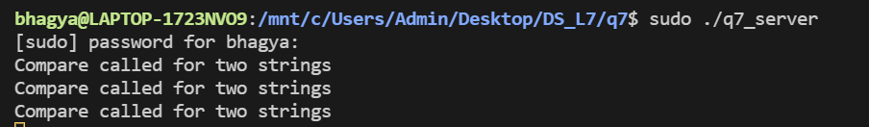

Client:

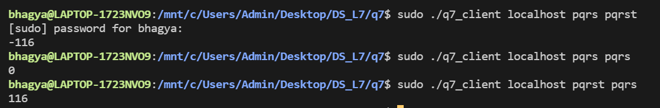

8.) Find out whether a given string is **substring or not**.

**[q8.x]**

struct strpair{

    int len1;

    char* a;

    int len2;

    char* b;

};

program ARR_PROG{

    version VERSION1 {

        int substring(strpair p) = 1;

    } = 2;

} =  0x20000007;

**Run Command** : rpcgen –a –C q8.x

* All required files will be created.
* The q8_client.c and q8_server.c files would be modified as following:

**[q8_client.c]**

*/\**

*\* This is sample code generated by rpcgen.*

*\* These are only templates and you can use them*

*\* as a guideline for developing your own functions.*

*\*/*

*#include* "q8.h"

void

arr_prog_2(char *host,char* a,char* b)

{

    CLIENT *clnt;

    int  *result_1;

    strpair  substring_2_arg = {strlen(a)+1,a,strlen(b)+1,b};

*#ifndef* DEBUG

    clnt = clnt_create (host, ARR_PROG, VERSION1, "udp");

*if* (clnt == NULL) {

        clnt_pcreateerror (host);

        exit (1);

    }

*#endif*  */* DEBUG */*

    result_1 = substring_2(&substring_2_arg, clnt);

*if* (result_1 == (int *) NULL) {

        clnt_perror (clnt, "call failed");

    }

*if*(*result_1 == 1){

        printf("Is a substring\n");

    }

*else* printf("Not a substring\n");

*#ifndef* DEBUG

    clnt_destroy (clnt);

*#endif*   */* DEBUG */*

}

int

main (int argc, char *argv[])

{

    char *host;

*if* (argc < 2) {

        printf ("usage: %s server_host\n", argv[0]);

        exit (1);

    }

    host = argv[1];

    arr_prog_2 (host,argv[2],argv[3]);

exit (0);

}

**[q8_server.c]**

*/\**

*\* This is sample code generated by rpcgen.*

*\* These are only templates and you can use them*

*\* as a guideline for developing your own functions.*

*\*/*

*#include* "q8.h"

int *

substring_2_svc(strpair *argp, struct svc_req *rqstp)

{

    static int  result;

    printf("Substring check is called for two strinsgs\n");

    int l1 = argp->len1 -1;

    int l2 = argp->len2 -1;

    result = 0;

*if*(l1 < l2){

*return* &result;

    }

    char temp[l2+1];

    temp[l2]=0;

*for*(int i=0;i<=l1-l2;i++){

        memcpy(temp,&argp->a[i],l2);

        result |= !strcmp(temp,argp->b);

    }

*return* &result;

}

**Run Command** : make –f Makefile.q8

[**Output**]

Server:

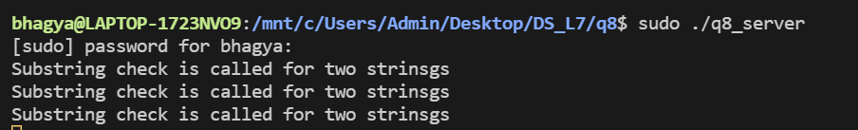

Client:

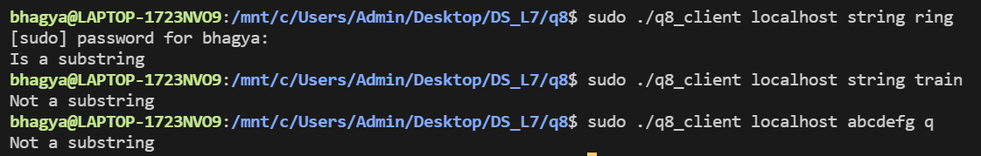

9.) **Concatenate** the two strings.

**[q9.x]**

struct strpair{

    int len1;

    char* a;

    int len2;

    char* b;

};

program CONCAT_PROG{

    version VERSION1 {

        string concatenate(strpair p) = 1;

    } = 1;

} =  0x4562877;

**Run Command** : rpcgen –a –C q9.x

* All required files will be created.
* The q9_client.c and q9_server.c files would be modified as following:

**[q9_client.c]**

*/\**

*\* This is sample code generated by rpcgen.*

*\* These are only templates and you can use them*

*\* as a guideline for developing your own functions.*

*\*/*

*#include* "q9.h"

void

concat_prog_1(char *host,char* a,char* b)

{

    CLIENT *clnt;

    char * *result_1;

    strpair  concatenate_1_arg = {strlen(a)+1,a,strlen(b)+1,b};

*#ifndef* DEBUG

    clnt = clnt_create (host, CONCAT_PROG, VERSION1, "udp");

*if* (clnt == NULL) {

        clnt_pcreateerror (host);

        exit (1);

    }

*#endif*  */* DEBUG */*

    result_1 = concatenate_1(&concatenate_1_arg, clnt);

*if* (result_1 == (char **) NULL) {

        clnt_perror (clnt, "call failed");

    }

    printf("%s\n",*result_1);

*#ifndef* DEBUG

    clnt_destroy (clnt);

*#endif*   */* DEBUG */*

}

int

main (int argc, char *argv[])

{

    char *host;

*if* (argc < 2) {

        printf ("usage: %s server_host\n", argv[0]);

        exit (1);

    }

    host = argv[1];

    concat_prog_1 (host,argv[2],argv[3]);

exit (0);

}

**[q9_server.c]**

*/\**

*\* This is sample code generated by rpcgen.*

*\* These are only templates and you can use them*

*\* as a guideline for developing your own functions.*

*\*/*

*#include* "q9.h"

char **

concatenate_1_svc(strpair *argp, struct svc_req *rqstp)

{

    static char * result;

    printf("Concatenation of two strings is called. \n");

    result = malloc(argp->len1 + argp->len2 +1);

    memcpy(result,argp->a,argp->len1);

    strcat(result,argp->b);

*return* &result;

}

**Run Command** : make –f Makefile.q9

[**Output**]

Server:

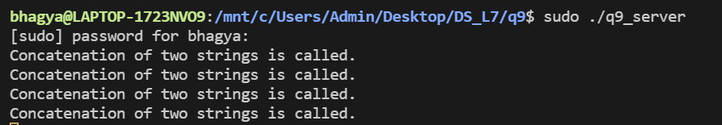

Client:

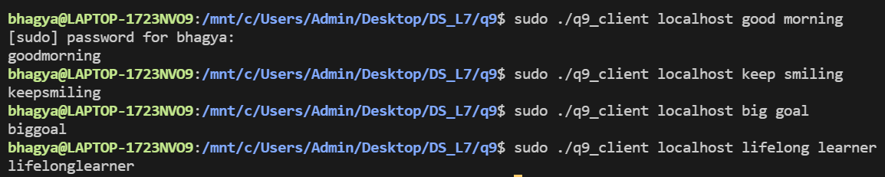

10.) **Reverse** the elements of an array.

**[q10.x]**

struct arraysize{

    int* arr;

    int size;

};

program ARR_PROG{

    version VERSION1 {

        arraysize reverse(arraysize arr) = 1;

    } = 2;

} =  0x20000005;

**Run Command** : rpcgen –a –C q10.x

* All required files will be created.
* The q10_client.c and q10_server.c files would be modified as following:

**[q10_client.c]**

*#include* "q10.h"

void

arr_prog_2(char *host,int n,int* arr)

{

    CLIENT *clnt;

    arraysize  *result_1;

    arraysize  reverse_2_arg = {arr,n};

*#ifndef* DEBUG

    clnt = clnt_create (host, ARR_PROG, VERSION1, "udp");

*if* (clnt == NULL) {

        clnt_pcreateerror (host);

        exit (1);

    }

*#endif*  */* DEBUG */*

    result_1 = reverse_2(&reverse_2_arg, clnt);

*if* (result_1 == (arraysize *) NULL) {

        clnt_perror (clnt, "call failed");

    }

*for*(int i=0;i<result_1->size;i++)printf("%d ",result_1->arr[i]);

    printf("\n");

*#ifndef* DEBUG

    clnt_destroy (clnt);

*#endif*   */* DEBUG */*

}

int

main (int argc, char *argv[])

{

    char *host;

*if* (argc < 2) {

        printf ("usage: %s server_host\n", argv[0]);

        exit (1);

    }

    host = argv[1];

    int n = atoi(argv[2]);

    int arr[n];

*for*(int i=0;i<n;i++)arr[i] = atoi(argv[i+3]);

    arr_prog_2 (host,n,arr);

exit (0);

}

**[q10_server.c]**

*#include* "q10.h"

arraysize *

reverse_2_svc(arraysize *argp, struct svc_req *rqstp)

{

    static arraysize  result;

    printf("Reversing the array...\n");

    result.size = argp->size;

    int* arr = malloc(argp->size * sizeof(int));

*for*(int i=0;i<result.size;i++)arr[i] = argp->arr[result.size-i-1];

    result.arr = arr;

*return* &result;

}

**Run Command** : make –f Makefile.q10

[**Output**]

Server:

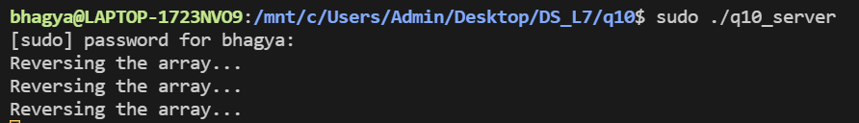

Client:

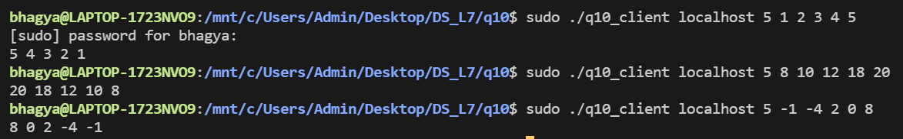

**SUBMITTED BY**: U19CS012

BHAGYA VINOD RANA