Artificial Intelligence (CS308)

Practical Exam

**U19CS012**

**Q3.)**

Find the results for following questions using PROLOG program:

1. Find the total number of diseases for each patient.

2. Find the name and zip code of each patient.

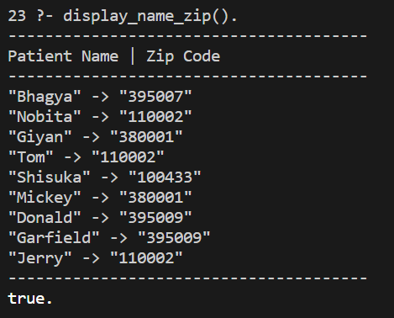

3. Write P_Id and name of all patients staying in Delhi.

4. List name of all patients treated by doctor D1.

5. List roll no. of all patients suffering from Common cold

6. List building_name and city_code for all patients in the

given format (format: [(building_name, citycode)]).

7. List all doctors for each given patient.

**Code**

**Output**

**SUBMITTED BY**: U19CS012

BHAGYA VINOD RANA