Artificial Intelligence (CS308)

Assignment - 2

**U19CS012**

1.) Load the following facts into familytree.pl, consult the prolog file and answer the given questions.

**Knowledge Base**

*% Program: family.pl*

*% U19CS012 [BHAGYA VINOD RANA]*

*% Knowledge Base*

*% parent(X,Y) -> X is the Parent of Y*

parent(albert, jim)*.*

parent(albert, peter)*.*

parent(jim, brian)*.*

parent(john, darren)*.*

parent(peter, lee)*.*

parent(peter, sandra)*.*

parent(peter, james)*.*

parent(peter, kate)*.*

parent(peter, kyle)*.*

parent(brian, jenny)*.*

parent(irene, jim)*.*

parent(irene, peter)*.*

parent(pat, brian)*.*

parent(pat, darren)*.*

parent(amanda, jenny)*.*

*% female(Person)*

*% Person is female.*

female(irene)*.*

female(pat)*.*

female(lee)*.*

female(sandra)*.*

female(jenny)*.*

female(amanda)*.*

female(kate)*.*

*% male(Person)*

*% Person is male.*

male(albert)*.*

male(jim)*.*

male(peter)*.*

male(brian)*.*

male(john)*.*

male(darren)*.*

male(james)*.*

male(kyle)*.*

*% yearOfBirth(Person, Year).*

*% Person's Year_of_Birth is Year.*

yearOfBirth(irene, 1923)*.*

yearOfBirth(pat, 1954)*.*

yearOfBirth(lee, 1970)*.*

yearOfBirth(sandra, 1973)*.*

yearOfBirth(jenny, 2004)*.*

yearOfBirth(amanda, 1979)*.*

yearOfBirth(albert, 1926)*.*

yearOfBirth(jim, 1949)*.*

yearOfBirth(peter, 1945)*.*

yearOfBirth(brian, 1974)*.*

yearOfBirth(john, 1955)*.*

yearOfBirth(darren, 1976)*.*

yearOfBirth(james, 1969)*.*

yearOfBirth(kate, 1975)*.*

yearOfBirth(kyle, 1976)*.*

*%1.  Is Albert a parent of Peter?*

*% parent(albert, peter).*

*%2.  Who is the child of Jim?*

*% parent(jim,Who).*

*%3.  Who are the parents of Brian?*

*% parent(Who,brian).*

*%4.  Is Irene a grandparent of Brian?*

*% Define the Rule Grandparent*

*% grandparent(G,C) - G is grandparent of C*

grandparent(G,C) *:-*

    parent(G, F),

    parent(F, C)*.*

*% grandparent(irene,brian).*

*%5.  Find all the grandchildren of Irene*

*% grandparent(irene, Who).*

*%6.  Now add the following rule to familytree.pl and re-consult:*

older(Person1, Person2) *:-*

    yearOfBirth(Person1, Year1),

    yearOfBirth(Person2, Year2),

    Year2 > Year1*.*

*%7.  Who is older than Pat?*

*% older(Who, pat).*

*%8.  Who is younger than  Darren?*

*% older(darren, Who).*

*%9.  List the siblings of Sandra.*

*% Define the Rule sibling.*

*% sibling(B,S) - B is the sibling of S*

sibling(B,S) *:-*

    parent(P, B),

    parent(P, S),

    B \= S*.*

*% sibling(sandra, Who).*

*%10.  Who is the older brother of Sandra?*

*% Define the Rule olderbrother*

olderbrother(X, Y)*:-*

    male(X),

    parent(P, X),

    parent(Z, Y),

    X \= Y,

    older(X, Y)*.*

*% olderbrother(Who, sandra).*

*%11.  Find the predecessors of Kyle.*

*% Define the Rule predecessor*

predecessor(X, Y)*:-*

    parent(X, Z),

    predecessor(Z, Y)*.*

predecessor(X, Y)*:-*

    parent(X, Y)*.*

*% predecessor(Who, kyle).*

*%12.  Does Kate have a sister?*

*% Define the Rule sister*

sister(X, Y)*:-*

    female(X),

    parent(P, X),

    parent(P, Y),

    X \= Y*.*

*% sister(Who, kate).*

*% Does Kate have Sister?*

*% sister(_, kate).*

*%13. How many females and males are there in the knowledge base?*

person(X)*:-*

    female(X)*.*

person(Y)*:-*

    male(Y)*.*

*% aggregate_all(count, person(Who), Total).*

*% For Individual Male and Female Count*

*% aggregate_all(count, male(X), Total).*

*% aggregate_all(count, female(X), Total).*

Use SWI – Prolog for answering the following questions (load the rules in the file familytree.pl):

1. Is Albert a parent of Peter?

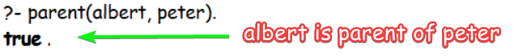

2. Who is the child of Jim?

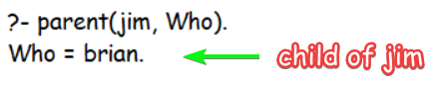

3. Who are the parents of Brian?

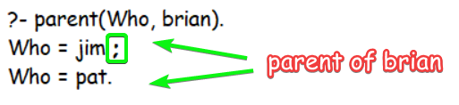

4. Is Irene a grandparent of Brian?

*% Define the Rule Grandparent*

*% grandparent(G,C) - G is grandparent of C*

grandparent(G,C) *:-*

    parent(G, F),

    parent(F, C)*.*

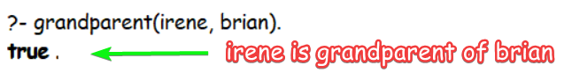

5. Find all the grandchildren of Irene

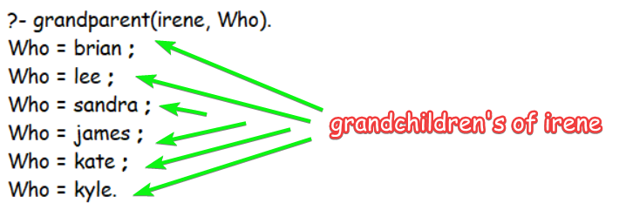

6. Now add the following rule to familytree.pl and re-consult:

older(Person1, Person2) :-

yearOfBirth(Person1, Year1),

yearOfBirth(Person2, Year2),

Year2 > Year1.

7. Who is older than Pat?

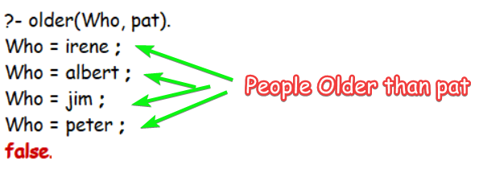

8. Who is younger than Darren?

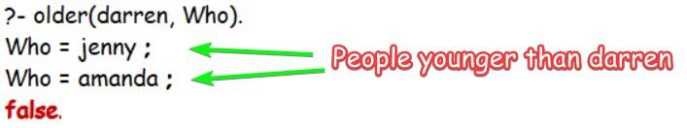

9. List the siblings of Sandra.

*% Define the Rule sibling.*

*% sibling(B,S) - B is the sibling of S*

sibling(B,S) *:-*

    parent(P, B),

    parent(P, S),

    B \= S*.*

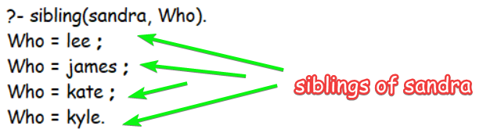

10. Who is the older brother of Sandra?

*% Define the Rule olderbrother*

olderbrother(X, Y)*:-*

    male(X),

    parent(P, X),

    parent(P, Y),

    X \= Y,

    older(X, Y)*.*

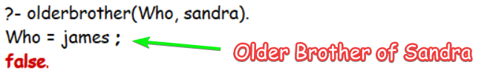

11. Find the predecessors of Kyle.

*% Define the Rule predecessor*

predecessor(X, Y)*:-*

    parent(X, Z),

    predecessor(Z, Y)*.*

predecessor(X, Y)*:-*

    parent(X, Y)*.*

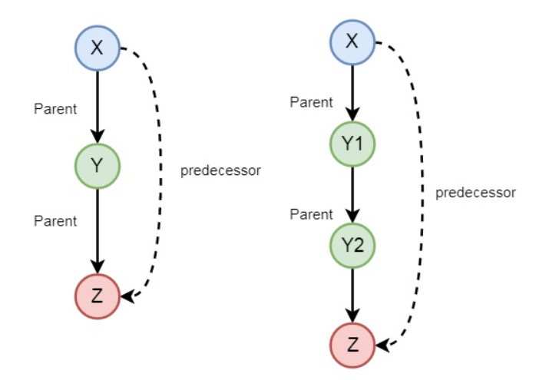

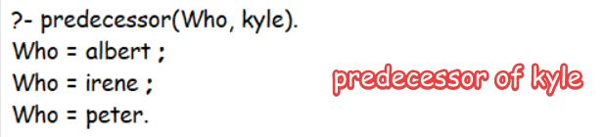

12. Does Kate have a sister?

*% Define the Rule sister*

sister(X, Y)*:-*

    female(X),

    parent(P, X),

    parent(P, Y),

    X \= Y*.*

List all the **Sister of Kate**.

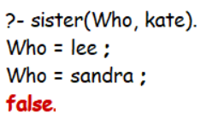

Does Kate have Sister?

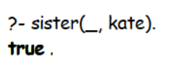

13. How many females and males are there in the knowledge base?

a.) For Individual Male & Female Count

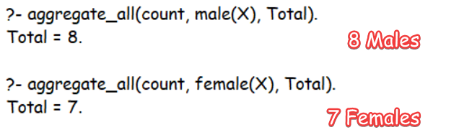

b.) For Combined Male & Female Count

person(X)*:-*

    female(X)*.*

person(Y)*:-*

    male(Y)*.*

aggregate_all(count, person(Who), Total)*.*

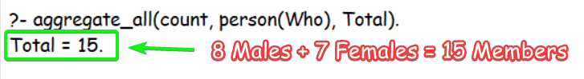

**SUBMITTED BY**: U19CS012

BHAGYA VINOD RANA