Artificial Intelligence (CS308)

Assignment - 3

**U19CS012**

1.) Consider the Following Story.

“**I** married a **widow** (call her W) who has a **grown-up daughter** (D). My **father** (F), who visited us quite often, fell in love with my **step-daughter** and married her. Hence my father became my **son-in-law** and my **step-daughter** became **my mother**. Some months later, **my wife** gave birth to a **son (S1)**, who became the **brother-in-law** of my **father**, as well as my **uncle**. The wife of my father (i.e) my **step-daughter** also had a son (S2).”

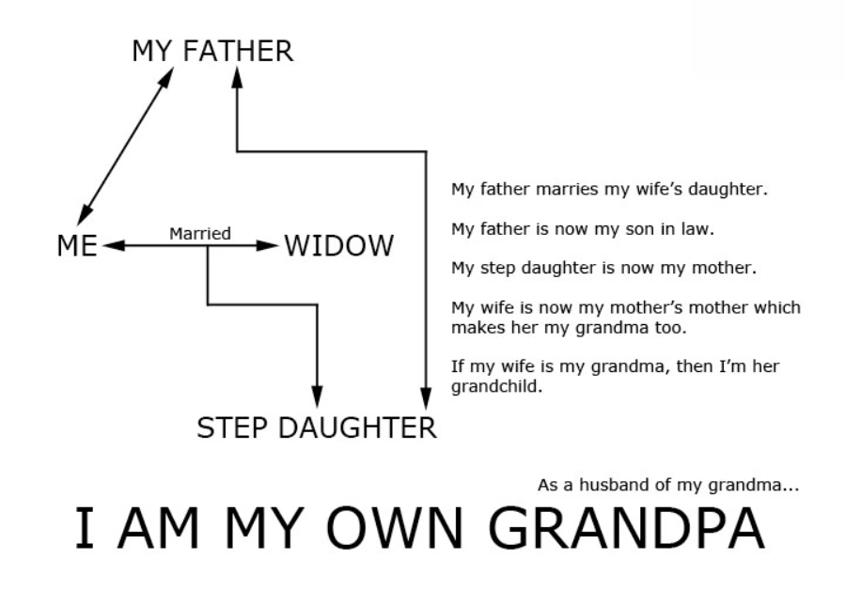

* Using Prolog, Create a List of **Facts** that represents the situation in the above Story.
* Add **Rules** defining the family relationships (such as father-in-law) described in the story.

**PROLOG Code**

*% [U19CS012] BHAGYA VINOD RANA*

*% Facts*

*% male(person) - person is male*

male(f)*.*

male(i)*.*

male(s1)*.*

male(s2)*.*

*% female(person) - person is female*

female(w)*.*

female(d)*.*

*% husband(h,w) - h is the husband of w*

husband(i,w)*.*

husband(f,d)*.*

*% father(f,s) - f is the father of s*

father(i,s1)*.*

father(f,s2)*.*

father(f,i)*.*

*% mother(m,s) - m is the mother of s*

mother(d,s2)*.*

mother(w,s1)*.*

mother(w,d)*.*

*% Relationships [Rules]*

*% Wife Relation [X is Wife of Y, if Y is the Husband of X]*

wife(X, Y) *:-* husband(Y, X)*.*

*% For Married Condition, X should be either Husband*

married(X, Y) *:-* husband(X, Y)*.*

married(X, Y) *:-* wife(X, Y)*.*

*% biological parent*

bio_parent(X, Y) *:-* father(X, Y)*.*

bio_parent(X, Y) *:-* mother(X, Y)*.*

*% daughter Relationship*

daughter(X, Y) *:-* female(X), bio_parent(Y, X)*.*

*% son*

son(X, Y) *:-* male(X), bio_parent(Y,X)*.*

*% step parent -> someone which your father/mother marries after*

*% old relationship ends*

step_parent(X, Z) *:-* married(X, Y), bio_parent(Y, Z), \+ bio_parent(X, Z)*.*

step_father(X, Z)*:-* step_parent(X, Z), male(X)*.*

step_mother(X, Z)*:-* step_parent(X, Z), female(X)*.*

step_daughter(X, Y)*:-* female(X), step_parent(Y, X)*.*

step_son(X, Y)*:-* male(X), step_parent(Y,X)*.*

parent(X, Y) *:-* step_parent(X, Y)*.*

parent(X, Y) *:-* bio_parent(X, Y)*.*

*% the father of one's husband or wife.*

father_in_law(X, Y)*:-* married(Y, Z), parent(X, Z), \+ parent(X, Y), male(X)*.*

mother_in_law(X, Y)*:-* married(Y, Z), parent(X, Z), \+ parent(X, Y), female(X)*.*

parent_in_law(X, Y) *:-* father_in_law(X, Y)*.* parent_in_law(X, Y) :- mother_in_law(X, Y)*.*

son_in_law(X, Y)*:-* parent_in_law(Y, X), male(X)*.*

daughter_in_law(X, Y)*:-* parent_in_law(Y, X), female(X)*.*

*% grandfather relationship*

grandfather(X, Z) *:-* parent(X, Y), parent(Y, Z), male(X)*.*

sibling(X, Y)*:-* parent(Z, X), parent(Z, Y), X \= Y*.*

dist_sibling(X, Y) *:-* distinct(sibling(X, Y))*.*

*% brother in law - the brother of one's wife or husband.*

brother_in_law(X, Z)*:-* married(Y, Z), sibling(X, Y), male(X)*.*

sister_in_law(X, Z)*:-* married(Y, Z), dist_sibling(X, Y), female(X)*.*

*% uncle*

uncle(X, Y)*:-* dist_sibling(X, Z), parent(Z, Y), male(X)*.*

So, Let’s **Execute the Prolog** file and **Check** if the facts and relationships are defined correctly.

“i” married a widow “w”.

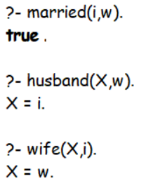

“w” has a daughter “d”.

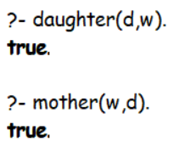

“d” is step-daughter of “i”.

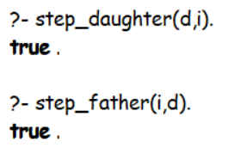

“d” married to i’s father “f”.

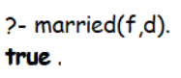

Hence, “f” became son-in-law of “i”.

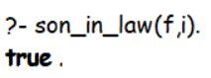

and i’s step-daughter “d” became his step-mother.

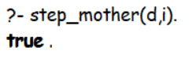

“i” and “w” gave birth to son “s1”.

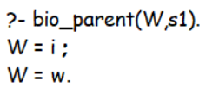

hence, “s1” became brother-in-law of “f”.

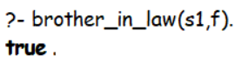

and “s1” became uncle of “i”.

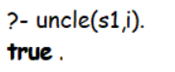

“d” and “f” had a son “s2”.

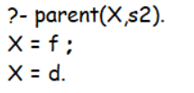

Show how a Prolog system would use your program to Prove the Goal

“**I am my own grandfather**"

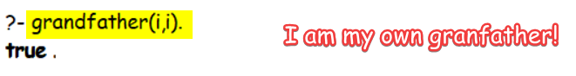

Show how a **Prolog** system would use your program to **prove** the goal **“I am my own grandfather".**

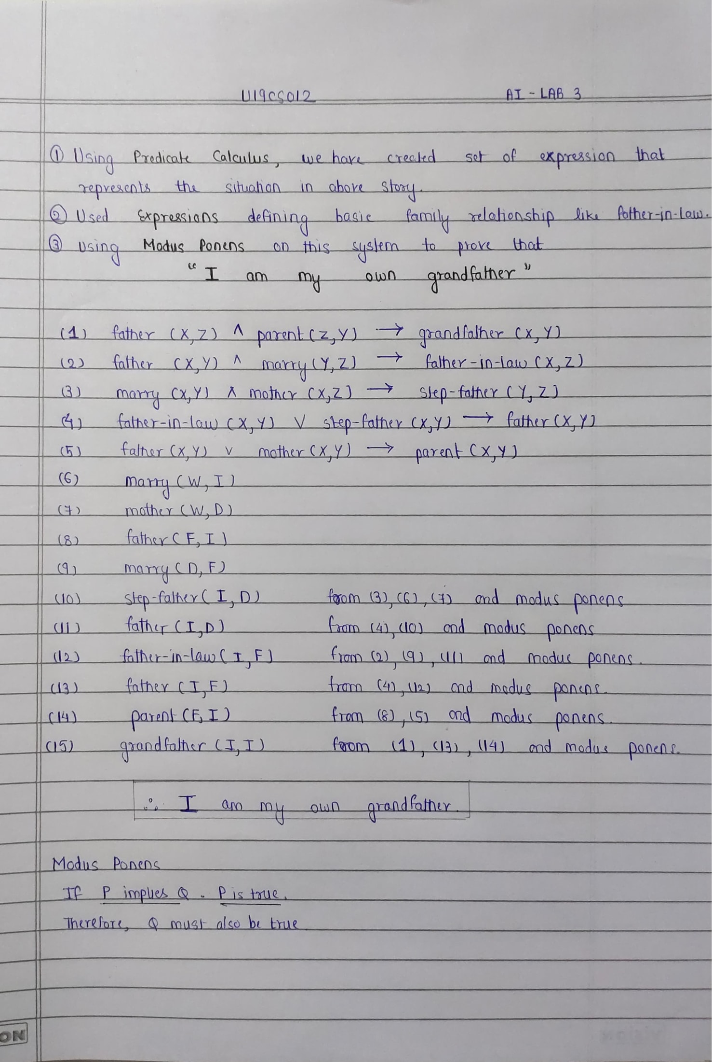

**SUBMITTED BY**: U19CS012

BHAGYA VINOD RANA