Artificial Intelligence (CS308)

Assignment - 6

**U19CS012**

**Monkey Banana Problem**

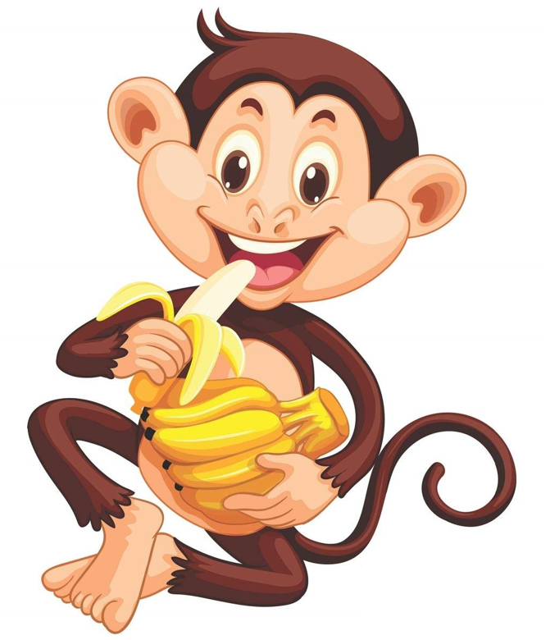

* There is a **monkey** at the door into a room.
* In the middle of the room a **banana** is hanging from the **ceiling**.
* The monkey is **hungry** and wants to get the banana, but he cannot stretch high enough from the floor.
* At the window of the room there is a box the monkey may use.

The monkey can perform the following **actions**:

* walk on the floor
* climb box
* push box
* grasp the banana (if standing on the box directly under the banana.)

**Can the Monkey get the Banana?**

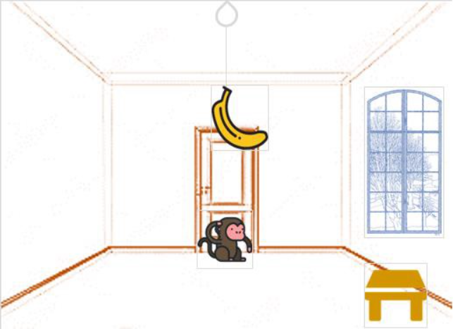

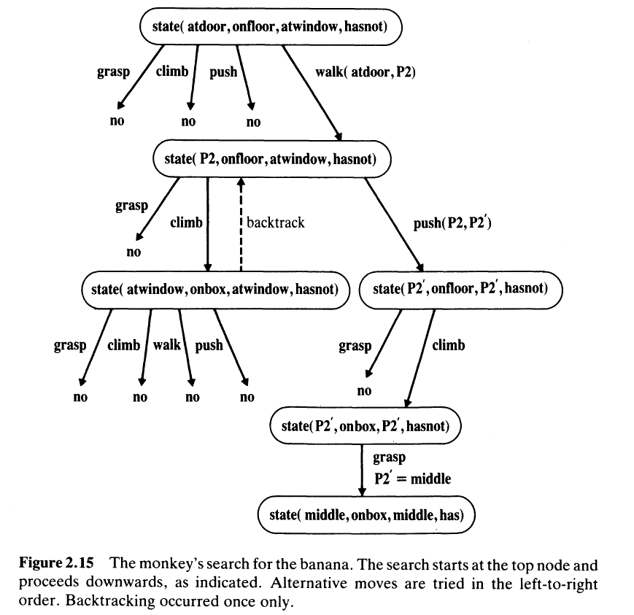

**Prolog Code**

*% Monkey-Banana Problem {[U19CS012] BHAGYA RANA}*

*% initial state: Monkey is at door, Monkey is on floor, Box is at window,* *Monkey doesn't have banana.*

*% state(Monkey location in the room, Monkey onbox/onfloor, box location, has/hasnot banana)*

*% Legal Actions Moves*

*% grab banana*

do( state(middle, onbox, middle, hasnot),

    grab,

    state(middle, onbox, middle, has) )*.*

*% climb box*

do( state(L, onfloor, L, Banana),

    climb,

    state(L, onbox, L, Banana) )*.*

*% push box from L1 to L2*

do( state(L1, onfloor, L1, Banana),

    push(L1, L2),

    state(L2, onfloor, L2, Banana) )*.*

*% walk from L1 to L2*

do( state(L1, onfloor, Box, Banana),

    walk(L1, L2),

    state(L2, onfloor, Box, Banana) )*.*

*% canget(State): monkey can get banana in State*

*% Monkey already has it, goal state*

canget(state(*_*, *_*, *_*, has))*.*

canget(State1)*:-*                     *% not goal state, do some work to get it*

      do(State1, Action, State2),    *% do something (grab, climb, push, walk)*

      canget(State2)*.*                *% canget from State2*

*% get plan = list of actions*

canget(state(*_*, *_*, *_*, has), [])*.*     *% Monkey already has it, goal state*

canget(State1, Plan) *:-*                *% not goal state, do some work to get it*

      do(State1, Action, State2),      *% do something (grab, climb, push, walk)*

      canget(State2, PartialPlan),     *% canget from State2*

      add(Action, PartialPlan, Plan)*.*  *% add action to Plan*

add(X,L,[X|L])*.*

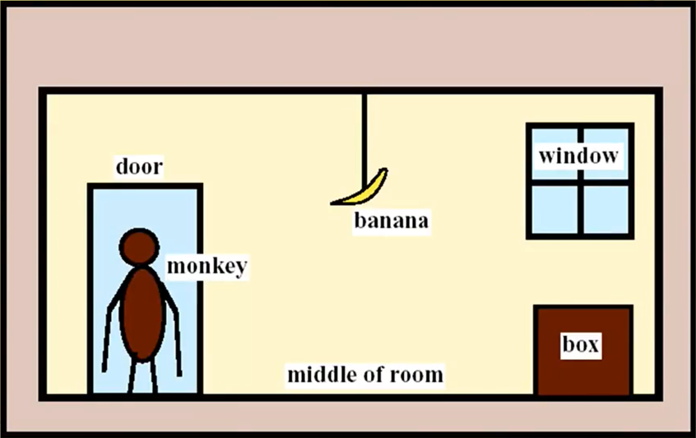

**Output**

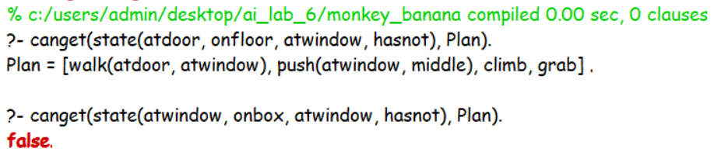

In case 2, Since Monkey can Only Climb once on the Box [There is no Action of Climbing Down the Box], Therefore it returns **False**.

**SUBMITTED BY**: U19CS012

BHAGYA VINOD RANA