Artificial Intelligence (CS308)

Assignment - 7

**U19CS012**

**Maze Problem**

You are Given a Maze of Room which are Labelled with Capital Letters like ‘A’ & ‘B’.

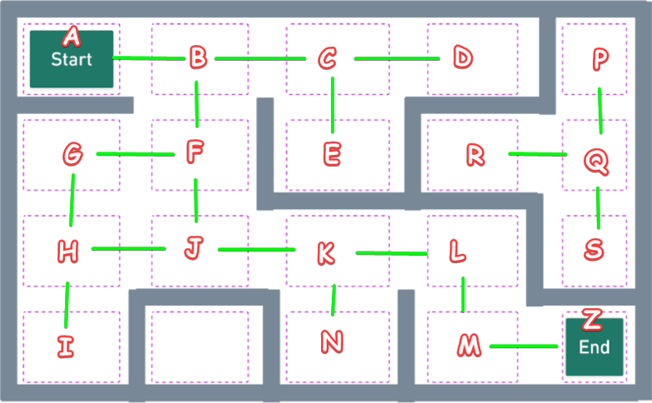

**Input**:

**Source** Room and **Destination** Room.

**Output**:

To Find out **Where the Destination Room can be Reached or Not**?

If it can be Reached, Print any Path to reach it.

**PROLOG Code** {Using B.F.S.}

*% path('X','Y') -> There is Path from Point 'X' to Point 'Y'*

path('A','B')*.*

path('B','C')*.*

path('B','F')*.*

path('C','D')*.*

path('C','E')*.*

path('F','G')*.*

path('F','J')*.*

path('G','H')*.*

path('H','I')*.*

path('H','J')*.*

path('J','K')*.*

path('K','L')*.*

path('K','N')*.*

path('L','M')*.*

path('M','Z')*.*

path('P','Q')*.*

path('Q','R')*.*

path('Q','S')*.*

*% Prolog F(x) to Append 2 List's*

appnd([],X,X)*.*

appnd([H|T],N,[H|T1])*:-*

    appnd(T,N,T1)*.*

*% F(x) to extract all the Un-Visited Nodes in Graph*

extend([Node|Path],NewPaths)*:-*

    bagof([NewNode,Node|Path],

          ( (path(Node,NewNode);path(NewNode,Node)),

            not(member(NewNode,[Node|Path]))),

            NewPaths

         ),*!.*

    extend(*_*, [])*.*

*% Termination Condition If Our Final Node {Goal} is Reached*

bfs([[Node|Path]|*_*],[Node|Path],Goal)*:-*

    Node=Goal*.*

*% B.F.S. Recursion*

bfs([Path|Paths], Sol, Goal)*:-*

    extend(Path, NewPaths),

    appnd(Paths, NewPaths, Paths1),

    bfs(Paths1, Sol, Goal)*.*

*% F(x) to Print the Entire Path from Source to Destination*

displaypath([])*:-*

    write("END"),nl*.*

displaypath([H|T])*:-*

    write(H),

    write(" -> "),

    displaypath(T)*.*

*% Main F(x) to Intiate the Search*

findpath(Start,Goal)*:-*

    bfs([[Start]], Sol, Goal),

    reverse(Sol, Path),

    displaypath(Path)*.*

**Output**

Q) *Does there a Path Exist from Point 'A' to Point 'Z'?*

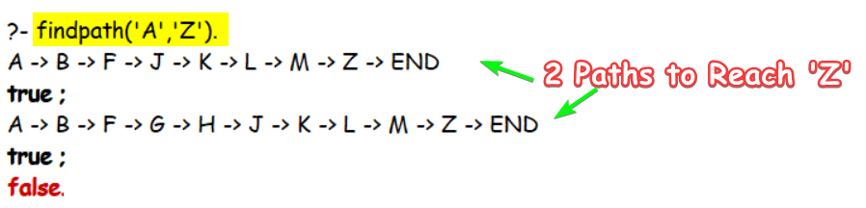

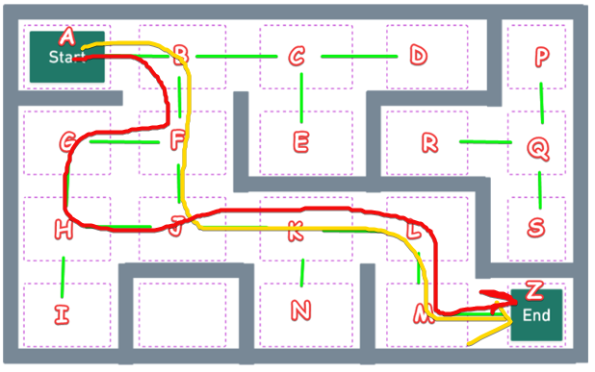

[Surprisingly, There are **Two** Paths to Reach ‘Z’.]

Q) *Does there a Path Exist from Point 'E' to Point 'M'?*

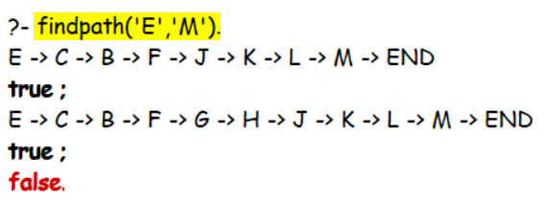

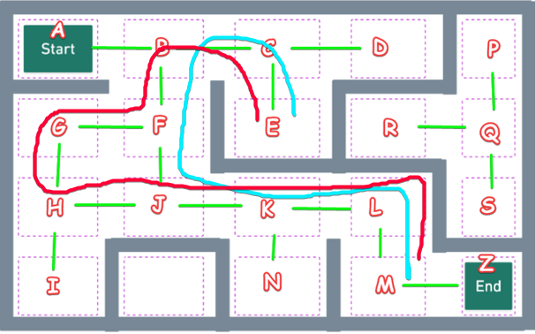

Q) *Does there a Path Exist from Point 'A' to Point 'P'?*

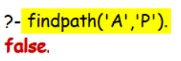 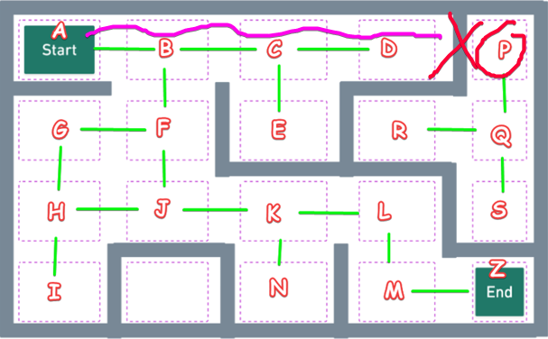

**SUBMITTED BY**: U19CS012

BHAGYA VINOD RANA