Artificial Intelligence (CS308)

Assignment - 8

**U19CS012**

Q1.) Implement **N Queens** Problem using below Algorithms in PROLOG.

* Breadth First Search
* Depth First Search

**Code**

*% Implement N-Queens using BFS and DFS.*

*% To make a empty board we first require to make rows and then columns*

*% Rows*

row(0,[])*.*

row(N,[0|T]) *:-* N > 0,

N1 is N - 1, row(N1,T)*.*

*% Columns using the same logic as rows*

col(0,*_*,[])*.*

col(N,H, [H|T1]) *:-* N > 0,

N1 is N - 1, col(N1,H,T1)*.*

*% Calling row and column to make an empty board.*

empty(N,Board) *:-*

    row(N,Row),

    col(N,Row,Board)*.*

*% Utility function to print output in a matrix format*

printBoard([])*.*

printBoard([X|Pt]) *:-* print(X),nl,printBoard(Pt)*.*

*% To get a cell value of coordinates (X,Y)*

getXY(X,Y,[*_*|Mat], Z) *:-*

    Y > 0,

    Y1 is Y - 1,

    getXY(X,Y1,Mat,Z), *!* *.*

getXY(X,0,[M|*_*],H) *:-*

    getX(X,M,H)*.*

*% To get a particular cell in a specific row*

getX(X,[*_*|Mat],H) *:-*

    X > 0,

    X1 is X - 1,

    getX(X1,Mat,H), *!* *.*

getX(0,[H|*_*],H)*.*

*% To change the a particular cell in a matrix*

changeXY(X,Y,[M|Mat],Z) *:-*

    Y > 0,

    Y1 is Y - 1,

    changeXY(X,Y1,Mat,Z1),

    Z = [M|Z1]*.*

changeXY(X,0,[M|Mat],Z) *:-*

    changeX(X,M,Z1),

    Z = [Z1|Mat]*.*

*% To change a particular cell {0,1} in a row*

changeX(X,[H|T],Z)*:-*

    X > 0,

    X1 is X - 1,

    changeX(X1,T,Z1),

    Z = [H|Z1]*.*

changeX(0,[*_*|T],[1|T])*.*

*% To check the queen in the UP direction.*

checkUp(-1,*_*,*_*)*.*

checkUp(X,Y,Board) *:-*

    X>=0,

    X1 is X-1,

    getXY(X,Y,Board,Val),

    Val is 0,

    checkUp(X1,Y,Board)*.*

*% To check the queen in the Left Diagonal direction.*

checkLeftUpDiagonal(-1,*_*,*_*)*.*

checkLeftUpDiagonal(*_*,-1,*_*)*.*

checkLeftUpDiagonal(X,Y,Board) *:-*

    X>=0,

    Y>=0,

    X1 is X-1,

    Y1 is Y-1,

    getXY(X,Y,Board,Val),

    Val is 0,

    checkLeftUpDiagonal(X1,Y1,Board)*.*

*% To check the queen in the Right Diagonal direction.*

checkRightUpDiagonal(*_*,N,N,*_*)*.*

checkRightUpDiagonal(-1,*_*,*_*,*_*)*.*

checkRightUpDiagonal(X,Y,N,Board) *:-*

    X>=0,

    X1 is X-1,

    Y<N,

    Y1 is Y+1,

    getXY(X,Y,Board,Val),

    Val is 0,

    checkRightUpDiagonal(X1,Y1,N,Board)*.*

*% Call check functions to check if the state is stable or not*

validityCheck(I, N, J, Board, NewBoard) *:-*

    checkUp(I,J,Board),

    checkLeftUpDiagonal(I,J,Board),

    checkRightUpDiagonal(I,J,N,Board),

    changeXY(I,J,Board,NewBoard)*.*

validityCheck(I,N,J,Board,Res) *:-*

        J>0,

        J1 is J-1,

        validityCheck(I,N,J1,Board,Res)*.*

*% Place the queen and check for validity*

placeQueenAtNewPos(I, N, Board, NewBoard) *:-*

    validityCheck(I, N, N, Board, NewBoard)*.*

*% DFS implementation*

dfs(CurrentBoard, N, N, FinalBoard)*:-*

    FinalBoard = CurrentBoard*.*

dfs(CurrentBoard, I, N, FinalBoard)*:-*

    I<N,

    I1 is I+1,

    placeQueenAtNewPos(I, N, CurrentBoard, NewBoard),

    dfs(NewBoard, I1, N, FinalBoard)*.*

*% BFS implementation*

bfs([],*_*,[])*.*

bfs([[CurrentBoard, I]|Tail],N,FinalBoard) *:-*

    I is N,

    bfs(Tail,N,NewTail),

    FinalBoard=[CurrentBoard|NewTail]*.*

bfs([[CurrentBoard, I]|Tail],N,FinalBoard) *:-*

    I < N,

    I1 is I+1,

    placeQueenAtNewPos(I, N, CurrentBoard, NewBoard),

    append(Tail,[[NewBoard, I1]],NBoard),

    bfs(NBoard,N,FinalBoard)*.*

*% Mian Driver function to call the above functions*

nQueens(N) *:-*

    empty(N,Board),

    write('1. BFS'), nl,

    write('2. DFS'), nl,

    read(Choice),

    (

        Choice == 1 *->*

            bfs([[Board,0]],N,[FinalBoard|*_*]),

            printBoard(FinalBoard)

        ;

        Choice == 2 ->

            dfs(Board,0,N,FinalBoard),

            printBoard(FinalBoard)

        ;

*% Else Invalid Input*

        write('Invalid Choice Entered!')

    )*.*

**Output**

Trivial Test Cases – for **n = 1, 2, 3**

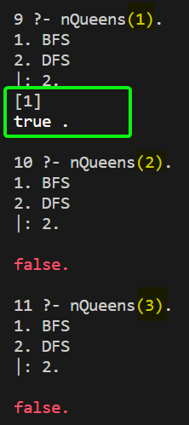

**n = 4**

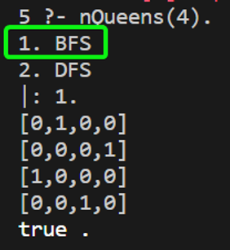 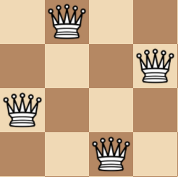 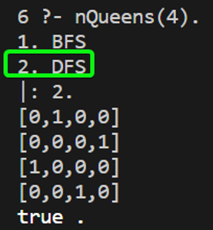

**n = 8**

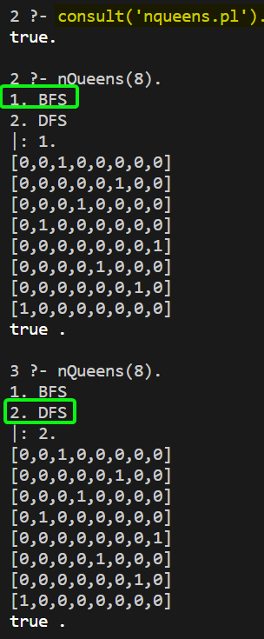 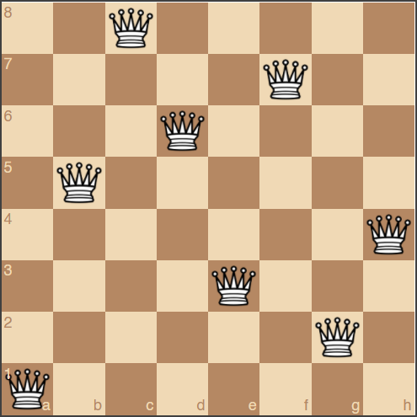

**n = 10, 12 & 16**

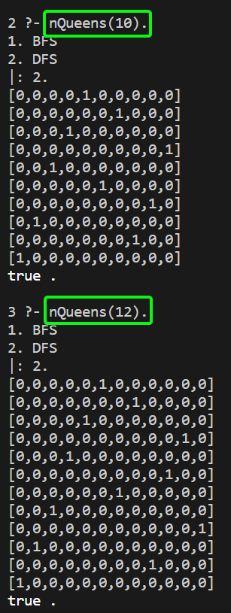 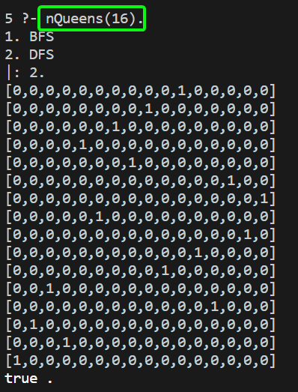

The n-queens problem is solvable for **n=1** and **n≥4**.

Q2.) Compare the **Complexity** of Both Algorithms.

Which algorithm is **best** suited for implementing N Queen’s problem and why?

1. Breadth First Search
2. Depth First Search

|  |  |  |
| --- | --- | --- |
| Algorithm | Time Complexity | Remarks |
| BFS | O(n^n) | It tries **every possible** solution |
| DFS | O(n!) | It **discards** the **Invalid solutions** and *their following Recursive calls* as and when they are found. |

BFS **O(n^n)**

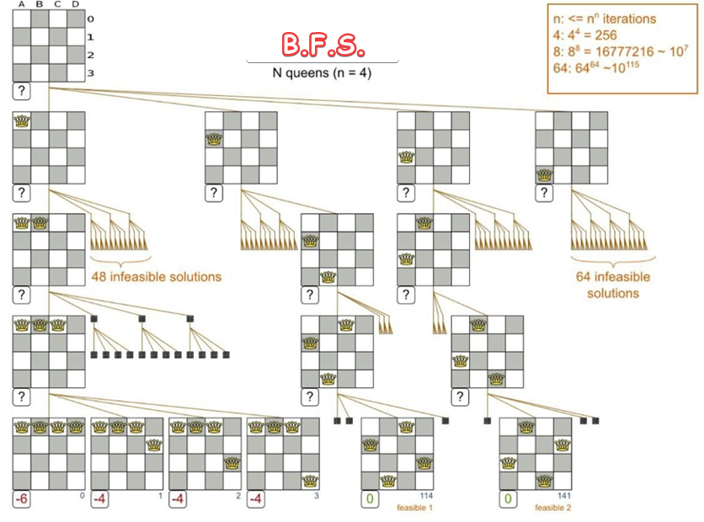

DFS **O(n!)**

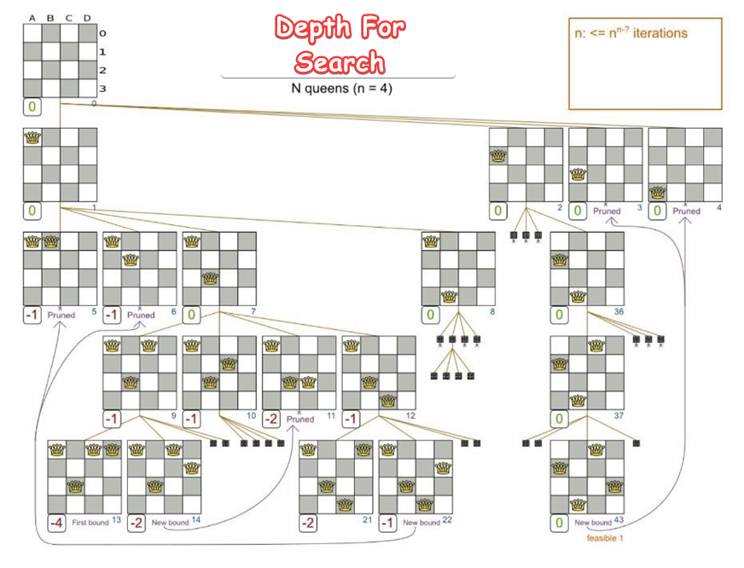

Therefore, **D.F.S.** is best Suited for **N-Queens** problem due to Lesser Time Complexity **(O(N!))** & Reduces the Sample Space at Every Step in Algorithm.

**SUBMITTED BY**: U19CS012

BHAGYA VINOD RANA