System Software (CS306)

Assignment - 3

**U19CS012**

1) Write a C/C++ program to test whether a given identifier is valid or not.

In order to qualify as a valid identifier, the string must satisfy the following conditions:

* It must start with either **underscore(_)** or any of the characters from the ranges **[‘a’, ‘z’] and [‘A’, ‘Z’].**
* There must **not be any white space** in the string.
* And, all the subsequent characters after the first character **must not** consist of any special characters like **$, #, %** etc.

**Code:**

*#include* <iostream>

*#include* <string>

using namespace std;

*// U19CS012 [BHAGYA VINOD RANA]*

*// This Checks if the Given String is Valid Identifier or Not*

bool is_valid_identfier(string s);

int main()

{

    string s;

    cout << "Enter String to Check for Type of Identifier : ";

    cin >> s;

*if* (is_valid_identfier(s))

        cout << s << " is Valid Identifier!\n";

*else*

        cout << s << " is Not a Valid Identifier!\n";

*return* 0;

}

*// This Checks if the Given String is Valid Identifier or Not*

bool is_valid_identfier(string s)

{

    int n = s.length();

*// If first character is not {_/[A-Z]/[a-z]}, then identifier is invalid*

*if* (!((s[0] >= 'a' && s[0] <= 'z') || (s[0] >= 'A' && s[0] <= 'Z') || s[0] == '_'))

*return* false;

*// All remaining Characters is not {_/[A-Z]/[a-z]/[0-9]}, then identifier is invalid*

*for* (int i = 1; i < s.length(); i++)

    {

*if* (!((s[i] >= 'a' && s[i] <= 'z') || (s[i] >= 'A' && s[i] <= 'Z') || (s[i] >= '0' && s[i] <= '9') || s[i] == '_'))

*return* false;

    }

*// String is a valid identifier*

*return* true;

}

**Output:**

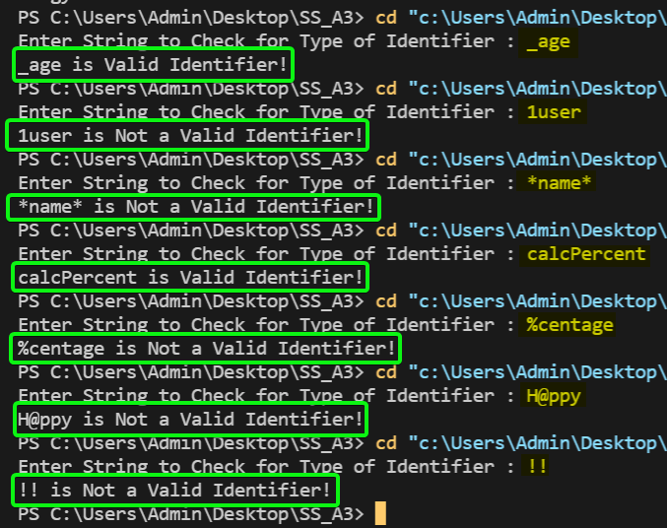

2) Write a C/C++ program to identify whether a given line is a comment or not.

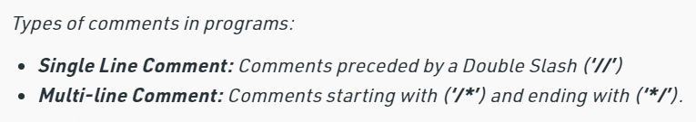

**Code:**

*#include* <bits/stdc++.h>

using namespace std;

*// U19CS012 [BHAGYA VINOD RANA]*

*// This Checks if the Given String is Valid Comment or Not*

void is_valid_comment(string line);

int main()

{

    string line;

    cout << "Enter a String to Check if it is Comment or Not : ";

    cin >> line;

    is_valid_comment(line);

*return* 0;

}

*// This Checks if the Given String is Valid Comment or Not*

void is_valid_comment(string line)

{

*if* (line.length() < 2)

    {

        cout << "It is Not a Comment!\n";

*return*;

    }

*else* *if* (line.length() == 2)

    {

*if* (line[0] == '/' && line[1] == '/')

        {

            cout << "It is a Single-line Comment!\n";

*return*;

        }

*else*

        {

            cout << "It is Not a Comment!\n";

*return*;

        }

    }

*else*

    {

*// Single Line Comment Format*

*if* (line[0] == '/' && line[1] == '/' && line[2] != '/')

        {

            cout << "It is a Single-line Comment!\n";

*return*;

        }

*// /* abcd */ Multi-Line Comment Format*

*if* ((line[0] == '/' && line[1] == '*') && (line[line.size() - 2] == '*' && line[line.size() - 1] == '/'))

        {

            cout << "It is a Multi-line Comment!\n";

*return*;

        }

        cout << "It is Not a Comment!\n";

    }

}

**Output:**

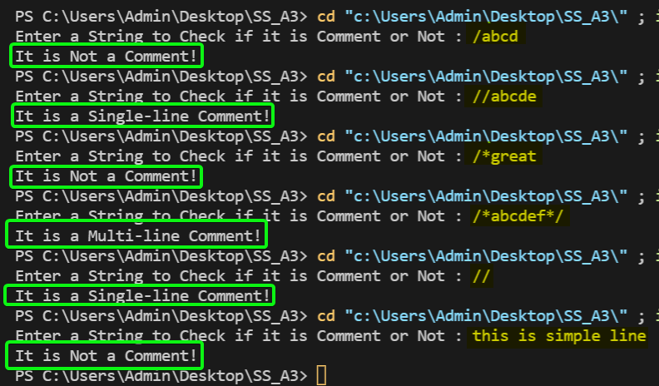

**SUBMITTED BY**: U19CS012

BHAGYA VINOD RANA