System Software (CS306) Assignment - 4

U19CS012

# 1) Write a C program to recognize strings under ‘a*’, ‘a*b+’, ‘abb’. Valid Strings

|  |  |
| --- | --- |
| **Pattern** | **Examples** |
| **a\*** | ε, a, aa, aaa, aaaa, aaaaa, ... |
| **a*b+** | b, ab, bb, abb, bbb, abbb, bbbb, abbbb, bbbbb, abbbbb, ... |
| **abb** | abb |

DFA for Regular Expression - [a*|a*b+|abb]

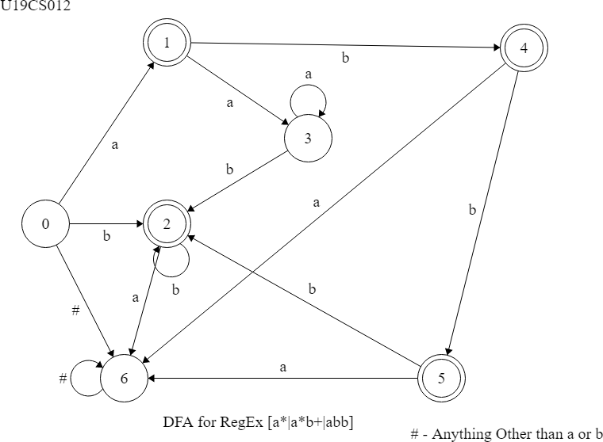

Tool Used - <https://www.cs.unc.edu/~otternes/comp455/fsm_designer/>

## Code:

*#include* <iostream>

*#include* <string>

// U19CS012 [BHAGYA VINOD RANA]

### using namespace std;

int main()

### {

string s; char c;

### int state = 0, i = 0;

cout << "Enter String : "; getline(cin, s);

### int n = s.length();

// Corner Case [For Empty String] && "aa" string acc to DFA if (n == 0)

### {

cout << "Ans : " << s << " is Accepted under RegEx [a*]\n\n";

*return* 0;

### }

// Iterate till the End of the String while (i < n)

### {

*// Check the State switch* (state)

### {

*case* 0:

### c = s[i++];

// If 'a' occurs, then Transition from State '0' to '1' if (c == 'a')

### state = 1;

// If 'b' occurs, then Transition from State '0' to '2' else if (c == 'b')

### state = 2;

else

### state = 6;

*break*; *case* 1:

### c = s[i++];

// If 'a' occurs, then Transition from State '1' to '3' if (c == 'a')

### state = 3;

// If 'b' occurs, then Transition from State '1' to '4' else if (c == 'b')

### state = 4;

else

### state = 6;

*break*; *case* 2:

### c = s[i++];

// If 'a' occurs, then Transition from State '2' to '6' if (c == 'a')

### state = 6;

// If 'b' occurs, then Transition from State '2' to '2' else if (c == 'b')

### state = 2;

else

### state = 6;

*break*; *case* 3:

### c = s[i++];

// If 'a' occurs, then Transition from State '3' to '3' if (c == 'a')

### state = 3;

// If 'b' occurs, then Transition from State '3' to '2' else if (c == 'b')

### state = 2;

else

### state = 6;

*break*; *case* 4:

### c = s[i++];

// If 'a' occurs, then Transition from State '4' to '6' if (c == 'a')

### state = 6;

// If 'b' occurs, then Transition from State '4' to '5' else if (c == 'b')

### state = 5;

else

### state = 6;

*break*; *case* 5:

### c = s[i++];

// If 'a' occurs, then Transition from State '5' to '6' if (c == 'a')

### state = 6;

// If 'b' occurs, then Transition from State '5' to '2' else if (c == 'b')

### state = 2;

else

### state = 6;

*break*; *case* 6:

// Dead State

c = s[i++];

// If 'a' occurs, then Transition from State '6' to '6' if (c == 'a')

state = 6;

// If 'b' occurs, then Transition from State '6' to '6' else if (c == 'b')

state = 6;

else

state = 6;

break;

// cout << "Invalid String Entered! [String Contains Other than letters 'a' and

'b'] \n\n";

}

}

*if* (state == 1 || state == 3)

cout << "Ans : " << s << " is Accepted under RegEx [a*]\n\n";

*else if* ((state == 2) || (state == 4))

cout << "Ans : " << s << " is Accepted under RegEx [a*b+]\n\n";

*else if* (state == 5)

cout << "Ans : " << s << " is Accepted under RegEx [abb]\n\n";

else

cout << "Ans : " << s << " is Not Accepted under Any RegEx [a*|a*b+|abb]\n\n";

*return* 0;

}

## Output:

|  |  |  |  |
| --- | --- | --- | --- |
| TestCase | Output | TestCase | Output |
| **a** | Check Tick Icon, Transparent Check Tick.PNG Images &amp; Vector - FreeIconsPNG | bbb | Check Tick Icon, Transparent Check Tick.PNG Images &amp; Vector - FreeIconsPNG |
| **aa** | Check Tick Icon, Transparent Check Tick.PNG Images &amp; Vector - FreeIconsPNG | abbb | Check Tick Icon, Transparent Check Tick.PNG Images &amp; Vector - FreeIconsPNG |
| **ε** | Check Tick Icon, Transparent Check Tick.PNG Images &amp; Vector - FreeIconsPNG | bba | https://banner2.cleanpng.com/20180326/rle/kisspng-x-mark-drawing-red-check-mark-cross-5ab88d63d7dd76.4974117815220442598842.jpg |
| **b** | Check Tick Icon, Transparent Check Tick.PNG Images &amp; Vector - FreeIconsPNG | bab | https://banner2.cleanpng.com/20180326/rle/kisspng-x-mark-drawing-red-check-mark-cross-5ab88d63d7dd76.4974117815220442598842.jpg |
| **ab** | Check Tick Icon, Transparent Check Tick.PNG Images &amp; Vector - FreeIconsPNG | baab | https://banner2.cleanpng.com/20180326/rle/kisspng-x-mark-drawing-red-check-mark-cross-5ab88d63d7dd76.4974117815220442598842.jpg |
| **bb** | Check Tick Icon, Transparent Check Tick.PNG Images &amp; Vector - FreeIconsPNG | abab | https://banner2.cleanpng.com/20180326/rle/kisspng-x-mark-drawing-red-check-mark-cross-5ab88d63d7dd76.4974117815220442598842.jpg |
| **abb** | Check Tick Icon, Transparent Check Tick.PNG Images &amp; Vector - FreeIconsPNG | aaaabbbba | https://banner2.cleanpng.com/20180326/rle/kisspng-x-mark-drawing-red-check-mark-cross-5ab88d63d7dd76.4974117815220442598842.jpg |

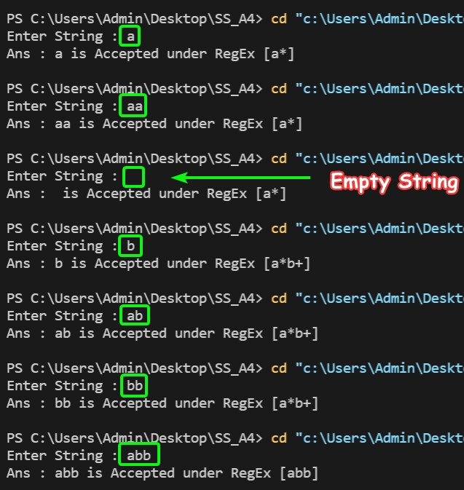

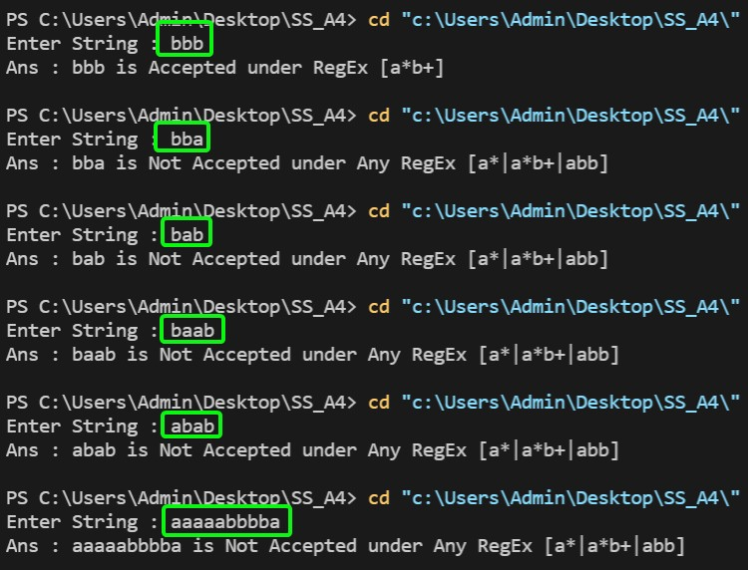

**SUBMITTED BY**: U19CS012

BHAGYA VINOD RANA