System Software (CS306)

Assignment - 7

**U19CS012**

1.) Generate Macro Definition Table(MDT) for given macro definition:

MACRO

CLEARMEM &X, &N, &REG=AREG

LCL &M

&M SET 0

MOVER &REG, ='0'

.MORE MOVEM &REG, &X + &M

&M SET &M+1

IAF (&M NE N) .MORE

MEND

**Code**

*#include* <stdio.h>

*#include* <string.h>

*#include* <stdlib.h>

*#include* <ctype.h>

*// Data Structure for MACRO Generation*

typedef struct MNT

{

    char name[20];

    int pp;

    int kp;

    int ev;

    int mdtp;

    int kpdtp;

    int sstp;

} MNT;

typedef struct MDT

{

    int index;

    char label[20];

    char opcode[20];

    char operands[100];

} MDT;

typedef struct EVNTAB

{

    int index;

    char name[20];

} EVNTAB;

typedef struct SSNTAB

{

    int index;

    char name[20];

} SSNTAB;

typedef struct PNTAB

{

    int index;

    char name[20];

} PNTAB;

typedef struct KPDTAB

{

    int index;

    char name[20];

    char default_value[20];

} KPDTAB;

MNT mnt[10];

MDT mdtable[20];

EVNTAB evntab[20];

SSNTAB ssntab[20];

PNTAB pntab[20];

KPDTAB kpdtab[20];

*// Check if Sequencing Symbol Exist? [If Yes, Return its Index Otherwise Return -1]*

int get_SS_idx(char *ss);

*// Check if Expansion Variable Exist? [If Yes, Return its Index Otherwise Return -1]*

int get_EV_idx(char *ev);

*// Check if Parameter Exist? [If Yes, Return its Index Otherwise Return -1]*

int get_Parameter_idx(char *p);

*// Filter the Input Buffer*

int filter_inp(char *name, char *buffer, int i);

*// Intial Values of All Tables Counter*

int mntc = 0, mdtc = 0, evntc = 0, ssntc = 0, pntc = 0, kpdtc = 0;

*// Based on Instruction, Updates the Tables*

void update_tables(char *buffer);

void main()

{

    FILE *in, *mdt;

    in = fopen("input.txt", "r");

    char buffer[250];

*while* (fgets(buffer, 250, in))

    {

*// Start of MACRO Detected*

*if* (strstr(buffer, "MACRO"))

        {

            fgets(buffer, 250, in);

            strcpy(mnt[mntc].name, strtok(buffer, " "));

            mnt[mntc].mdtp = mdtc;

            mnt[mntc].kpdtp = kpdtc;

            mnt[mntc].sstp = ssntc;

            char *temp;

*while* (temp = strtok(NULL, ", "))

            {

                char *param;

*if* (param = strchr(temp, '='))

                {

                    mnt[mntc].kp++;

*// Update the Keyword Parameter Default Table*

                    strcpy(kpdtab[kpdtc].default_value, param + 1);

                    strncpy(kpdtab[kpdtc].name, temp + 1, strlen(temp) - strlen(param) - 1);

                    kpdtab[kpdtc].name[strlen(temp) - strlen(param) - 1] = '\0';

                    kpdtab[kpdtc].index = kpdtc;

*// Update the Parameter Table*

                    strcpy(pntab[pntc].name, kpdtab[kpdtc].name);

                    pntab[pntc].index = pntc;

                    kpdtc++;

                    pntc++;

                }

*else*

                {

                    mnt[mntc].pp++;

*// Update the Paramater Table*

                    strcpy(pntab[pntc].name, temp + 1);

                    pntab[pntc].index = pntc;

                    pntc++;

                }

            }

            mntc++;

*while* (fgets(buffer, 250, in))

            {

*// End of Macro Detected -> Exit from this Loop*

*if* (strstr(buffer, "MEND"))

                {

                    strcpy(mdtable[mdtc].opcode, "MEND");

*// Update the Macro Defination Table*

                    mdtable[mdtc].index = mdtc;

                    mdtc++;

*break*;

                }

                update_tables(buffer);

            }

        }

    }

    fclose(in);

*// Print the Final Results*

*// Macro Name Table*

    printf("\nMNT (Macro Name Table)\n");

    printf("Name\t\t#PP\t#KP\t#EV\t#MDTP\t#KPDTP\t#SSTP\n");

*for* (int i = 0; i < mntc; i++)

    {

        printf("%s\t%d\t%d\t%d\t%d\t%d\t%d\n", mnt[i].name, mnt[i].pp, mnt[i].kp, mnt[i].ev, mnt[i].mdtp, mnt[i].kpdtp, mnt[i].sstp);

    }

*// Parameter Name Table*

    printf("\nPNTAB (Parameter Name Table)\n");

    printf("Sr. No\tName\n");

*for* (int i = 0; i < pntc; i++)

    {

        printf("%d\t%s\n", pntab[i].index, pntab[i].name);

    }

*// Expansion Time Variable Name Table*

    printf("\nEVNTAB (Expansion Time Variable Name Table)\n");

    printf("Index\tName\n");

*for* (int i = 0; i < evntc; i++)

    {

        printf("%d\t%s\n", evntab[i].index, evntab[i].name);

    }

*// Sequencing Symbol Table*

    printf("\nSSNTAB (Sequencing Symbol Name Table)\n");

    printf("Index\tSS Name\n");

*for* (int i = 0; i < ssntc; i++)

    {

        printf("%d\t%s\n", ssntab[i].index, ssntab[i].name);

    }

*// Keyword Parameter Default Value Table*

    printf("\nKPDTAB (Keyword Parameter Default Value Table)\n");

    printf("Index\tParamter Name\tDefault Value\n");

*for* (int i = 0; i < kpdtc; i++)

    {

        printf("%d\t%s\t\t%s\n", kpdtab[i].index, kpdtab[i].name, kpdtab[i].default_value);

    }

*// Macro Definition Table*

    printf("\nMDTABLE (Macro Definition Table)\n");

    printf("Sr. No\tLabel\tOpcode\tOperands\n");

*for* (int i = 0; i < mdtc; i++)

    {

        printf("%d\t%s\t%s\t%s\n", mdtable[i].index, mdtable[i].label, mdtable[i].opcode, mdtable[i].operands);

    }

}

*// Check if Sequencing Symbol Exist? [If Yes, Return its Index Otherwise Return -1]*

int get_SS_idx(char *ss)

{

*for* (int i = 0; i < 20; i++)

    {

*if* (strcmp(ssntab[i].name, ss) == 0)

*return* i;

    }

*return* -1;

}

*// Check if Expansion Variable Exist? [If Yes, Return its Index Otherwise Return -1]*

int get_EV_idx(char *ev)

{

*for* (int i = 0; i < 20; i++)

    {

*if* (strcmp(evntab[i].name, ev) == 0)

*return* i;

    }

*return* -1;

}

*// Check if Parameter Exist? [If Yes, Return its Index Otherwise Return -1]*

int get_Parameter_idx(char *p)

{

    int i;

*for* (i = 0; i < 20; i++)

    {

*if* (strcmp(pntab[i].name, p) == 0)

*return* i;

    }

*return* -1;

}

*// Filter the Input Buffer*

int filter_inp(char *name, char *buffer, int i)

{

    int j = i;

*if* (buffer[i] == '.')

        j++;

*while* (isalpha(buffer[j]))

        j++;

    strncpy(name, buffer + i, j - i);

    name[j - i] = '\0';

*return* j;

}

*// Based on Instruction, Updates the Tables*

void update_tables(char *buffer)

{

    char label[20], opcode[20], operands[100], temp[20];

*// Tokenise the Input via " " [SPACE]*

    strcpy(label, strtok(buffer, " "));

*// If Input is "." -> Sequencing Symbol & Macro Name Table to be Updated*

*if* (label[0] == '.')

    {

        ssntab[ssntc].index = ssntc;

        strcpy(ssntab[ssntc].name, label);

        sprintf(mdtable[mdtc].label, "(S, %d)", ssntc);

        ssntc++;

        strcpy(opcode, strtok(NULL, " "));

    }

*// If Input is "&" -> Macro Defination Table to be Updated*

*else* *if* (label[0] == '&')

    {

        int ev = get_EV_idx(label + 1);

        sprintf(mdtable[mdtc].label, "(E, %d)", ev);

        strcpy(opcode, strtok(NULL, " "));

    }

*else*

    {

        strcpy(opcode, label);

        strcpy(mdtable[mdtc].label, "");

    }

    strcpy(mdtable[mdtc].opcode, opcode);

    strcpy(operands, strtok(NULL, ""));

    operands[strlen(operands) - 1] = '\0';

*// LCL -> Local EV & GBL -> Global EV {Event Table to be Updated}*

*if* (strcmp(opcode, "LCL") == 0 || strcmp(opcode, "GBL") == 0)

    {

        evntab[evntc].index = evntc;

        strcpy(evntab[evntc].name, operands + 1);

        sprintf(mdtable[mdtc].operands, "(E, %d)", evntc);

        evntc++;

    }

*else*

    {

        int i = 0;

*while* (operands[i] != '\0')

        {

*if* (operands[i] == '&')

            {

                i = filter_inp(temp, operands, i + 1);

                int param = get_Parameter_idx(temp);

                int ev = get_EV_idx(temp);

*if* (param >= 0)

                {

                    sprintf(temp, "(P, %d)", param);

                    strcat(mdtable[mdtc].operands, temp);

                }

*else* *if* (ev >= 0)

                {

                    sprintf(temp, "(E, %d)", ev);

                    strcat(mdtable[mdtc].operands, temp);

                }

*else*

                {

                    strcat(mdtable[mdtc].operands, temp);

                }

            }

*else* *if* (operands[i] == '.')

            {

                i = filter_inp(temp, operands, i);

                int ss = get_SS_idx(temp);

                sprintf(temp, "(S, %d)", ss);

                strcat(mdtable[mdtc].operands, temp);

            }

*else*

            {

                sprintf(mdtable[mdtc].operands, "%s%c", mdtable[mdtc].operands, operands[i++]);

            }

        }

    }

    mdtable[mdtc].index = mdtc;

    mdtc++;

}

**Output**

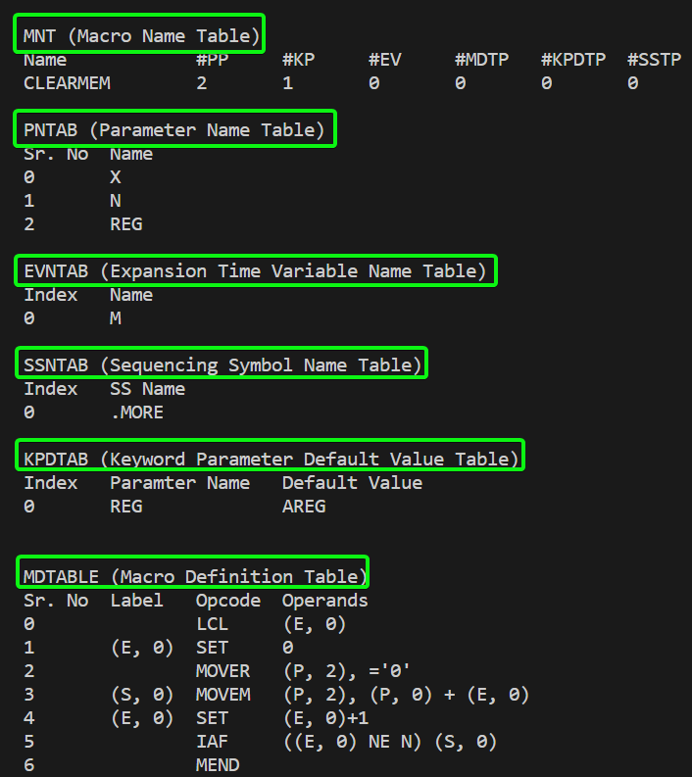

**SUBMITTED BY**: U19CS012

BHAGYA VINOD RANA