System Software (CS306)

Assignment - 8

**U19CS012**

1.) Write a LEX Program to **Count** the Number of **Lines**, **Characters** and **Words** of the given **Input File**.

**Lex File**

%{

*#include*<stdio.h>

    int wcount=0;

    int lcount=0;

    int ccount=0;

%}

digit[0-9]

letter[a-zA-Z]

**%%**

\n  {lcount++;}

({letter}|{digit})+  {wcount++; ccount+=yyleng;}

[ ] ccount++;

**%%**

int main(){

    yyin=fopen("input.txt","r");

    yylex();

    printf("\ntotal word count:%d\n",wcount);

    printf("total line count:%d\n",lcount);

    printf("total character count:%d\n",ccount);

*return* 0;

}

**Output**

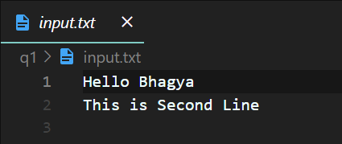

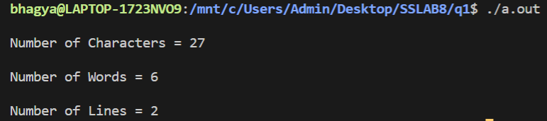

2.) Write a LEX Program to find out the Total number of **Vowels** and **Consonants** from the Given Input string.

**Lex File**

%{

    int vowel=0;

    int consonants=0;

%}

vowel[aeiouAEIOU]

consonant[b-df-hj-np-tv-zB-DF-HJ-NP-TV-Z]

**%%**

{vowel} {vowel++;}

{consonant} {consonants++;}

**%%**

int main(){

    yylex();

    printf("Total vowels:%d \nTotal consonants: %d\n",vowel,(consonants));

*return* 0;

}

**Output**

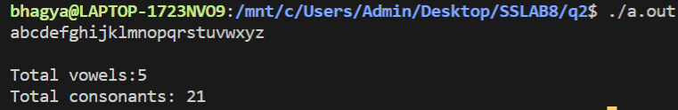

3.) Write a LEX Program to convert **Lowercase** string to **Uppercase**.

**Input**: abc

**Output**: ABC

**Lex File**

%{

*#include*<stdio.h>

%}

lower[a-z]

upper[A-Z]

**%%**

{lower} { printf("%c",yytext[0]-32);}

{upper} {printf("%c",yytext[0]);}

. {printf("%c",yytext[0]);}

**%%**

int main(){

    yylex();

*return* 0;

}

**Output**

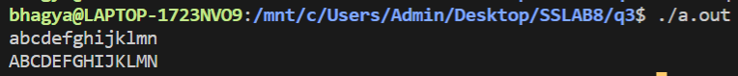

4.) Write a Lex program to check **Valid/Invalid**

1. **Mobile Number** (considering 10-digit mobile number followed by country code +91)

**Lex File**

**%%**

[+][0-9]{1,3}[1-9][0-9]{9} {printf("\nMobile Number Valid\n");}

.+ {printf("\nMobile Number Invalid\n");}

**%%**

int main(){

    yylex();

*return* 0;

}

**Output**

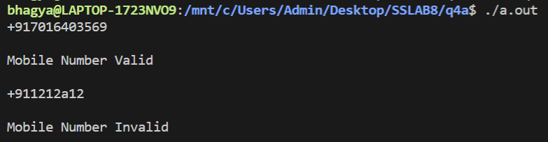

1. Email address

**Lex File**

**%%**

[a-zA-Z_.0-9]+[@][a-zA-Z.]+[.][a-zA-Z]+ {printf("\n Valid Email\n");}

.+ {printf("\nInvalid Email\n");}

**%%**

int main(){

    yylex();

*return* 0;

}

**Output**

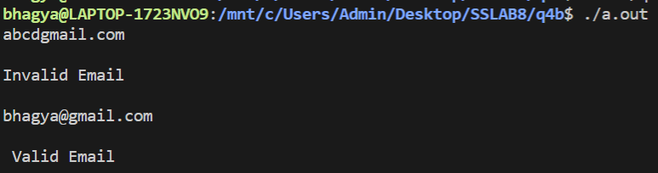

5. Write a **LEX** program to Implement a **Simple** **Calculator**.

**Lex File**

%{

*#include*<math.h>

    int op=0,i;

    double a,b;

    void calculate();

%}

number [0-9]+|([0-9]*)"."([0-9]*)

pow "^"

**%%**

\+ {op=1;}

[-] {op=2;}

[*] {op=3;}

[/] {op=4;}

{pow} {op=5;}

\n { printf("answer=%f\n",a);}

{number}  {calculate();}

**%%**

void calculate(){

*if*(op==0){

        a=atof(yytext);

    }

*else*{

        b=atof(yytext);

*switch*(op){

*case* 1: a=a+b;

*break*;

*case* 2: a=a-b;

*break*;

*case* 3: a=a*b;

*break*;

*case* 4: a=a/b;

*break*;

*case* 5: *for*(i=a;b>1;b--){

                    a=a*i;

            }

*break*;

        }

        op=0;

    }

}

int main(){

    yylex();

*return* 0;

}

**Output**

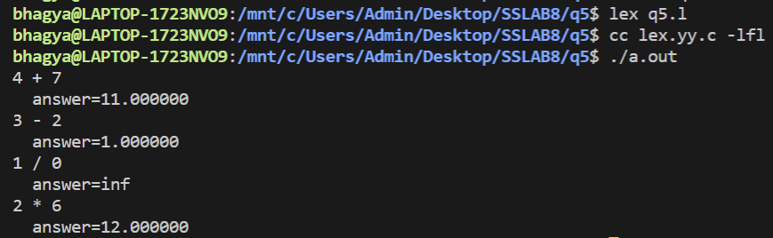

Harder Test Cases

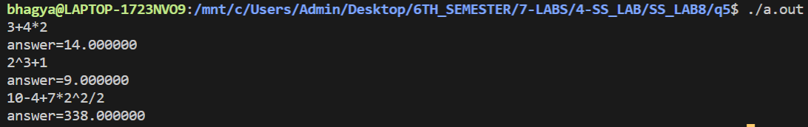

**SUBMITTED BY**: U19CS012

BHAGYA VINOD RANA