System Software (CS306)

Assignment - 9

**U19CS012**

1.) Write a LEX program to Identify **Identifiers**, **Constants** and **Keywords** (*int, float*) used in **C/C++** from a given Input File.

**Lex File**

%{

%}

alphabet [a-zA-Z]

digit [0-9]

**%%**

asm|double|new|switch|auto|else|operator|template|break|enum|private|this|case|extern|protected|throw|catch|float|public|try|char|for|register|typedef|class|friend|return|union|const|goto|short|unsigned|continue|if|signed|virtual|default|inline|sizeof|void|delete|int|static|volatile|do|long|struct|while { printf("%s is Reserved Keyword (C/C++)!\n",yytext);}

([_]|({alphabet}))([_]|({alphabet})|({digit}))* { printf("%s is Valid Identifier!\n",yytext);}

({digit})+|(({digit})+[.]({digit})+) { printf("%s is Valid Constant!\n",yytext);}

["](.)*["] {printf("%s is String Constant!\n",yytext);}

[']({alphabet})*['] {printf("%s is String Constant!\n",yytext);}

**%%**

int main()

{

    yyin=fopen("input.txt","r");

    yylex();

*return* 0;

}

**Output**

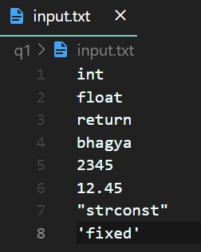

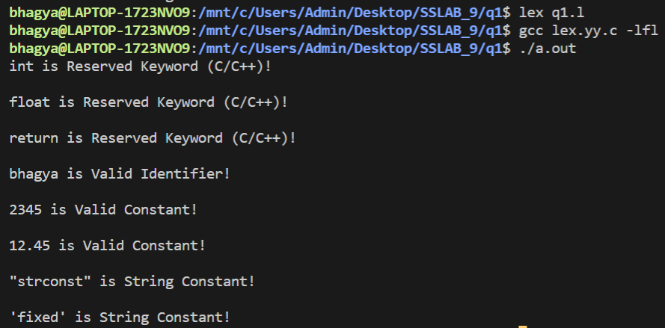

2.) Write a LEX Program to find **Octal** and **Hexadecimal** numbers.

**Lex File**

%{

%}

octal [0-7]

hex [0-9A-Fa-f]

**%%**

({octal})+ {printf("%s is Octal Number [Also a Hexa-Decimal Number]!\n",yytext);}

({hex})+ {printf("%s is Hexa-Decimal Number!\n",yytext);}

**%%**

int main()

{

    yyin=fopen("input.txt","r");

    yylex();

*return* 0;

}

**Output**

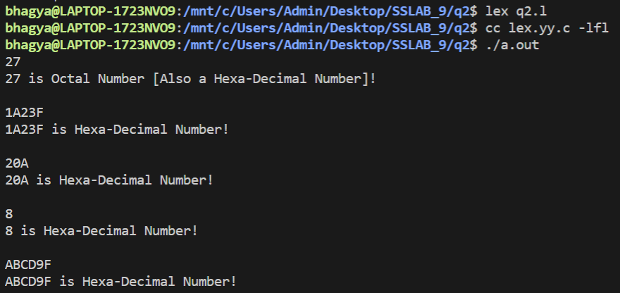

3. Write a LEX Program to **Count** and Display Single line and Multiline comments.

**Lex File**

%{

int single = 0;

int multi = 0;

%}

**%%**

\/\/(.*) {printf("Single Line Comment!\n");single++;}

"/*"([^*]|\*+[^*/])*\*+"/" {printf("Multi Line Comment!\n");multi++;}

**%%**

int main()

{

    yyin=fopen("input.txt","r");

    yylex();

    printf("Number of Single Line Comments : %d\n",single);

    printf("Number of Multi Line Comments : %d\n",multi);

*return* 0;

}

**Output**

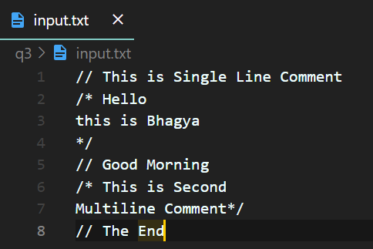

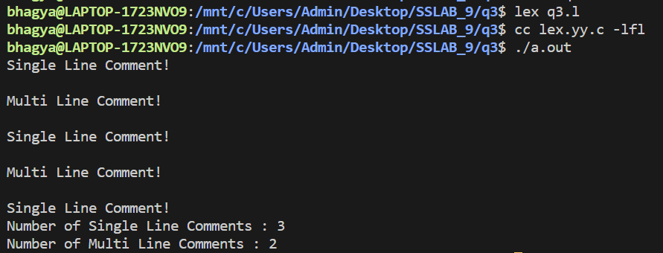

4.) Write a LEX Program to **Count** no of Negative, Positive and Zero numbers.

**Lex File**

%{

int neg = 0;

int zero = 0;

int pos=0;

%}

**%%**

[0]+ {printf("Zero Number : %s",yytext);zero++;}

^[1-9][0-9]* {printf("Positive Number : %s",yytext);pos++;}

[-][0-9]+ {printf("Negative Number : %s",yytext);neg++;}

**%%**

int main()

{

    yyin=fopen("input.txt","r");

    yylex();

    printf("\nNumber of Positive Numbers : %d\n",pos);

    printf("Number of Zero's : %d\n",zero);

    printf("Number of Negative Numbers : %d\n",pos);

*return* 0;

}

**Output**

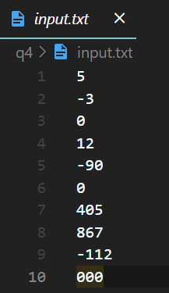

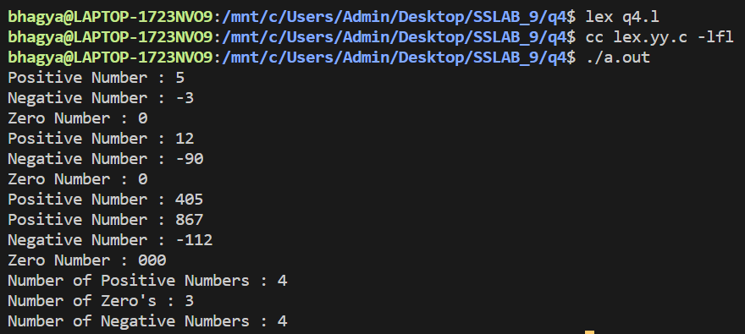

5.) Write a LEX Program to Accept **Strings** that start with **aa** and end with **bcd**.

**Lex File**

%{

int cnt=0;

%}

**%%**

(aa).*(bcd) {printf("%s : Match Found!",yytext);cnt++;}

**%%**

int main()

{

    yyin=fopen("input.txt","r");

    yylex();

    printf("\nNumber of Strings Starting with aa & Ending with bcd are : %d\n",cnt);

*return* 0;

}

**Output**

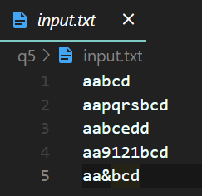

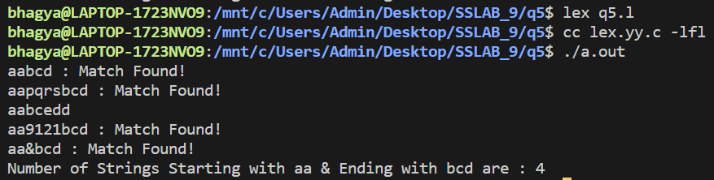

**SUBMITTED BY**: U19CS012

BHAGYA VINOD RANA