PROJECT REPORT OF COOP II
ON
DevSphere
submitted in partial fulfilment of the requirements for the award of degree of

BACHELOR OF ENGINEERING
In
COMPUTER SCIENCE AND ENGINEERING
Submitted by: Supervised By:
Bhagya Sharma Prof. Dr. Darpan Anand
2210990210

DEPARTMENT OF COMPUTER SCIENCE AND ENGINEERING
CHITKARA UNIVERSITY
CHANDIGARH-PATIALA NATIONAL HIGHWAY, RAJPURA, PUNJAB, INDIA

CONTENTS

S.No. | Title | Page No.
 | Declaration | 1
 | List of Figures and Tables | 2
 | Abstract | 3
1 | Introduction | 4
2 | System Requirements | 4
2 | Methodology | 5
3 | Software Design (architecture/UML/DFD/UI-UX whichever is relevant to your project ) | 6-7
4 | Implementation Details (Frameworks, APIs/Core logic /code snippets/Database design and schema) | 8
5 | Testing and Validation | 8
6 | Major Findings/Outcomes/Output/Results | 9
7 | Conclusion and Future Scope | 10
 | References | 10
 | Appendices

DECLARATION

I hereby declare that the project work titled, Devsphere submitted as part of Bachelor’s degree in CSE, at Chitkara University, Punjab, is an authentic record of our own work carried out under the supervision of Prof. Dr. Darpan Anand

Signature(s):
Bhagya Sharma

ABSTRACT

Devsphere is a unified developer-centric web platform designed to streamline how developers present their technical work and how it is evaluated by recruiters and collaborators. In the existing ecosystem, developers rely on multiple platforms such as GitHub for source code, blogging platforms for technical writing, and deployment services like Vercel for hosting applications. This fragmentation leads to inefficiencies in managing a cohesive professional identity and makes it difficult to assess a developer’s complete capabilities in a structured manner.

The proposed system integrates GitHub-based authentication, automated profile data extraction, blog creation, project showcasing, and live deployment previews into a single platform. By leveraging GitHub OAuth, Devsphere ensures secure authentication and verified identity while simplifying onboarding. The system fetches relevant user data and repositories, allowing developers to present their work without redundant manual effort. Additionally, integration with deployment platforms enables live previews of applications, enhancing interactivity and usability.

The platform is built using modern web technologies including Next.js, React, TypeScript, and Tailwind CSS, with backend logic handled through server-side rendering and APIs. The expected outcome is a scalable, user-friendly system that improves developer visibility, reduces fragmentation, and provides a structured approach to portfolio management.

- Introduction
In the digital era, developers are increasingly required to maintain an online presence that reflects their technical expertise, project experience, and problem-solving capabilities. However, the current landscape is highly fragmented, with different platforms serving isolated purposes. GitHub is widely used for version control and code hosting, blogging platforms are used for sharing knowledge, and deployment services host live applications. While each of these platforms is effective individually, they lack integration, resulting in a scattered representation of a developer’s work.
Devsphere addresses this issue by offering a centralized solution that combines these functionalities into a unified interface. The platform not only simplifies portfolio creation but also enhances discoverability and evaluation by providing a comprehensive view of a developer’s profile, projects, and live demonstrations.

2. System Requirements

2.1 Functional Requirements

- User authentication via GitHub OAuth
- Fetch and display GitHub profile data
- Create, edit, and publish blog posts
- Showcase projects with repository links
- Display live deployment previews
- Manage user profile data
- 3.2 Non-Functional Requirements
- Scalability to support multiple users
- Responsive UI for different devices
- Secure handling of authentication tokens
- Efficient data fetching and caching
- High availability and performance

3. Methodology

The development of Devsphere follows a modular and iterative approach. The project is divided into multiple stages, each focusing on a specific functionality. Initially, the authentication system is implemented using GitHub OAuth to ensure secure user access. This is followed by integration with the GitHub API to fetch user data and repositories.
The system then incorporates a blog management module, allowing users to create and publish content. Project showcasing is implemented by mapping GitHub repositories to structured project cards. Finally, live deployment previews are integrated using Vercel URLs embedded within the platform.
This step-by-step approach ensures that each module is independently functional and can be tested before integration into the overall system.

4. Software Design

4.1 System Architecture
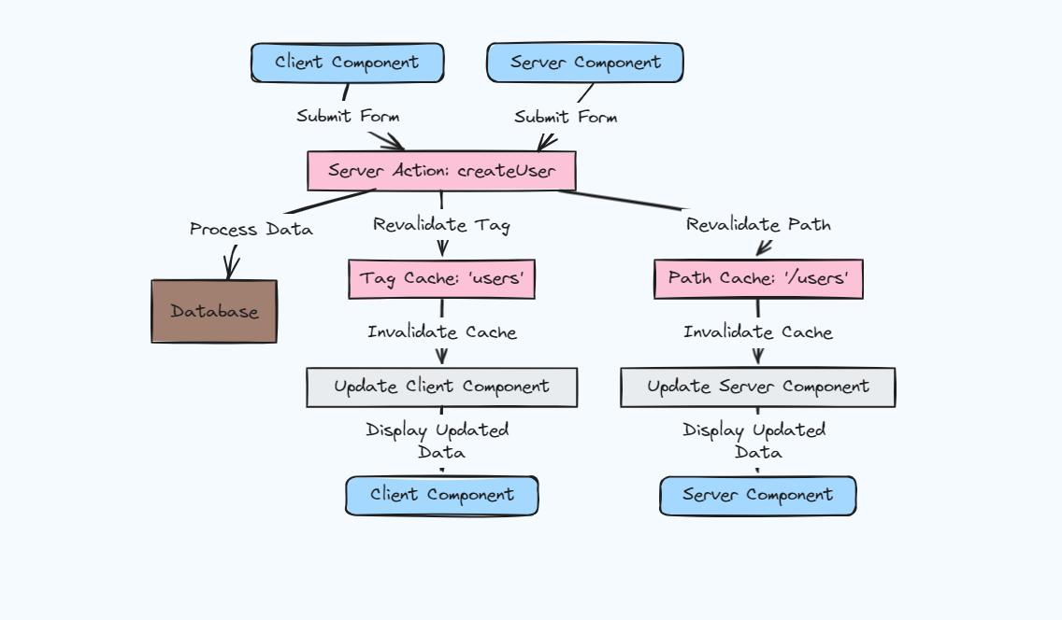

The system follows a full-stack architecture using Next.js, where both frontend and backend logic are handled within a single framework.

4.2 UI/UX Design

The user interface is designed to be minimal, intuitive, and developer-friendly. Key design principles include:
- Clean layout with clear navigation
- Responsive components
- Consistent styling using Tailwind CSS
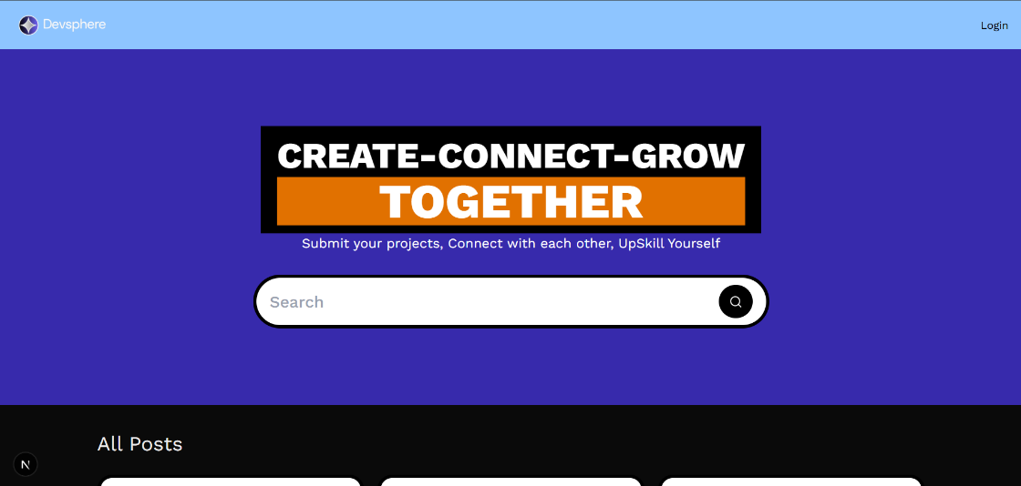
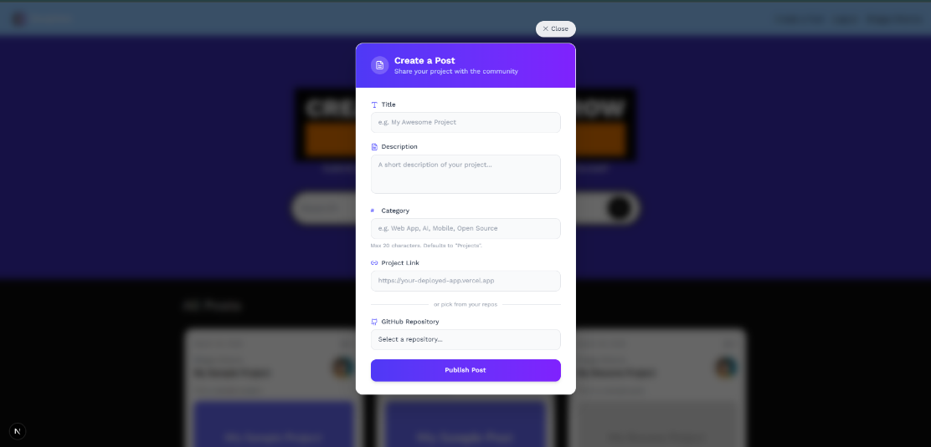

5. Implementation Details

5.1 Frameworks and Tools

- Next.js (Frontend + Backend)
- React (UI Components)
- TypeScript (Type Safety)
- Tailwind CSS (Styling)

5.2 APIs Used

- GitHub API (User and repository data)
- Vercel (Live deployment URLs)

5.3 Core Logic

- OAuth-based authentication flow
- Server-side data fetching
- Database storage for user and project data
- Rendering project previews using iframe

5.4 Database Design

Entities include:
- User
- Blog
- Project
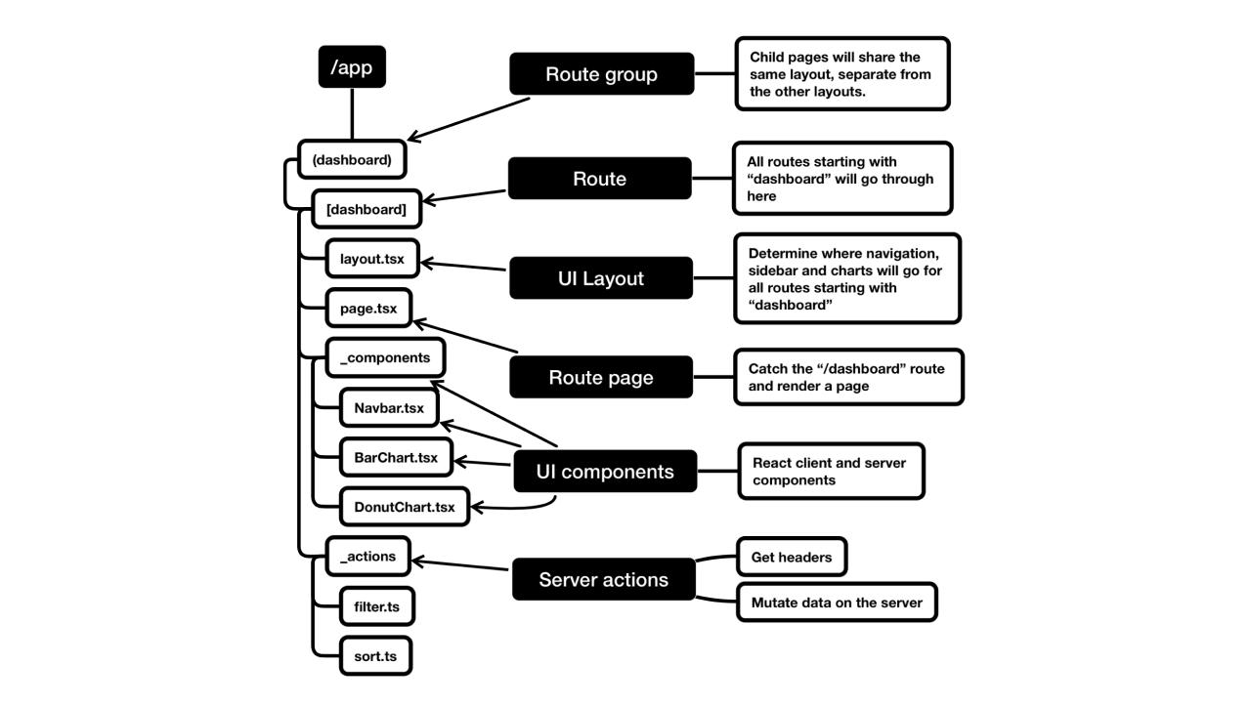

6. Testing and Validation

The system is tested across multiple stages:

- Unit Testing: Individual components tested independently
- Integration Testing: Interaction between modules verified
- UI Testing: Ensures responsiveness and usability
- API Testing: Validates GitHub data fetching
The application is also tested for edge cases such as invalid URLs, authentication failures, and missing data.

7. Major Findings / Results

The system successfully:

- Authenticates users via GitHub
- Fetches and displays profile data
- Enables blog creation
- Showcases projects
- Displays live deployed applications
The integration of live previews significantly enhances user interaction compared to traditional portfolio platforms.

8. Conclusion and Future Scope

Devsphere effectively addresses the problem of fragmented developer presence by integrating multiple functionalities into a single platform. It simplifies portfolio management and enhances visibility for developers.
Future Scope
- AI-based recommendations
- Developer networking features
- Advanced analytics
- Integration with more platforms

9. References

- GitHub REST API Documentation – https://docs.github.com/en/rest
- Vercel Documentation – https://vercel.com/docs
- Next.js Official Documentation – https://nextjs.org/docs
- React Official Documentation – https://react.dev
- Auth.js (NextAuth) Documentation – https://authjs.dev
- Prisma ORM Documentation – https://www.prisma.io/docs
- Tailwind CSS Documentation – https://tailwindcss.com/docs
- Sanity CMS Documentation – https://www.sanity.io/docs

