## Practical 05 – Activity 05

Bhagya Wijeratne  
15219

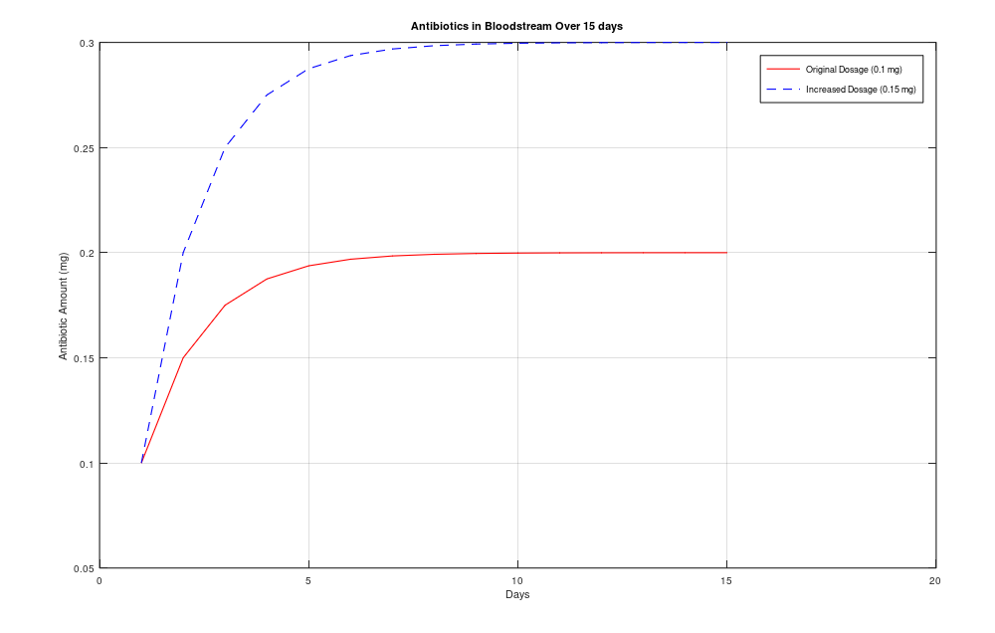

## Octave code

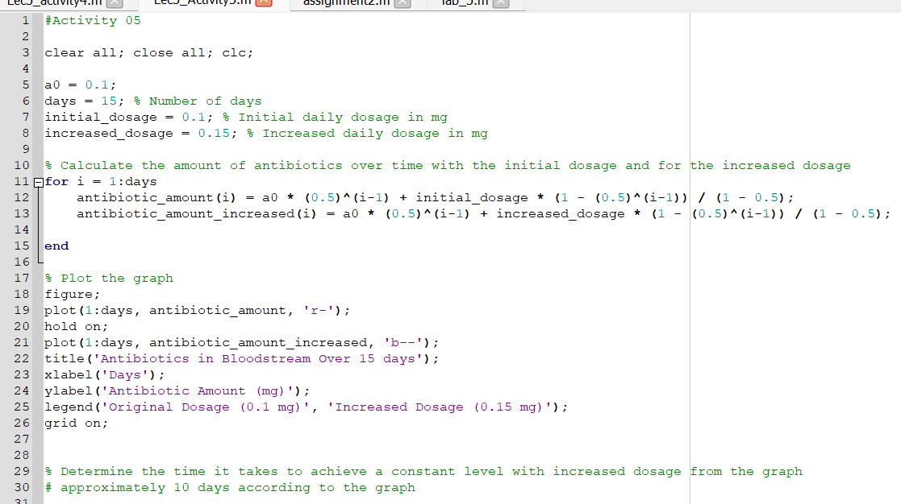

The time it takes to achieve a constant level with increased dosage from the graph  
Approximately 10 days according to the graph