Introducing a Productivity Tracking App
Project Proposal



- Submitted by:
Team 1 - Syntax Squad

- Date of submission: 17.09.2023

- Supervised by:
Lecturer Dhananjaya Perera

Introduction

As a result of the modernization of the world, human life has become increasingly complicated. It has now become a challenging obstacle for many individuals to identify their priorities, plan their day-to-day lives, and maintain the balance between the financial, professional, and personal conditions of their lives. Therefore, productive time and task management have become significantly important to extract the maximum use of human life. So, this project aims to create a user-friendly web/mobile application that enables individuals and businesses to monitor, manage, and optimize their daily activities for improved productivity. By providing insights into time allocation, task completion, and goal attainment, this project aims to enhance personal and professional efficiency.

Objectives

Our group intends to produce an app containing options mainly for time management, task prioritization, goal setting, reminders, and progress visualization. Therefore, the following features would be displayed in the applet.

- Login Page
- Calendar
- To do list
- Expense tracker
- Journal
- Study tracker feature
- Add custom project
- Edit profile feature

Methodology

JAVA object-oriented programming language is being used in the implementation process conducted by the group members following the identification of the app using UML Class diagram, Use case diagram, and an Activity diagram. References and tutorials on the internet such as Tutorialspoint, JAVApoint, GeeksforGeeks will be used as the resources for guidance throughout the project. The project will encompass the following deliverables:

- Fully functional web/mobile applications with user registration and authentication.
- Task input and management functionality with the ability to set deadlines and priorities.
- Data visualization features such as charts and graphs displaying productivity metrics.

Relevant UML Diagrams

- Use case diagram for the system

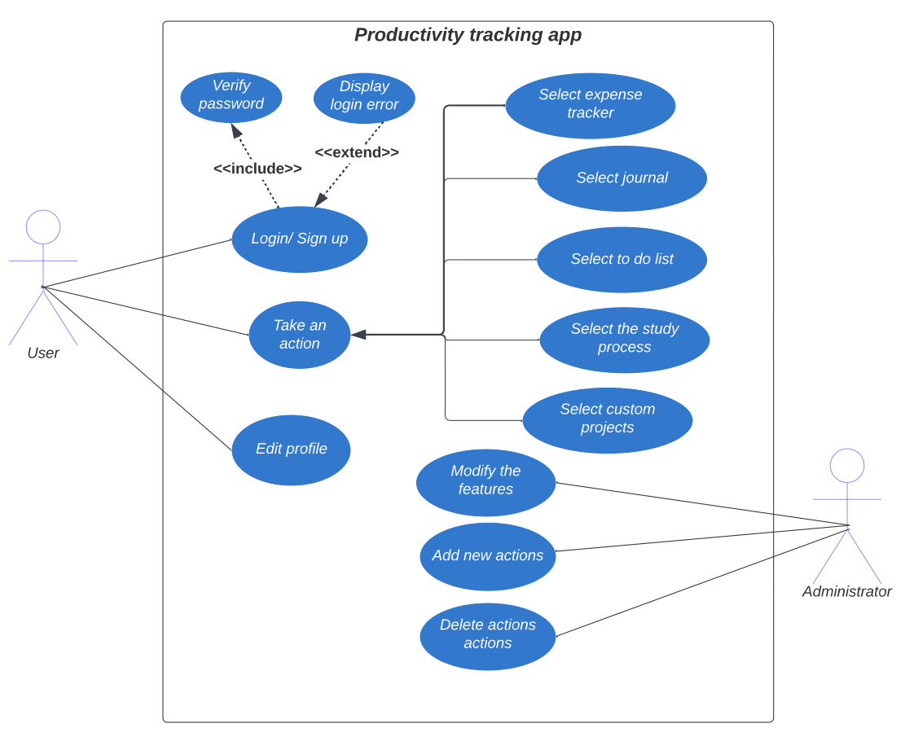

- Flowchart for login and sign up process

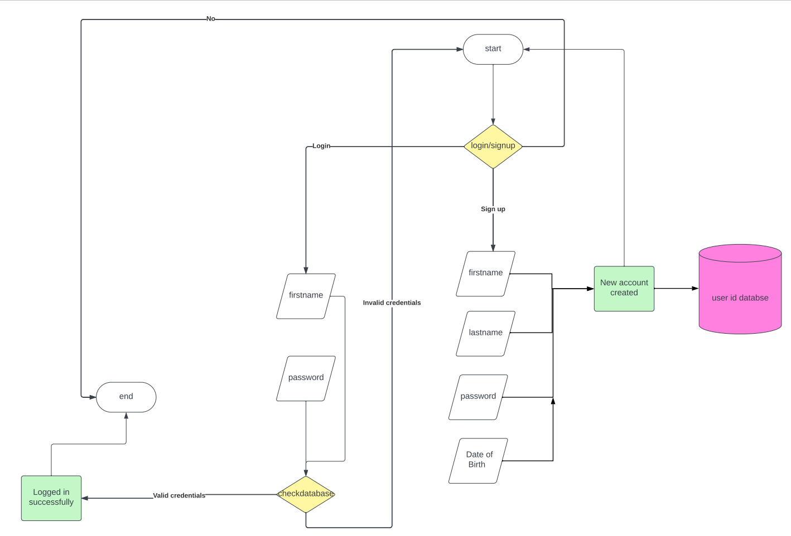

- Flowchart for main menu operations
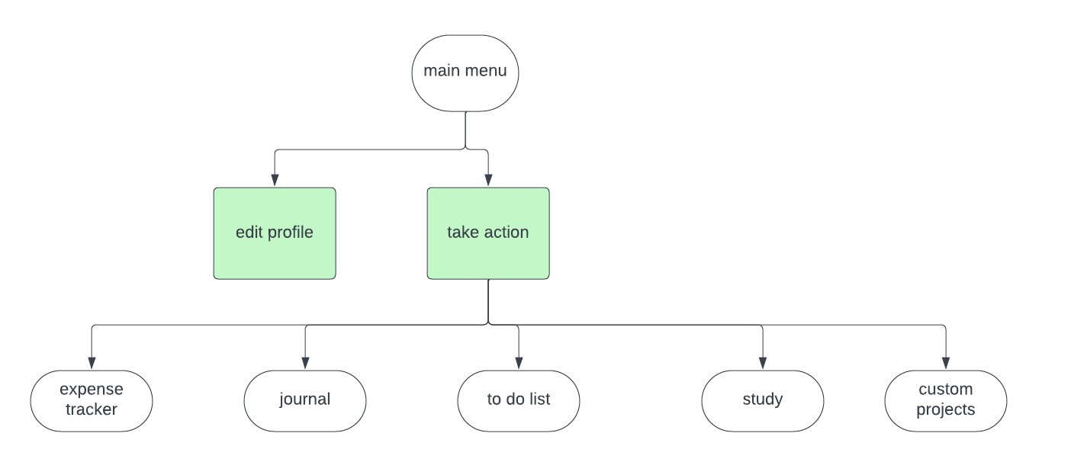
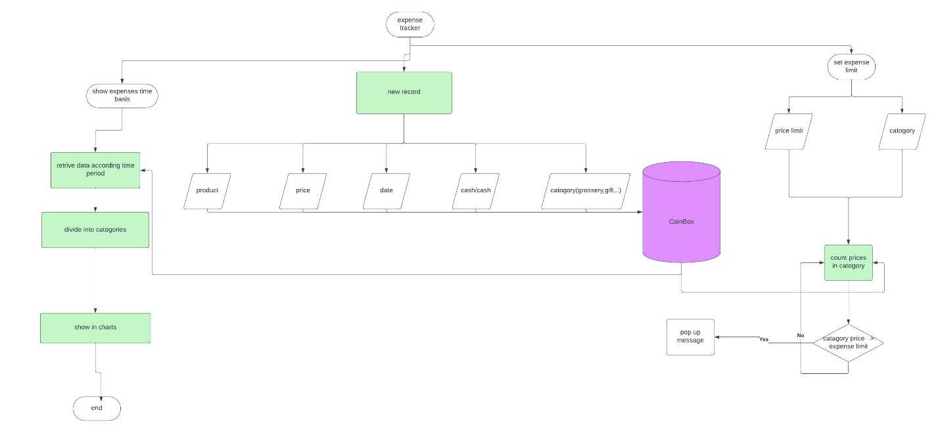
- Flowchart for the expense tracker functionality

- Flowchart for the journal functionality

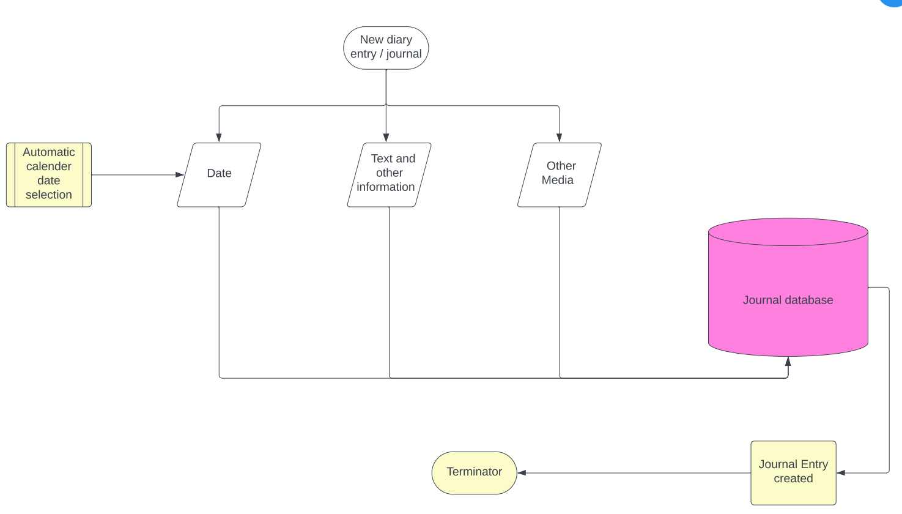

- Flowchart for the To do list functionality

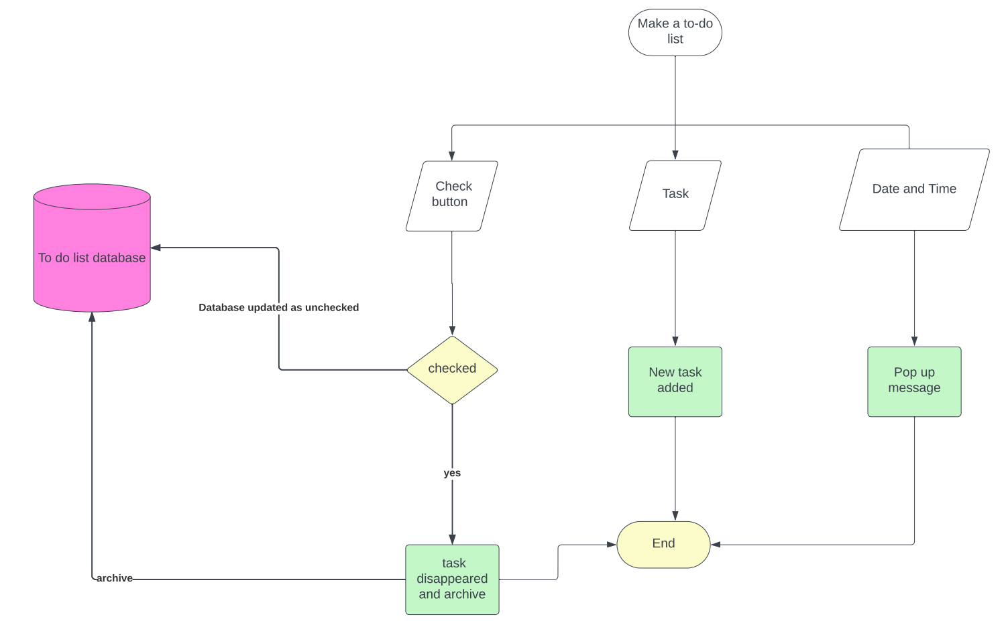

- Flowchart for the study process functionality
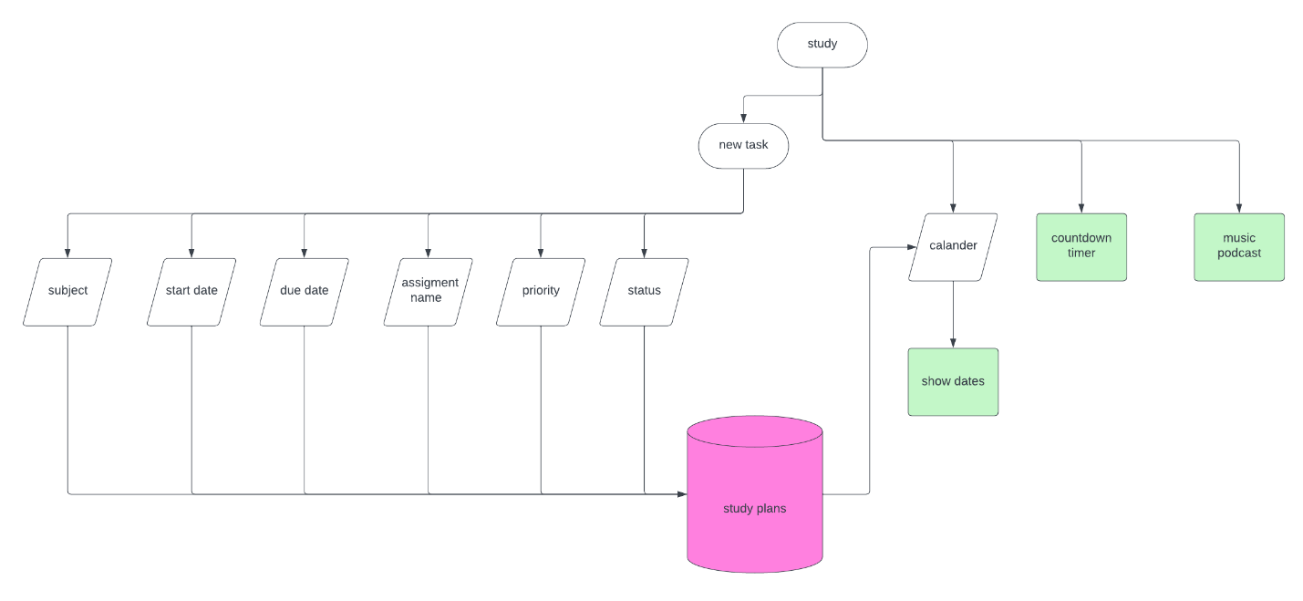

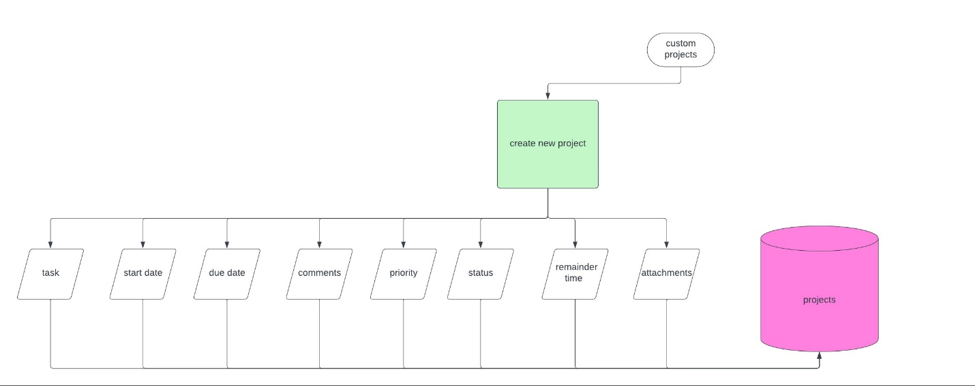
- Flowchart for the custom project creation

Syntax Squad

- Group Members:
- Hasara K.V.P (Group Leader)
- Wijeratne K. A. B. K.
- Adikaram W. A. D. V. V.
- Herath H. M. S. H.
- Priyanka P. N.
- Perera H. C. S.
- Alagoda M. A. K. H.
- Morais M. S. T. A.
- Gunawardhana M.K.M.D.S.P.
- Madushanka M. G. T.

