CHAPTER 1
INTRODUCTION
Road traffic accidents have become one of the most serious global public health and safety challenges in recent years. According to the World Health Organization, nearly 1.35 million people die every year due to road traffic injuries, while millions more suffer severe physical disabilities and financial losses. Developing countries contribute to the majority of these fatalities because of rapid urbanization, increasing vehicle population, weak traffic management systems, and poor adherence to safety regulations. In India, road accidents continue to rise at an alarming rate, with reports from the Ministry of Road Transport and Highways stating that more than 1,50,000 people lose their lives annually in traffic-related incidents. Among all vehicle categories, two-wheelers contribute the highest percentage of accident deaths, accounting for nearly 44% of total fatalities. The major causes identified behind these accidents are riding without a helmet, over speeding, negligence of traffic rules, and riding under the influence of alcohol.
Helmets are considered one of the most effective safety measures for reducing head injuries and fatalities during road accidents. However, many riders either avoid wearing helmets completely or wear them improperly only to escape penalties during police inspections. Similarly, drunk driving remains another major reason for fatal accidents, as alcohol affects the rider’s concentration, judgment, reaction time, and motor coordination. Even though governments enforce helmet laws and conduct breath analyzer tests at checkpoints, the existing enforcement mechanisms are largely manual, location-dependent, and reactive in nature. Traffic police personnel cannot monitor every vehicle continuously, and violations often go undetected in remote or less monitored areas.
As a result, there is a need for an intelligent automated system capable of ensuring rider safety compliance before the vehicle is allowed to operate. Advancements in embedded systems, wireless communication, Internet of Things (IoT), and sensor technologies have created opportunities for developing smart transportation safety systems. Integrating electronic sensors and communication modules into everyday protective equipment such as helmets can significantly improve road safety standards. The proposed Smart Helmet System is developed as an intelligent embedded solution that combines

helmet detection, alcohol sensing, vehicle ignition control, GPS tracking, GSM communication, and wireless interconnection into a unified framework. The system is specifically designed for two-wheeler riders to ensure that the motorcycle engine starts only when the rider is wearing the helmet properly and is not under the influence of alcohol. The proposed system consists of two separate but interconnected units: the helmet-side transmitter unit and the motorcycle-side receiver unit. The transmitter unit, embedded inside the helmet, includes an ESP32 microcontroller, an MQ-3 alcohol sensor, and a helmet detection switch such as a reed switch or magnetic sensor. The helmet detection mechanism verifies whether the rider is actually wearing the helmet, while the MQ-3 sensor continuously analyzes the rider’s breath to detect alcohol concentration. The collected information is transmitted wirelessly using the ESP-NOW protocol to the receiver unit installed on the motorcycle. The receiver unit also uses an ESP32 microcontroller and contains an LCD display, buzzer, relay module, GPS module, GSM module, and power circuitry. Based on the data received from the helmet unit, the receiver unit decides whether to allow or block the engine ignition. If the rider satisfies both conditions helmet worn and alcohol level below threshold the relay activates and allows the engine to start. If any condition fails, the engine remains locked and warning alerts are displayed on the LCD screen along with buzzer notifications. This automated decision-making mechanism acts as a preventive safety approach rather than relying solely on punishment after rule violations.
Apart from rider safety enforcement, the system also addresses emergency response challenges associated with road accidents. In many accident cases, victims are unable to contact emergency services immediately due to unconsciousness or remote accident locations. Delayed medical assistance significantly increases fatality rates. To overcome this problem, the proposed system integrates a Neo-6M GPS module and a SIM800L GSM module for real-time emergency communication. During an accident situation, the system can obtain the current GPS coordinates and automatically send an emergency SMS containing the rider’s location to predefined contacts or emergency services. Unlike older Arduino-based prototypes that support limited processing and short-range Bluetooth communication, the ESP32-based design provides faster processing speed, better reliability, and longer wireless range. The use of ESP-NOW communication eliminates the requirement for routers or mobile internet connectivity, making the system more practical for real-world deployment.

CHAPTER 2
LITERATURE SURVEY
1.Real-Time Accident Detection and Alcohol Monitoring using a Smart Helmet
Simi M. S., Vaishnavi A. S., and Liyana Shibu (2025). This paper proposed a smart helmet system capable of real-time accident detection and alcohol monitoring using embedded sensors and wireless communication modules. The system continuously monitored alcohol concentration and detected accidents using motion and vibration sensors. Upon accident detection, emergency messages were automatically transmitted to predefined contacts using GSM communication along with GPS coordinates. The research highlighted the importance of rapid emergency response in reducing accident fatalities. The system demonstrated improved safety through real-time monitoring and automatic emergency communication.
Limitations:
- Accident detection accuracy depended on vibration thresholds.
- GSM communication depended on network availability.
- GPS tracking accuracy reduced in obstructed areas.
- Continuous monitoring increased power consumption.
- Sensor sensitivity varied with environmental conditions.
2. Embedded IoT Smart Helmet for Accident Prevention and Detection
P. Venkatesh, S. Pranav Kumar, and N. Akhil (2025). This paper proposed an embedded IoT-based smart helmet system for accident prevention and automatic emergency detection. The system integrated ESP32 microcontroller, MQ-3 alcohol sensor, accelerometer sensor, GPS tracker, GSM module, and wireless communication technologies. The helmet continuously verified helmet usage and rider sobriety before allowing vehicle ignition. During accident conditions, the accelerometer detected sudden impacts and triggered automatic emergency notifications with GPS coordinates. The researchers emphasized low-cost implementation, low-power operation, and real-time monitoring for practical deployment in two-wheeler transportation systems.
Limitations:
- Sensor calibration accuracy affected system reliability.
- GPS functionality depended on outdoor satellite visibility.
- GSM communication depended on network coverage availability.
- Continuous sensing operations increased battery consumption.
- Embedded system debugging complexity was high.
3. Smart Helmet with Real-Time Rider Monitoring System
R. Santhosh Kumar, V. Abinaya, and T. Naveena (2025). This paper presented a real-time rider monitoring smart helmet system designed using ESP32, MQ-3 alcohol sensor, pulse monitoring sensor, GPS module, and GSM communication system. The system continuously monitored rider health conditions, alcohol levels, and accident situations during vehicle operation. The researchers emphasized the integration of wearable healthcare monitoring with transportation safety applications. Emergency notifications were automatically transmitted whenever abnormal rider conditions or accidents were detected. The study demonstrated the growing importance of smart wearable systems in ensuring both rider health and road safety.
Limitations:
- Health monitoring sensors required regular calibration.
- GPS tracking accuracy depended on signal strength.
- Continuous monitoring increased processor workload.
- Sensor data synchronization complexity was high.
- System cost increased due to additional health sensors.
4. IoT-Based Smart Helmet with Accident Identification System
A. Praveen Kumar, D. Karthikeyan, and M. Rahul (2024). This paper introduced an IoT-based smart helmet equipped with accident identification and rider safety monitoring capabilities. The proposed system used ESP32 microcontroller integrated with MQ-3 alcohol sensor, MEMS accelerometer, GPS tracker, and GSM module. The helmet communicated wirelessly with the motorcycle ignition system and prevented the engine from starting if the rider was intoxicated or not wearing the helmet properly. The MEMS accelerometer continuously monitored vehicle motion and detected sudden impacts during accidents. Upon accident detection, emergency alerts along with the rider’s location were automatically transmitted to predefined contacts. The study highlighted the importance of real-time monitoring and automated emergency communication in modern transportation safety systems
Limitations:
- MEMS sensors were sensitive to road vibrations.
- GPS performance reduced in tunnels and indoor locations.
- GSM modules required high current supply stability.
- Sensor calibration was necessary for accurate operation.
- Wireless communication reliability depended on distance.
5. Intelligent Smart Helmet for Accident Prevention
S. Dinesh Kumar, P. Mahalakshmi, and R. Karthika (2024). This research developed an intelligent smart helmet system for preventing road accidents using IoT sensors and embedded communication modules. The helmet incorporated alcohol sensing, helmet detection, vibration sensing, GPS tracking, and GSM-based emergency notification. The proposed system continuously monitored rider conditions and prevented engine ignition whenever safety requirements were not satisfied. The researchers focused on improving accident prevention through automatic enforcement mechanisms instead of relying solely on manual traffic monitoring. The emergency notification system was capable of transmitting real-time location details immediately after accident detection.
Limitations:
- Accident detection depended on sensor threshold accuracy.
- Wireless communication reliability reduced over long distances.
- GPS modules consumed additional battery power.
- Sensor drift affected long-term performance.
- System installation complexity increased setup time.

6. Kavitha S. Tammineni Loksai, and Shiva Kumar (2024) .
This research proposed a multi-domain smart helmet using ESP32, ESP-NOW protocol, GPS module, GSM communication, accelerometer sensors, and alcohol detection mechanisms. The helmet transmitter unit collected alcohol and helmet status information and wirelessly transmitted it to the receiver unit mounted on the motorcycle. The receiver unit processed the data and controlled the ignition system accordingly. Emergency alerts containing GPS location coordinates were transmitted using GSM technology during accident situations. The study focused on integrating multiple safety features into a compact wearable system for transportation safety applications.
Limitations:
- GPS functionality depended on satellite availability.
- ESP-NOW communication required paired devices.
- Battery backup duration was limited for long rides.
- Accelerometer threshold tuning required precision.
- Environmental noise affected sensor readings occasionally.
7. IoT-Based Smart Helmet with Accident Identification System
A. Praveen Kumar, D. Karthikeyan, and M. Rahul (2024) This paper introduced an IoT-based smart helmet equipped with accident identification and rider safety monitoring capabilities. The proposed system used ESP32 microcontroller integrated with MQ-3 alcohol sensor, MEMS accelerometer, GPS tracker, and GSM module. The helmet communicated wirelessly with the motorcycle ignition system and prevented the engine from starting if the rider was intoxicated or not wearing the helmet properly. The MEMS accelerometer continuously monitored vehicle motion and detected sudden impacts during accidents. Upon accident detection, emergency alerts along with the rider’s location were automatically transmitted to predefined contacts. The study highlighted the importance of real-time monitoring and automated emergency communication in modern transportation safety systems
Limitations:
- MEMS sensors were sensitive to road vibrations.
- GPS performance reduced in tunnels and indoor locations.
- GSM modules required high current supply stability.
- Sensor calibration was necessary for accurate operation.
- Wireless communication reliability depended on distance.
8. Intelligent Smart Helmet for Accident Prevention
S. Dinesh Kumar, P. Mahalakshmi, and R. Karthika (2024) This research developed an intelligent smart helmet system for preventing road accidents using IoT sensors and embedded communication modules. The helmet incorporated alcohol sensing, helmet detection, vibration sensing, GPS tracking, and GSM-based emergency notification. The proposed system continuously monitored rider conditions and prevented engine ignition whenever safety requirements were not satisfied. The researchers focused on improving accident prevention through automatic enforcement mechanisms instead of relying solely on manual traffic monitoring. The emergency notification system was capable of transmitting real-time location details immediately after accident detection.
Limitations:
- Accident detection depended on sensor threshold accuracy.
- Wireless communication reliability reduced over long distances.
- GPS modules consumed additional battery power.
- Sensor drift affected long-term performance.
- System installation complexity increased setup time.
9. Accident and Alcohol Detection by using AI-Enabled Smart Helmet
Ankit Ranjan Agrawal, Renu Yadav, and Vibhor Harit (2024).This paper introduced an AI-enabled smart helmet system integrating accident monitoring, alcohol sensing, mobile communication, and AI-based analytics for transportation safety. The researchers combined real-time monitoring techniques with intelligent data processing algorithms to improve accident prevention and rider monitoring accuracy. The system utilized embedded sensors, mobile connectivity, and AI-based processing to identify unsafe riding conditions. The work emphasized the growing role of artificial intelligence in wearable transportation safety systems.
Limitations:
- AI processing required higher computational resources.
- Real-time analytics increased system complexity.
- Power consumption was higher due to AI operations.
- Model accuracy depended on training datasets.
- Hardware cost increased significantly.
10. AI-Based Smart Helmet for Road Safety Applications
Rahul Verma, Kunal Mehta, and Aditi Sharma (2024) . This paper introduced an AI-based smart helmet system that used machine learning algorithms and embedded sensors for rider safety monitoring. The system combined alcohol detection, accident monitoring, fatigue analysis, and GPS tracking into a single wearable platform. Artificial intelligence algorithms analyzed rider behavior patterns and identified unsafe driving conditions in real time. The helmet also included GSM communication for emergency alerts and cloud-based monitoring support. The study highlighted the increasing role of AI and IoT technologies in next-generation transportation safety systems.
Limitations:
- AI algorithms required higher processing capability.
- Training datasets affected prediction accuracy.
- Continuous cloud connectivity increased dependency on internet services.
- Real-time AI processing consumed additional power.
- System implementation complexity was high.
11. Smart Helmet for Monitoring Construction Workers Using IoT-Based ESP32 and LoRa
Hadi Supriyanto, Ismail Rokhim, and Vincent Eliezer (2024). This paper presented an IoT-based smart helmet system for construction worker safety using ESP32 and LoRa communication. The helmet integrated MPU9250 sensors for motion tracking and accident detection. Kalman filtering and sensor fusion algorithms were applied to improve motion analysis accuracy. LoRa communication enabled long-range real-time monitoring and data transmission. The study demonstrated the effectiveness of smart wearable devices in industrial safety applications and real-time worker monitoring.
Limitations:
- LoRa communication had limited data transfer speed.
- Sensor fusion increased computational requirements.
- Motion detection accuracy depended on calibration.
- The system was optimized mainly for industrial use.
- GPS integration was not included.
12. Alcohol Detection Using Smart Helmet System
Dr. C. Gangaiah Yadav, V. Jahnavi, and V. Dilli Kumari (2023). This paper focused on developing a smart helmet system for alcohol detection using MQ-series sensors and embedded electronics. The helmet monitored alcohol concentration and prevented engine ignition during intoxication. The study emphasized the role of electronics and automation in reducing road accidents caused by drunk driving. The researchers compared different MQ-series sensors and identified MQ-3 as the most suitable sensor for alcohol sensing applications.
Limitations:
- The system focused mainly on alcohol detection only.
- No GPS tracking mechanism was included.
- Emergency communication features were absent.
- Sensor output varied with temperature changes.
- The system lacked advanced communication protocols.
13. Smart Helmet with Alcohol and Accident Detection
R. Manoj Kumar, P. Naveen Kumar, and S. Harish (2023). This paper proposed a smart helmet system integrating alcohol detection, accident monitoring, and wireless communication technologies for improving rider safety. The system used MQ-3 alcohol sensor, vibration sensors, ESP32 microcontroller, GPS module, and GSM communication unit. The helmet continuously monitored the rider’s alcohol level and transmitted safety information wirelessly to the motorcycle unit. Accident detection was implemented using vibration and motion sensors, which automatically triggered emergency SMS alerts with GPS coordinates. The researchers emphasized the importance of combining preventive safety measures with emergency response systems in order to reduce accident fatalities among two-wheeler riders. The system successfully demonstrated automatic ignition control and emergency notification under accident conditions.
Limitations:
- Sensor accuracy depended on environmental conditions.
- GSM communication required stable network coverage.
- GPS signals were unreliable in enclosed locations.
- Vibration sensors required precise calibration.
- Continuous monitoring increased battery consumption.
14. Wireless Smart Helmet with GPS and GSM Integration
M. Karthikeya, P. Sriram, and V. Nandhini (2023). This paper proposed a wireless smart helmet system integrating GPS and GSM communication for rider safety enhancement. The helmet used alcohol sensing, helmet detection, wireless transmitter modules, and emergency communication technologies to improve accident prevention. The GPS module continuously tracked the rider’s location and transmitted coordinates through GSM communication during accident situations. The wireless communication mechanism allowed the motorcycle unit to verify helmet status before engine ignition. The researchers focused on creating a compact and low-cost wearable safety device suitable for practical transportation applications.
Limitations:
- GPS accuracy decreased in urban obstruction areas.
- GSM modules required stable voltage regulation.
- Wireless communication range was limited.
- Sensor accuracy changed with environmental conditions.
- Battery charging circuitry required optimization.

15. Smart Helmet using ESP32 for Rider Safety
K. Surya Prakash, M. Vishnu Vardhan, and A. Sai Teja (2023). This paper proposed a smart helmet system using ESP32 microcontroller for enhancing two-wheeler rider safety through alcohol detection, helmet verification, and emergency communication. The system used an MQ-3 alcohol sensor for breath analysis and a helmet detection switch to verify whether the rider was wearing the helmet correctly. The ESP32 controller wirelessly transmitted the collected data to the motorcycle receiver unit using Wi-Fi-based communication. The researchers also integrated GPS and GSM modules to provide emergency assistance during accidents. The study demonstrated that ESP32-based architectures provide better processing speed, lower power consumption, and improved wireless communication compared to conventional Arduino-based systems.
Limitations:
- Wi-Fi communication required proper network configuration.
- GPS accuracy decreased in obstructed environments.
- Sensor readings fluctuated with temperature changes.
- GSM communication depended on mobile network availability.
- Battery charging management was not fully optimized.

CHAPTER 3
OBJECTIVES
3.1 Primary Objectives:
- To design and implement a smart helmet embedded system that prevents two-wheeler ignition unless the rider wears the helmet properly and is free from alcohol influence. The system aims to enhance rider safety by automatically enforcing helmet compliance and sobriety verification before vehicle operation.
- To develop a dual-ESP32 architecture consisting of a helmet-side transmitter unit and a motorcycle-side receiver unit for reliable and high-speed wireless communication. The communication system should ensure low latency, stable data transmission, and real-time synchronization between both units without requiring internet connectivity or external routers.
- To integrate an MQ-3 alcohol sensor for real-time breath alcohol detection and threshold-based engine cut-off. The objective is to continuously monitor the rider’s breath alcohol concentration and automatically disable vehicle ignition whenever alcohol levels exceed the predefined safety threshold.
- To implement a helmet detection mechanism using a reed switch or magnetic sensor that verifies whether the rider is physically wearing the helmet before allowing vehicle ignition. This objective ensures that the rider cannot bypass helmet safety requirements.
- To interface a SIM800L GSM module with a Neo-6M GPS module for automatic emergency SMS communication during accident situations. The system should be capable of transmitting real-time GPS coordinates and emergency alerts to predefined contacts or emergency services for faster rescue response.
- To provide a real-time feedback and alert mechanism using a 16x2 I2C LCD display and buzzer system. The LCD should display rider status messages such as “Wear Helmet,” “Alcohol Detected,” or “Ride Safe,” while the buzzer should provide immediate audio warnings during unsafe conditions.

3.2 Secondary Objectives:
- To ensure that the proposed smart helmet system remains low-cost, affordable, and manufacturable using commercially available electronic components. The design objective is to make the system practical for large-scale adoption among two-wheeler riders.
- To achieve a compact, lightweight, and wearable design for the helmet transmitter unit so that rider comfort is not affected during long-duration usage. The embedded hardware should be properly integrated inside the helmet without causing inconvenience to the rider.
- To minimize power consumption in the battery-operated helmet unit by using energy-efficient components, optimized sensor operation, and low-power communication techniques. This objective helps in extending battery life and improving portability.
- To validate the performance and reliability of the proposed system through both simulation and practical hardware implementation. Simulation platforms such as Wokwi and Proteus will be used for preliminary verification, while real-time hardware testing will confirm proper functioning of sensors, communication modules, ignition control, and emergency alert mechanisms.
- To improve road safety by reducing accidents caused due to drunk driving and helmet negligence through proactive prevention mechanisms rather than depending only on manual traffic enforcement systems.
- To design a system capable of providing fast emergency response support by reducing the delay in accident reporting through automatic GPS location sharing and GSM-based communication.
- To ensure reliable wireless communication between the helmet and motorcycle units using ESP-NOW protocol with minimal latency and stable operation under real-time riding conditions.

CHAPTER 4
METHODOLOGY
4.1 Block Diagram
HELMATE PART

ESP-32 CONTROLLER
SWITCH

MQ135
ESP NOW TX

POWER SUPPLY

BIKE PART
LCD DISPLAY

ESP32 CONTROLLER

ESP32 NOW TX
MOTOR
RELAY
BUZZER
POWER SUPPLY
GSM
GPS

Figure 4.1: Block diagram

4.2 Hardware Requirement:
4.2.1 ESP32 Microcontroller (ESP32-WROOM-32)
The ESP32-WROOM-32 microcontroller is the main processing unit used in both the transmitter and receiver sections of the Smart Helmet Safety System. It is a powerful dual-core Xtensa LX6 microcontroller operating at a clock frequency of up to 240 MHz, providing high-speed data processing and multitasking capabilities. The module contains 520 KB SRAM and 4 MB integrated flash memory, which is sufficient for storing firmware, communication protocols, and sensor processing algorithms.
The ESP32 supports 34 programmable GPIO pins that are used for interfacing sensors, relay modules, LCD displays, GPS modules, GSM modules, and other peripherals. It also includes 18 ADC channels with 12-bit resolution, allowing accurate analog sensor data acquisition such as alcohol level readings from the MQ-3 sensor.
One of the major advantages of the ESP32 is its built-in wireless communication support, including Wi-Fi, Bluetooth 4.2, BLE, and ESP-NOW protocol. In this project, ESP-NOW communication is used to establish fast and reliable wireless data transfer between the helmet unit and motorcycle unit without requiring internet connectivity.
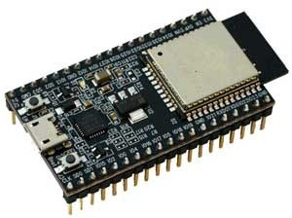
The microcontroller operates at 3.3V and supports low-power modes such as deep sleep, making it suitable for battery-operated embedded systems. Multiple UART and I2C interfaces simplify integration with GSM, GPS, and LCD modules. Due to its low cost, compact size, wireless capability, and high performance, ESP32 is highly suitable for IoT based safety applications.
Figure. 4.2.1: ESP32 Microcontroller
4.2.2 MQ-3 Alcohol Sensor
The MQ-3 sensor is used for detecting alcohol vapor from the rider’s breath. It is specifically designed for ethanol detection and provides high sensitivity to alcohol concentration in air. The sensor operates using a heating element and semiconductor sensing layer that changes resistance based on alcohol presence.
The MQ-3 sensor works with a 5V power supply and generates an analog voltage output proportional to the detected alcohol concentration. The ESP32 reads this analog value through its ADC pins and compares it with a predefined threshold value to determine whether the rider is under the influence of alcohol.
The sensor requires an initial warm-up period of approximately 20 seconds to stabilize the internal heater and provide accurate readings. Experimental testing showed that alcohol levels above the threshold trigger the engine locking mechanism and activate warning indications.
The MQ-3 sensor offers low cost, simple interfacing, fast response time, and reliable alcohol detection, making it suitable for real-time vehicle safety systems. However, periodic calibration is required for maintaining accuracy under different environmental conditions such as temperature and humidity.
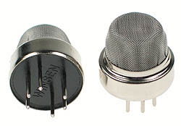

Fig. 4.2.2: MQ-3 Alcohol Sensor
4.2.3 A SIM800L GSM Module
The SIM800L GSM module is used for sending emergency SMS alerts during accident si tuations. It is a compact quad-band GSM/GPRS communication module supporting GSM frequencies of 850, 900, 1800, and 1900 MHz, allowing operation in most mobile networks worldwide.
The module communicates with the ESP32 using UART serial communication and supports standard AT commands for SMS, voice calling, and GPRS operations. In this project, the SIM800L module is programmed to automatically send emergency alert messages containing GPS coordinates and Google Maps location links to predefined contact numbers.
The module requires a stable operating voltage between 3.4V and 4.4V and can draw peak currents up to 2A during GSM transmission bursts. Therefore, a dedicated LM2596 DC-DC buck converter is used to provide a stable high-current power supply. Additional electrolytic capacitors are connected near the VCC pin to reduce voltage fluctuations and improve transmission stability.
The SIM800L module enhances the emergency response capability of the system by enabling rapid communication with emergency contacts after accidents. Its compact design, low power consumption, and reliable GSM functionality make it highly suitable for embedded IoT safety systems.
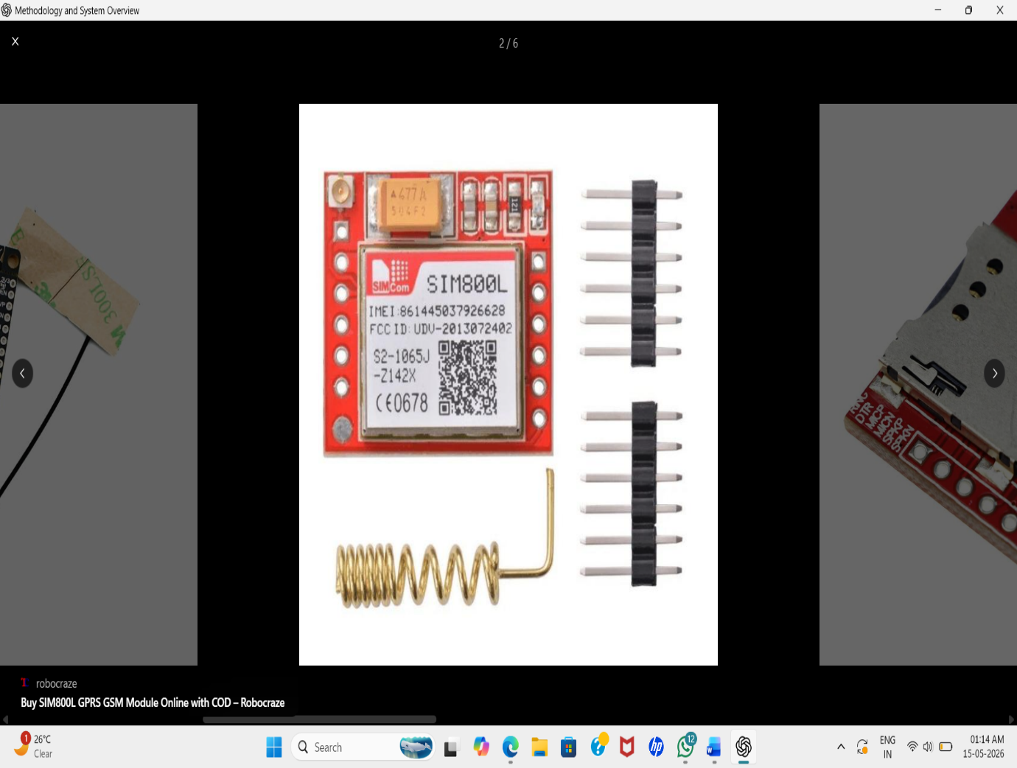
Figure. 4.2.3: SIM800L GSM module
4.2.4 GPS Module (Neo-6M / u-blox)
The Neo-6M GPS module is used for obtaining real-time geographical location coordinates of the rider during emergency situations. It is based on the u-blox NEO-6M chipset and communicates with the ESP32 through UART serial communication using NMEA 0183 protocol sentences.

The module supports up to 50 tracking channels and provides location accuracy of approximately 2.5 meters under open sky conditions. It operates within a voltage range of 3.3V to 5V, making it compatible with most embedded systems.
During system startup, the GPS module performs satellite acquisition, which typically requires around 27 seconds during cold start conditions. Once the satellite connection is established, latitude and longitude coordinates are updated continuously in real time.
The module also contains built-in EEPROM memory to store previous location data, allowing faster satellite reacquisition after restart. In this project, GPS coordinates are included in emergency SMS alerts sent through the GSM module, helping emergency services quickly locate accident victims.
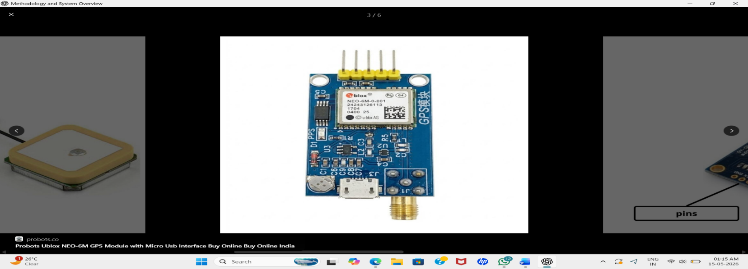
Figure. 4.2.4: GPS Module (Neo-6M / u-blox)
4.2.5 I2C LCD Display (16x2 with PCF8574 Backpack)
The 16x2 I2C LCD display is used for displaying system status messages and user notifications. The display can show 16 characters per line across two lines and is connected to the ESP32 using the PCF8574 I2C I/O expander.
The use of I2C communication significantly reduces GPIO pin usage because only two pins, SDA and SCL, are required for interfacing. This simplifies wiring and improves circuit compactness. The default I2C address of the module is 0x27, which can be modified if required. The LCD display provides real-time messages such as “Ride Safe!”, “Wear Helmet!”, and “Drunk! Engine Blocked” based on system conditions. This improves user interaction and provides immediate feedback to the rider. The display operates at 5V and includes onboard backlight functionality for better visibility during day and night conditions. Due to its simplicity, low cost, and ease of programming using the LiquidCrystal_I2C library, it is widely used in embedded applications.
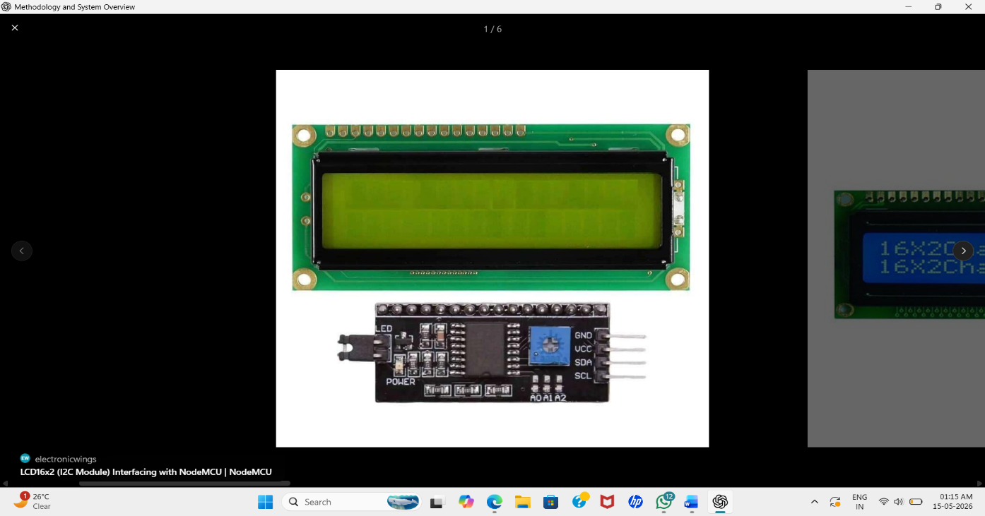
Figure. 4.2.5: I2C LCD Display (16x2 with PCF8574 Backpack)
4.2.6 Relay Module (5V Single Channel)
The relay module is used for controlling the motorcycle ignition system based on safety conditions evaluated by the ESP32 receiver unit. It acts as an electrically controlled switch capable of handling higher voltage and current loads safely. The module operates using a 5V coil and supports switching capacities up to 10A for both AC and DC loads. The relay used in this project contains SPDT (Single Pole Double Throw) contacts, providing Normally Open (NO), Normally Closed (NC), and Common terminals.
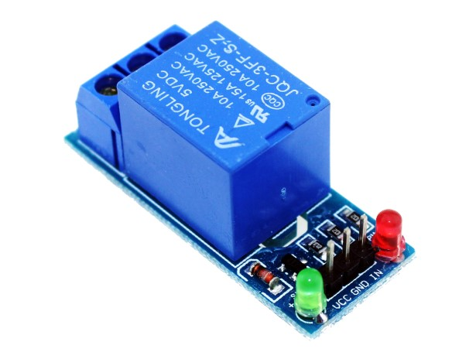
The relay is triggered through an optocoupler-isolated active LOW input, improving electrical isolation and protecting the ESP32 from voltage spikes generated by inductive loads. Indicator LEDs are included to show relay activation status visually. When safety conditions are satisfied, the ESP32 activates the relay, enabling vehicle ignition. If unsafe conditions are detected, the relay disconnects the ignition system, preventing vehicle operation.
Figure . 4.2.6: Relay Module (5V Single Channel)

4.3 Software Requirements
Software Installation
Installing ARDUINO IDE
To install the Arduino IDE for Windows, follow these instructions:
- Download .exe file f
- rom website: http://arduino.cc/en/Main/Software/
- Once the download is complete, double-click the file, and extract it. (Usually the file is downloaded in .zip format)
- The extracted “Arduino” named folder is to be copy and paste it into C-Drive, and Open the folder, if you wish create the shortcut of Arduino.exe file on your desktop.
Installing DRIVERS
The next task is to install the drivers for your Arduino board’s USB interface.
- Connect your Arduino to your PC with the USB cable. After a few moments an error message will be displayed, which will say something like “Device driver software not successfully installed.” Just close that dialog or balloon.
- Navigate to the Windows Control Panel. Open the Device Manager and scroll down until you see the ports or Arduino,
- Right-click Arduino Uno under Other Devices and select Update Driver Software. Then, select browse option and update the drivers.
area, the text area, and the message window area.
The Command Area
The command area includes the title bar, menu items, and icons. The title bar displays the sketch’s filename. Below this is a series of menu items (File, Edit, Sketch, Tools, and Help) and icons.
The Icons
Below the menu toolbar are six icons. Mouse over each icon to display its name. The icons, from left to right, are as follows:
- Verify: Click this to check that the Arduino sketch is valid and doesn’t contain any programming mistakes.
- Upload: Click this to verify and then upload your sketch to the Arduino board.
- New: Click this to open a new blank sketch in a new window.
- Open: Click this to open a saved sketch. Save Click this to save the open sketch.
- Serial Monitor: Click this to open a new window for use in sending and receiving data between your Arduino and the IDE.
Taking a look Around the IDE
The IDE is divided into three main areas: the command
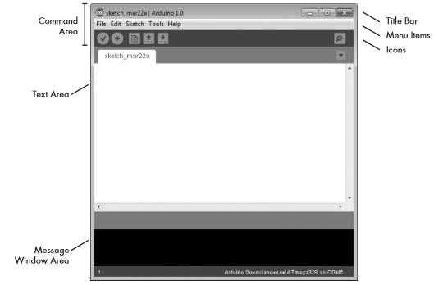
The Text Area
Figure 4.3.1 Arduino IDE Software
The actual code is written in this block.
The Message Window Area
The message window area is shown at the bottom side. Messages from the IDE appear in the black area. The messages you see will vary and will include messages about verifying sketches, status updates, and so on.

4.4 Circuit Diagram

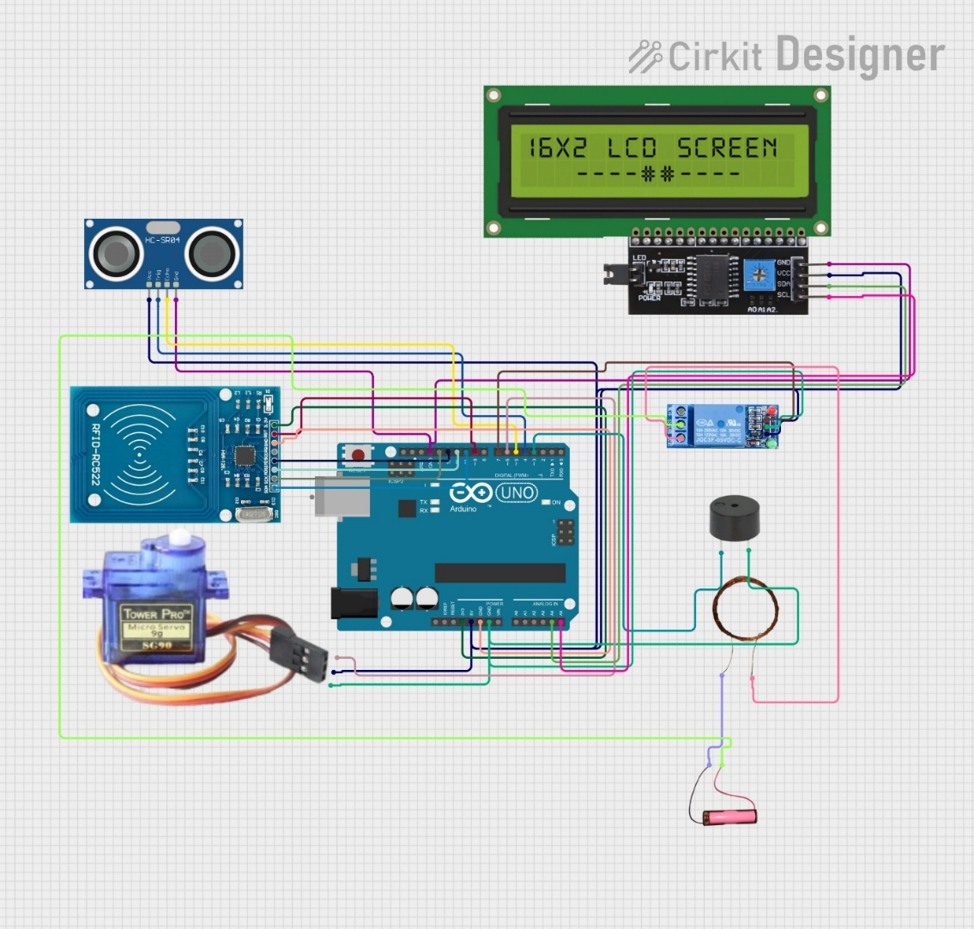
Figure. 4.4.1: Circuit Diagram
  - Working
The The Advanced Smart Helmet System is a safety-oriented embedded system developed to reduce road accidents and protect riders. The system combines various sensors and communication modules to ensure that the rider follows safety measures before operating the vehicle and receives immediate assistance during emergencies.
Initially, an IR sensor placed inside the helmet detects whether the rider is wearing the helmet properly. When the rider wears the helmet, the sensor sends a signal to the microcontroller. If the helmet is not worn, the system prevents the vehicle from starting, thereby encouraging the mandatory use of helmets and improving rider safety.
The system also includes an MQ-3 alcohol sensor that continuously checks the rider's breath for the presence of alcohol. If the detected alcohol level exceeds the predefined limit, the sensor sends a signal to the microcontroller, which disables the

ignition system. As a result, the vehicle cannot be started, helping to prevent accidents caused by drunk driving.
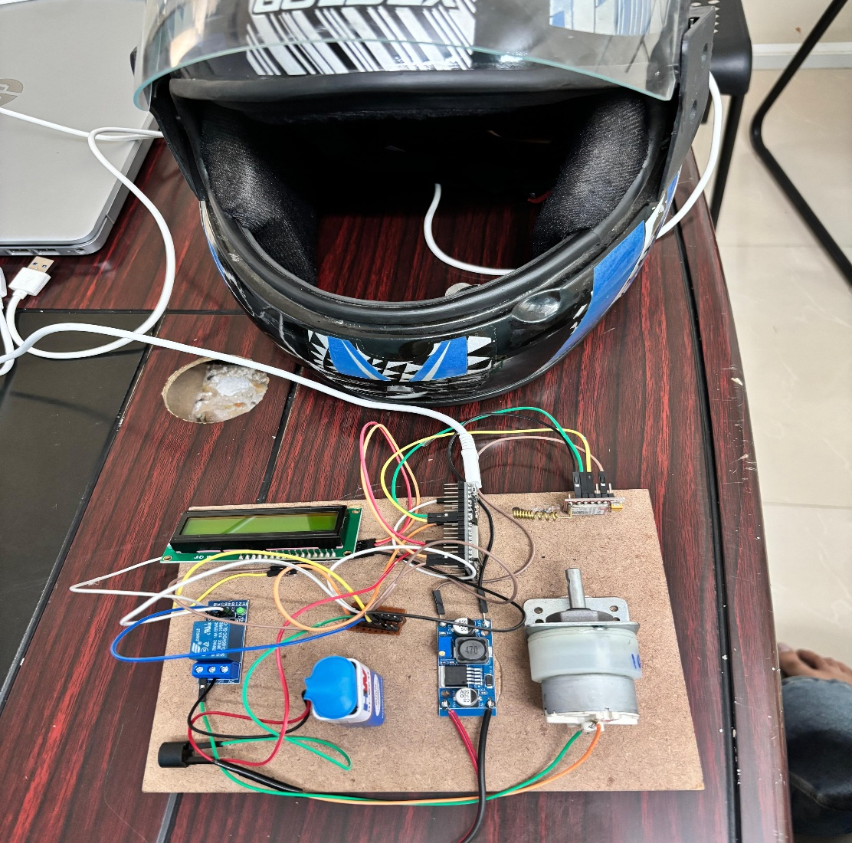
Figure 4.5.1 Working
A microcontroller such as Arduino or Node MCU acts as the central processing unit of the system. It receives input from all sensors, processes the collected data, and makes decisions based on predefined conditions. The microcontroller controls a relay module connected to the vehicle's ignition system and allows the vehicle to start only when all safety conditions are satisfied.
For accident detection, the system uses a vibration sensor or accelerometer that continuously monitors sudden impacts, abnormal movements, or collisions. When a severe impact is detected, the sensor immediately informs the microcontroller, which recognizes the situation as a potential accident and initiates emergency actions.
After an accident is detected, the GPS module is activated to determine the exact geographical location of the rider. The GPS module collects the latitude and longitude coordinates of the accident site and forwards this information to the microcontroller for further processing.
The GSM module then sends an emergency alert message containing the accident information and GPS location coordinates to pre-stored emergency contacts, family members, or rescue services. This feature helps in providing timely medical assistance and reduces the delay in emergency response.
Thus, the Advanced Smart Helmet System integrates helmet detection, alcohol monitoring, ignition control, accident detection, GPS tracking, and GSM communication into a single intelligent safety solution. The system enhances rider safety, prevents unauthorized vehicle operation, and ensures rapid emergency assistance during accidents.

CHAPTER 5
RESULTS AND DISCUSSIONS
5.1 Result
1. Power-ON Sequence
- Both Transmitter (Helmet Unit) and Receiver (Motorcycle Unit) are powered ON successfully using regulated power supply modules.
- The MQ-3 alcohol sensor requires approximately 20 seconds warm-up time for stable alcohol detection. A firmware delay is implemented to ensure accurate sensor readings.
- The GPS module initializes and acquires satellite signals within 30–60 seconds during cold start conditions. Once connected, real-time location coordinates are updated continuously.
- ESP-NOW wireless communication is established between both ESP32 modules using registered MAC addresses for secure and reliable data transfer.
- LCD display initializes properly and shows system startup messages indicating successful module initialization.
- During testing, stable communication between the transmitter and receiver units was achieved with minimal packet loss.
2. Transmitter Unit (Helmet) Operation Loop
- The ESP32 transmitter continuously reads the MQ-3 alcohol sensor analog value at a sampling rate of approximately 10Hz for real-time alcohol monitoring.
- Helmet wearing status is detected using the helmet switch sensor connected to GPIO pins, where HIGH indicates helmet worn and LOW indicates helmet not worn.
- The collected sensor data packet containing helmet status and alcohol sensor value is broadcast to the receiver unit through ESP-NOW communication every 500ms.
- Experimental results show that the transmitter unit provides fast response and accurate sensor data transmission without noticeable delay.
- The wireless transmission range was found sufficient for normal motorcycle operation and maintained stable connectivity during testing.
3. Receiver Unit (Motorcycle) Operation Loop
- The receiver ESP32 successfully receives the wireless ESP-NOW data packets transmitted from the helmet unit.
- The decision-making algorithm evaluates two major conditions:
  - Whether the rider is wearing the helmet
  - Whether the alcohol level is below the predefined threshold
- If both conditions are satisfied, the relay module activates and allows the DC motor (vehicle ignition) to start. The LCD displays the message “Ride Safe!” and the buzzer remains OFF.
- If the helmet is not worn, the relay remains OFF, the motor stays disabled, the buzzer activates, and the LCD displays “Wear Helmet!”.
- If alcohol is detected above the threshold limit, the system blocks engine ignition, activates the buzzer, and displays “Drunk! Engine Blocked” on the LCD screen.
- Continuous GPS data parsing is performed using TinyGPS++ library, and real-time latitude and longitude coordinates are updated successfully.
- Test results indicate that the ignition control mechanism responds immediately based on rider safety conditions, improving overall vehicle safety.
4. Emergency Alert Sequence (Accident Detection)
- The vibration/tilt sensor continuously monitors sudden impacts or abnormal tilt conditions during vehicle operation.
- When the sensor detects vibration beyond the predefined threshold for more than 500ms, the system identifies it as a possible accident condition.
- The GPS module retrieves accurate latitude and longitude coordinates using the TinyGPS++ library.
- The SIM800L GSM module is controlled through AT commands to send emergency SMS alerts containing accident information and live Google Maps location link.
- Emergency alert messages are successfully transmitted to two pre-programmed emergency contact numbers during testing.
- The buzzer generates an SOS alert pattern consisting of three short beeps, three long beeps, and three short beeps for nearby attention and emergency indication.
- Experimental observations confirm that the emergency alert system responds quickly and improves the chances of immediate rescue assistance after accidents

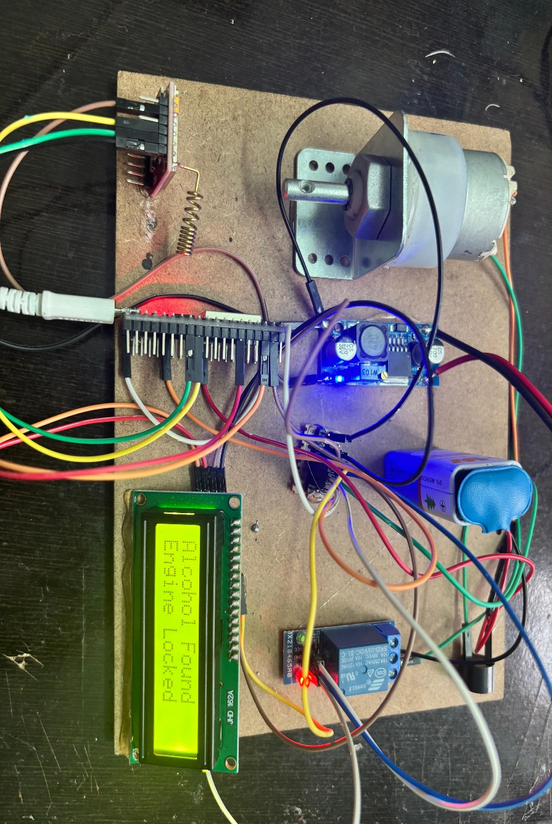
Figure 5.1.1 Output display on LCD

5.2 Applications
- It can be used as an effective real-time rider safety and accident prevention system.
- This technology can be extended to cars by replacing the helmet detection mechanism with seat belt detection systems.
- Integration with mobile applications can allow live tracking, emergency notifications, and health monitoring features.
- The system can be enhanced with AI-based accident prediction and smart traffic analysis capabilities.
- Advanced biometric authentication such as fingerprint or face recognition can be added for vehicle security.
- Cloud storage can be implemented to store riding history, accident records, and emergency data for future analysis.
- Smart navigation and voice assistance features can be integrated for safer and hands-free riding experience.
- Future versions can support smart city transportation systems and connected vehicle communication technologies.
5.3 Advantages and Disadvantages

5.3.1 Advantages:
- Enhances rider safety by ensuring the helmet is worn before starting the vehicle.
- Prevents drunk driving through alcohol detection using the MQ-3 sensor.
- Provides real-time accident detection and emergency alert messaging with GPS location.
- Wireless ESP-NOW communication offers fast and reliable data transfer between helmet and vehicle units.
- Reduces road accidents and improves overall transportation safety.
- Low-cost, energy-efficient, and easy to implement using easily available components.
5.3.2 Disadvantages:
  - System performance may be affected by sensor inaccuracies or environmental conditions.
  - Continuous operation of wireless modules and sensors increases power consumption and requires regular battery charging.

CHAPTER 6
CONCLUSION AND FUTURE SCOPE
6.1 Conclusion
The Smart Helmet System presented in this synopsis addresses a critical gap in two-wheeler road safety by integrating multiple embedded technologies into a unified, automated safety enforcement solution. The system successfully combines helmet detection, breath alcohol analysis, engine ignition control, real-time feedback, GPS tracking, and GSM emergency alerting into a single cohesive platform.
The dual ESP32 architecture provides sufficient processing power, GPIO availability, and wireless capability at a very low cost (approximately Rs.2,460), making this solution viable for mass deployment. Unlike existing systems that address only one aspect of rider safety, the proposed integrated approach ensures that the vehicle physically cannot be started unless safety compliance is verified.
The key contributions of this project are:
- First-time integration of helmet detection + alcohol sensing + ignition control + GPS + GSM in a single affordable system.
- Use of ESP-NOW protocol for fast (2ms latency), reliable, infrastructure-free wireless communication between helmet and motorcycle.
- Automated emergency location SMS via SIM800L + Neo-6M GPS for immediate accident response.
- Total system cost under Rs.2,500 making it commercially viable for mass market deployment.
Future enhancements may include: cloud connectivity for fleet management, integration with a mobile application for parental or employer monitoring, AI-based drowsiness detection via camera module, and replacement of the mechanical helmet switch with a pressure/strain gauge sensor for more reliable helmet fitting detection.
In conclusion, the Smart Helmet System is a practical, affordable, and scalable solution that has the potential to significantly reduce road accident fatalities among two-wheeler riders globally. With further development and government or industry support, this technology can be standardized as mandatory equipment for all two-wheelers.
6.2 Future Scope
• A compact high-definition camera can be mounted on the helmet for recording the rider’s activities and surrounding road conditions. The recorded footage can be useful for accident analysis, evidence collection, security purposes, and real-time traffic monitoring.
• Vehicle-to-Vehicle (V2V) communication can be implemented using advanced wireless technologies to allow riders to exchange safety alerts, traffic updates, accident warnings, and emergency messages between nearby vehicles. This can improve road safety and reduce accidents.
• Solar panels can be enhanced to provide efficient renewable power for the helmet electronics. The stored solar energy can also be used for charging mobile phones, Bluetooth devices, and other portable gadgets during travel.
• Artificial Intelligence and Machine Learning algorithms can be integrated to analyze rider behavior and predict dangerous driving patterns such as overspeeding, rash driving, or sudden braking. The system can then provide smart warnings to the rider.
• Cloud and IoT connectivity can be added for real-time monitoring and data storage. Family members or emergency services can track the rider’s live location, riding status, and emergency alerts through a mobile application.
• Voice assistant and Bluetooth communication features can be integrated into the helmet for hands-free calling, navigation guidance, and voice-controlled operations, improving rider convenience and safety.
• Advanced accident detection systems using accelerometers and gyroscope sensors can be incorporated to improve the accuracy of crash detection and enable faster emergency response.
• The system can be further developed into a fully smart connected helmet compatible with smart city and intelligent transportation systems for future autonomous and connected vehicle environments.

REFERENCES
[1] Hegde N.V., Agarwal A., and Moharir M. (2025). A Novel AI-Driven System for Real-Time Detection of Mirror Absence, Helmet Non-Compliance, and License Plates Using YOLOv8 and OCR. arXiv, 2025.
[2] Rawat D., Gupta K., Basu Roy A., and Sarvadevabhatla R. (2025). DashCop: Automated E-ticket Generation for Two-Wheeler Traffic Violations Using Dashcam Videos. arXiv, 2025.
[3] Ministry of Road Transport and Highways, Government of India (2025). Road Safety Annual Report 2024. New Delhi, India.
[4] IEEE Intelligent Transportation Systems Society (2025). Recent Advances in Smart Rider Safety Systems. IEEE Publications.
[5] Shankar R., Mishra D., and Gupta S. (2023). Comprehensive Review of Smart Helmet Technologies for Road Safety. IEEE Transactions on Intelligent Transportation Systems, Vol. 24, Issue 2, pp. 1587–1604.
[6] Ministry of Road Transport and Highways, Government of India (2023). Road Accidents in India 2022. MoRTH Annual Statistical Report.
[7] Espress if Systems (2023). ESP32 Technical Reference Manual v5.1. Espressif Systems, Shanghai.
[8] Supriyanto H., Rokhim I., and Eliezer V. (2024). Smart Helmet for Monitoring Construction Workers Using IoT-based ESP32 and LoRa. Indonesian Journal of Computer Science, Vol. 13, No. 4.
[9] Zohari M.H., Elias M.L.M., and Al-Fadhali N.M.A. (2024). Safety Helmet with Collision Detection System. Journal of Advanced Industrial Technology and Applications, Vol. 5, No. 1, pp. 76–82.
[10] Kavitha S., Loksai T., Naidu V.B., Kumar S., and Venkatesha B. (2024). Multi-Domain Smart Safety Helmet. International Research Journal on Advanced Engineering Hub, Vol. 2, Issue 5, pp. 1311–1317.

[11] Tahemeen T. and Patil R. (2024). IoT Based Solutions for Accident Detection and Intimation. Journal of Scientific Research and Technology, Vol. 2, Issue 9, pp. 93–102.
[12] Asri R.P. and Sardi J. (2024). Smart Helmet Based on Microcontroller for Motorcyclists. Jurnal Teknik Elektro Indonesia, Vol. 5, No. 2, pp. 397–410.
[13] Mane V.M. and Durge H.A. (2024). Multifeatured Electronic Helmet to Enhance Road Safety and Rider’s Comfort. Proceedings of Engineering and Technology Innovation.
[14] Siam S.M.K.M., Sumaiya K.I., Al-Amin M.R., Turjo T.H., Rahim A.H.M.A., and Hasan M.R. (2024). Real-Time Accident Detection and Physiological Signal Monitoring to Enhance Motorbike Safety and Emergency Response. arXiv, 2024.
[15] Choi L. and Greer R. (2024). Evaluating Vision-Language Models for Zero-Shot Detection, Classification, and Association of Motorcycles, Passengers, and Helmets. arXiv, 2024.
[16] Kumar K., Singh P., and Yadav A. (2022). GPS-GSM Based Automatic Vehicle Accident Detection and Alert System. IOSR Journal of Electronics and Communication Engineering, Vol. 17, Issue 3, pp. 41–48.
[17] Priya S., Kumar M., and Rao B. (2022). I2C Communication for Multi-Device LCD Interfacing in Embedded Systems. International Journal of Computer Applications, Vol. 183, Issue 45, pp. 18–24.
[18] World Health Organization (2022). Global Status Report on Road Safety 2022. WHO Press, Geneva.
[19] Sharma R., Patel V., and Singh A. (2022). IoT-Based Smart Transportation and Safety Monitoring Systems. Springer Nature.
[20] Verma A., Gupta N., and Sharma P. (2022). Wireless Sensor Networks for Intelligent Road Safety Applications. Elsevier.
[21] Nithyashri N., Devi S., and Rajan T. (2021). Alcohol Detection and Helmet Sensing Using Raspberry Pi with OpenCV. IJERT, Vol. 10, Issue 5.

[22] Al-Turjman M., Hassan R., and Nawaz A. (2021). ESP32-Based IoT Architecture for Smart Safety Wearables. IEEE Internet of Things Journal, Vol. 8, Issue 4, pp. 2850–2861.
[23] Joshi A., Mehta V., and Kaur P. (2021). MQ-3 Alcohol Sensor Characterization for Embedded Breathalyzer Applications. Sensors and Actuators B: Chemical, Vol. 332.
[24] Rao P., Kulkarni S., and Deshmukh R. (2021). Smart Rider Assistance System Using Embedded Sensors. International Journal of Engineering Research.
[25] Chen Y., Wang J., and Li H. (2021). Wearable Safety Devices for Transportation Applications. IEEE Access.
[26] Ahmad M., Khan I., and Memon A. (2020). IoT-Based Smart Helmet for Coal Miners Safety Monitoring. IEEE Access, Vol. 8, pp. 33446–33456.
[27] Pallavi B., Shetty N., and Rao K. (2020). Vehicle Ignition Control System with Drunk Driving Detection Using MQ-3 and Arduino Mega. IJAREEIE, Vol. 9, Issue 8, pp. 3120–3128.
[28] Gupta S., Verma N., and Pandey R. (2020). Performance Analysis of ESP-NOW Protocol for Real-Time IoT Communication. ICIoTCT 2020, pp. 112–119.
[29] U-blox AG (2020). NEO-6 u-blox 6 GPS Modules Data Sheet. U-blox AG, Switzerland.
[30] Kumar S., Reddy V., and Patel M. (2020). Embedded IoT Solutions for Vehicle Safety and Accident Prevention. International Journal of Advanced Research in Engineering and Technology.

