1. What is Data driven testing?

Read the data from external recourse & run the test is called Data driven testing (parameterization)

1. Why Data Driven testing ?

As per the rule of the automation data shouldn’t not hardcoded because data modification & maintainace is tedious job , instead we should get the data from external resource like xlsx, .properties file , db , XML, JSON

1. What is Advantages of Data driven testing
2. Maintenance of the test data is easy
3. Modification of the test data in external recourse is easy
4. Cross browser testing is easy
5. Running test scripts in different env is easy
6. Running test scripts in different credentials is easy
7. We can create the test data prior the Suite execution (we can also get the data from testData team )
8. Rerunning test Script with multiple time is easy
9. How to read data from properties File?

* Get the java Object of the Physical file using “FileInputSteam
* Create a Object “Properties” class & load all the keys
* Read the data using getProperty(“Key”)

Note : properties file light weight & faster in execution compare to Excel

1. What Debuging ?

Run the test slow mode based on user instruction is called debug Mode

1. Why Debuging ?

When we run 1000 of test Scripts in batch, if any test scripts is failed due to some issue,

In order to find out the root cause of the issue we go for debug Mode

1. Explain Debug mode Option in Eclipse , how will you debug the test.

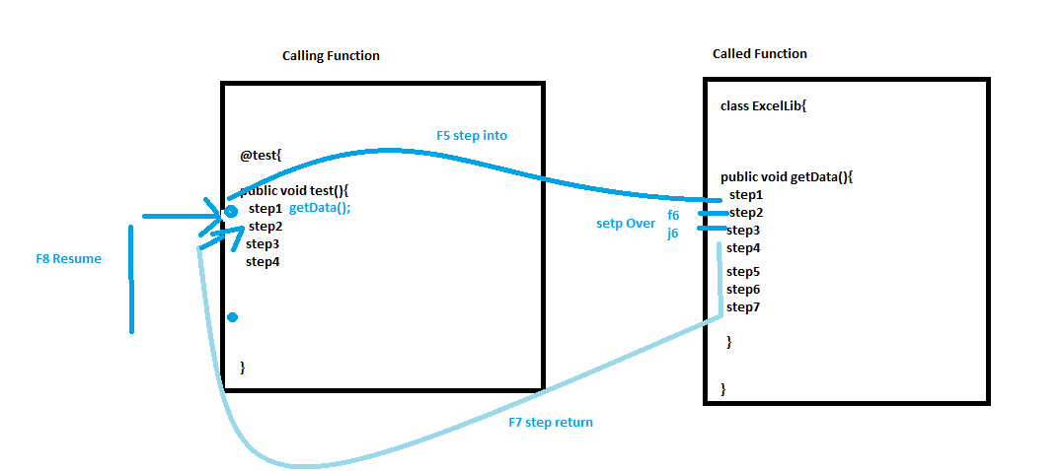

Debug mode we have below features in eclipse to execute test in Slow Mode

BreakPoint : used to pause the execution in runtime execution

EG : click on blue line eclipse or CRL + SWT + B

F5 : push execution control from calling function to the called Function & pause the execution in the first line of the called Function

F6 : execute line by line

F7 : push execution control from called function to the calling Function by execution remaining called function steps in fast mode & pause the execution where it’s being called

F8 : resume the execution from one breakpoint to another breakpoint in fast mode

Ctl+F2 : terminate the execution

We have 2 debug window

Variables: its will list out all the Variables / object values

Expression Window : used to execute piece of java /selenium code in run time with modification

1. What is Object/Elements Repository

Its collection of elements locators & business libraries in one place , & its shared by multiple test scripts

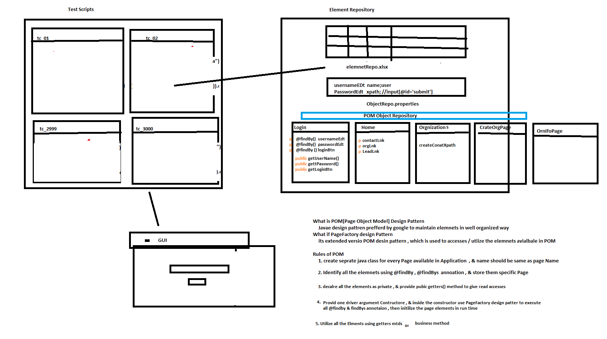

1. Why repository

As per the rule of the automation, we should not hardcode elements in test Scripts instead, we should get elements from Object Repository , because in Agile process due to frequent requirement changes , modification & maintenance of elements is tedious job

1. What is the advantages repository?
2. Reusability of elements, no need to write xpath again & again
3. Modification in Repository is easy, when GUI / frequent requirement changes
4. Maintenance is easy, because all the elements we kept in one place
5. Test Script Code Optimized
6. More Readability
7. Test Script development id faster due to business lib
8. Test Script is more robust
9. Handle Stale Elements Exception.
10. Type Of Framework
11. Data driven framework [TDD –TestNG/Junit]
12. Modular Driver framework [TDD –TestNG/Junit]
13. Keyword driven framework [TDD –TestNG/Junit]
14. Hybrid driven Framework [TDD –TestNG/Junit]
15. BDD framework [BDD -Cucumber]
16. What id Data driven FrameWork

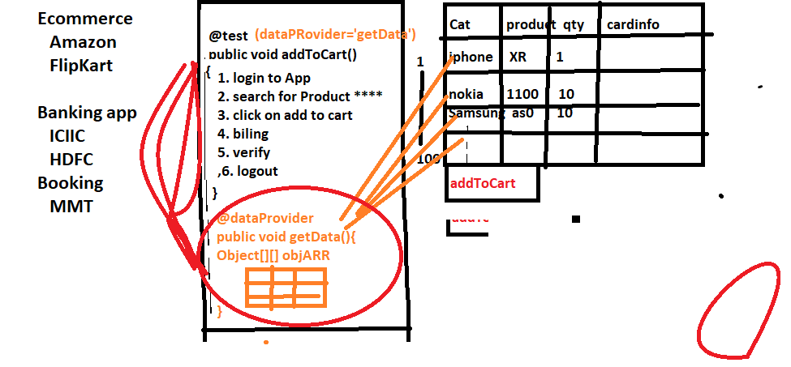

Whenever we need to test the application with huge set of data , we go for data driven framework

In data driven framework every test will have dedicated @dataProvider annotation & will have separate excel sheet for every test

@dataProvider

When ever need to execute same test with different set of data we go for dataprovider annotation

13 What is modular driven framework

When ever application is huge / contains lots of module we prefer moduler driven framework

In modular driven framework , all framework components will maintain in module wise

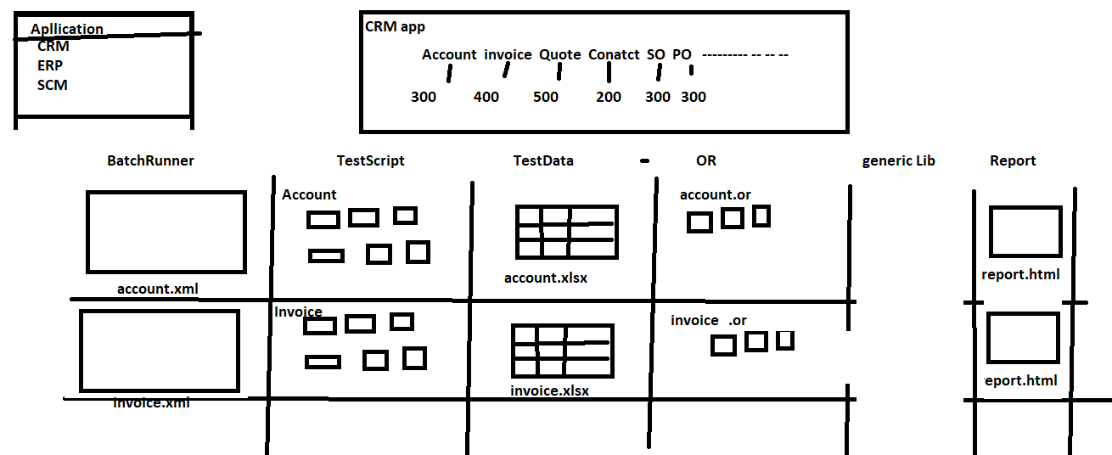

1. What is KeyWord driven Framework

When manual test Engineer want to write Automation test script With less knowledge on automatio tool & coding we for keyWordDriven framework

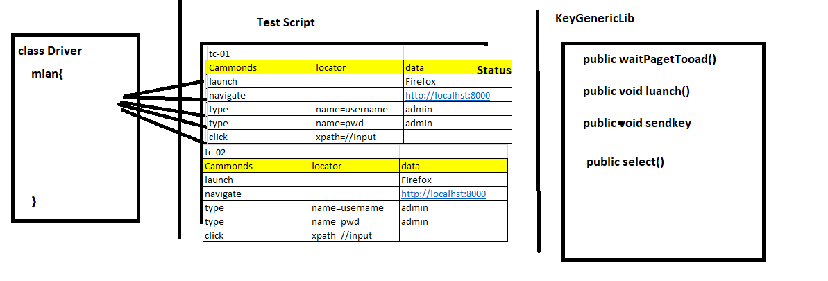

14 Hybrid driven framework

Combination of more than one framework is called hybrid driven framework

EG : the framework which we designed is hybrid because its combination of data driven + Modular driven + kewordword driven framework

BDD Framework

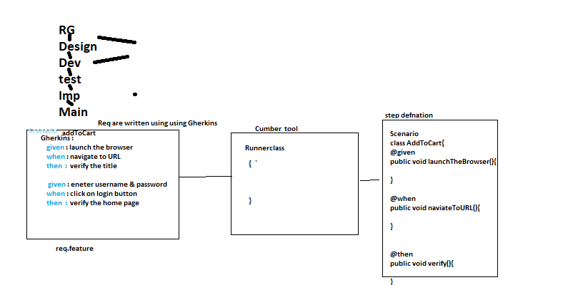

1. What is Github

It’s a distributed cloud centralized repository where we can maintain our sourceCode / TestScripts / CRS doc /build of the application in one place

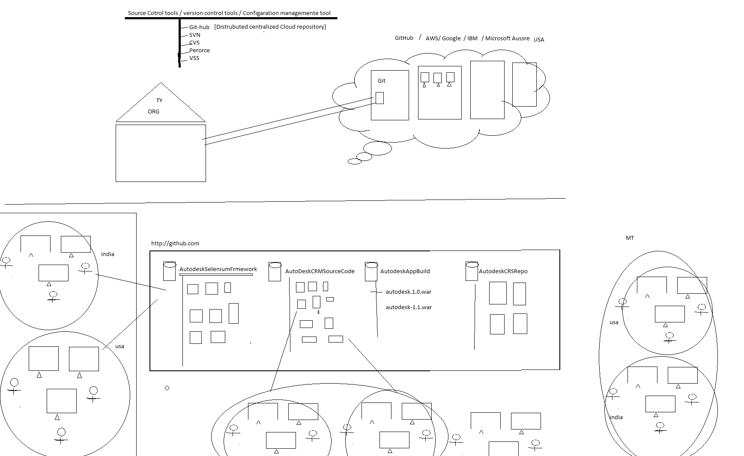

1. Git Architecture

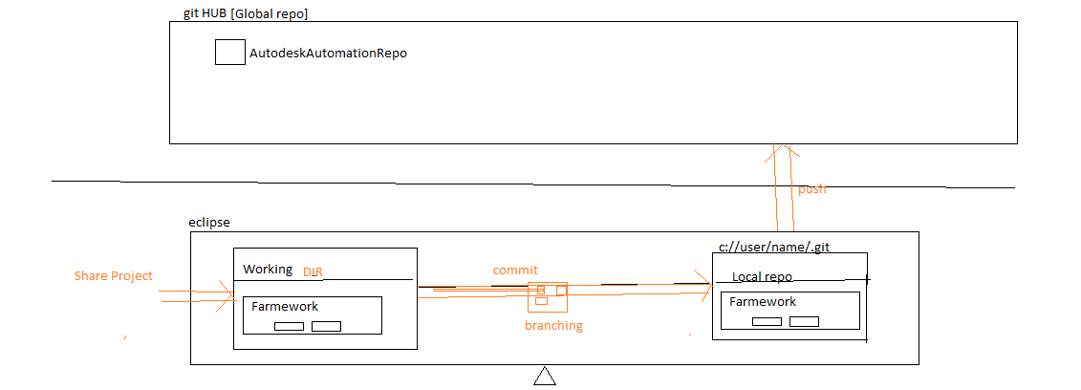

1. What is Maven

It’s build testing tool, which is used to check the integration issue between the framework component whenever modification, addition deletion happened in the framework

1. Why maven if required?

When multiple engineer working with the same framework , their might be chances one engineer modification might affect entire framework , in order to resolve this issue we go for Maven

1. Advantages of Maven
2. integration & compilation issue between the framework component whenever modification , addition deletion happened in the framework
3. handle dependencies jars
4. create framework configuration quick setup for new engineers
5. create framework folder structure
6. we can run the test script in command Line without Eclipse
7. Which is used to check framework build broken or not ?
8. Maven majorly support in Jenkins for CD/CI
9. Maven also support Command Line parameters

-Dkey = value

Useage in java/Selenium Code s

String var = system.getProperty(“Key”)

Eclipse Usage

Right Click on testing File -> Run Configuration 🡺

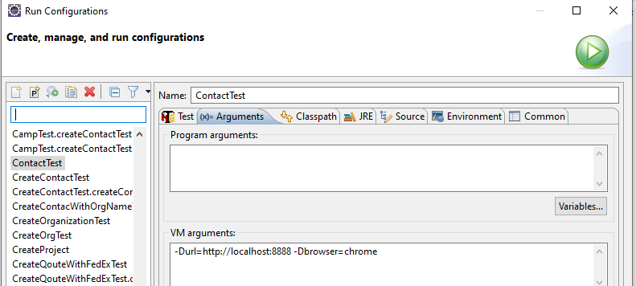

1. Maven Command line Software installation
2. 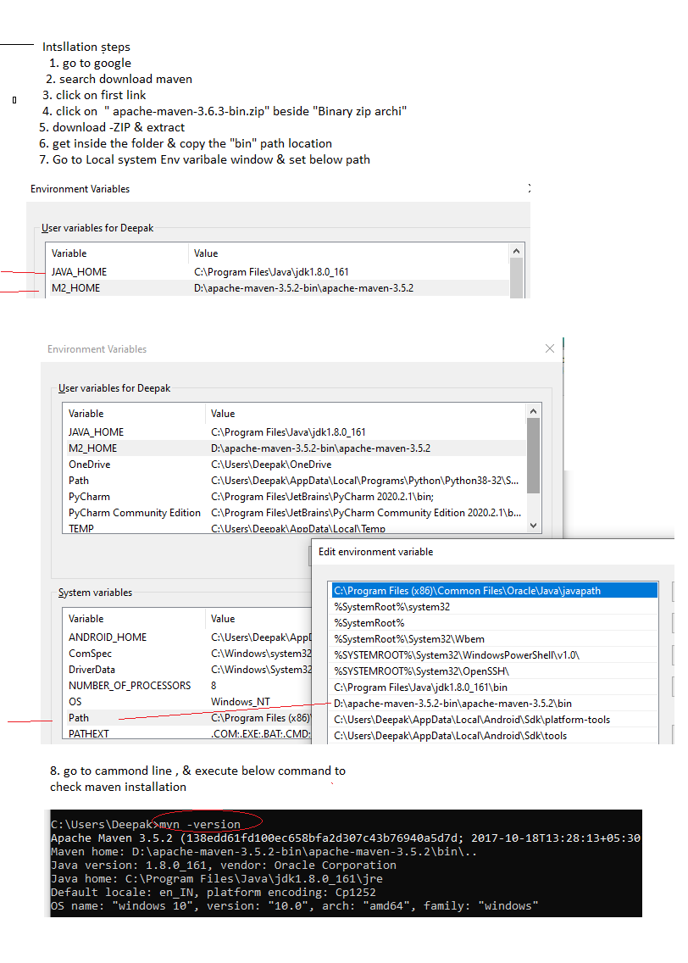
3. Explain maven Build Life Cylcle

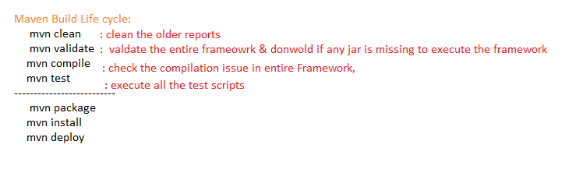

1. Installation Steps :
2. Download Jenkins & install
3. Login to Jenkins & install below Plugin

Jenkins 🡺 Manager Jenkins 🡺 Manage Plugin🡺 Select “Available”

Search & install below Plugins

. Maven Integration

GitHub Integration

1. Configure Env variables in Jenkins for below PlatForm/Software

. JDK : C:\Program Files\Java\jdk1.8.0_161

. Maven : D:\apache-maven-3.5.2-bin\apache-maven-3.5.2

.Git : C:\Program Files\Git\bin\git.exe

Jenkins 🡺 Manager Jenkins🡺 Global tool Configuration

1. What is Jenkins:

Its CI/CD/CD tools

1. What is use of Jenkins in Testing

Jenkins is a Continuous integration tool where continuously monitor the framework Build in git location, then perform appropriate action based on request

Advantages of Jenkins

1. Jenkins Provide 3 level of execution

. On demand : based on Customer demand we can start the execution

. On Scheduling: based on scheduled time , start the execution automatically

. POLL SCM : where continuously monitor the SCM(GitHub) & automatically start the execution whenever we get new Build / one new test script is getting added to Git

1. Email Notification :

. Jenkins sends out an execution Report via email, once execution is completed

. Jenkins also Send Build broken Email, when Compilation issue between the framework component

1. Jenkins also support run time **parameter**
2. Jenkins also Support **Pipeline** Jobs