Measuring Sentence Complexity from Eye-Tracking Measures: An English Replication with GPT-2 Surprisal and a Morphology-Aware Extension to Tamil
A Project Report submitted by
Bhagyalaxmi Pandiyan
in partial fulfillment of the requirements for the award of the degree of
Master of Technology in Data Engineering
[Insert IIT Jodhpur logo here]
Indian Institute of Technology Jodhpur
Data Engineering
November 2026

Declaration
I hereby declare that the work presented in this Project Report titled Measuring Sentence Complexity from Eye-Tracking Measures: An English Replication with GPT-2 Surprisal and a Morphology-Aware Extension to Tamil submitted to the Indian Institute of Technology Jodhpur in partial fulfilment of the requirements for the award of the degree of Master of Technology in Data Engineering, is a bonafide record of the research work carried out under the supervision of Dr. Sidharth Ranjan. The contents of this Project Report in full or in parts, have not been submitted to, and will not be submitted by me to, any other Institute or University in India or abroad for the award of any degree or diploma.

Signature
Bhagyalaxmi Pandiyan
M25DE2070
Certificate
This is to certify that the Project Report titled Measuring Sentence Complexity from Eye-Tracking Measures: An English Replication with GPT-2 Surprisal and a Morphology-Aware Extension to Tamil, submitted by Bhagyalaxmi Pandiyan (M25DE2070) to the Indian Institute of Technology Jodhpur for the award of the degree of Master of Technology in Data Engineering, is a bonafide record of the research work done under my supervision. To the best of my knowledge, the contents of this report, in full or in parts, have not been submitted to any other Institute or University for the award of any degree or diploma.

Signature
Dr. Sidharth Ranjan
Acknowledgements
I am grateful to my supervisor, Dr. Sidharth Ranjan, for the guidance and feedback given throughout this project. I thank the Tamil readers who gave their time to rate sentences and to take part in the eye-tracking study, and the creators of the Dundee corpus, StoryWeaver, UD Tamil-TTB and the open-source tools on which this work is built.
Use of AI tools. Large language models were part of this work in two ways. As research objects, Claude Opus 5.5 produced the Tamil simplifications that were evaluated, and Gemini was evaluated as an LLM judge and is used for live simplification in the toolkit; both uses are reported in the text. As assistants, AI tools were used to help write and debug code and to help draft and edit this report. All experiments were run with the project code, all reported numbers come from its output files, and I have checked the content of this report.
Abstract
This thesis studies how sentence complexity can be measured from human reading behaviour, and how such measures transfer from English to Tamil. First, the two-stage model of Singh et al. is replicated on the Dundee eye-tracking corpus: System 1 predicts four word-level reading-time measures from linguistic features, and System 2 uses these predictions to decide which sentence of a Wikipedia–Simple Wikipedia pair is harder. System 2 reaches 74.15% and 75.26% accuracy, matching the original study. Adding contextual GPT-2 surprisal improves all four reading-time models and exceeds the original results for regression-path and total duration. Second, word-level and morphology-aware difficulty metrics are built for Tamil and tested on graded texts, human-written simplifications, a rating study of LLM simplifications, and a webcam eye-tracking study. Morphological features carry signal on their own but add no reliable gain over word-level features. All components are available in an interactive toolkit.
Contents
1. INTRODUCTION 1
1.1 Motivation 1
1.2 Problem Definition and Objectives 1
1.3 Research Questions 2
1.4 Contributions 2
1.5 Organisation of the Report 3
2. BACKGROUND 4
2.1 Readability and Sentence Complexity 4
2.2 Eye Movements in Reading 4
2.3 Surprisal and Neural Language Models 5
2.4 The Two-Stage Model of Singh et al. 5
2.5 Tamil and Agglutinative Morphology 5
2.6 Text Simplification and Its Evaluation 6
2.7 Webcam Eye-Tracking 6
3. DATA AND METHODS 7
3.1 Overview 7
3.2 English Data 7
3.3 Reading-Time Measures and Aggregation 8
3.4 System 1 Features 8
3.5 System 1 Model 9
3.6 System 2 Model 9
3.7 GPT-2 Surprisal (Phase 2) 9
3.8 Tamil Graded Data (Phase 3) 10
3.9 Tamil Features and Difficulty Metrics 11
3.10 LLM Simplification and Human Evaluation 12
3.11 Webcam Eye-Tracking Study 12
3.12 Statistical Analysis 13
3.13 Software 13
4. EXPERIMENTS I: ENGLISH REPLICATION AND GPT-2 ENHANCEMENT 14
4.1 System 1: Predicting Reading Times 14
4.2 Feature Ablation 14
4.3 Investigating the First Fixation Duration Gap 15
4.4 System 2: Classifying Sentence Pairs 16
4.5 Phase 2: GPT-2 Surprisal 17
4.6 Redundancy of the GPT-2 Feature 18
4.7 Summary of the English Experiments 18
5. EXPERIMENTS II: TAMIL SENTENCE COMPLEXITY 19
5.1 Single-Feature Baselines 19
5.2 Pair Ranking with Feature Groups 19
5.3 LLM Simplification 20
5.4 Human Evaluation 21
5.5 LLM as a Judge 22
5.6 Webcam Eye-Tracking 22
5.7 External Test on Human Simplifications (OasisSimp) 25
5.8 Summary of the Tamil Experiments 26
6. THE TOOLKIT 27
6.1 Design 27
6.2 Phase 2 Tab 28
6.3 Tamil Tab and Safeguards 28
6.4 Reproducibility 28
7. DISCUSSION 29
7.1 What the Replication Shows 29
7.2 What GPT-2 Adds 29
7.3 Why Morphology Did Not Help in Tamil 29
7.4 Automatic Scores and Human Judgments 30
7.5 Webcam Eye-Tracking as a Tool for Low-Resource Languages 30
7.6 Limitations 30
7.7 Ethical Considerations 31
8. CONCLUSION 32
8.1 Summary 32
8.2 Future Work 32
REFERENCES 33
APPENDIX A: REPRODUCING THE RESULTS 36
APPENDIX B: SIMPLIFICATION PROMPT 37

List of Figures
Figure 3.1: Overview of the three phases of the project and the toolkit. 7
Figure 4.1: Test R² of System 1 for the four reading-time measures: replication, replication with GPT-2 surprisal (Section 4.5), and the original paper. 14
Figure 4.2: Cumulative development R² for FFD in the replication and in the original paper. 15
Figure 5.1: Textbook pair accuracy by the class gap between the two sentences. 20
Figure 5.2: Cross-validated R² of the Tamil word reading-time models. 24
Figure 5.3: Mean sentence reading time by pre-defined difficulty band. 25
Figure 6.1: Start page of the Sentence Difficulty Toolkit with the three tabs. 27

List of Tables
Table 3.1: English data sets and resources used in Phases 1 and 2. 7
Table 3.2: Feature groups of System 1. 8
Table 3.3: Tamil data sets used in Phase 3. 10
Table 3.4: The twelve Tamil sentence features. 11
Table 4.1: System 1 results on the Dundee corpus compared with Singh et al. [3]. 14
Table 4.2: Cumulative development R² for FFD as feature groups are added. 15
Table 4.3: Explanations tested for the FFD gap. 16
Table 4.4: System 2 pairwise accuracy on 117,712 Wikipedia–Simple Wikipedia pairs (10-fold cross-validation). 17
Table 4.5: Parser-based syntactic surprisal and GPT-2 surprisal as predictors of FFD. 17
Table 4.6: FFD test R² for GPT-2 variants. 17
Table 4.7: Test R² of System 1 with and without GPT-2 surprisal (with context). 18
Table 5.1: Test accuracy of selected single features (chance = 50%). 19
Table 5.2: Pair-ranking test accuracy with 95% bootstrap confidence intervals. 19
Table 5.3: Gain over the word-level model A (paired bootstrap, percentage points). 20
Table 5.4: Mean feature values of original and simplified sentences (60 pairs). 21
Table 5.5: Reader judgments of the sixty original–simplified pairs (12 readers, 6 ratings per item). 21
Table 5.6: Spearman correlation between metric scores and mean human difficulty. 22
Table 5.7: Gemini as an LLM judge compared with the human readers. 22
Table 5.8: Readers of the webcam eye-tracking study. 23
Table 5.9: Cross-validated R² for Tamil word reading times (95% sentence-bootstrap intervals). 23
Table 5.10: Spearman correlation of metric scores with Tamil sentence reading time. 24
Table 5.11: Accuracy on 1,904 OasisSimp Tamil pairs (models trained on StoryWeaver only). 25
Table 6.1: Tabs of the toolkit. 27
Table 6.2: Test R² of the reduced System 1 used in the Phase 2 tab. 28
Table A.1: Pipeline scripts and their outputs. 36

1. INTRODUCTION

1.1 Motivation
Every reader has met a sentence that had to be read twice. Sometimes the cause is a rare word, sometimes a long chain of clauses, and sometimes a construction that leads the reader down the wrong path before the last word forces a reinterpretation. Being able to measure this kind of difficulty automatically is useful in several settings: choosing reading material for school children, checking whether public information is accessible, and evaluating systems that rewrite text into simpler language. Classical readability formulas estimate difficulty from surface counts such as words per sentence and syllables per word [1]. They are easy to compute, but they say little about where in a sentence a reader actually struggles.
Eye-tracking offers a more direct view. When people read, their eyes do not move smoothly; they stop on words (fixations) and jump between them (saccades), and the duration and pattern of these stops reflect the effort spent on each word [2]. Singh et al. [3] used this observation to build a two-stage model of sentence complexity. In the first stage, a regression model learns to predict four word-level reading-time measures from linguistic features, using the Dundee eye-tracking corpus [4]. In the second stage, the predicted reading times are used as features to decide which of two sentences is harder to read. Because the second stage only needs predicted reading times, the model can score any new sentence without running a new eye-tracking experiment.
This thesis starts from that model and asks two further questions. The first concerns English: modern neural language models such as GPT-2 [5] give much better estimates of how predictable a word is than the statistical parsers available in 2016. Does replacing the older predictability features with GPT-2 surprisal improve the prediction of reading times? The second concerns transfer to another language. Tamil, a Dravidian language spoken by more than seventy million people, is agglutinative: a single written word often consists of a stem followed by several grammatical suffixes [6]. In such a language, a long word is not necessarily a rare or difficult word; it may simply carry case, tense and person markers that English would express with separate words. This raises a natural hypothesis: for Tamil, morphemes rather than words may be the better unit for measuring difficulty.

1.2 Problem Definition and Objectives
The problem addressed in this thesis is the automatic estimation of sentence complexity from features that are grounded in human reading behaviour, and the transfer of such estimation from a resource-rich language (English) to a language with very limited resources for this task (Tamil). For Tamil there is, to our knowledge, no eye-tracking corpus comparable to Dundee and no sentence-level readability dataset, so part of the work consists of building evaluation data. The objectives are:
- Replicate the two-stage model of Singh et al. [3] on the Dundee corpus and compare every reported number with the original paper.
- Enhance the reading-time model with GPT-2 surprisal and measure the gain on all four reading-time measures.
- Extend the approach to Tamil by building a word-level difficulty metric and a morphology-aware metric, and test whether morphology improves difficulty prediction on graded Tamil text.
- Validate both Tamil metrics against people: a rating study of sentences simplified by a large language model (LLM), and a webcam eye-tracking study of Tamil reading.
- Deliver an interactive toolkit that runs every part of the work live on sentences typed by a user.

1.3 Research Questions
The experiments are organised around four research questions (RQ):
- RQ1. Can the published results of the two-stage model be reproduced from the original data sources, and where they cannot, why not?
- RQ2. Does contextual GPT-2 surprisal improve the prediction of word reading times beyond the original lexical and syntactic features?
- RQ3. In Tamil, do morphological features improve sentence-difficulty prediction over a word-level baseline?
- RQ4. Do the word-level and morphology-aware Tamil metrics agree with human judgments of simplified text and with Tamil reading times measured by webcam eye-tracking?

1.4 Contributions
The main contributions of this work are the following. First, a complete and documented replication of the two-stage model, in which the classification stage matches or slightly exceeds the published accuracy (74.15% and 75.26% against 73.82% and 75.21%), together with a careful analysis of the one result that could not be reproduced, the first fixation duration model. Second, evidence that GPT-2 surprisal raises the test R² of all four reading-time measures, so that regression-path and total duration predictions now exceed the original paper. Third, the first systematic comparison, to our knowledge, of word-level and morphology-aware difficulty features for Tamil on two graded corpora, an external set of human simplifications, a human rating study and a webcam eye-tracking study. Its central finding is negative but consistent: morphological features carry signal on their own, but they add no reliable information once word-level features are included. Fourth, two reusable tools: a browser-based eye-tracking study for Tamil and a toolkit that demonstrates all phases of the project live.

1.5 Organisation of the Report
Chapter 2 reviews the background on readability, eye movements, surprisal, Tamil morphology and text simplification. Chapter 3 describes all data sets and methods. Chapter 4 reports the English experiments (replication and GPT-2 enhancement), and Chapter 5 the Tamil experiments. Chapter 6 presents the toolkit. Chapter 7 discusses the results and the limitations of the work, and Chapter 8 concludes with directions for future work. Appendix A explains how to reproduce every result from the project repository, and Appendix B lists the simplification prompt.

2. BACKGROUND

2.1 Readability and Sentence Complexity
Research on readability has a long history. Early formulas such as the Flesch Reading Ease score combine average sentence length with average word length in syllables [1]. These formulas were designed for whole texts and assume that longer words and longer sentences are harder. Later work in natural language processing treated readability as a supervised learning problem, combining many lexical, syntactic and discourse features in a classifier trained on graded texts [7], [8]. Graded texts, such as school books written for different ages, provide convenient labels, but the label belongs to the whole book; individual sentences inside a book can vary widely in difficulty.
At the level of a single sentence, psycholinguistic theories point to two broad sources of difficulty. Memory-based accounts, such as the dependency locality theory [9], locate difficulty in long-distance dependencies that require the reader to hold material in working memory. Expectation-based accounts locate difficulty in unpredictable words: a word that the reader did not expect takes longer to process [10], [11]. Both kinds of predictors have been tested on eye-tracking corpora, and both explain part of the variance in reading times [12].

2.2 Eye Movements in Reading
During reading, the eyes alternate between fixations, which last around 200–250 ms on average, and rapid saccades. Not every word is fixated; short and predictable words are often skipped, and readers sometimes move back to earlier words (regressions) [2]. Eye-tracking studies summarise this behaviour with word-level measures. Following Singh et al. [3], four measures are used in this thesis:
- First fixation duration (FFD): the duration of the first fixation on a word during the first pass through the text.
- First pass duration (FPD): the sum of all fixations on a word during the first pass, before the eyes leave the word in either direction.
- Regression path duration (RPD): the time from the first fixation on a word until the eyes move past it to the right, including any regressions to earlier words.
- Total duration (TD): the sum of all fixations on the word, including later re-readings.
FFD reflects early lexical access, while RPD and TD also include integration and re-analysis. The Dundee corpus [4] provides these measures for ten native English readers who read twenty newspaper editorials, about 50,000 words in total, on a high-precision eye-tracker. It has become a standard resource for testing models of reading.

2.3 Surprisal and Neural Language Models
Surprisal theory states that the processing cost of a word is proportional to its surprisal, the negative logarithm of its probability given the preceding context [10], [11]:
S(w_{i}) = −log P(w_{i} | w₁, …, w_{i−1}) (2.1)
Large studies have confirmed that reading time grows roughly linearly with surprisal [13]. The quality of the surprisal estimate depends on the language model. Singh et al. used n-gram probabilities for lexical surprisal and a probabilistic parser for syntactic surprisal [14]. Transformer language models such as GPT-2 [5] condition on much longer contexts and give better next-word predictions. Their surprisal estimates predict human reading times well [15], although larger models are not always better: Oh and Schuler showed that surprisal from larger Transformer models can fit reading times worse, because these models predict rare and specialised words too well compared with human readers [16].

2.4 The Two-Stage Model of Singh et al.
Singh et al. [3] proposed to quantify sentence complexity with two systems. System 1 is a linear regression model that predicts each of the four reading-time measures for every word from linguistic features: word length, sentence length, word frequency, age of acquisition, transition probabilities, lexical and syntactic surprisal, entropy reduction, embedding depth and a set of parser-based hierarchical features. System 2 then represents a sentence by the vector of reading times predicted by System 1 and trains a classifier on pairs of sentences from English Wikipedia and Simple English Wikipedia [17] to decide which member of the pair is the complex one. In the original paper, System 1 reached test R² values between 0.516 and 0.649, and System 2 reached about 74–75% pairwise accuracy. The appeal of this design is that System 2 inherits a notion of difficulty grounded in reading behaviour, but can be applied to any text.

2.5 Tamil and Agglutinative Morphology
Tamil is a Dravidian language with a rich, mostly suffixing morphology [6]. Nouns take case, number and postpositional suffixes, and verbs take tense, person, number and gender markers, as well as a range of non-finite forms (participles and converbs) that are used to build complex sentences. As a consequence, a single written Tamil word can correspond to a whole English phrase. For difficulty measurement this matters in two ways. First, word length in characters mixes two different things: the length of the stem and the number of grammatical suffixes. Second, a word-frequency list will contain many rare surface forms of common stems. A morphology-aware representation, which counts morphemes and estimates the predictability of stems and suffixes separately, could in principle separate these sources of difficulty. Tools for Tamil morphology include unsupervised segmenters such as Morfessor [18], whose Tamil models are distributed with the IndicNLP resources [19], and neural pipelines such as Stanza [20], trained on the Universal Dependencies treebanks [21], [22].

2.6 Text Simplification and Its Evaluation
Text simplification rewrites a text so that it is easier to read while keeping its meaning. Modern systems increasingly use large language models prompted with instructions. Evaluating simplification is difficult: automatic measures can show that a rewrite is shorter or uses more frequent words, but they cannot show by themselves that the result is easier to understand, correct and faithful to the original [23]. Human evaluation therefore remains the reference. This thesis uses LLM simplification not as an end in itself, but as a test bed: if a complexity metric is useful, its scores should agree with what readers say about original and simplified sentences.

2.7 Webcam Eye-Tracking
Laboratory eye-trackers are accurate but expensive and require participants to come to the lab. WebGazer [24] estimates gaze in the browser from an ordinary webcam, after the participant calibrates it by clicking on points on the screen. Its spatial error is much larger than that of a laboratory tracker (typically more than 100 pixels) and its sampling rate is limited by the camera to around 30 Hz. Fixations can still be detected from the gaze samples with a dispersion-threshold algorithm [25]. Webcam tracking therefore cannot replace laboratory data at the level of single words, but it makes small reading studies possible in languages, such as Tamil, for which no eye-tracking data exist.

3. DATA AND METHODS

3.1 Overview
The work consists of three phases that share the same idea: difficulty is estimated from linguistic features whose relevance is checked against human behaviour. Figure 3.1 summarises the phases. Phase 1 replicates the English two-stage model, Phase 2 adds GPT-2 surprisal to it, and Phase 3 builds and evaluates two difficulty metrics for Tamil. All phases are available in a single interactive toolkit.
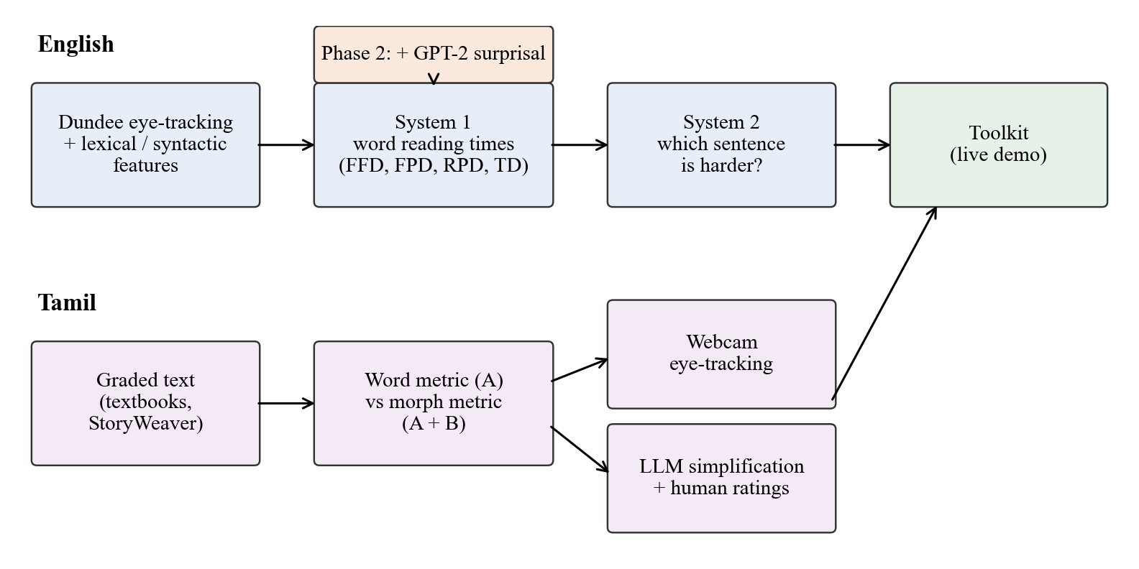
Figure 3.1: Overview of the three phases of the project and the toolkit.

3.2 English Data
Table 3.1 lists the English resources. The Dundee corpus provides the reading times. The British National Corpus [26] provides bigram counts for transition probabilities and lexical surprisal, the Penn Treebank [27] provides part-of-speech statistics for syntactic features, and the age-of-acquisition norms of Kuperman et al. [28] provide the age at which words are typically learned. Word frequencies are taken from the wordfreq package [29]. The sentence pairs for System 2 come from the aligned English Wikipedia–Simple Wikipedia corpus of Hwang et al. [17].
Table 3.1: English data sets and resources used in Phases 1 and 2.
Resource | Content | Use
Dundee corpus [4] | 10 readers, 20 editorials, 50,647 word positions, 2,369 sentences | Reading-time targets (System 1)
British National Corpus [26] | About 100 million words | Transition probabilities, lexical surprisal, entropy
Penn Treebank [27] | Wall Street Journal, POS-tagged and parsed | Syntactic surprisal, parser features
Age-of-acquisition norms [28] | Ratings for about 30,000 words | Mean and standard deviation of AoA
wordfreq [29] | Multi-source word frequencies | Word frequency feature
Wikipedia–Simple Wikipedia [17] | 117,712 aligned sentence pairs | Training and testing System 2

3.3 Reading-Time Measures and Aggregation
The Dundee eye-movement files were parsed into one record per reader and word, from which FFD, FPD, RPD and TD were computed with the definitions of Section 2.2. Because the goal is to predict the difficulty of a word, not the behaviour of one reader, the measures were aggregated per word position. For a word w read by N = 10 readers, the target value is
RT(w) = (1 / N) Σ_{s=1..N} RT_{s}(w), with RT_{s}(w) = 0 if reader s skipped w (3.1)
so that skipping contributes a zero reading time. This word-level average produced 50,647 training rows and gave the closest match to the published results among the aggregation schemes we tested (Section 4.3).

3.4 System 1 Features
System 1 uses the feature groups of the original paper, summarised in Table 3.2. Lexical features are computed per word. Syntactic features combine bigram statistics from the British National Corpus, part-of-speech bigram statistics from the Penn Treebank, and dependency parses distributed with the Dundee corpus. Syntactic surprisal was additionally computed with the left-corner parser of van Schijndel et al. [14], the method used in the original paper.
Table 3.2: Feature groups of System 1.
Group | Features | Source
Word length | Number of letters | Dundee text
Sentence length | Number of words in the sentence | Dundee text
Frequency | Log word frequency | wordfreq
Age of acquisition | Mean and standard deviation of AoA | Kuperman et al.
Transition probability | Forward and backward bigram probability | BNC
Surprisal | Lexical, syntactic and total surprisal | BNC, left-corner parser
Entropy reduction | Decrease in next-word entropy | BNC
Embedding | Embedding depth and depth difference | Dependency parses
Hierarchical structure | Eight binary parser operations (h1–h8) | Parser

3.5 System 1 Model
For each reading-time measure, System 1 is a ridge regression model [30] trained on standardised features x with target y:
β* = argmin_{β} ( |y − Xβ|² + α |β|² ) (3.2)
The regularisation strength α is selected on a development set from {0.01, 0.1, 1, 10, 100}; ridge regression was preferred over ordinary least squares because the hierarchical features h1–h8 are strongly collinear. Following the original paper, the model also learns a threshold τ that models word skipping: predictions below τ are set to zero,
ŷ' = ŷ if ŷ ≥ τ, and ŷ' = 0 otherwise (3.3)
where τ is tuned on the development set (for FFD the selected value was 55 ms; for the other measures no threshold improved the fit). Sentences, not words, are split 60/20/20 into training, development and test sets (random seed 42), so that no sentence contributes words to more than one set. Performance is the coefficient of determination on the held-out test words,
R² = 1 − Σ_{i} (y_{i} − ŷ_{i})² / Σ_{i} (y_{i} − ȳ)² (3.4)
An ablation study adds the feature groups one at a time in the order of the original paper and records the cumulative development R².

3.6 System 2 Model
System 2 decides which sentence of a pair is more complex. In the base model, System 1 predicts the FFD of every word; the predictions for each sentence are padded or truncated to 60 positions, and the two vectors are concatenated into a 120-dimensional representation of the pair. The extended model adds, for each sentence, its length, its mean predicted FFD and its summed lexical surprisal. A logistic regression classifier estimates
P(A is harder | A, B) = σ(w^{T} [f(A); f(B)] + b) (3.5)
where f(·) is the sentence representation and σ the logistic function. Both orders of every pair are included, giving 235,424 instances, and accuracy is estimated with stratified 10-fold cross-validation. A linear support vector machine with the same features was also trained as the counterpart of the SVMrank model in the original paper. All models use scikit-learn [31].

3.7 GPT-2 Surprisal (Phase 2)
For Phase 2, the surprisal of every Dundee word was computed with the 124-million-parameter GPT-2 model [5] using the Transformers library [32]. GPT-2 works on subword tokens produced by byte-pair encoding, so a word may consist of several tokens. The surprisal of a word is the sum of the surprisals of its tokens,
S(w) = Σ_{t ∈ tokens(w)} −ln P(t | preceding tokens) (3.6)
measured in nats. Tokens are assigned to words through their character offsets. One subtle point required a fix: the tokenizer attaches the space before a word to the word's first token, so a token can start inside the preceding context while belonging to the current word. Tokens are therefore assigned by the position where they end, not where they start. Two versions were computed: surprisal of each sentence in isolation (preceded only by the beginning-of-text token) and surprisal with up to three preceding sentences of the same editorial (at most 300 tokens) as context. A larger model, GPT-2 medium (355 million parameters), was also tested. The GPT-2 feature was evaluated by adding it to the System 1 feature set and by swapping it in for the parser-based syntactic surprisal.

3.8 Tamil Graded Data (Phase 3)
No sentence-level readability data exist for Tamil, so two graded sources were used as proxies (Table 3.3). The first is the set of Tamil language textbooks of the Tamil Nadu State Board for Classes 3 to 12. Prose sentences were extracted from the PDF files; poetry was excluded and three regular expressions repaired font-encoding artefacts. The second source is StoryWeaver [33], an open library of children's books whose Tamil titles carry reading levels 1 to 4; we used the short descriptions of the books. In both cases the difficulty label belongs to a book, not to a sentence.
Pairs were built from sentences whose labels differ enough to make the comparison meaningful: at least three school classes for textbooks and at least two reading levels for StoryWeaver. The pair order was randomised, and the train/test split (80/20) was made by textbook page or by StoryWeaver book, so that sentences from the same page or book never appear in both sets. A length-matched subset contains the test pairs whose sentence lengths differ by at most one word; on this subset, sentence length alone cannot solve the task.
Table 3.3: Tamil data sets used in Phase 3.
Data set | Size | Labels / use
Tamil Nadu textbooks, Classes 3–12 | 2,351 sentences; 8,004 pairs (4,176 train, 3,828 test) | School class; pair ranking
StoryWeaver book descriptions [33] | 7,080 sentences; 7,492 pairs (5,994 train, 1,498 test) | Reading level 1–4; pair ranking, metric training
Simplification set | 60 sentences (30 textbook Class 11–12, 30 StoryWeaver level 4) | LLM simplification and human ratings
UD Tamil-TTB [22] | 100 news sentences (6–16 words) | Webcam eye-tracking study
OasisSimp Tamil [34] | 520 complex sentences, 1,904 human simplification pairs | External test (Section 5.7)

3.9 Tamil Features and Difficulty Metrics
Each Tamil sentence is described by twelve features in three groups (Table 3.4). Group A mirrors the English word-level features. Group B is the morphology-aware extension. Group C adds two dependency-based syntax measures. Stanza [20] provides tokenisation, lemmas, morphological features and dependency parses; on the UD Tamil-TTB test set its lemma accuracy is 91.4% and its case accuracy 94.6%. Morpheme boundaries come from the pretrained Tamil Morfessor model of the IndicNLP resources [18], [19]. Word frequencies are taken from wordfreq.
Table 3.4: The twelve Tamil sentence features.
Group | Feature | Description
A: word-level | n_words | Number of words
A: word-level | word_len | Mean word length in characters
A: word-level | word_zipf | Mean word frequency (Zipf scale)
A: word-level | word_surprisal | Mean word surprisal from Tamil GPT-2
B: morphology | morphs_per_word | Mean number of morphemes per word
B: morphology | stem_surprisal | Mean surprisal of the stem span
B: morphology | suffix_surprisal | Mean surprisal of the suffix span
B: morphology | feats_per_word | Marked morphological features per word
B: morphology | lemma_zipf | Mean frequency of the dictionary form
B: morphology | nonfinite_verbs | Number of participles and converbs
C: syntax | tree_depth | Depth of the dependency tree
C: syntax | dep_distance | Mean dependency distance

Surprisal comes from a Tamil GPT-2 model [35]. Its tokenizer is a byte-level encoder that splits a Tamil word into about seven tokens on average, and its token boundaries do not match morpheme boundaries. Token surprisal is therefore spread over the characters the token covers and summed over the character span of each word, stem or suffix. This gives an alignment-based estimate of morpheme surprisal rather than the output of a model trained on morphemes.
Difficulty models are trained on pairs. For a pair of sentences with feature vectors x_{A} and x_{B}, a logistic regression without intercept models the probability that A is the harder sentence:
P(A harder) = σ(w^{T} (x_{A} − x_{B})) (3.7)
Because the model is linear in the feature difference, its weight vector also defines a score for a single sentence, score(s) = w^{T} x_{s}, where a higher score means a harder sentence. Two metrics are defined in this way and trained on the StoryWeaver training pairs: the word metric, which uses group A only, and the morph metric, which uses groups A and B. Model comparisons on the pair task use the combinations A, B, C, A+B, A+C and A+B+C.

3.10 LLM Simplification and Human Evaluation
To test the metrics on texts that differ in a controlled way, sixty complex sentences were selected at random from the eligible Class 11–12 textbook sentences and StoryWeaver level-4 sentences (10–30 words, no extraction artefacts). One LLM system, Claude Opus 5.5 [36], rewrote each sentence for a Class 3–5 child, using a fixed prompt (Appendix B) that asked it to keep the meaning, use common words, avoid long suffix chains and, if needed, split the sentence. When a rewrite contained several sentences, its features were averaged over them, so that splitting did not change the score merely by changing the number of sentences.
The sixty original–simplified pairs were divided into two Google Forms of thirty pairs each. In every pair the two versions appeared in random order as A and B, and readers were not told which one was generated. For each pair, readers answered five questions: which sentence was easier (A, B, or the same), how difficult A and B each were, from 1 (very easy) to 5 (very hard), whether the two sentences had the same meaning (1–5), and whether either sentence contained errors. Twelve native or fluent Tamil readers took part, five in the first form and seven in the second. As an additional, separately reported analysis, a Gemini model [37] answered the same questions as an LLM judge; its answers were never pooled with the human ratings.

3.11 Webcam Eye-Tracking Study
To test the original System 1 task on Tamil, a browser-based reading study was built. The reading material consists of 100 sentences, each 6 to 16 words long, taken from the UD Tamil-TTB treebank, which is built from Dinamani newspaper text [22], excluding sentences with digits, Latin script, brackets or quotation marks. The candidates were ranked by a combination of length, dependency distance, tree depth and word length and divided into easy, medium and hard thirds, from which 33, 33 and 34 sentences were sampled. After 20 of the sentences, readers answered a yes/no question asking whether a given word had appeared in the sentence, which checks that they were actually reading.
The study runs in the participant's own browser and uses WebGazer [24] for gaze estimation. It begins with a 13-point click calibration and a 9-point validation; if the median validation error exceeds 150 pixels, the participant recalibrates. The sentences are shown whole, one at a time, in random order and in four blocks of 25 with a break and a short recalibration after each block. Before each sentence, a fixation dot is used for drift correction. The participant presses ENTER after reading. Fixations are detected with a dispersion-threshold algorithm [25] (dispersion 100 px, duration 80–1,200 ms) and assigned to word boxes, and FFD, FPD, RPD and TD are computed with the same definitions as in the Dundee pipeline. A sentence is marked unusable for word-level analysis when fewer than 70% of its gaze samples are valid or more than half fall outside the text. Each sentence is uploaded to a Google Sheet as soon as it is finished, and no webcam images are stored.
Participants were included if they answered at least 80% of the probes correctly, a rule fixed before the data were analysed. Two further decisions were made after the experimenter confirmed the identity of participants: two different people who had typed the same participant code were treated as two readers, and for one person who took part twice, only sentences read for the first time were used.

3.12 Statistical Analysis
Because test sets in Phase 3 are small, all comparisons are reported with bootstrap confidence intervals [38]. For the pair task, 1,000 bootstrap samples of test sentences are drawn, and the gain of one model over another is computed on the same samples (a paired bootstrap); the one-sided p-value is the share of samples in which the gain is not positive. Human ratings are compared with metric scores with Spearman's rank correlation ρ, using 2,000 bootstrap samples of items in which both texts of a pair are always resampled together. In the eye-tracking study, each word's reading time is the average over those readers with usable gaze on its sentence, with a skipped word contributing zero exactly as in Equation 3.1, and linear regressions are evaluated with 10-fold cross-validation grouped by sentence, so that the words of one sentence are never split between training and test folds. Every word-level model also contains control variables for layout: the word's position, whether it starts or ends a line, and the length of its sentence. For the sentence-level analysis, reading times are log-transformed, trimmed at three standard deviations, standardised within each reader and averaged.

3.13 Software
All code is written in Python. Data handling uses pandas, models use scikit-learn [31], language models use PyTorch and Transformers [32], and the toolkit uses Gradio [39]. The eye-tracking study is written in JavaScript and hosted as a static web page. Every script reads its inputs from and writes its outputs to the project folders, so that each result in Chapters 4 and 5 can be regenerated by running the scripts listed in Appendix A in order.

4. EXPERIMENTS I: ENGLISH REPLICATION AND GPT-2 ENHANCEMENT

4.1 System 1: Predicting Reading Times
Table 4.1 compares the System 1 results with the original paper. Three of the four measures are close to the published values. The model for total duration slightly exceeds the paper (0.538 against 0.516), while first-pass and regression-path duration fall short by 0.039 and 0.012 R². The clear exception is first fixation duration, where the replication reaches 0.447 against 0.649. Train, development and test R² are close to each other, so the models do not overfit.
Table 4.1: System 1 results on the Dundee corpus compared with Singh et al. [3].
Measure | Threshold | Train R² | Dev R² | Test R² | Paper R²
FFD | 55 ms | 0.498 | 0.506 | 0.447 | 0.649
FPD | – | 0.582 | 0.583 | 0.561 | 0.600
RPD | – | 0.579 | 0.583 | 0.558 | 0.570
TD | – | 0.563 | 0.565 | 0.538 | 0.516

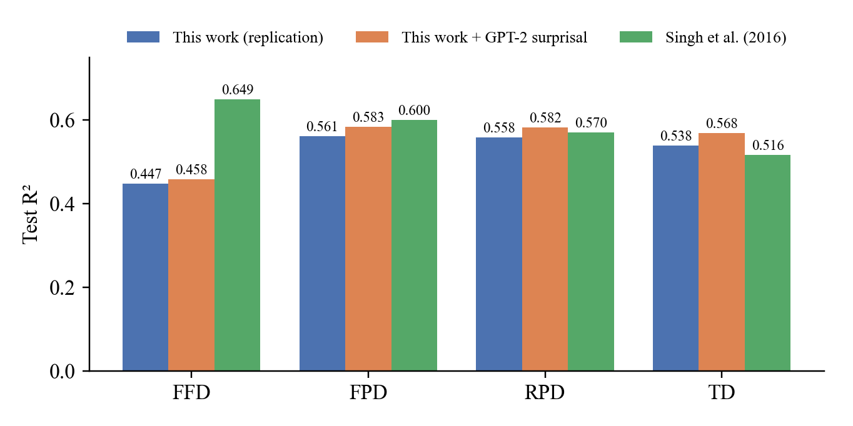
Figure 4.1: Test R² of System 1 for the four reading-time measures: replication, replication with GPT-2 surprisal (Section 4.5), and the original paper.

4.2 Feature Ablation
The ablation study (Table 4.2 and Figure 4.2) shows where the FFD gap comes from. In the original paper, word length alone gives R² = 0.267, and adding sentence length raises it by 0.233 to 0.500. In the replication, word length alone already gives 0.447, and sentence length adds nothing. After word frequency is added, both curves are at almost the same level (0.505 and 0.506). From that point on, the paper reports a slow, steady increase from the remaining features, while in the replication they add almost nothing (0.506 → 0.507). The difference between the two studies is therefore concentrated in two places: the first step (word length and sentence length) and the small cumulative contribution of the parser-based features.
Table 4.2: Cumulative development R² for FFD as feature groups are added.
Step | Feature group added | This work | Paper
1 | Word length | 0.447 | 0.267
2 | + Sentence length | 0.447 | 0.500
3 | + Word frequency | 0.505 | 0.506
4 | + Mean AoA | 0.505 | 0.510
5 | + SD of AoA | 0.505 | 0.516
6 | + Transition probabilities | 0.506 | 0.544
7 | + Lexical surprisal | 0.506 | 0.568
8 | + Syntactic surprisal | 0.506 | 0.575
9 | + Entropy reduction | 0.506 | 0.579
10 | + Embedding depth | 0.506 | 0.580
11 | + Embedding difference | 0.507 | 0.581
12 | + Hierarchical structure (h1–h8) | 0.506 | 0.585

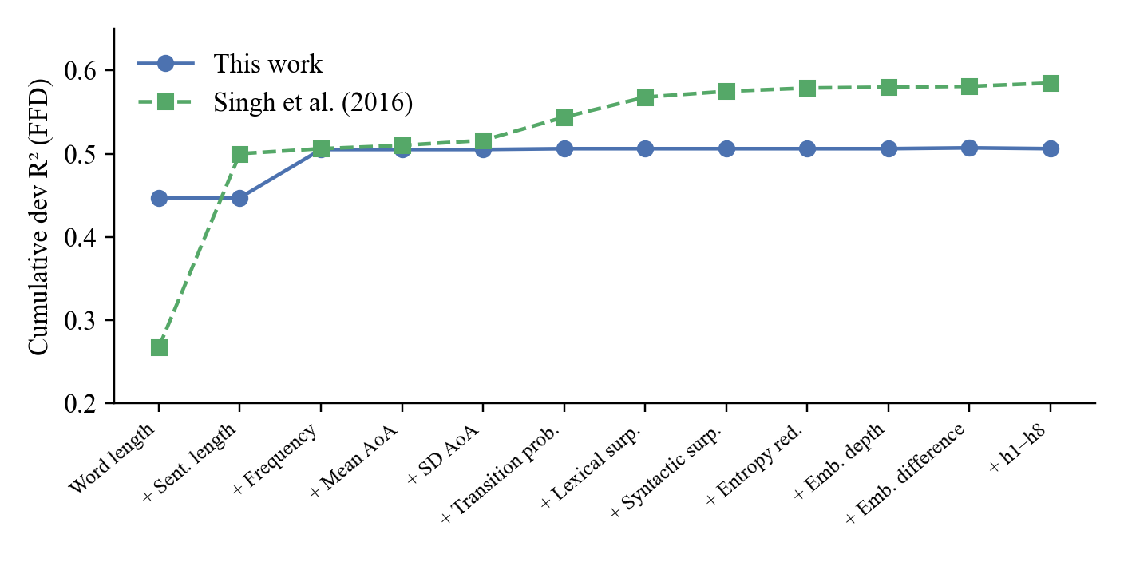
Figure 4.2: Cumulative development R² for FFD in the replication and in the original paper.

4.3 Investigating the First Fixation Duration Gap
Because the FFD gap is the main result that could not be reproduced, several explanations were tested in turn. They are summarised in Table 4.3.
Table 4.3: Explanations tested for the FFD gap.
Hypothesis | Test | Outcome
Sentence length carries a strong signal that the replication misses | Correlation of sentence length with FFD | r = −0.058 here; the paper's own Table 1 reports r = −0.009. Rejected.
The parser-based syntactic surprisal was computed incorrectly | Recomputed with the left-corner parser of the original method on all 50,647 words | r = −0.017 with FFD (paper: −0.067); adds 0.000 R². Rejected.
Skipped words (RT = 0) let word length act as a skipping predictor | Train on fixated words only | No word-level average equals zero (minimum FFD 5.1 ms); results identical. Rejected.
A different aggregation of readers was used | Mean over fixating readers; per-reader events; full grid with zeros | Word-length R² of 0.028, 0.008 and 0.128, all further from the paper
The paper's two tables use different data or definitions | Compare r(word length, FFD) with single-feature R² | Paper: r = 0.765 implies R² = 0.585, yet its ablation reports 0.267. Inconsistent.

The last row deserves explanation. For a regression with a single predictor, the R² on the same data equals the square of the Pearson correlation. The original paper reports a correlation of 0.765 between word length and FFD, which corresponds to R² = 0.585, but its ablation table gives R² = 0.267 for word length alone. Both numbers cannot describe the same data and model. In the replication, the two quantities agree (squared correlation 0.451, train R² 0.445, development R² 0.447). Ordinary overfitting cannot explain the paper's difference, because a one-feature model trained on about 30,000 words generalises almost perfectly. We therefore conclude that the FFD gap most likely reflects a difference in data preparation or reporting in the original study that cannot be recovered from the paper, rather than an error in the replication. A related observation supports this view: at the level of individual fixation events, word length explains less than 1% of FFD variance; its strong effect appears only after averaging over a fixed set of ten readers, where it captures how likely a word is to be fixated rather than how long it is fixated.

4.4 System 2: Classifying Sentence Pairs
Table 4.4 shows the System 2 results. Both logistic regression models match or slightly exceed the original paper: 74.15% for the base model (paper 73.82%) and 75.26% for the extended model (paper 75.21%). The linear SVM gives practically the same accuracy. This is an important result for the replication: although the FFD predictions of System 1 explain less variance than in the paper, they carry enough information about sentence difficulty to reproduce the classification results. The extended model's small gain shows that sentence length and summed surprisal add information beyond the word-by-word reading-time profile.
Table 4.4: System 2 pairwise accuracy on 117,712 Wikipedia–Simple Wikipedia pairs (10-fold cross-validation).
Model | Classifier | This work | Paper
Base RT | Logistic regression | 74.15% | 73.82%
Base RT | Linear SVM (SVMrank) | 74.13% | 73.79%
Extended RT | Logistic regression | 75.26% | 75.21%
Extended RT | Linear SVM (SVMrank) | 75.23% | 75.09%

4.5 Phase 2: GPT-2 Surprisal
The analysis above showed that the parser-based syntactic surprisal carries no information about FFD in this data, in agreement with the near-zero correlation in the original paper. GPT-2 surprisal behaves very differently (Table 4.5): it correlates with FFD at r = 0.454 and explains 22% of the development variance on its own. It is also not just a proxy for word length; adding it to word length raises the development R² from 0.447 to 0.467.
Table 4.5: Parser-based syntactic surprisal and GPT-2 surprisal as predictors of FFD.
Feature | Correlation with FFD | R² alone (dev)
Syntactic surprisal (left-corner parser) | −0.017 | 0.000
GPT-2 surprisal (124M, sentence only) | 0.454 | 0.220

The GPT-2 experiments retrain their own baseline on the same split; because this baseline uses the left-corner parser surprisal column, its FFD R² (0.444) differs by 0.003 from Table 4.1, and all gains below are measured against this matched baseline. Table 4.6 compares the GPT-2 variants. Swapping the syntactic surprisal for GPT-2 surprisal is slightly better than adding it. Giving GPT-2 the three preceding sentences as context improves both the correlation (0.465) and the FFD test R² (0.458). The larger GPT-2 medium model is worse than the small model, in line with the finding of Oh and Schuler that larger Transformer models fit human reading times less well [16].
Table 4.6: FFD test R² for GPT-2 variants.
Variant | Correlation with FFD | FFD test R²
Baseline (no GPT-2) | – | 0.4439
GPT-2 added as an extra feature | 0.454 | 0.4509
GPT-2 replaces syntactic surprisal | 0.454 | 0.4514
GPT-2 medium (355M) replaces syntactic surprisal | 0.407 | 0.4483
GPT-2 with three preceding sentences as context | 0.465 | 0.4577

Table 4.7 applies the best variant to all four measures. GPT-2 surprisal improves every measure, and the gain grows from early to late measures: +0.014 for FFD, +0.025 for FPD, +0.027 for RPD and +0.032 for TD. With this feature, the replication now exceeds the original paper on regression-path duration (0.582 against 0.570) and total duration (0.568 against 0.516), and is within 0.017 of it on first-pass duration. This pattern is plausible: later measures include re-reading and integration, which depend more on how well a word fits its context.
Table 4.7: Test R² of System 1 with and without GPT-2 surprisal (with context).
Measure | Baseline | + GPT-2 | Gain | Paper
FFD | 0.444 | 0.458 | +0.014 | 0.649
FPD | 0.558 | 0.583 | +0.025 | 0.600
RPD | 0.555 | 0.582 | +0.027 | 0.570
TD | 0.536 | 0.568 | +0.032 | 0.516

4.6 Redundancy of the GPT-2 Feature
To check whether GPT-2 surprisal simply repeats information that the model already had, its correlation with the other features was examined. At the word level it correlates moderately with the other predictability measures (lexical surprisal r = 0.56, word frequency r = −0.65, age of acquisition r = 0.54, word length r = 0.51), as expected, but hardly at all with the parser-based syntactic surprisal (r = 0.014). At the sentence level, one aggregation should be avoided: the sum of GPT-2 surprisal over a sentence correlates at r = 0.914 with sentence length, because longer sentences simply contain more words. The mean surprisal per word does not have this problem and correlates at 0.45–0.53 with the four sentence-level reading measures.

4.7 Summary of the English Experiments
The replication answers RQ1 positively for System 2 and for three of the four System 1 measures. The one gap, FFD, was investigated systematically and traced to an inconsistency inside the original paper rather than to the replication pipeline. For RQ2, GPT-2 surprisal is a clear improvement over the parser-based predictability feature: it raises the R² of all four measures and lifts two of them above the original results, while a larger language model does not help.

5. EXPERIMENTS II: TAMIL SENTENCE COMPLEXITY

5.1 Single-Feature Baselines
Before training models, each feature was tested on its own: for every test pair, the sentence with the larger (or smaller, depending on the direction learned on the training pairs) value is predicted to be harder. Table 5.1 shows selected results. On textbooks, the number of words is by far the strongest single cue (62.2%), but its accuracy falls to 54.5% on length-matched pairs, and mean word length is at chance. On StoryWeaver, mean word length is surprisingly strong and remains strong on length-matched pairs (63.7%). The number of morphemes per word reaches 56.3%, clearly above chance but below word length.
Table 5.1: Test accuracy of selected single features (chance = 50%).
Feature | Textbooks | Textbooks, length-matched | StoryWeaver | StoryWeaver, length-matched
Number of words (A) | 62.2% | 54.5% | 61.8% | 53.7%
Mean word length (A) | 48.6% | 49.6% | 61.5% | 63.7%
Morphemes per word (B) | 52.8% | 54.6% | 56.3% | 56.4%
Suffix surprisal (B) | 48.2% | 45.2% | 56.5% | 56.9%
Dependency distance (C) | 62.0% | 55.5% | 59.4% | 51.8%

5.2 Pair Ranking with Feature Groups
Table 5.2 reports the pairwise models. On StoryWeaver, the word-level model (A) reaches 63.8%, the morphology-only model (B) 60.5%, and the combination A+B 63.4%. On textbooks, all models are weaker; the syntax-only model is best overall (62.5%), and the word-level model reaches 57.5%. The morphology-only model is near chance on textbooks but performs comparatively well on the length-matched StoryWeaver pairs (59.7%, above the 57.3% of the word-level model).
Table 5.2: Pair-ranking test accuracy with 95% bootstrap confidence intervals.
Model | Textbooks | Textbooks, length-matched | StoryWeaver | StoryWeaver, length-matched
A: word-level | 57.5% [50.8, 64.1] | 49.0% | 63.8% [57.7, 69.7] | 57.3%
B: morphology | 51.9% [44.7, 58.8] | 48.2% | 60.5% [54.6, 66.5] | 59.7%
C: syntax | 62.5% [55.7, 68.7] | 55.0% | 59.8% [53.3, 66.2] | 51.6%
A + B | 57.9% [50.5, 64.6] | 49.5% | 63.4% [57.5, 69.4] | 57.3%
A + C | 57.6% [50.6, 63.9] | 49.8% | 64.3% [58.3, 70.2] | 59.4%
A + B + C | 57.7% [50.2, 64.0] | 49.4% | 63.3% [57.3, 69.0] | 57.1%

The key question for RQ3 is whether adding the morphological features to the word-level features helps. Table 5.3 answers it with paired bootstrap comparisons. In neither data set is the gain of A+B over A distinguishable from zero (+0.3 points on textbooks, −0.3 points on StoryWeaver, with confidence intervals of about ±4 points). The syntax features also add nothing reliable.
Table 5.3: Gain over the word-level model A (paired bootstrap, percentage points).
Comparison | Textbooks: gain [95% CI] | p | StoryWeaver: gain [95% CI] | p
A + B vs A | +0.3 [−4.2, +4.9] | 0.437 | −0.3 [−4.0, +3.8] | 0.587
A + C vs A | +0.1 [−2.6, +2.5] | 0.473 | +0.5 [−1.2, +2.4] | 0.297
A + B + C vs A | +0.2 [−4.0, +4.6] | 0.480 | −0.5 [−4.1, +3.5] | 0.615

Figure 5.1 shows textbook accuracy as a function of the class gap between the two sentences. Accuracy rises from about 52% for a gap of three classes to about 62–64% for a gap of six, as expected if larger gaps produce clearer differences, but it falls again for the largest gaps, which contain few pairs. The curves for A, A+B and A+B+C cross repeatedly, again showing no consistent advantage for the morphology-aware model.
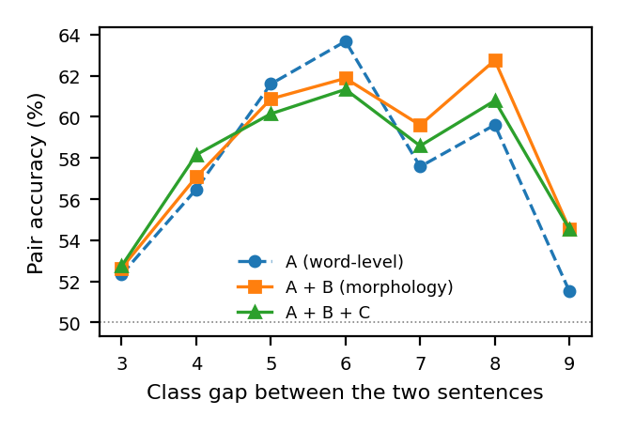
Figure 5.1: Textbook pair accuracy by the class gap between the two sentences.

5.3 LLM Simplification
Both metrics scored every one of the sixty LLM rewrites as easier than its original. The mean score decrease was 0.874 for the word metric (95% CI 0.750–1.009) and 0.911 for the morph metric (0.780–1.038). Table 5.4 shows how the features changed. The rewrites were much shorter (12.8 → 6.8 words per sentence), because the LLM split 50 of the 60 sentences, producing 2.22 sentences per rewrite on average. Non-finite verbs fell from 2.5 to 1.0 per sentence and the dependency tree became shallower. Morphemes per word decreased only slightly. One feature moved in the 'wrong' direction: word surprisal increased, most likely because shorter sentences give the language model less context.
Table 5.4: Mean feature values of original and simplified sentences (60 pairs).
Feature | Original | Simplified | Change
Words per sentence | 12.75 | 6.79 | −5.96
Mean word length | 7.86 | 7.27 | −0.59
Word frequency (Zipf) | 4.04 | 4.53 | +0.49
Word surprisal (bits) | 12.17 | 12.70 | +0.53
Morphemes per word | 1.44 | 1.34 | −0.10
Suffix surprisal (bits) | 2.40 | 1.79 | −0.60
Lemma frequency (Zipf) | 4.12 | 4.65 | +0.53
Non-finite verbs | 2.52 | 0.98 | −1.54
Dependency tree depth | 5.48 | 3.82 | −1.67
Dependency distance | 2.53 | 2.00 | −0.53

5.4 Human Evaluation
The human ratings give a more cautious picture than the metrics (Table 5.5). In about half of the judgments (49%) the rewrite was picked as the easier sentence; the original was picked in 29%, and the rest rated the two as equally easy. Mean rated difficulty fell from 2.31 to 1.97. Meaning preservation received a mean rating of 3.72 out of 5, and readers reported errors in 27% of rewrites, but also in 33% of the original sentences, which suggests that some reported 'errors' reflect unfamiliar style rather than true mistakes.
Table 5.5: Reader judgments of the sixty original–simplified pairs (12 readers, 6 ratings per item).
Measure | Original | Simplified
Chosen as easier | 29% | 49%
Mean difficulty (1–5) | 2.31 | 1.97
Errors reported | 33% | 27%
Meaning preserved (1–5) | 3.72 (pair rating)

Table 5.6 compares the metrics with the readers. Across the 120 texts, both metric scores correlate positively with mean human difficulty: ρ = 0.323 for the word metric and ρ = 0.281 for the morph metric. The difference between them (−0.042, CI −0.106 to 0.021) is not significant, so there is no evidence that the morph metric agrees better with readers. At the pair level, which asks whether the metric can tell how much easier a particular rewrite became, both correlations are close to zero. Agreement among readers was also low (mean pairwise ρ of 0.054 and 0.058 in the two forms), which limits how precise any item-level comparison can be.
Table 5.6: Spearman correlation between metric scores and mean human difficulty.
Level | Word metric | Morph metric | Morph − word
Text level (120 texts) | 0.323 [0.149, 0.484] | 0.281 [0.103, 0.452] | −0.042 [−0.106, 0.021]
Pair level (60 score changes) | 0.039 [−0.238, 0.298] | 0.036 [−0.253, 0.304] | −0.003 [−0.162, 0.153]

5.5 LLM as a Judge
Gemini answered the same sixty items as the readers (Table 5.7). It agreed with the mean human difficulty about as well as the metrics did (ρ = 0.297), and better than a typical single reader agreed with the other readers (mean 0.112). However, it was far more optimistic: it chose the simplified version in 90% of cases, rated meaning preservation higher and found almost no errors. Its difficulty ratings correlated strongly with both metrics (0.773 with the word metric, 0.728 with the morph metric), which suggests that the LLM judge relies on similar surface cues. An LLM judge is therefore not a substitute for human evaluation in this setting.
Table 5.7: Gemini as an LLM judge compared with the human readers.
Measure | Humans (mean of 12) | Gemini
Chooses simplified as easier | 49% | 90%
Difficulty, original → simplified | 2.31 → 1.97 | 3.50 → 2.07
Meaning preserved (1–5) | 3.72 | 4.33
Errors in simplified | 27% | 0%
Correlation with mean human difficulty | 0.112 (single reader vs others) | 0.297 [0.118, 0.459]

5.6 Webcam Eye-Tracking

5.6.1 Participants and data quality
Seven reading sessions were recorded in addition to developer test sessions (Table 5.8). Five readers met the inclusion rule. One person took part twice: in the first visit this person read 50 sentences and answered only 58% of the questions correctly, so that session was excluded; from the second visit, only the 50 sentences that were new to the reader were kept. One reader with 75% probe accuracy was excluded from the main analysis and used in a sensitivity analysis. The included readers' median validation error was 114–144 pixels, while the median word on the screen was 153 pixels wide; webcam gaze error is therefore roughly one word. Readers agreed only weakly on individual words: averaged over all pairs of readers, ρ ranged from 0.10 (FFD) to 0.20 (TD), while sentence reading times, which come from the ENTER key rather than from gaze, agreed much better (ρ = 0.64).
Table 5.8: Readers of the webcam eye-tracking study.
Reader | Sentences | Usable gaze | Probe accuracy | Median RT (s) | Included
R001 | 100 | 83% | 95% | 6.5 | Yes
R02 | 100 | 70% | 95% | 8.9 | Yes
R04 | 100 | 55% | 90% | 8.0 | Yes
R05 | 100 | 44% | 80% | 10.1 | Yes
123 (second session) | 50 new | 34% | 88% | 15.1 | Yes
1111 (first session) | 50 | 36% | 58% | 3.3 | No (< 80%)
R03 | 100 | 53% | 75% | 8.0 | Sensitivity only

5.6.2 Word reading times
Once sentences with unusable gaze were set aside, the analysis kept 1,021 words in 97 sentences, each word read by 2.90 readers on average. Table 5.9 and Figure 5.2 show the cross-validated R². The absolute values are far below those of the Dundee experiments, as expected from webcam data. The pattern, however, is clear. For three of the four measures (FPD, RPD and TD), each feature group improves on the layout controls: word-level features add 0.054–0.095 R² and morphological features 0.033–0.057, all with confidence intervals above zero. Combining the two groups, however, gives no benefit over the word-level group alone for any measure (ΔR² between −0.002 and −0.004, all intervals including zero). First fixation duration is the exception: no feature group improves on the controls, which is unsurprising given how coarsely a webcam samples gaze in space and time.
Table 5.9: Cross-validated R² for Tamil word reading times (95% sentence-bootstrap intervals).
Measure | Controls only | A: word-level | B: morphology | A + B
FFD | 0.100 [0.060, 0.137] | 0.105 [0.064, 0.144] | 0.099 [0.061, 0.137] | 0.103 [0.064, 0.141]
FPD | 0.087 [0.048, 0.123] | 0.141 [0.089, 0.193] | 0.120 [0.072, 0.168] | 0.137 [0.084, 0.190]
RPD | 0.037 [0.011, 0.064] | 0.132 [0.071, 0.189] | 0.094 [0.050, 0.139] | 0.130 [0.069, 0.188]
TD | 0.027 [−0.004, 0.076] | 0.103 [0.032, 0.208] | 0.071 [0.028, 0.141] | 0.099 [0.030, 0.202]

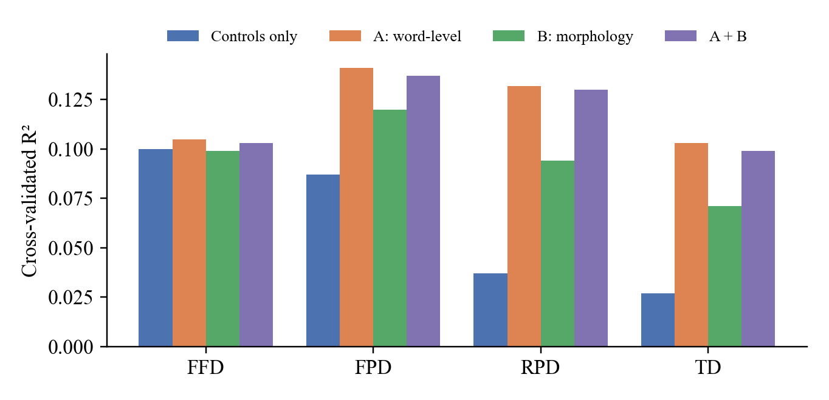
Figure 5.2: Cross-validated R² of the Tamil word reading-time models.
In the full model for total duration, word length has by far the largest standardised coefficient (+118 ms per standard deviation). The number of morphemes correlates with TD (ρ = 0.18), but less strongly than word length (ρ = 0.32). This points to redundancy as the reason for the main result. Each additional suffix lengthens a Tamil word, so the length of the word already contains most of the information carried by its morpheme count.

5.6.3 Sentence reading times
At the sentence level (Table 5.10), the word metric correlates with mean reading time at ρ = 0.851 and the morph metric at ρ = 0.682; the difference favours the word metric. However, sentence length alone reaches ρ = 0.883, so this result mainly reflects length. When reading time per word is used instead, which removes the effect of length, neither metric correlates reliably. The morph metric is slightly closer than the word metric (difference +0.133, CI +0.012 to +0.249), but since both correlations are themselves indistinguishable from zero, this is best seen as a hint for future work. Mean reading time increased across the difficulty bands that were defined before the study (Figure 5.3): 7.2 s for easy, 9.4 s for medium and 11.9 s for hard sentences.
Table 5.10: Spearman correlation of metric scores with Tamil sentence reading time.
Target | Word metric | Morph metric | Morph − word | Words alone
Sentence reading time | 0.851 [0.789, 0.895] | 0.682 [0.542, 0.780] | −0.169 [−0.285, −0.081] | 0.883
Reading time per word | −0.050 [−0.246, 0.152] | 0.084 [−0.129, 0.295] | +0.133 [0.012, 0.249] | −0.421

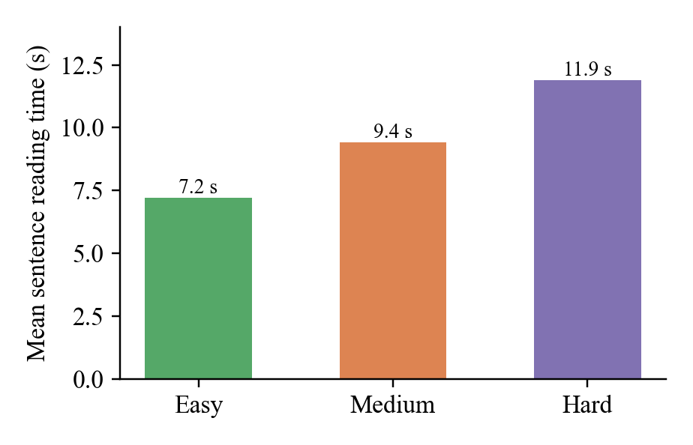
Figure 5.3: Mean sentence reading time by pre-defined difficulty band.

5.6.4 Sensitivity analysis
Repeating the analysis with the sixth reader, who answered 75% of the questions correctly, leads to the same conclusions: TD R² of 0.045 for the controls, 0.153 for A, 0.106 for B and 0.146 for A+B, with a gain of A+B over A of −0.007 (CI −0.015 to 0.000). The sentence-level correlations are 0.864 for the word metric and 0.693 for the morph metric. The conclusions therefore do not depend on the inclusion rule.

5.7 External Test on Human Simplifications (OasisSimp)
All the tests above use either book-level labels or simplifications produced by an LLM. To test the models on the same kind of data as the English System 2, sentences paired with versions simplified by people, we used the Tamil part of OasisSimp [34], a recently released dataset in which trained annotators simplified 520 complex Tamil sentences, each in two to five ways. Simplifications identical to the original were removed, leaving 1,904 (complex, simplified) pairs. None of the models was trained or tuned on these data: all are the pair models of Section 5.2, fitted on the StoryWeaver training pairs. A model is correct when it scores the complex sentence as harder; confidence intervals resample complex sentences, so that the several simplifications of one sentence always stay together.
Table 5.11: Accuracy on 1,904 OasisSimp Tamil pairs (models trained on StoryWeaver only).
Model | All pairs [95% CI] | Length-matched (359 pairs) | Gain over A (all / length-matched)
A: word-level (word metric) | 95.6% [94.6, 96.7] | 90.5% | –
B: morphology | 79.7% [77.6, 81.7] | 71.3% | −16.0 / −19.2
C: syntax | 77.6% [75.3, 79.7] | 51.3% | –
A + B (morph metric) | 93.4% [92.1, 94.7] | 83.3% | −2.3 / −7.2
A + C | 95.2% [94.0, 96.3] | 89.1% | −0.5 / −1.4
Number of words alone | 90.8% [89.2, 92.3] | 62.4% | –

Both metrics transfer very well to this new data: the word metric identifies the complex sentence in 95.6% of pairs and the morph metric in 93.4%, far above chance and well above the 74–75% of the English System 2 on Wikipedia pairs, although the two tasks are not directly comparable because the OasisSimp simplifications are much shorter (15.6 against 22.8 words on average). The length-matched pairs show that the word metric does not rely on length alone: where sentence length cannot help (62.4% for the number of words), it still reaches 90.5%, mainly through word frequency and word length. Here, for the first time in this project, the difference between the metrics is significant, and it favours the word metric: adding the morphological features lowers accuracy by 2.3 points overall (CI −3.3 to −1.2) and by 7.2 points on length-matched pairs (CI −11.3 to −2.9).

5.8 Summary of the Tamil Experiments
The Tamil experiments give a consistent answer to RQ3 and RQ4. Morphological features are not noise: on their own they predict reading level on StoryWeaver and reading times in the eye-tracking study. But in every test, graded text, LLM and human simplifications, human ratings and eye-tracking, they add nothing reliable once word-level features are present, and the morph metric never agrees with people better than the word metric; on the human simplifications of OasisSimp it is significantly worse. Both metrics recognise LLM simplifications as easier and correlate moderately with human difficulty, yet neither can tell how much easier an individual rewrite is.

6. THE TOOLKIT

6.1 Design
The toolkit makes every phase of the project usable on new input. It is a web application built with Gradio [39] that runs locally and can also produce a temporary public link. It does not reimplement the methods: each tab imports the project's own feature extraction and model code, so the scores it shows are identical to those reported in Chapters 4 and 5. The language models load in the background in about one minute after start-up, so the English classification tab is available immediately. Figure 6.1 shows the start page and Table 6.1 summarises the three tabs.
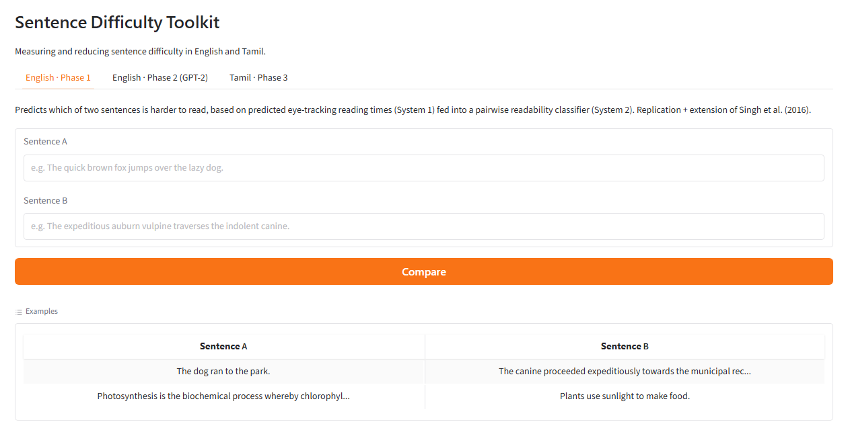
Figure 6.1: Start page of the Sentence Difficulty Toolkit with the three tabs.
Table 6.1: Tabs of the toolkit.
Tab | User input | Output | Phase
English · Phase 1 | Two English sentences | Which sentence is harder, with confidence (System 2) | 1
English · Phase 2 (GPT-2) | One English sentence | GPT-2 surprisal and predicted FFD, FPD, RPD and TD for every word, with and without GPT-2 | 2
Tamil · Phase 3, section 1 | Two Tamil sentences | Which sentence is harder (word metric) and whether the morph metric agrees | 3
Tamil · Phase 3, section 2 | One Tamil sentence | Word and morph scores, nearest StoryWeaver level, morpheme table and all twelve features | 3
Tamil · Phase 3, section 3 | A Tamil sentence or a study pair | Live simplification with Gemini, or a pair from the human study; before/after scores and the readers' ratings | 3

6.2 Phase 2 Tab
The System 1 models of Chapter 4 use parser-based features that cannot be computed instantly for a new sentence. The Phase 2 tab therefore uses a reduced System 1, trained with the same data, split and training procedure, on the features the application can compute live: word length, sentence length, word frequency, the two age-of-acquisition features, and GPT-2 surprisal (sentence only). Table 6.2 shows that GPT-2 improves all four measures for this reduced model as well. A garden-path sentence illustrates the tab: in The horse raced past the barn fell, GPT-2 assigns the final word a surprisal of 16.5 nats, the highest in the sentence, and the predicted total duration of that word rises from 160 ms without GPT-2 to 184 ms with it.
Table 6.2: Test R² of the reduced System 1 used in the Phase 2 tab.
Measure | Without GPT-2 | With GPT-2 surprisal
FFD | 0.447 | 0.450
FPD | 0.560 | 0.574
RPD | 0.557 | 0.573
TD | 0.538 | 0.557

6.3 Tamil Tab and Safeguards
The Tamil tab shows the central idea of Phase 3 in front of the user: the morpheme table lists, for every word, its Morfessor segmentation, its dictionary form, its part of speech, its marked grammatical features and whether it is a non-finite verb. The simplification section calls the Gemini API; if the main model does not respond, a smaller model is used. Because a live LLM may fail or produce a poor rewrite, the user can instead load any of the thirty StoryWeaver pairs from the human study, together with what the readers said about them. Textbook sentences are not offered, because they are protected by copyright. During testing, the live model once changed the subject of a sentence from 'she' to 'I'; this is precisely the kind of meaning error that the human study was designed to detect, and the tab makes it visible rather than hiding it.

6.4 Reproducibility
The project repository contains the complete pipeline for every phase, the toolkit and the eye-tracking study, with a README file for each part. Data that cannot be redistributed (the Dundee corpus, the Penn Treebank, the textbooks, and the personal data of participants and raters) are excluded, and the README files explain how to obtain or regenerate them. Appendix A lists the order in which the scripts are run.

7. DISCUSSION

7.1 What the Replication Shows
The replication reproduced the main claim of Singh et al.: reading times predicted from linguistic features are an effective basis for deciding which of two sentences is harder. System 2 matched the published accuracy even though System 1 explained less FFD variance than reported. This suggests that the classification result is robust to the details of the reading-time model. The FFD gap itself could not be closed, but it was narrowed down to an inconsistency between two tables of the original paper. This illustrates a general point about replication: when a paper reports a single correlation and a single-feature R² that cannot both hold for the same data, the most useful outcome of a replication is to document the inconsistency clearly rather than to tune the pipeline until a number matches.

7.2 What GPT-2 Adds
GPT-2 surprisal replaced a feature that carried no information (parser-based syntactic surprisal) with one that carries a great deal. Its benefit increases from early to late measures, which fits the view that predictability affects not only the first look at a word but also re-reading and integration. That the larger GPT-2 model fitted worse supports the observation of Oh and Schuler [16] and suggests that, for modelling human reading, a language model that is 'human-like' in its expectations matters more than one that is simply more accurate. Context from preceding sentences helped, which makes sense for editorials, where each sentence builds on the previous ones.

7.3 Why Morphology Did Not Help in Tamil
The starting hypothesis was that, in an agglutinative language, morphemes would be a better unit than words. The evidence does not support the stronger form of this hypothesis. Across five independent tests, morphological features predicted difficulty when used alone but added nothing to word-level features. The most likely explanation is redundancy: in Tamil, suffixes make words longer, so word length, word frequency and word surprisal already reflect much of the morphological complexity. A second explanation is measurement error. The morpheme segmentation is unsupervised, the morphological analyses are automatic, and morpheme surprisal is estimated by aligning a byte-level language model to character spans. Errors in these steps could hide a real contribution. The experiments do not separate the two explanations. The result therefore does not mean that morphology plays no role when people read Tamil. What it shows is narrower: with the present segmenter, analyser, language model and amount of data, the morphological features do not beat a word-level baseline.
One observation points in the opposite direction and deserves follow-up. On length-matched StoryWeaver pairs, the morphology-only model was the best of the basic models, and in the eye-tracking study the morph metric was slightly closer to per-word reading time than the word metric. When the dominant effect of length is removed, morphology may carry some of the remaining signal. The external OasisSimp test argues against this reading, however: on its length-matched pairs the morph metric was clearly worse than the word metric. Testing the question properly requires reading-time data on many more sentences than this project could collect.

7.4 Automatic Scores and Human Judgments
The simplification study shows why automatic difficulty scores should not be used on their own to evaluate simplification. Both metrics declared every rewrite easier, largely because the rewrites were shorter. Readers agreed on average, but much less uniformly: they preferred the rewrite in about half of the cases, saw some meaning loss, and reported errors. Neither metric could predict how much easier an individual rewrite would be judged. The LLM judge, which was strongly correlated with the metrics, was also far more positive than the readers. Automatic scores and LLM judges are therefore useful as a first filter, but the reader remains the reference.

7.5 Webcam Eye-Tracking as a Tool for Low-Resource Languages
The eye-tracking study shows that a browser-based study can collect usable reading data for Tamil at low cost. Sentence reading times were reliable across readers, increased with pre-defined difficulty and were well predicted by the metrics. Word-level measures were much noisier: the gaze error of about one word and the 30 Hz sampling rate make FFD in particular unreliable. With these limits in mind, the study reproduced, in Tamil and with real readers, the same pattern found in the corpus experiments, which strengthens the overall conclusion.

7.6 Limitations
- Proxy labels. Textbook classes and StoryWeaver levels label books, not sentences; pair accuracy measures agreement with these labels rather than with comprehension.
- Small human samples. The rating study had twelve readers and low inter-rater agreement; the eye-tracking study had five included readers. Both are pilot-scale.
- Tool quality. The segmenter, the morphological analyser and the Tamil language model all make mistakes, and the morpheme-level surprisal is only an approximation obtained by aligning character spans.
- One simplification system. All rewrites came from one LLM and one prompt; other systems may behave differently.
- Webcam precision. Gaze error close to one word limits all word-level conclusions in Tamil.
- FFD replication. The FFD result of the original paper could not be reproduced, and its cause could only be narrowed down, not confirmed.

7.7 Ethical Considerations
Participants in the rating and eye-tracking studies took part voluntarily. The eye-tracking study stored only gaze coordinates and basic information (age, gender, native language), never webcam images. Personal data of raters and readers are kept out of the public repository. Textbook sentences are used only for analysis and are not redistributed. LLMs were used as research objects (simplifier and judge) and as software assistants during development; all reported results come from the project code.

8. CONCLUSION

8.1 Summary
This thesis studied how sentence complexity can be estimated from features grounded in reading behaviour, and how such estimation transfers from English to Tamil. The two-stage model of Singh et al. was replicated on the Dundee corpus: the sentence classification results were matched (74.15% and 75.26%), three of the four reading-time models were close to the published values, and the one gap, first fixation duration, was traced to an inconsistency within the original paper. Contextual GPT-2 surprisal improved all four reading-time measures and lifted regression-path and total duration above the original results.
For Tamil, a word-level and a morphology-aware difficulty metric were built and evaluated on two graded corpora, an external set of 1,904 human-simplified sentence pairs (OasisSimp), a human rating study of LLM simplifications and a new webcam eye-tracking study with five readers. On the human simplifications the word metric identified the complex sentence in 95.6% of pairs without any training on that data. The results were consistent across all tests: morphological features carry signal on their own but do not improve on word-level features, and the morph metric never agreed with people better than the word metric. Both metrics recognised simplified sentences as easier, but neither could replace human judgment. All parts of the work are available in an interactive toolkit that runs them live on user input.

8.2 Future Work
- Collect more Tamil reading data, with more readers and ideally a laboratory eye-tracker or larger text, to test whether morphology helps once sentence length is controlled.
- Improve the morphological representation with a validated Tamil morphological analyser and a language model trained on morpheme units.
- Fine-tune GPT-2 on newspaper text, or use its predictive entropy, to further improve English reading-time prediction.
- Compare several simplification systems and prompts, and use the reading-time models to guide simplification rather than only to evaluate it.
- Extend the toolkit with a Tamil reading-time tab once enough eye-tracking data are available to train a Tamil System 1.

REFERENCES
[1] R. Flesch, "A new readability yardstick," Journal of Applied Psychology, vol. 32, no. 3, pp. 221–233, 1948.
[2] K. Rayner, "Eye movements in reading and information processing: 20 years of research," Psychological Bulletin, vol. 124, no. 3, pp. 372–422, 1998.
[3] A. D. Singh, P. Mehta, S. Husain, and R. Rajkumar, "Quantifying sentence complexity based on eye-tracking measures," in Proc. Workshop on Computational Linguistics for Linguistic Complexity (CL4LC), Osaka, Japan, 2016, pp. 202–212.
[4] A. Kennedy, R. Hill, and J. Pynte, "The Dundee Corpus," in Proc. 12th European Conference on Eye Movements (ECEM), Dundee, U.K., 2003.
[5] A. Radford, J. Wu, R. Child, D. Luan, D. Amodei, and I. Sutskever, "Language models are unsupervised multitask learners," OpenAI, Technical Report, 2019.
[6] T. Lehmann, A Grammar of Modern Tamil. Pondicherry, India: Pondicherry Institute of Linguistics and Culture, 1989.
[7] K. Collins-Thompson, "Computational assessment of text readability: A survey of current and future research," ITL – International Journal of Applied Linguistics, vol. 165, no. 2, pp. 97–135, 2014.
[8] S. Vajjala and D. Meurers, "On improving the accuracy of readability classification using insights from second language acquisition," in Proc. 7th Workshop on Building Educational Applications Using NLP, Montréal, Canada, 2012, pp. 163–173.
[9] E. Gibson, "Linguistic complexity: Locality of syntactic dependencies," Cognition, vol. 68, no. 1, pp. 1–76, 1998.
[10] J. Hale, "A probabilistic Earley parser as a psycholinguistic model," in Proc. 2nd Meeting of the North American Chapter of the Association for Computational Linguistics (NAACL), Pittsburgh, PA, USA, 2001, pp. 159–166.
[11] R. Levy, "Expectation-based syntactic comprehension," Cognition, vol. 106, no. 3, pp. 1126–1177, 2008.
[12] V. Demberg and F. Keller, "Data from eye-tracking corpora as evidence for theories of syntactic processing complexity," Cognition, vol. 109, no. 2, pp. 193–210, 2008.
[13] N. J. Smith and R. Levy, "The effect of word predictability on reading time is logarithmic," Cognition, vol. 128, no. 3, pp. 302–319, 2013.
[14] M. van Schijndel, A. Exley, and W. Schuler, "A model of language processing as hierarchic sequential prediction," Topics in Cognitive Science, vol. 5, no. 3, pp. 522–540, 2013.
[15] E. G. Wilcox, J. Gauthier, J. Hu, P. Qian, and R. Levy, "On the predictive power of neural language models for human real-time comprehension behavior," in Proc. 42nd Annual Meeting of the Cognitive Science Society, 2020, pp. 1707–1713.
[16] B.-D. Oh and W. Schuler, "Why does surprisal from larger Transformer-based language models provide a poorer fit to human reading times?," Transactions of the Association for Computational Linguistics, vol. 11, pp. 336–350, 2023.
[17] W. Hwang, H. Hajishirzi, M. Ostendorf, and W. Wu, "Aligning sentences from Standard Wikipedia to Simple Wikipedia," in Proc. 2015 Conference of the North American Chapter of the Association for Computational Linguistics: Human Language Technologies, Denver, CO, USA, 2015, pp. 211–217.
[18] M. Creutz and K. Lagus, "Unsupervised models for morpheme segmentation and morphology learning," ACM Transactions on Speech and Language Processing, vol. 4, no. 1, pp. 1–34, 2007.
[19] A. Kunchukuttan, "The IndicNLP Library," 2020. [Online]. Available: https://github.com/anoopkunchukuttan/indic_nlp_library
[20] P. Qi, Y. Zhang, Y. Zhang, J. Bolton, and C. D. Manning, "Stanza: A Python natural language processing toolkit for many human languages," in Proc. 58th Annual Meeting of the Association for Computational Linguistics: System Demonstrations, 2020, pp. 101–108.
[21] J. Nivre et al., "Universal Dependencies v2: An evergrowing multilingual treebank collection," in Proc. 12th Language Resources and Evaluation Conference (LREC), Marseille, France, 2020, pp. 4034–4043.
[22] L. Ramasamy and Z. Žabokrtský, "Prague dependency style treebank for Tamil," in Proc. 8th International Conference on Language Resources and Evaluation (LREC), Istanbul, Turkey, 2012, pp. 1888–1894.
[23] W. Xu, C. Callison-Burch, and C. Napoles, "Problems in current text simplification research: New data can help," Transactions of the Association for Computational Linguistics, vol. 3, pp. 283–297, 2015.
[24] A. Papoutsaki, P. Sangkloy, J. Laskey, N. Daskalova, J. Huang, and J. Hays, "WebGazer: Scalable webcam eye tracking using user interactions," in Proc. 25th International Joint Conference on Artificial Intelligence (IJCAI), New York, NY, USA, 2016, pp. 3839–3845.
[25] D. D. Salvucci and J. H. Goldberg, "Identifying fixations and saccades in eye-tracking protocols," in Proc. 2000 Symposium on Eye Tracking Research & Applications (ETRA), Palm Beach Gardens, FL, USA, 2000, pp. 71–78.
[26] BNC Consortium, The British National Corpus, version 3 (BNC XML Edition). Oxford University Computing Services, 2007.
[27] M. P. Marcus, B. Santorini, and M. A. Marcinkiewicz, "Building a large annotated corpus of English: The Penn Treebank," Computational Linguistics, vol. 19, no. 2, pp. 313–330, 1993.
[28] V. Kuperman, H. Stadthagen-Gonzalez, and M. Brysbaert, "Age-of-acquisition ratings for 30,000 English words," Behavior Research Methods, vol. 44, no. 4, pp. 978–990, 2012.
[29] R. Speer, wordfreq (version 3.0), Zenodo, 2022, doi: 10.5281/zenodo.7199437.
[30] A. E. Hoerl and R. W. Kennard, "Ridge regression: Biased estimation for nonorthogonal problems," Technometrics, vol. 12, no. 1, pp. 55–67, 1970.
[31] F. Pedregosa et al., "Scikit-learn: Machine learning in Python," Journal of Machine Learning Research, vol. 12, pp. 2825–2830, 2011.
[32] T. Wolf et al., "Transformers: State-of-the-art natural language processing," in Proc. 2020 Conference on Empirical Methods in Natural Language Processing: System Demonstrations, 2020, pp. 38–45.
[33] Pratham Books, "StoryWeaver." [Online]. Available: https://storyweaver.org.in/
[34] H. Liu, M. Tian, I. Ali, H. Gao, Q. We, B. Yang, U. Thayasivam, E.-S. A. Lee, P. Nakwijit, S. Ranathunga, and R. Shekhar, "OasisSimp: An open-source Asian-English sentence simplification dataset," in Proc. 15th Language Resources and Evaluation Conference (LREC), 2026.
[35] Abinayam, "gpt-2-tamil," Hugging Face model repository. [Online]. Available: https://huggingface.co/abinayam/gpt-2-tamil
[36] Anthropic, "Claude Opus 5.5" (large language model), 2026. [Online]. Available: https://www.anthropic.com/claude
[37] Google, "Gemini 3.5 Flash and Flash-Lite" (large language models), Gemini API, 2026. [Online]. Available: https://ai.google.dev/
[38] B. Efron and R. J. Tibshirani, An Introduction to the Bootstrap. New York, NY, USA: Chapman & Hall, 1993.
[39] A. Abid, A. Abdalla, A. Abid, D. Khan, A. Alfozan, and J. Zou, "Gradio: Hassle-free sharing and testing of ML models in the wild," arXiv:1906.02569, 2019.

APPENDIX A: REPRODUCING THE RESULTS
The repository is organised by phase. Table A.1 lists the main scripts in the order in which they are run; each reads the outputs of the previous one. Phase 1 and 2 scripts are in phase1_replication/, Phase 3 scripts in phase3_tamil_extension/src/, the eye-tracking study in Tool/TamilReadingWeb/ and the toolkit in toolkit/.
Table A.1: Pipeline scripts and their outputs.
Script | What it does | Main output
step1_parse_dundee.py | Parses Dundee eye movements into FFD, FPD, RPD, TD | dundee_rt.csv
step2_lexical_features.py | Word length, frequency, AoA, transition probabilities | lexical_features.csv
step3_syntactic_features.py | Surprisal, entropy, embedding, h1–h8 | syntactic_features.csv
step4_system1.py | Trains System 1, ablation, Table 4.1–4.2 | system1_models.pkl
step5_system2.py | Trains and evaluates System 2, Table 4.4 | accuracy report
compute_gpt2_surprisal.py, train_system1_gpt2.py | GPT-2 surprisal and Phase 2 comparison, Tables 4.5–4.7 | gpt2_surprisal_*.csv
step0–step2 (Phase 3) | Downloads textbooks, extracts sentences, builds pairs | graded_pairs.csv
step3–step6 (Phase 3) | Tamil features and pair models, Tables 5.1–5.3 | summary.md
step7–step9 (Phase 3) | Simplification set, scores, human evaluation, Tables 5.4–5.6 | human_eval_summary.md
step10_llm_judge.py | Gemini judge, Table 5.7 | llm_judge_*.md
step11_eyetracking.py | Eye-tracking analysis, Tables 5.8–5.10 | eyetracking_summary.md
step12_oasissimp.py | External test on OasisSimp Tamil pairs, Table 5.11 | oasissimp_summary.md
toolkit/app.py | Interactive toolkit, Chapter 6 | web application

APPENDIX B: SIMPLIFICATION PROMPT
The following instructions were given to the LLM for every sentence (the Tamil sentence was inserted at the end):
You are an expert Tamil teacher. Rewrite the Tamil sentence below so that a child in Class 3–5 (about 8–10 years old) can read and understand it easily. Rules: (1) Keep the same meaning. Do not add new information and do not drop important information. (2) Use common, everyday Tamil words instead of rare or literary words. (3) Use shorter words: avoid long words with many suffixes joined together where a simpler form exists. (4) You may split one long sentence into two or three short sentences. (5) Write natural, correct written Tamil (not colloquial spoken Tamil, not English, no transliteration). (6) If a sentence is already simple, still write the simplest version you can. Output only the simplified Tamil text, nothing else.

