Gender/Race wage gap in Miami Dade County

Bhagyalakshmi Patchipalu
Big Data Analytics
Saint Thomas University
Miami Gardens, USA
bpatchipalu@stu.edu

Abstract— Since the mid-1970s, a few authors have determined sexual orientation wage differentials among women and men of equivalent efficiency. This paper attempts to forecast the Unemployment rate, gender pay gap and Pay by races for Miami Dade County. An annual time series data for the period of 1990-2019 has been used in this study. The outcomes uncover that the sexual orientation imbalance exists for all day laborers and have statistically significant. The Average Male Salary is 1.22 times of Average Female Salary and woman makes 82 cents for every dollar the man makes in Miami Dade County, FL, USA. This demonstrates that there is a gender inequality in all divisions.
Keywords— unemployment rate, gender, time-series, data, male, female, salary, significant, inequality.

Introduction
This examination report investigates the sexual orientation pay gap, which is characterized as the distinction between the normal regularly scheduled pay of people. Just as taking a gander at essential contrasts in pay, the exploration recognizes the qualities that clarify those distinctions, for example, age, occupation and dimension of training. The report is expected to discuss and feature zones where intercession might be required.
The gender wage gap has now been seriously examined for a few decades, yet additionally remains a zone of dynamic and creative research. In this study, it demonstrates the pattern in the gender wage gap and their potential clarifications. At that point overview the writing to recognize what has been found out about the clarifications of the gap. Our essential spotlight will be on the Miami Dade County and their wages. This examination will likewise figure the joblessness rate to see whether it is diminishing or not and estimating the normal pay dependent on their race. The emphasis on the Miami Dade County is to some degree intended to make our errand progressively sensible, as there has been a blast of research on this subject crosswise over numerous regions and Countries. In any case, we trust quite a bit of what we have discovered for the Miami Dade County is pertinent to different areas and Countries, especially other financially propelled Countries.

LIterature Review
The literature on the economics of discrimination started with Becker’s seminal study in 1957. Since then due to the proliferation of the use of microdata in the last three decades, the study of gender wage differentials became a routine job for labor economists. Microdata allowed to assess the productivity of individuals and to compare wages of equally productive males and females.
Reference [1] has frequently been applied to data from the most different countries and time periods. Given the importance and timeliness of the topic, many reviews or surveys of the development of gender wage gaps have been done.
Reference [2] were the first to complement this survey literature with meta-analyses, which systematically covered the published papers on gender wage differentials in the US. In their first study, in 1998, they identified 12 factors which affected the reported US gender wage differential and explained 80% of its variation.

time seriesAnalysis for unemployment

Collecting and tidying the data
The data is collected from https://www.bls.gov/ (U.S. Bureau of Labor Statistics )website for Miami-Dade County. The unemployment dataset is used for analysis. The data had been transferred from XLX format to a CSV file format which can be transferred to R Studio. The data is structured and it had been cleaned. The actual plot is shown below. Figure 1 represents the unemployment rate from 1990 to 2019.
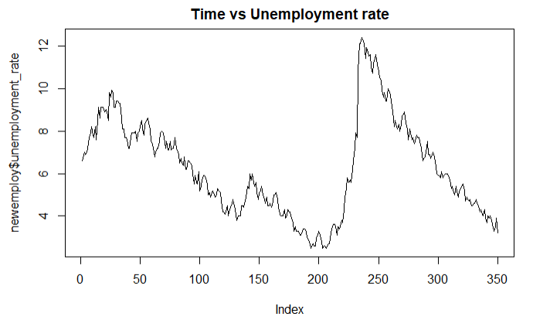
Fig 1: Time vs Unemployment

Forecasting unemployment for next three years
For anticipating this investigation, Time Series Analysis is utilized to figure the unemployment rate. The outcomes demonstrate that there is a descending and upward pattern appeared in Figure 2.
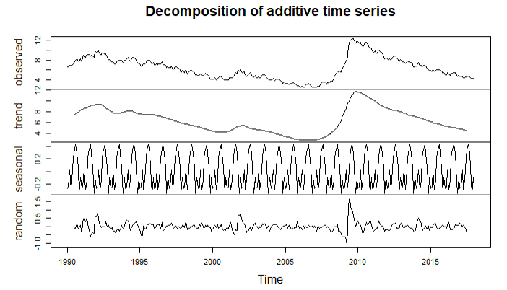
Fig 2: Decomposition analysis of Unemployment rate
For Forecasting, ARIMA Model is used which is Time Series Analysis. This had been anticipated the unemployment rate for next five years. The chart underneath demonstrates that there is an abatement of 2.845611% in the unemployment for the following five years.
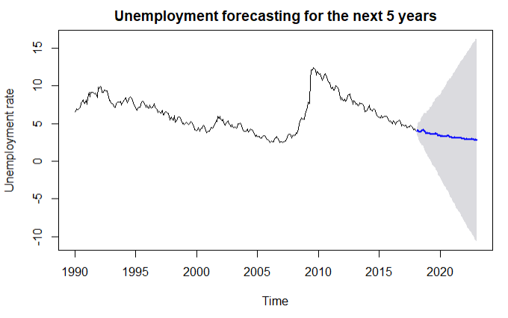
Fig 3: Forecast for next three years
The shaded area demonstrates that there is an expanding blunder for one years from now. The non-seasonally balanced unemployment rate for Miami-Dade County was down to 4.1% in August 2018. Year-over-year there was a 1.0% lessening, as the unemployment rate for January 2016 was 5.1%.

GENDER PAY GAP Time series analysis
Culture, Tradition, And overt Discrimination will in general make prohibitive the terms by which womens may participate in the work power. These impacts consolidate to produce a troublesome word related dispersion of female specialists versus male laborers and to make pay contrasts among males and females inside a similar occupation. The outcome is an unending wage gap among male and female full-time, all year laborers. Unfortunately, clarifications at this dimension of sweeping statement are fundamentally unmistakable. It is the motivation behind this paper to gauge the normal degree of victimization female specialists in the Miami Dade County and to give a quantitative appraisal of the wellsprings of male-female pay differentials.

The Miami-Dade County Human assets division gave the full database of region representatives with data on their pay rates, employing information, work classification and different attributes. The information was last refreshed in January 2019. The accompanying segment depicts the qualities of Miami-Dade County representatives generally speaking and with correlation crosswise over sexes.

Not only in Miami Dade county, women who also work full time in the United States lose a considerable amount approximately $900 billion consistently because of the compensation wage gap. These lost wages mean women and their families have less cash on hand to help themselves, contribute to their future’s, and spend on any extra expenses for their families. Women and their families, subsequently endure financial hardship.

Forecasting Average monthly salary for both genders
The first way is to look at the data is to examine the pay of men and women across all jobs in the MDC. To do that, take a look at the pay for salaried, full time employees from 1998-2018. Here is a plot of the salaries for men and women: it shows, in a glance, what they’re getting paid monthly. This gives us a rough idea of how men and women are paid by the MDC.
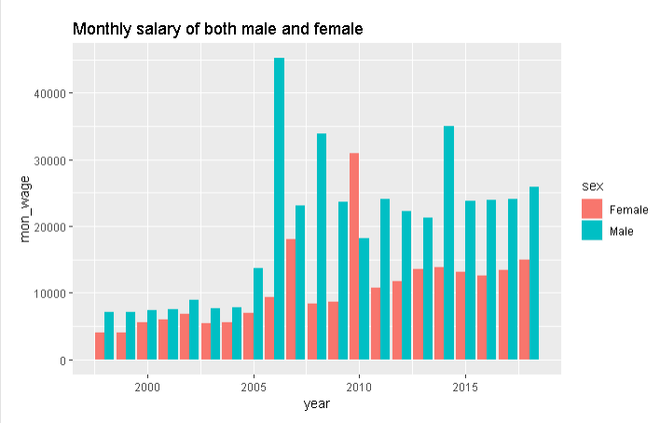
Fig 4: Monthly wage between male and female
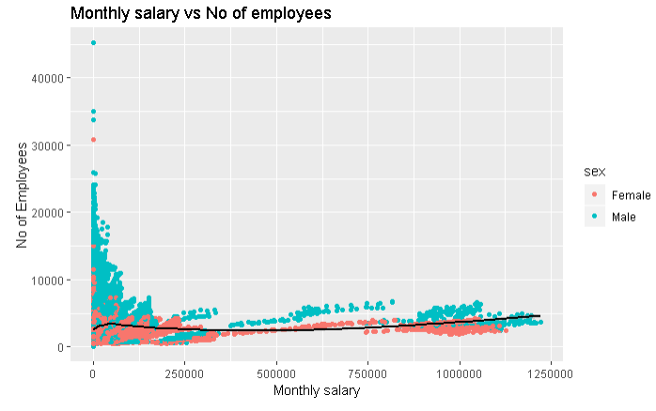
Fig 5: Monthly wage vs No of Employees between male and female
The outcomes demonstrate that there is a downward and upward pattern appeared in Figure 6.
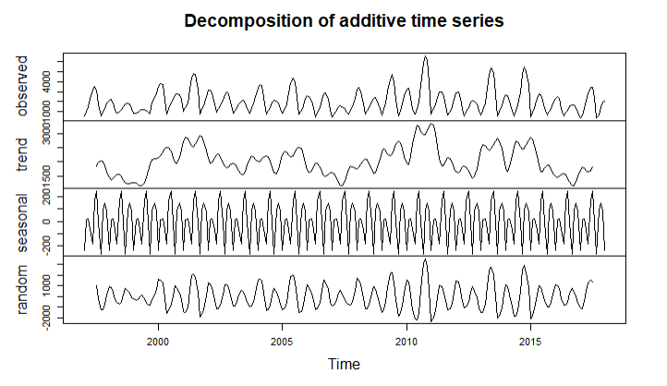
Fig 6: Decomposition analysis of the gender pay gap for both genders
Forecasting monthly average Salary for both genders as shown in Figure 7. The Predicted Average Monthly Salary for both genders is $ 1756.245
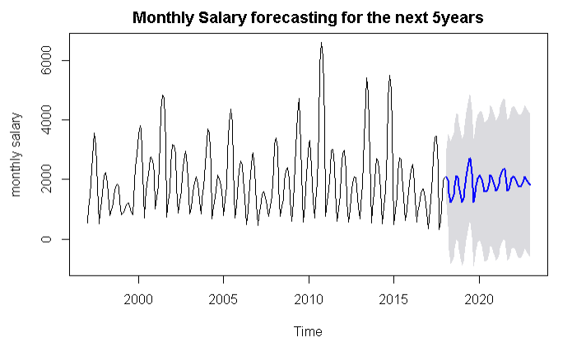
Fig 7: Forecast monthly salary for both genders

Forecasting for Male Average salary
By using Time series analysis, we are forecasting male salary for next 5 years. The decomposition of gender pay gap for female is shown in below graph.
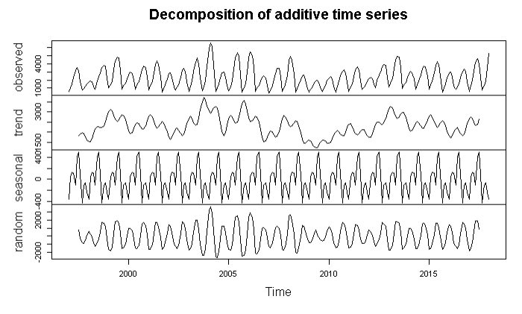
Fig 8: Decomposition analysis of the gender pay gap for male
Forecasting Male monthly Average Salary as shown in Figure 9. The Predicted Average Salary Male is $ 2391.5799 for the year 2020.
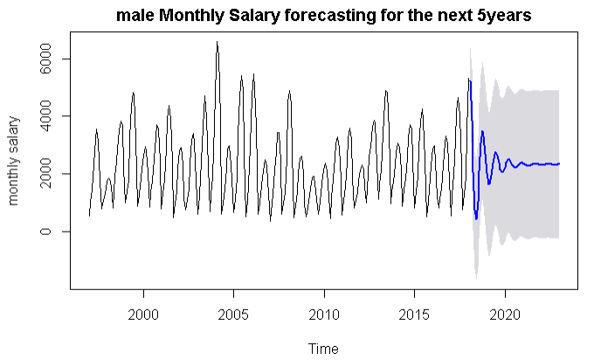

Fig 9: Forecast monthly salary for male

Forecasting for Female Average salary
By using Time series analysis, we are forecasting female salary for next 5 years. Let’s look at the trend in female salary.
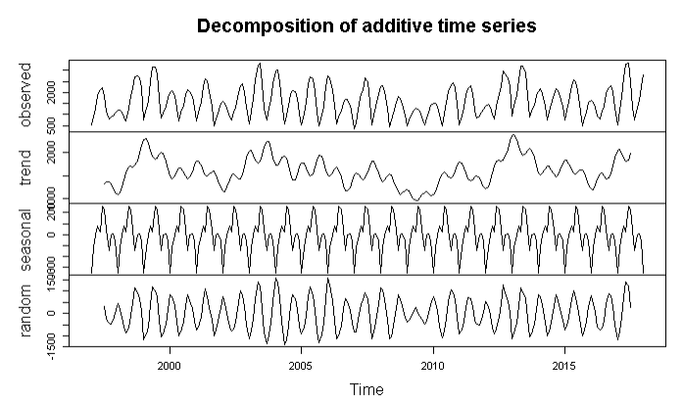
Fig 10: Decomposition analysis of the gender pay gap for female
Forecasting Female Average Salary as shown in Figure 11. The Predicted Average Salary Female is $ 1607.044 for the year 2020.
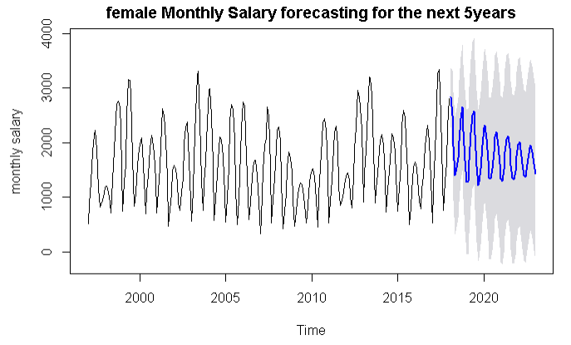
Fig 11: Forecast monthly salary for female
By Analyzing Male and Female Average Salary, we found that the Average Male Salary is 1.788439 times of Average Female Salary. The average woman’s monthly pay is $ 1607.044 lower than the average man’s. Stated differently, the average woman makes 56 cents for every dollar the average man makes.
By aggregating, the salary of male we sorted the top 3 departments with highest paid in Miami Dade county.
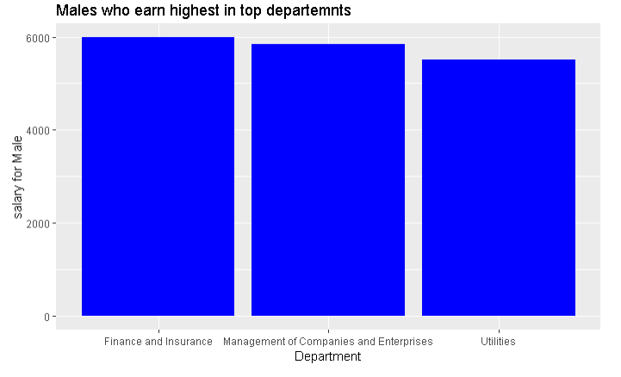
Fig 12: Men earning highest in top three departments

By aggregating, the salary of female we sorted the top 3 departments with highest paid in Miami Dade county.
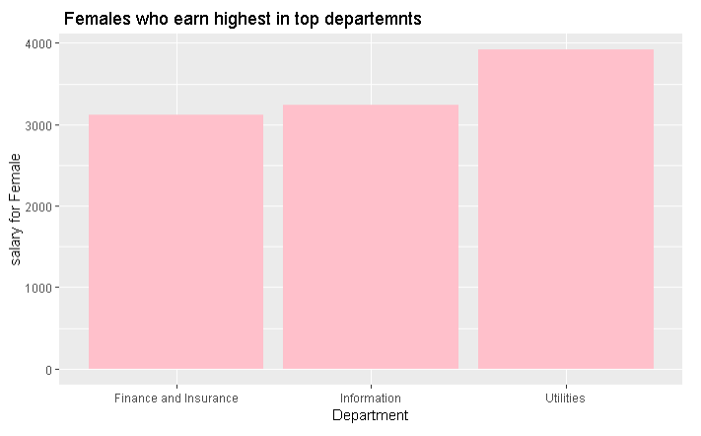
Fig 13: Females earning highest in top three departments
By aggregating, the salary of male and female we sorted the top eight departments with highest paid in Miami Dade County. We can observe that there are few females in top eight departments.
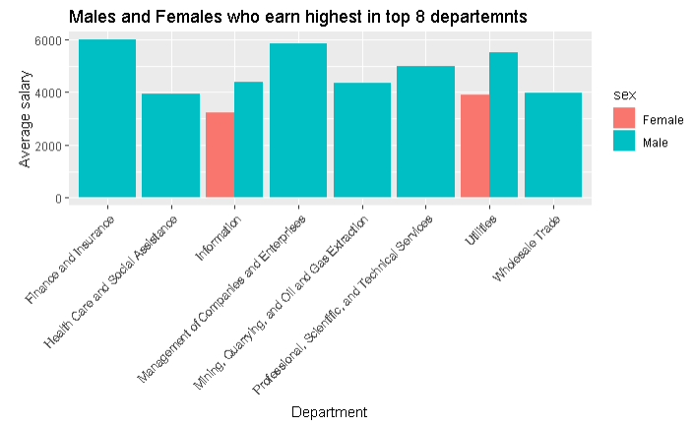 Fig 14: Males and Females who earn highest in top eight departments

Race pay gap-time series analysis
While factual proportions of compensation disparity between dark people and their white partners exist, wage imbalance is still inadequately comprehended because of an absence of writing with strong exact information to connect information with a precise model of pay segregation.
The chart shows the monthly salary by racial group.
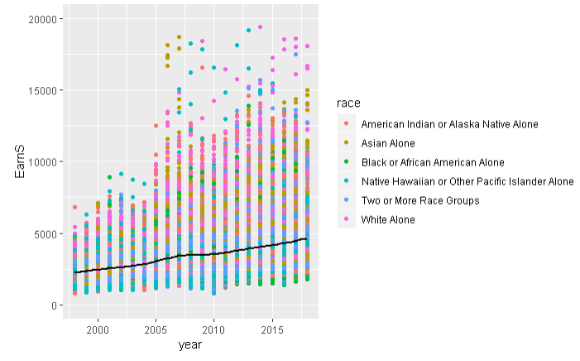
Fig 15: Monthly earnings by racial group

Forecasting for Whites Average salary
By using Time series analysis, we are forecasting white monthly salary for next 3 years. Let’s look at the trend in decomposition analysis.
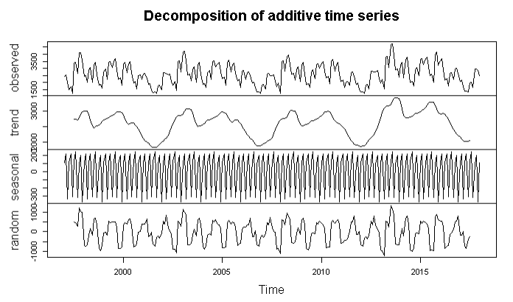
Fig 16: Decomposition analysis of the pay gap for whites
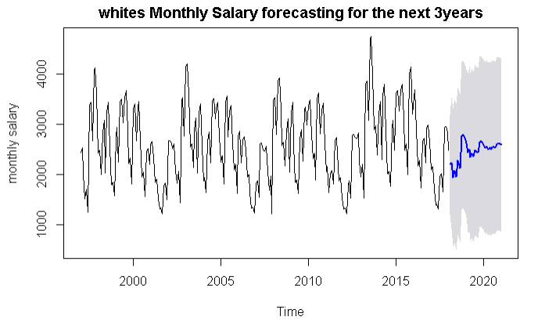
Fig 17: Forecasting whites monthly salary for next three years

Forecasting for Blacks Average salary
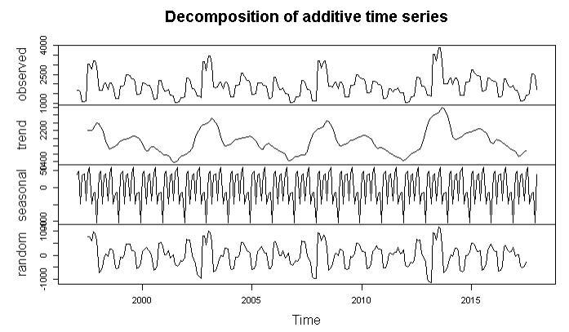
Fig 18: Decomposition analysis of the pay gap for blacks
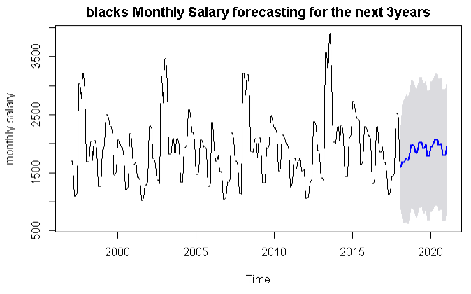Fig 19: Forecasting blacks monthly salary for next three years

Forecasting for American Indian Average salary
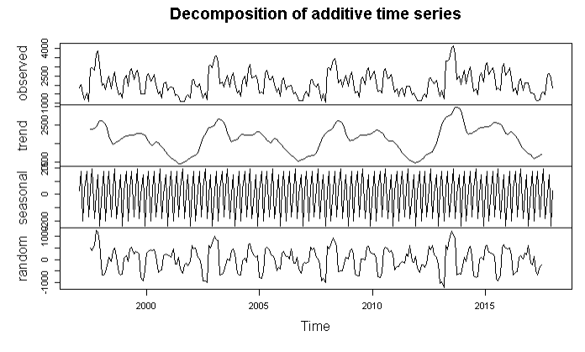
Fig 20: Decomposition analysis of the pay gap for American Indian

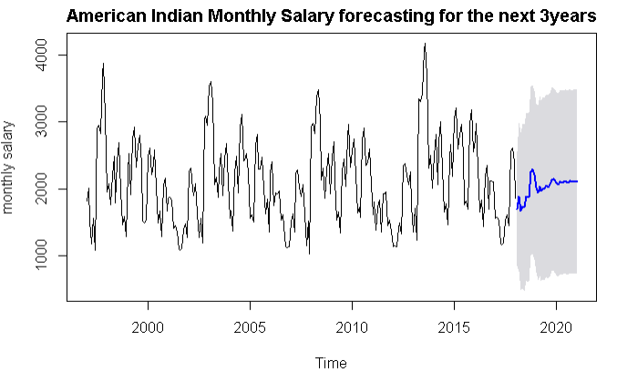
Fig 21: Forecasting American Indian monthly salary for next three years

Forecasting for Asian Average salary
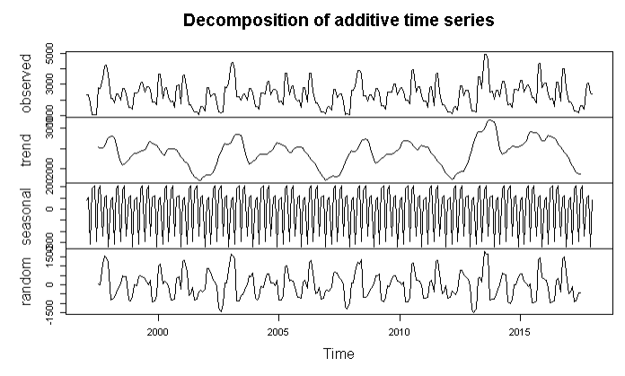
Fig 22: Decomposition analysis of the pay gap for Asians
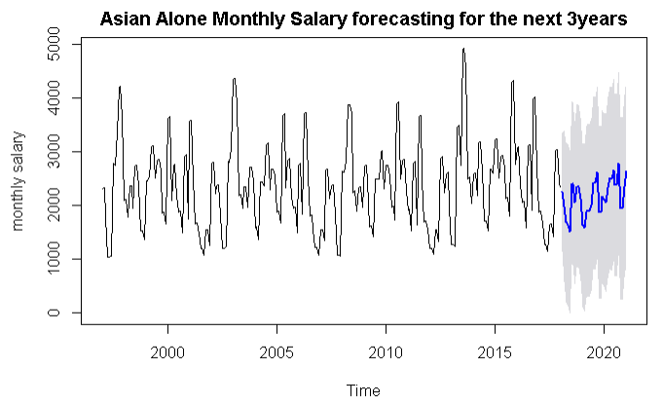
Fig 23: Forecasting Asians monthly salary for next three years

Forecasting for Native Hawaiian Average salary
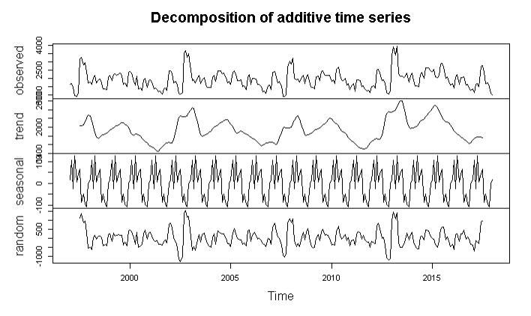
Fig 24: Decomposition analysis of the pay gap for Native Hawaiian

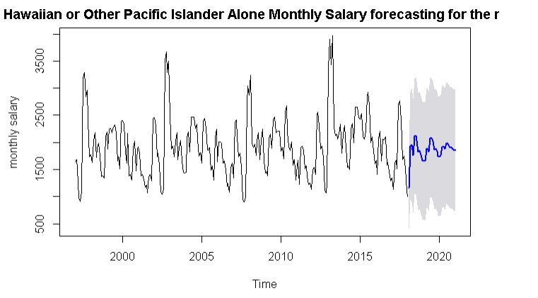
Fig 25: Forecasting Native Hawaiian monthly salary for next three years

Forecasting for Two or More Race Groups Average salary
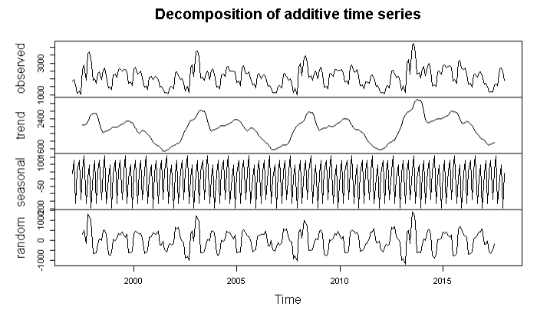
Fig 26: Decomposition analysis of the pay gap for two or more races
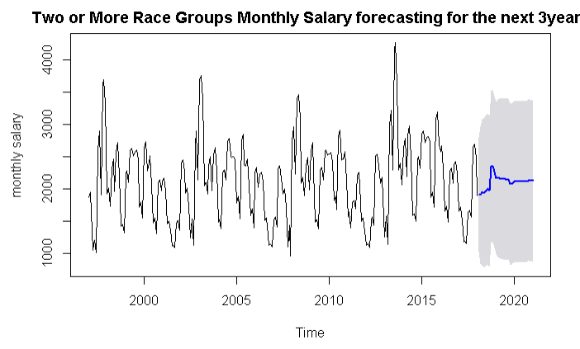
Fig 27: Forecasting two or more races monthly salary for next three years

Equations
The earnings ratio and the gender pay gap is calculated for year 2020, using these formulas:

Earnings ratio = women’s earnings /men’s earnings
=1337.244/2391.5799
= 0.55914*100=55.914%
Pay gap= [(men earnings-women earnings)/men earnings]*100
=[( 2391.5799-1337.244)/2391.5799]*100
= 0.4408*100= 44.08 %
There is 44%pay gap between male and female in Miami Dade County.
Pay gap by Racial group: Predictionof wages among all races are calculated and it was observed that white people get highest among all races .
Whites vs Blacks = 31%
Whites vs American Indian = 19%
Whites vs Asian = 10%
Whites vs Native hawaiian = 29%
Whites vs Two more races = 19%

tables
- Predicted mean for unemployment rate and for both genders
- Predicted mean for racial group
year | unemployment rate | monthly salary for both genders($) | male monthly salary($) | female monthly salary($)
2018 | 3.805754 | 1498.338 | 2704.6827 | 1672.656
2019 | 3.451452 | 2023.74 | 2097.5065 | 1948.803
2020 | 3.184723 | 1756.245 | 2391.5799 | 1607.044
2021 | 2.990021 | 2024.609 | 2321.5901 | 1749.507
2022 | 2.845611 | 1870.168 | 2328.1066 | 1611.062
Year | Whites | Blacks | American Indian | Asian | Native Hawaiian | Two or more races
2018 | 2735.714 | 1963.285 | 2209.224 | 2123.790 | 1668.979 | 2269.647
2019 | 2636.112 | 1796.690 | 2129.658 | 2162.898 | 1754.709 | 2090.901
2020 | 2603.66 | 1808.080 | 2104.084 | 2349.654 | 1854.058 | 2128.060

conclusion

Based on the analysis, by 2022 there will be a decrease in Unemployment rate of 2.84 %. Even then, gender wage gap still exits.

There is a 44% gender wage gap between male and female, which represents that the men’s salary is 1.78 times of women’s salary from which one can deduce that for every dollar man earns, a woman earns 56 cents.

Therefore, the prescription for Miami-Dade County would be to either increase female wages by 44% to bridge the pay gap, which would exist until 2020 or hire more female employees in the above-mentioned (Figure. 14) departments such that the amount of female workers is evident among men workers.

Moreover, the gap present on racial grounds is the highest among blacks and whites, which needs to be curtailed.

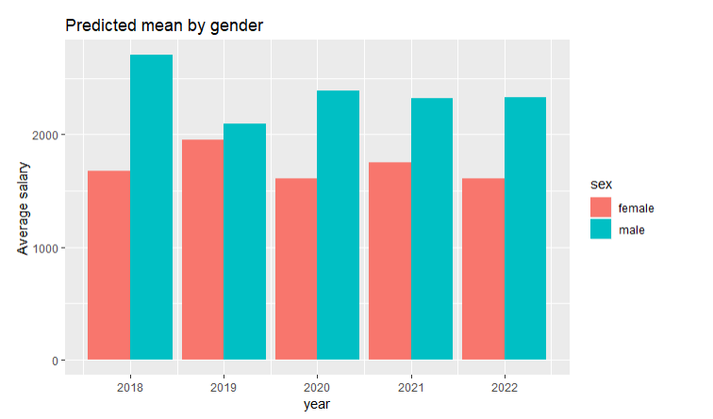
Fig 28: Predicted Average salary by gender
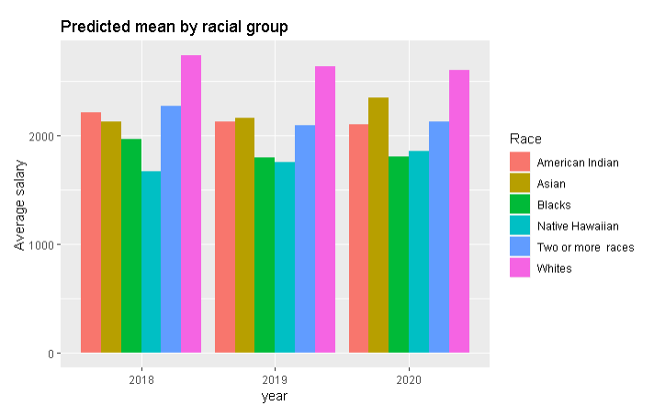
Fig 29: Predicted Average salary by demography
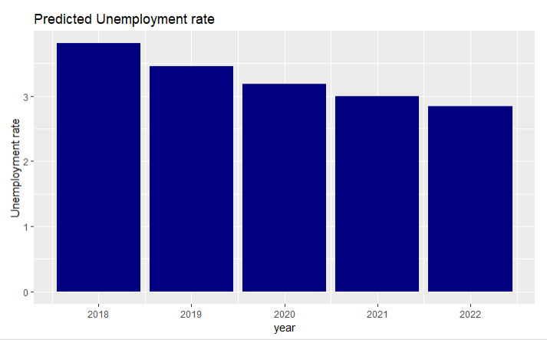
Fig 30: Predicted Average salary by unemployment rate

Acknowledgment
I take this opportunity to express my gratitude to Professor Dr. Sean Mondesire who supported me throughout the course of this project. I am thankful for aspiring guidance, invaluably constructive criticism and friendly advice during the project work. I am sincerely grateful to my friends for sharing their truthful and illuminating views on a number of issues related to the project.
I express my warm thanks to Miami Dade County for giving us opportunity to do this project.

References

- R. Oaxaca, “Male–female wage differentials in urban labor markets”, International Economic Review , vol.14(3), pp. 693–709, 1973.
- S.B Jarrell, and Stanley, “Declining bias and gender wage discrimination?A meta-regression analysis”, Journal of Human Resources, vol. 39(3), pp. 828–838 , 2004.
- F. Bettio, “The pros and cons of occupational gender segregation in Europe”, Canadian Public Policy, vol. 28, S1, pp. 65–84, 2002
- F.D Blau, and L.M Kahn, “Understanding international differences in the gender pay gap”, Journal of Labour Economics, vol. 21(1), pp. 106–44, 2003.
- M. Brynin, and F. Perales, “Gender wage inequality: the de-gendering of the occupational structure”, European Sociological Review, vol.
- 32( 1), pp. 162-74, 2016.
- H. Joshi, G. Makepeace, and P. Dolton, “More or less unequal? Evidence on the pay of men and women from the British Birth Cohort Studies”, Gender, Work and Organization, vol. 14(1), pp. 37-55, 2007.
- A. Levanon, P. England and P. Allison, “Occupational feminization and pay: assessing causal dynamics using 1950-2000 Census data”, Social Forces, vol. 88,(2), pp. 865–92, 2009.
- C. Magnusson, ‘More women, lower pay? Occupational sex composition, wages and wage growth’, Acta Sociologica, vol. 56(3), pp. 227-45, 2013.
.

