Uncertainty-Aware Segmentation in Musculoskeletal Ultrasound
A pipeline study in preparation for synovitis imaging
Bhagyaprasad Vastrad
Bengaluru, India | October 2026

Abstract
Automated segmentation of ultrasound images could help make the assessment of inflammatory arthritis more consistent, but an average accuracy figure does not tell a clinician which individual outputs to trust. I asked whether uncertainty estimates can point to segmentations that are likely to be wrong. I do not have synovitis data, so I built and tested the full pipeline on a public musculoskeletal ultrasound dataset of 8,169 images from one scanner at one centre, using subject-level splits. A U-Net with a ResNet34 encoder reached a mean test Dice of 0.897, and a five-member deep ensemble reached 0.902. I called a segmentation a failure when it’s Dice fell below 0.7, a placeholder threshold, which happened for 43 of 1,643 test images. Ensemble mutual information identified these failures with an AUROC of 0.79 (95% interval 0.70 to 0.88), against 0.55 (0.37 to 0.78) for the entropy of a single model. Flagging the 5% most uncertain images caught 40% of the failures. When I withheld one muscle from training, Dice on that muscle fell from about 0.89 to between 0.74 and 0.76. I also describe the data problems I found and the checks I ran. The data show muscle, not synovitis, and the intervals are wide because failures were rare, so these results show that the pipeline is workable. They do not show how it performs on synovitis.

1. Introduction
Ultrasound is widely used to look for inflammation in arthritis, and reading it takes training and time. Two clinicians can outline the same tissue differently, and image quality changes with the scanner, the operator and the patient. A segmentation model could make part of this work more consistent. The usual way to judge such a model is an average overlap score on a test set. That number is useful, but it does not tell a clinician whether the outline on the screen right now is one to trust.
My question is narrow. If a segmentation model also reports how uncertain it is, does that uncertainty point to the outputs that are wrong? If it does, uncertain cases could be sent to an expert while confident ones are accepted. If it does not, that is worth knowing before anyone relies on it.
My longer-term target is synovitis segmentation. My search found no public synovitis ultrasound dataset with expert masks, so I built and tested the whole pipeline on a public musculoskeletal ultrasound dataset. The aim is to have a pipeline that is already tested when I can apply it to synovitis data under the data governance of a research group that holds such data.
This paper reports that preparatory work. Its contributions are modest, and I list them plainly:
- A pipeline with leakage controls (subject-level splits, U-Net, deep ensemble, test-time augmentation) and the reliability metrics I plan to use later.
- A comparison of five uncertainty scores for identifying failed segmentations, with intervals that reflect how few failures there were.
- Two distribution-shift experiments and an estimate of run-to-run noise.
- An account of data problems I found and how they affected the results.
This is not a study of synovitis, and I do not claim it is.

2. Background
The U-Net [2] is a standard architecture for medical image segmentation. It has an encoder that compresses the image and a decoder that rebuilds a mask, with links between the two. I used it with a ResNet34 encoder [8].
There are several common ways to estimate how uncertain a network is. A deep ensemble trains several networks that differ in their random starting point and looks at how much their predictions disagree [3]. Monte Carlo dropout keeps dropout switched on at test time and repeats the prediction [4]. Test-time augmentation repeats the prediction on slightly altered copies of the image. The simplest option is the entropy of one network's own output probabilities.
Calibration asks whether a stated probability matches how often it is right, and the expected calibration error (ECE) is a common summary of it [5]. Selective prediction asks what happens to accuracy if the least certain cases are set aside, which is shown with a risk-coverage curve [6]. I use both ideas in the evaluation.

3. Data
I used the musculoskeletal ultrasound segmentation dataset released by Marzola and colleagues [1]. It holds transverse B-mode images of three muscles: biceps brachii (BB), gastrocnemius medialis (GM) and tibialis anterior (TA). Each image has a manual segmentation mask. The images come from healthy and pathological subjects, because the original study concerns neuromuscular disease.
The collection has 8,169 images: 2,734 of BB, 1,830 of GM and 3,605 of TA. Of these, 527, 350 and 513 respectively are pathological. All images were acquired at one centre (Radboud University Medical Center, Nijmegen) on one scanner (Esaote MyLab Twice) with a 3 to 13 MHz linear probe and a fixed preset. Data collection began in 2003. Each image is 504 by 480 pixels and each mask is binary. The data are open access, and the authors ask users to cite their paper, which I do.
File names follow the pattern anon_subject_imagenumber, so one subject contributes several images (a median of three). Across the three muscle folders there are 1,363 distinct subject IDs. None of the 8,169 masks is empty. The mask covers on average 16% to 22% of the image depending on muscle and condition, and 50 masks cover under 2%.
The same ID appears in more than one muscle folder, for example in both the BB and TA folders for 734 IDs. I could not confirm that an ID means the same person in different folders. The overlaps are close to what unrelated numbering would give by chance (387 observed for BB and GM against about 380 expected), and 325 IDs are labelled healthy in one folder and pathological in another. I therefore treated each ID as one person everywhere. That choice can only separate subjects more than necessary, so it cannot cause leakage.

4. Methods
Figure 1 gives an overview of the pipeline. The subsections below describe each step.
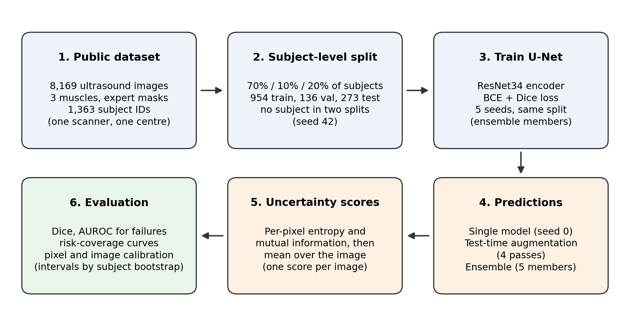
Figure 1. Overview of the pipeline. Subjects, not images, were assigned to training, validation and test sets. Validation images were used only to choose training weights and to fit the image-level calibration mapping. All reported results use the test subjects.

4.1 Splits and preprocessing
I assigned subjects to splits with a fixed random seed of 42: 70% to training (954 subjects), 10% to validation (136) and 20% to testing (273). All images of a subject went to the same split, and the same assignment was used for every muscle. The code stops with an error if any subject appears in two splits. This gave 5,688 training, 838 validation and 1,643 test images.
Images were converted to grayscale and resized to 256 by 256 pixels, with bilinear interpolation for images and nearest-neighbour for masks, and scaled to the range minus 1 to 1. To avoid uploading about 3 GB of PNG files to a cloud notebook, I saved the resized images and masks in one compressed array file.

4.2 Model and training
I used a U-Net with a ResNet34 encoder initialised with ImageNet weights, one input channel and one output channel, from the segmentation_models_pytorch library [7]. The loss was the sum of binary cross-entropy and Dice loss. I used the AdamW optimiser [9] with a learning rate of 3e-4 and a batch size of 16, for at most 30 epochs. Training stopped after 6 epochs without improvement in validation Dice, and I kept the weights with the best validation Dice. Augmentation was a random horizontal flip and a mild brightness change (gain 0.9 to 1.1, shift of plus or minus 0.05). I trained on a free cloud GPU (an NVIDIA T4). One run took roughly 20 to 30 minutes.

4.3 Experiments
- Experiment A: train on all muscles and both conditions.
- Experiment B (muscle shift): train on BB and GM only, and test on all muscles, so that TA is unseen.
- Experiment C (disease shift): train on healthy images only, and test on all images.
The test set was always the same 1,643 images from 273 subjects, so results can be compared image by image.

4.4 Ensemble and test-time augmentation
I trained four more models with seeds 1 to 4 on the same split and settings as Experiment A. Together with the first model they form a five-member ensemble. The members share the pretrained encoder, the data and the split, and differ in the starting weights of the decoder, the data order and the augmentation, so their diversity is limited. For test-time augmentation I ran the seed 0 model on four versions of each image: the original, a horizontal flip (flipped back afterwards), a darker copy (gain 0.9) and a brighter copy (gain 1.1).

4.5 Uncertainty scores
For each pixel I averaged the foreground probabilities from the available predictions (five ensemble members, four augmented passes, or one model). I then computed the predictive entropy of that average. For ensembles and augmentation I also computed mutual information, which is the predictive entropy minus the average entropy of the individual predictions. It is zero when all predictions agree. I turned each pixel map into one image-level score by taking the mean over all pixels. For a single model only the entropy exists.
I did not include Monte Carlo dropout. My trained networks have no dropout layers, so it would have needed a separate model, which I leave for later.

4.6 Evaluation
Dice was computed for every image at a threshold of 0.5, and two empty masks count as a Dice of 1. I defined a failed segmentation as a Dice below 0.7. This is a placeholder, and in a clinical study the threshold would be set with clinicians. I also checked thresholds from 0.5 to 0.8.
To judge how well an uncertainty score identifies failures, I used the area under the ROC curve (AUROC): the chance that a randomly chosen failed image has a higher score than a randomly chosen successful one, where 0.5 is no better than guessing. I also drew risk-coverage curves. Images are sorted from most to least certain, and I track the mean Dice of the images kept as I keep fewer of them. I compared the area under this curve with two references: a random ordering and a perfect ordering by true Dice.
For pixel-level calibration I computed ECE with 15 equal-width bins on the foreground probability, and the Brier score. For image-level calibration I did not treat the uncertainty score as a probability. Instead I fitted a logistic regression from the standardised log of the score to failure, using validation images only, and evaluated the resulting failure probabilities on the test images with ECE, the Brier score and a Brier skill score. The skill score compares against always predicting the validation failure rate, so a value above 0 means the mapping is useful.

4.7 Statistics
I computed 95% intervals by resampling subjects, not images, with at least 1,000 resamples, because images of one subject are not independent. Differences between methods were computed on the same resamples.

5. Results

5.1 Segmentation accuracy and training noise
Experiment A reached a mean test Dice of 0.897 (median 0.922). Five runs with different seeds gave 0.8967, 0.8969, 0.8963, 0.8997 and 0.8942, a standard deviation of about 0.002. Pathological muscle was harder than healthy muscle, with Dice of about 0.83 to 0.89 for pathological groups and 0.88 to 0.94 for healthy ones. The validation Dice was close to the test Dice, so I saw no sign of overfitting to the validation set.
The five-member ensemble reached 0.9022. That is 0.0055 higher than a single model (95% interval 0.0031 to 0.0082), and higher than the best single member (0.8997). The gain is small, but it is larger than the training noise.

5.2 Do uncertainty scores identify failures?
Of the 1,643 test images, the ensemble failed on 43 (2.6%), from 17 subjects. Table 1 and Figure 2 show how well each score separated failures from successes. Each score is judged against the failures of the predictor it belongs to.
Table 1. AUROC for identifying failed segmentations (Dice below 0.7)
Uncertainty score | AUROC | 95% interval
Single model, entropy | 0.55 | 0.37 to 0.78
Test-time augmentation, entropy | 0.61 | 0.43 to 0.83
Test-time augmentation, mutual information | 0.73 | 0.65 to 0.85
Ensemble, entropy | 0.69 | 0.56 to 0.84
Ensemble, mutual information | 0.79 | 0.70 to 0.88

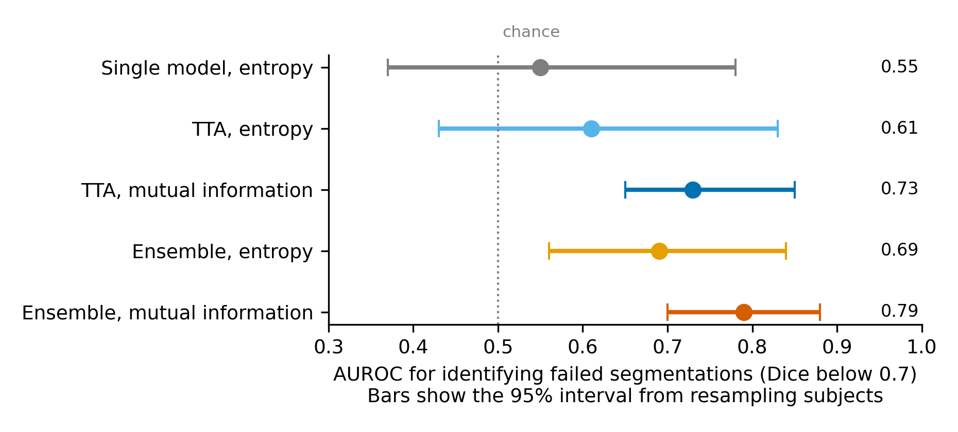
Figure 2. AUROC for identifying failed segmentations (Dice below 0.7) with 95% intervals from resampling subjects. The dotted line at 0.5 is no better than chance. The ensemble had 43 failures among 1,643 test images.
Ensemble mutual information beat single-model entropy by 0.24 AUROC (interval 0.02 to 0.42). Single-model entropy showed no evidence of any signal. The advantage of mutual information over ensemble entropy was 0.10, but its interval (minus 0.02 to 0.21) includes zero, so I cannot say that one is better than the other.

5.3 What this means in practice
If I flag the 5% most uncertain test images (82 images) using ensemble mutual information, 17 of the 43 failures are among them, which is 40%. About one in five flagged images is a real failure, roughly eight times the base rate of 2.6%, and the other four in five are false alarms. Flagging the top 10% catches about half of the failures.
Figure 3 shows the risk-coverage curves. The mean Dice over all images is 0.902. If I keep only the 90% most certain images it rises to 0.913, and for the 50% most certain it is 0.922. Ensemble mutual information closes about 29% of the gap between a random ordering and a perfect ordering. Single-model entropy did worse than a random ordering. Figure 4 shows every test image, which makes clear how many failures sit among low-uncertainty images.
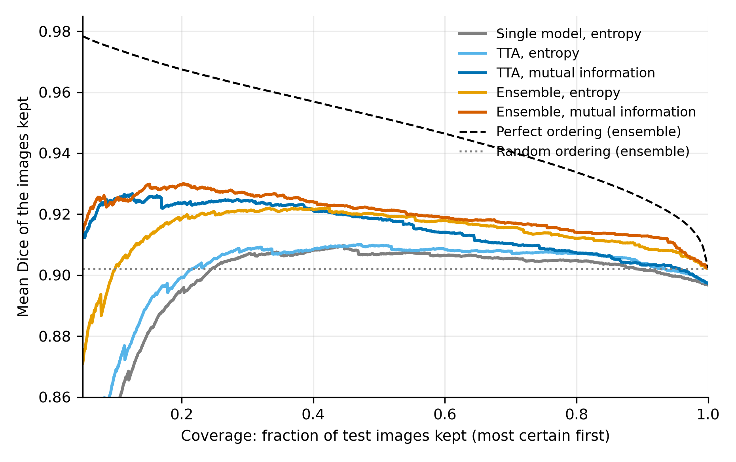
Figure 3. Risk-coverage curves on the test subjects. Images are sorted from most to least certain, and each curve shows the mean Dice of the images kept. The dashed line is a perfect ordering by true Dice and the dotted line is a random ordering. Curves start at 5% coverage and the vertical axis is cut at 0.86, so the lowest parts of some curves are not shown. With very few images kept, the mean is dominated by a handful of cases, for example two near-empty images of subject 1244 that the ensemble ranked as the most certain of all.
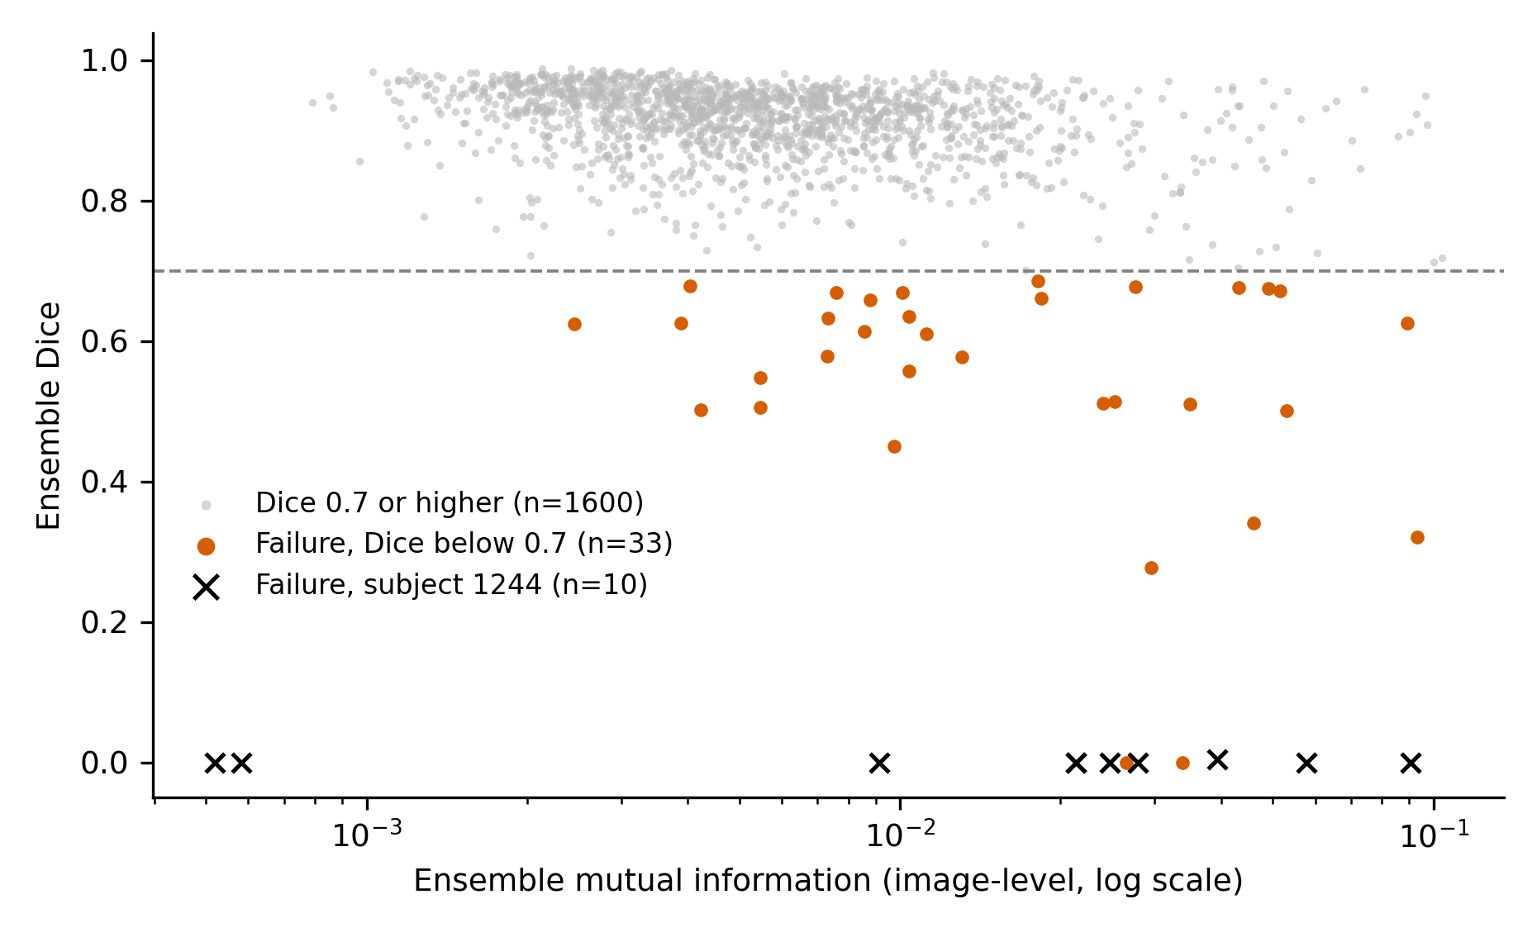
Figure 4. Ensemble mutual information and Dice for each of the 1,643 test images. The dashed line is the failure threshold of 0.7. Crosses mark the ten failures from subject 1244, whose images show other muscles. Failures occur across the range of uncertainty, with more of them toward the high-uncertainty side.

5.4 Calibration
At pixel level the ensemble was better calibrated than a single model, with ECE of 0.0125 against 0.0194 and a Brier score of 0.0250 against 0.0275. Most pixels are easy background, so these numbers are dominated by easy pixels.
At image level the benefit was weak. The Brier skill score of the logistic mapping from ensemble mutual information was 0.066, or 0.040 when one problem subject (Section 5.7) was left out. The ECE at image level was very small, but only because failures are rare, so I do not rely on it alone. The score ranks images reasonably well, but it does not yet give failure probabilities that I would trust.

5.5 Distribution shift
Table 2 and Table 3 and Figure 5 show the two shift experiments.
Table 2. Dice on TA images (muscle shift)
Setting | Dice on TA
TA seen in training (five seeds) | 0.888 to 0.894
TA withheld, first run | 0.741
TA withheld, second run of the same setting | 0.754
TA withheld, label text masked (Section 5.7) | 0.761

When TA was withheld, Dice on TA fell by about 0.13 to 0.15, while Dice on BB and GM barely changed. This held in every run.
Table 3. Dice on pathological images pooled over all muscles (disease shift)
Setting | Dice
Trained on all images (five seeds) | 0.853 to 0.861
Trained on healthy only, first run | 0.806
Trained on healthy only, second run | 0.833

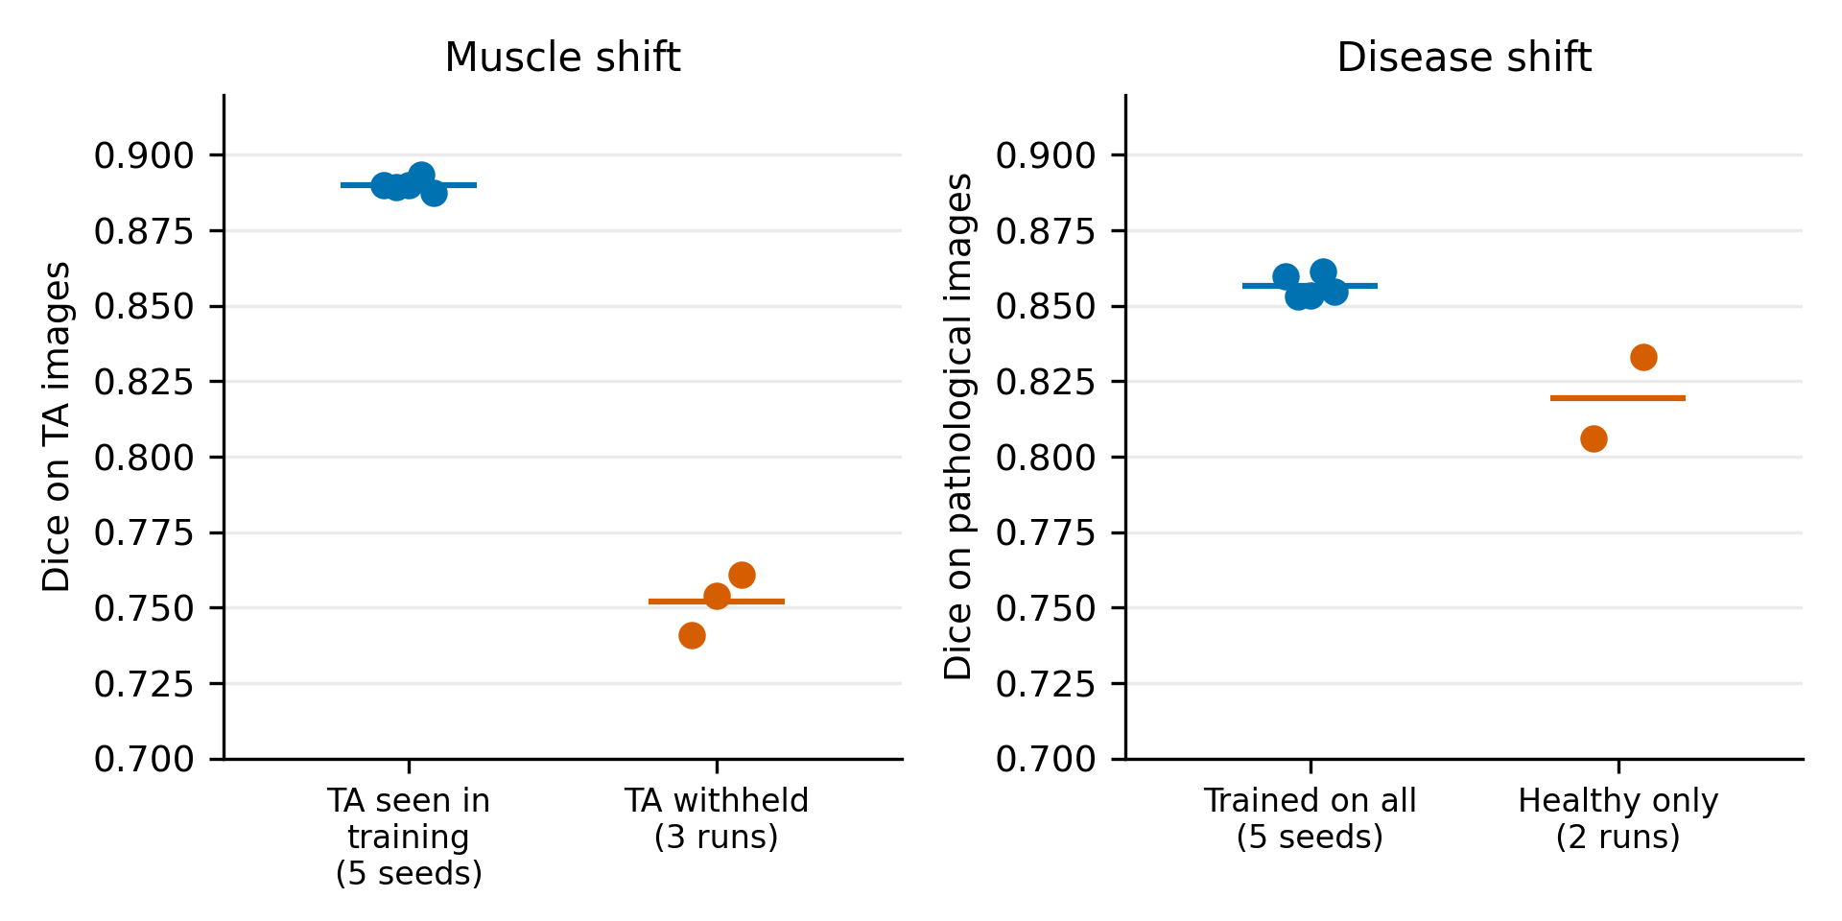
Figure 5. Dice when the setting changes. Left: Dice on TA images when TA was in the training data (five seeds) and when it was withheld (three runs). Right: Dice on pathological images pooled over muscles, for models trained on all images (five seeds) and on healthy images only (two runs). Dots are individual runs and lines are means.
The disease-shift effect is smaller and less certain. The two runs of the same setting differ by 0.027, which is about as large as the effect I wanted to measure. For GM pathological images alone the values were 0.737 and 0.794 against about 0.84 to 0.87. I first read the first run as a clear drop of 0.054, and the second run showed that I had given that single number too much weight.
Repeated runs of identical settings differ by about 0.002 in overall Dice, 0.01 to 0.02 in the unseen-muscle case and up to 0.03 in the healthy-only case. Any shift comparison has to be judged against that.
I did not run the uncertainty analysis on the shifted models, so I cannot yet say whether uncertainty rises under shift.

5.6 Sensitivity checks
At a failure threshold of 0.5 the AUROC of ensemble mutual information was 0.82, but with only 16 failures. Within healthy images alone it was 0.77, within pathological images alone 0.82, and for images whose true mask covers at least 5% of the image 0.84. Failures were concentrated in pathological muscle (about 10% of images, against 1% to 4% for healthy). Mutual information and entropy were strongly correlated (0.85), and mutual information was also correlated with true mask size (0.27), so I cannot rule out that part of the signal reflects mask size.

5.7 Two data findings
Images of other muscles in the BB folder. Ten of the 20 test images with Dice below 0.5 came from one subject (ID 1244) in the biceps folder, with masks covering about 0.5% of the image. When I looked at that subject's images, each carried a text label printed in the bottom-left corner (Figure 6). Three read biceps brachii, and the rest named other muscles, which look like masseter, temporalis, depressor anguli oris, orbicularis oris, zygomaticus and buccinator. So the folder contained facial muscle images with small structures outlined. These ten were not failures on biceps. I kept them in all main results. Leaving the subject out changed the AUROC of ensemble mutual information to 0.80 and that of single-model entropy to 0.65, so the gap between them narrows from 0.24 to about 0.15.
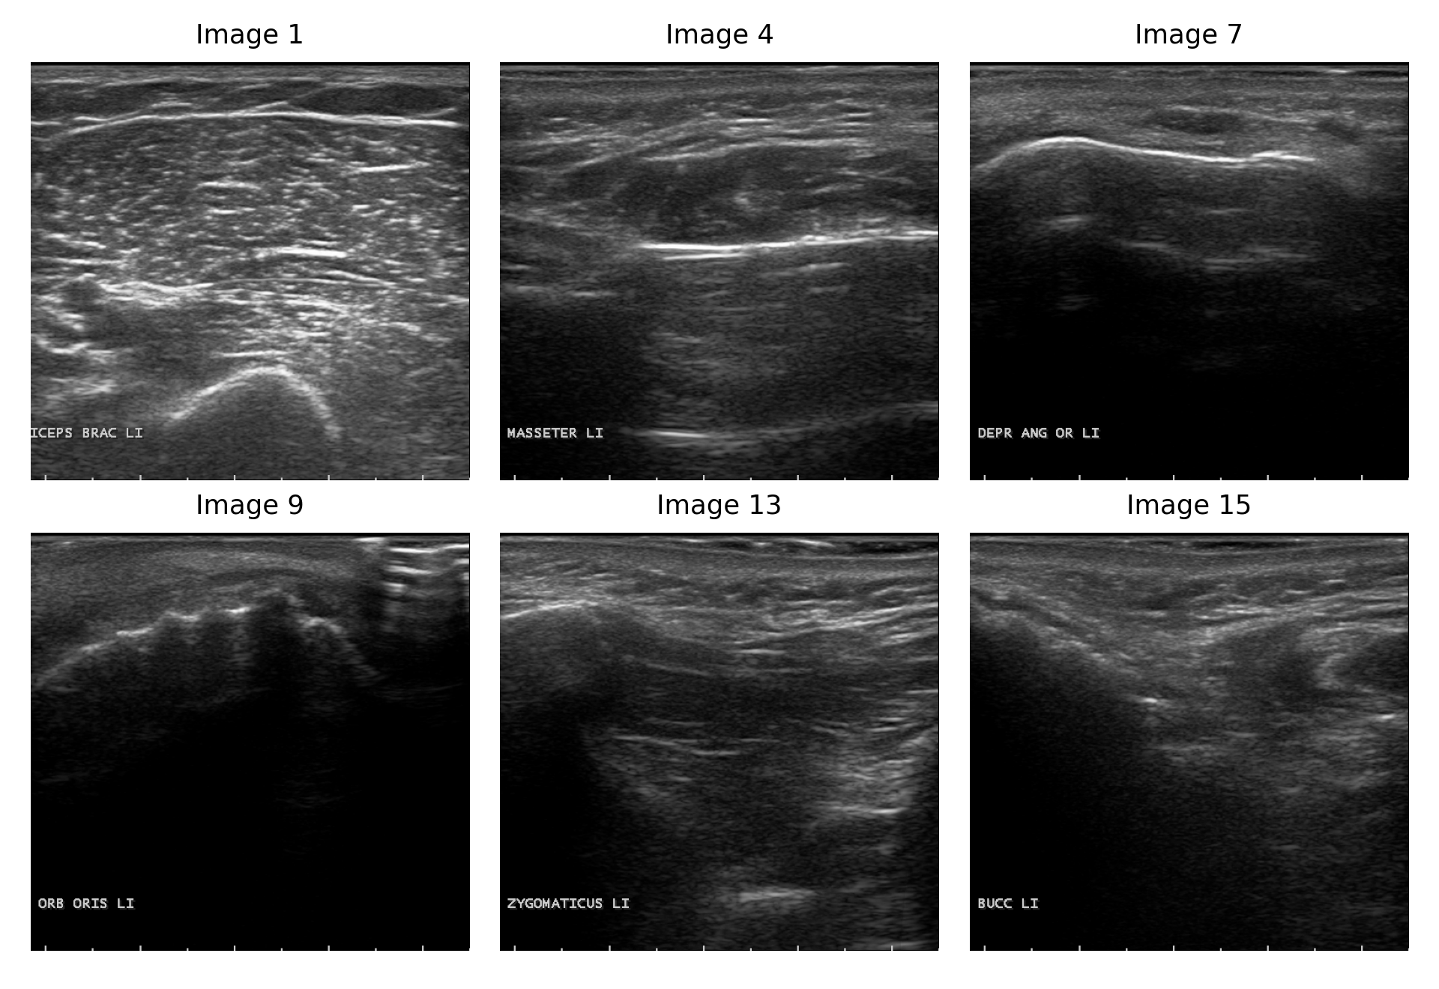
Figure 6. Six images from subject 1244 in the biceps folder. Each carries a burned-in text label. Images 1 to 3 are labelled biceps brachii, image 4 masseter, image 7 depressor anguli oris, image 9 orbicularis oris, image 13 zygomaticus and image 15 buccinator (my reading of the abbreviations). Image 9 received the lowest ensemble uncertainty of any test image. Masks are not shown. Images are from the public dataset [1].
These images also showed a failure mode I expect to matter for synovitis. Two of them (orbicularis oris, nearly black images with masks of roughly 70 and 290 pixels) received the lowest ensemble uncertainty of all 1,643 test images. The models confidently predicted almost nothing and missed a very small structure. Because my image score is a mean over all pixels, a tiny region has little influence on it.
Burned-in muscle labels. Because every image I looked at carries the muscle name as text, a network could read the label instead of learning anatomy. That would also confuse the unseen-muscle experiment, since the TA label is never seen in training. I blacked out the label region (rows 210 to 241 and columns 0 to 134 at 256 by 256 pixels; Figure 7) and retrained. Dice for all muscles was 0.8961 against 0.8967, and for the unseen muscle 0.761 against 0.741, which is inside the run-to-run noise. I conclude that the label did not matter for Dice in these two single-seed checks. I did not check whether it affects uncertainty.
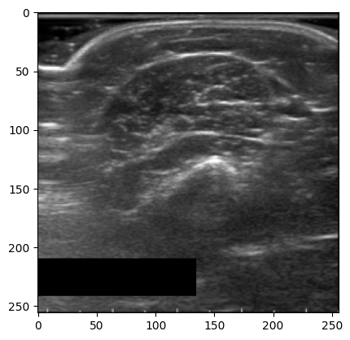
Figure 7. Check of the label blackout. A test image after the bottom-left region was set to zero. The label is gone and the muscle is untouched. Axes show pixel positions at 256 by 256 resolution.

6. Problems I met and how I handled them
No synovitis data. I used a public muscle dataset as a stand-in and kept the claims limited to what that data can support.
A wrong dataset size. Before downloading the data I had been working from a figure of 3,917 images. After downloading, the folders held 8,169, and I used that number everywhere.
Several images per person. A random split by image would let the model see the same person in training and testing. I split by subject and added an assertion that stops the code if a subject is in two splits. The ID overlap between muscle folders looked like chance, so I treated every ID as one person.
Training speed. My laptop had no GPU, and I estimated that an epoch would take tens of minutes on the CPU. I moved training to a free cloud GPU and saved the images as small arrays instead of uploading 3 GB. Later I used up the free GPU allowance. One run had silently fallen back to the CPU and produced no output for over 40 minutes, which is how I noticed.
Unexpected failures. Instead of dropping the worst images, I looked at them. That is how I found the facial muscle images and the burned-in labels. I reported results with and without the subject and tested the effect of the labels.
Run-to-run noise. I had one run for each shift experiment at first. Repeating them showed larger variation than the five seeds of Experiment A, and I revised my reading of the disease-shift result.
Overwritten models. Rerunning my experiment cells overwrote the saved models from the first runs. I restored them from my backup archive and checked the restore by test Dice (0.8967, 0.8330 and 0.8873, matching the originals). I also added a check that refuses to overwrite a finished run.
A flawed calibration design. My first plan treated one minus the uncertainty score as a probability of success. That is not justified for an uncalibrated score. I replaced it with the logistic mapping fitted on validation data.
Monte Carlo dropout. I had planned it, then found that the trained models contain no dropout layers. I left it out.

7. Discussion
The main finding is that disagreement between ensemble members pointed to failed segmentations better than the confidence of one network. I did not test why. One possible reason is that the entropy of one network is high along fuzzy muscle boundaries in every image, whether or not the segmentation fails, while disagreement between members rises when the answer depends on training details. This is an idea, not a result.
The benefit in practice is moderate. Setting aside a tenth of the images would catch about half of the failures, but most flags are false alarms. This is a reasonable first signal, not a finished safety tool.
The shift experiments show that the model loses accuracy when the anatomy changes, and the muscle-shift effect was large and held up in every check. The next question is whether the uncertainty rises when that happens, and I have not answered it.
The confident misses on tiny structures matter most for my goal. Synovitis regions can be small and sometimes absent. A mean-over-image score may hide them, so a score focused on the predicted region and its surroundings would be worth testing.

8. Limitations
- The data come from one scanner at one centre, so I cannot say anything about generalisation across devices or centres.
- The images show muscle, not synovitis, and the targets are large (about a fifth of the image). The handling of empty masks and boundary metrics was therefore barely tested.
- There were only 43 failures, so intervals are wide and subgroup results (for example per muscle) are unreliable.
- The failure threshold of 0.7 is a placeholder.
- Ensemble members share the data, the split and the pretrained encoder, so their diversity is limited.
- Each shift experiment used one or two runs, and repeated runs vary noticeably.
- I could not confirm that subject IDs identify the same person across muscle folders.
- I did not analyse uncertainty under shift or include Monte Carlo dropout.
- I looked at one subject's images closely, not the whole dataset, so other mislabelled images may exist.

9. Next steps
- Apply the pipeline to synovitis ultrasound data under the data governance of a research group that holds it, and agree the failure definition with clinicians.
- Test centre and device shift where multicentre data allow it.
- Run the ensemble on the shifted models and test whether uncertainty rises under shift.
- Add Monte Carlo dropout with a model trained with dropout layers.
- Try image-level scores that focus on the predicted region, and compare logistic and isotonic calibration when there are more failures.
- Check the rest of the data for off-target images with one stated rule applied to every subject.

10. Use of AI assistance
Claude, an AI assistant developed by Anthropic, was used to support research planning, code development, and manuscript preparation. I conducted the experiments, reviewed the results, and investigated unexpected findings. I take responsibility for the reported results, analysis, and conclusions.

11. Data and code availability
The dataset is public and described in reference [1]. My notebooks are available on request.

References
- Marzola F, van Alfen N, Doorduin J, Meiburger KM. Deep learning segmentation of transverse musculoskeletal ultrasound images for neuromuscular disease assessment. Computers in Biology and Medicine, 2021, article 104623.
- Ronneberger O, Fischer P, Brox T. U-Net: convolutional networks for biomedical image segmentation. MICCAI, 2015.
- Lakshminarayanan B, Pritzel A, Blundell C. Simple and scalable predictive uncertainty estimation using deep ensembles. NeurIPS, 2017.
- Gal Y, Ghahramani Z. Dropout as a Bayesian approximation: representing model uncertainty in deep learning. ICML, 2016.
- Guo C, Pleiss G, Sun Y, Weinberger KQ. On calibration of modern neural networks. ICML, 2017.
- Geifman Y, El-Yaniv R. Selective classification for deep neural networks. NeurIPS, 2017.
- Iakubovskii P. Segmentation Models PyTorch. GitHub repository, 2019.
- He K, Zhang X, Ren S, Sun J. Deep residual learning for image recognition. CVPR, 2016.
- Loshchilov I, Hutter F. Decoupled weight decay regularization. ICLR, 2019.

