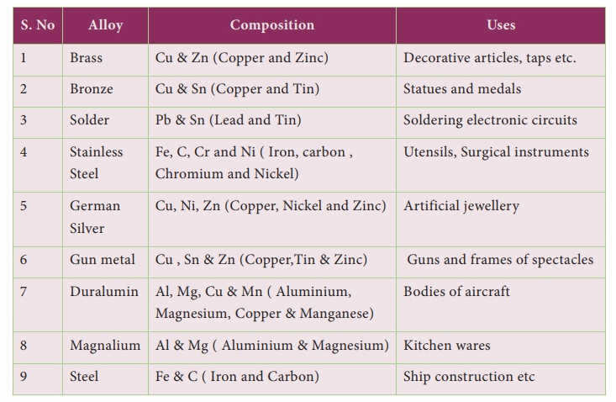

**CHEMISTRY**

**Competency based question**

**Chapter 3 –Metals and Non metals**

**1.**  A metal ‘X’ loses two electrons and a non-metal ‘Y’ gains one electron. Show the electron dot structure of compound formed between them is ionic or covalent? Does it have high melting point or low? Will it conduct electricity in solid state or in aqueous solution and why? Will it be soluble in water?

**2.**  A student was given Mn, Zn, Fe and Cu metals. Identify which of them

      (a) will not displace H2 from dil. HCl.

      (b) will react only with steam to give H2(g).

      (c) Will give H2 with 5% HNO3.

      Write the chemical reactions involved.

**3.**  Compound **X** and aluminium are used to join railway tracks.

      (a) Identify the compound X.

      (b) Name the reaction.

      (c) Write down its reaction.

**4.**  A metal **A**, which is used in thermite process, when heated with oxygen gives an oxide **B,** which is amphoteric in nature? Identify **A and B**. Write down the reactions of oxide B with HCl and NaOH.

**5.**  A non-metal **A** is an important constituent of our food and forms two oxides **B** and **C**. Oxide **B** is toxic whereas **C** causes global warming. Identify **A, B and C**.

**6**.Prakash treated a lustrous, divalent element M with sodium hydroxide. He observed the formation of bubbles in the reaction mixture. He made the same observations when this element was treated with hydrochloric acid. Suggest how can he identify the produced gas. Write chemical equations for both reactions.

**7**. Why should the metal sulphides and carbonates be converted to metal oxides in the extraction process of metal?

**8**. When a metal X is treated with cold water, it gives a basic salt Y with the molecular formula XOH (Molecular mass = 40) and liberates a gas Z which easily catches fire. Identify X, Y and Z and also write the reaction involved.

**9**. A metal that exists as a liquid at room temperature is obtained by heating its sulphide in the presence of air. Identify the metal and its ore and give the reaction involved.

**10** What happens when

(a) ZnCO3 is heated without oxygen?

(b) A mixture of Cu2O and Cu2S is heated?

**11**  A metal M does not liberate hydrogen from acids but reacts with oxygen to give a black colour product. Identify M and black coloured products and explain M’s reaction with oxygen.

**12** Of the three metals, X, Y and Z. X react with cold water, Y with hot water and Z with steam. Identify X, Y and Z and also arrange them in order of increasing reactivity.

Choose the most current in each of the following :

**13**. All the following materials show property of malleability except

a. Iron b. Graphite c. Aluminium d. Silver

X is the product formed when sulphur reacts with oxygen, it dissolves in water to produce Y Choose correct option for X and Y.

|  |  |  |
| --- | --- | --- |
|  | X | Y |
| a | SO2 | ACID |
| b | SO3 | NEUTRAL |
| c | SO2 | BASE |
| d | SO3 | ACID |

**14**. If copper is kept open in air, it slowly loses its shining brown surface and gains a green coating. It is due to the formation of

(a) CuSO4 (b) CuCO3  (c) Cu(NO3 ) 2 (d) CuO

**15**.The chief ore of aluminum is

(a) Bauxite (b) Cryolite (c) cinnabar (d) pyrolusite

**16.** The electronic configuration of three elements X, Y and Z are as follows:

X = 2,8,3, Y = 2, 8,7, Z = 2,4 Which two elements will combine to form an ionic compound and write the correct formula,

1. XY3 (b) ZY (c) XZ3 (d) XY2