1.Valid Parentheses
class Solution {
public boolean isValid(String s) {
Stack<Character> st = new Stack<>();

for(char c: s.toCharArray()) {
if(c == '(' || c == '[' || c == '{') {
st.push(c);
} else {
if(st.isEmpty()) return false;

char top = st.pop();
if(c == ')' && top != '('
|| c == ']' && top != '['
|| c == '}' && top != '{') {
return false;
}
}
}

return st.isEmpty();
}
}

Approach:
- Push opening brackets (, [, { onto a stack as you scan the string.
- For closing brackets, check if the stack is empty (invalid) or if the top matches the corresponding opening bracket, otherwise return false.
- Valid if and only if the stack is empty at the end (all brackets matched in correct order).

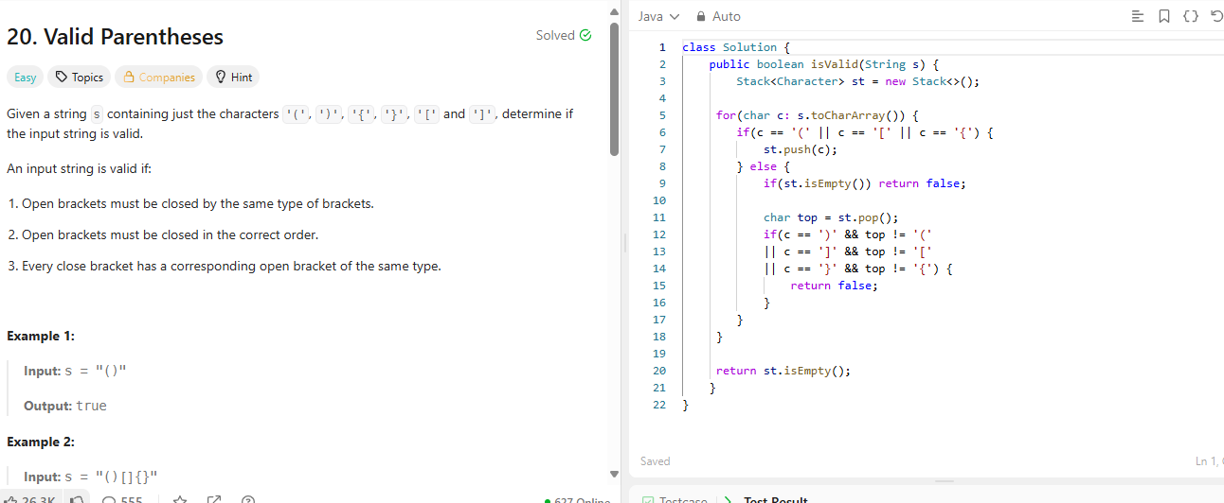
2. Daily Temperature
class Solution {
public int[] dailyTemperatures(int[] temperatures) {
int n = temperatures.length;
int[] output = new int[n];
Stack<Integer> stack = new Stack<>();

for(int i = 0; i < n; i++) {
while(!stack.isEmpty() && temperatures[i] > temperatures[stack.peek()]){
int prevIndex = stack.pop();
output[prevIndex] = i - prevIndex;
}
stack.push(i);
}
return output;
}
}

Approach:
- Use a stack of indices to keep track of days with no warmer temperature found yet.
- For each day, pop indices from the stack while the current temperature is warmer
- Update their output as the difference in days.
- Push current day’s index onto the stack.
- Any index left in the stack at the end means no warmer day → stays 0.

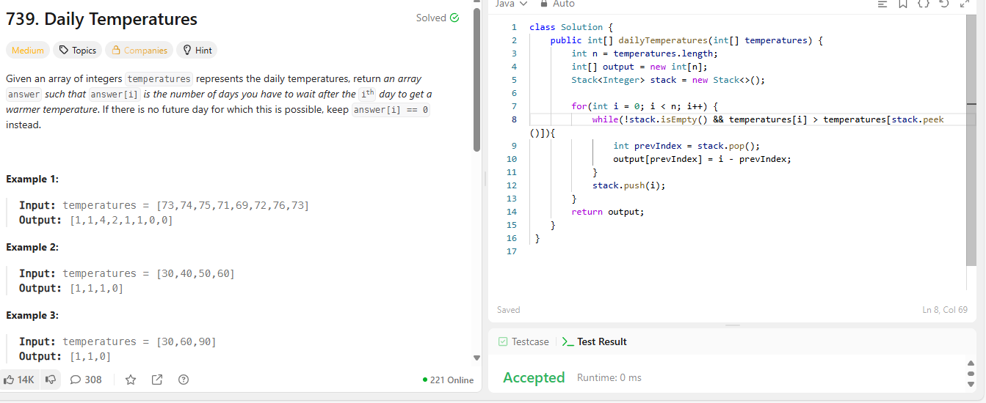

3. Next Greater Element
class Solution {
public int[] nextGreaterElements(int[] nums) {
int n = nums.length;
int[] output = new int[n];
Arrays.fill(output, -1);
Stack<Integer> stack = new Stack<>();

//Looping through array twice because it is a circular array.
for(int i = 0; i < 2 * n; i++) {
int curr = nums[i % n];
while(!stack.isEmpty() && nums[stack.peek()] < curr) {
int index = stack.pop();
output[index] = curr;
}

if(i < n) {
stack.push(i);
}
}
return output;
}
}

Approach:
- Use a stack of indices to keep track of numbers with no next greater number found yet.
- For each number, pop indices from the stack while the current number is greater than previous.
- Update their output as the greater number found.
- Push current number’s index onto the stack.
- Any index left in the stack at the end means no greater number found ahead → stays -1.

