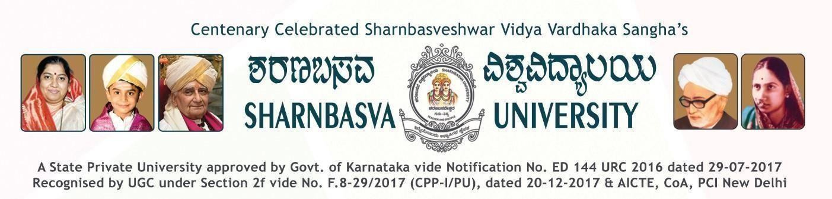
A PROJECT REPORT
ON

“REAL-TIME FACE RECOGNITION ATTENDANCE SYSTEM”
Submitted to



Department of Computer Science & Design
in partial fulfilment of the 5TH Semester Project
Submitted by
BHAGYASHREE (SG24CSD007) CHETANA (SG24CSD011)
MAHANTESH (SG24CSD019)
SUPRIYA (SG24CSD049)
Under the Guidance of:
PROF. SOUMYA MITEKAR
DEPARTMENT OF COMPUTER SCIENCE & DESIGN
FACULTY OF ENGINEERING AND TECHNOLOGY [CO-ED] SHARNBASVA UNIVERSITY, KALBURAGI
2025-2026

CERTIFICATE

This is to certify that the project titled “REAL-TIME FACE RECOGNITION ATTENDANCE SYSTEM” is a Bonafide work carried out by BHAGYASHREE (SG24CSD007), CHETANA (SG24CSD011), MAHANTESH (SG24CSD019), SUPRIYA (SG24CSD049) in partial fulfilment of B. Tech 5TH Semester in Computer Science and Design of the Faculty of Engineering and Technology (Co-Education), SHARNBASVA UNIVERSITY, Kalaburagi during the year 2025-2026.

NAME | USN
BHAGYASHREE | SG24CSD007
CHETANA | SG24CSD011
MAHANTESH | SG24CSD019
SUPRIYA | SG24CSD049

GUIDE CHAIRPERSON DEAN

Name of the Examiners Signature with date

1.

2.

ACKNOWLEDGEMENT

Any achievement, be scholastic or otherwise does not depend solely on the individual efforts but also on the guidance, encouragement and co-operation of intellectuals, elders and friends. A number of personalities, in their own capacities have helped us in carrying out this project work. We would like to take this opportunity to thank them all.

First of all, We would like to express our immense gratitude to Dr. Anilkumar Bidve, Vice Chancellor, Sharnbasva University, Kalaburagi for his help and inspiration during the tenure of the course.

We also extend our sincere thanks to Dr. S G Dollegoudar, Registrar, Sharnbasva University, Kalaburagi.

We also extend our sincere thanks to Dr. S S Honnali, Registrar (Evaluation) Sharnbasva University, Kalaburagi.
We also extend our sincere thanks to Dr. Laxmi Patil Maka, Dean Sharnbasva University, Kalaburagi. We also extend our sincere thanks to Dr. Kiran Maka, Finance Officer, Sharnbasva University,
Kalaburagi.

We also extend our sincere thanks to Dr. Shivakumar Jawalgi, Dean Faculty of Engineering & Technology-Co.Edu. Sharnbasva University, Kalaburagi.

We also extend our sincere thanks to Chairman Dr. Sachinkumar Veerashetty, Department of Computer Science and Design, Faculty of Engineering and Technology-Co-Education, for his constant encouragement.

We also extend our sincere thanks to my Guide Prof. Soumya Mitekar, Assistant Professor, Department of Computer Science & Design, Faculty of Engineering and Technology Co-Education, for his constant encouragement.

We also extend our sense of gratitude and sincere thanks to all the faculty members of Computer Science & Design, Faculty of Engineering and Technology-Co-Education for their constant encouragement and support.

BHAGYASHREE (SG24CSD007) CHETANA (SG24CSD011)
MAHANTESH (SG24CSD019)
SUPRIYA (SG24CSD049)

3

