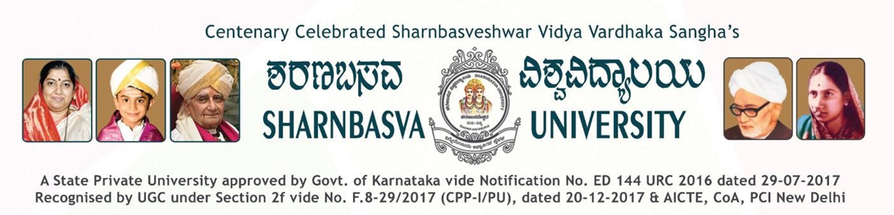

A
PROJECT REPORT
ON
“INTELLIHELMET: ADVANCED IOT-ENABLEDALCOHOL DETECTION SYSTEM FORENHANCED ROAD SAFETY”
Submitted in partial fulfillment for the award of
MASTER OF TECHNOLOGY
IN
COMPUTER SCIENCE AND ENGINEERING
Submitted by:
SOUMYA R MITEKAR
(USN: SW22SCS008)

UNDER THE GUIDANCE OF:
Prof. CHETHANA S PATIL.
Asst. Professor
Dept. of Computer Science and Engineering
Faculty of Engineering Technology (Exclusively for Women)

Department of Computer Science and Engineering
Faculty of Engineering Technology (Exclusively for Women)
Sharnbasva University, Kalaburagi
2023-2024

