CHAPTER 1

PREAMBLE

1.1 Introduction
The advancement of robotics and wireless communication technologies has led to the development of smart robotic systems capable of performing tasks with minimal human intervention. Robotic vehicles are widely used in automation, surveillance, transportation, and educational applications.
This project, Bluetooth-Controlled Smart Navigation Robot Using ESP32, is designed to demonstrate wireless robotic control using an ESP32 microcontroller and Bluetooth communication. The robot is built using an ESP32, L298N motor driver, BO motors, 4WD chassis, and lithium battery power supply.
The robot receives commands through a Bluetooth-enabled mobile application. Based on the user's selection, the robot can move toward predefined destinations such as Home, School, Office, and Hostel. The ESP32 processes the received commands and controls the movement of the motors through the L298N motor driver module.
This project provides practical knowledge of embedded systems, robotics, motor control, and wireless communication technologies. It demonstrates how a low-cost robotic platform can be developed for educational and automation purposes.
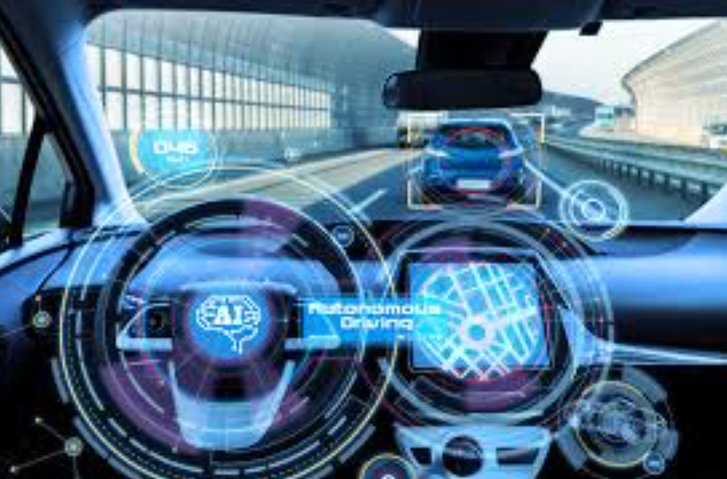
Snapshot 1.1 Smart Drving

1.2 Overview of Internet of Things (IoT)
The Internet of Things (IoT) is a technology that enables devices to communicate and exchange information through wireless networks. IoT systems combine sensors, controllers, communication modules, and software to perform intelligent operations.
Although this project primarily uses Bluetooth communication, it is related to IoT concepts because it enables wireless control of a robotic system. The ESP32 microcontroller can also be upgraded with Wi-Fi connectivity in the future to support cloud-based monitoring and control.
The main components of the system are:
- ESP32 Microcontroller
- Bluetooth Communication
- L298N Motor Driver
- Mobile Application Interface
The project demonstrates the basic concepts of smart wireless robotic systems and future IoT-based automation.

1.3 Problem Definition
Traditional robotic vehicles often rely on wired communication or simple remote controls, which limit flexibility and user convenience. Many systems do not support intelligent destination-based navigation and wireless control.
The main objective of this project is to develop a smart robotic vehicle capable of:
- Bluetooth-based wireless control
- Mobile application control
- Destination-based navigation
- Movement toward predefined locations such as Home, School, Office, and Hostel
- Low-cost and efficient robotic automation
The project aims to provide an easy-to-use robotic platform suitable for educational and research purposes.

1.4 Motivation
The motivation behind this project is the increasing use of robotics and automation in modern applications. Smart robotic systems help reduce human effort and improve efficiency in various fields.
This project was developed to gain practical experience in ESP32 programming, Bluetooth communication, motor control, and robotic system design. It also provides an understanding of how wireless communication can be used to control robotic vehicles.
Another motivation is to create a low-cost robotic platform using easily available components. The project demonstrates how ESP32, L298N motor drivers, BO motors, and Bluetooth technology can be integrated to develop a functional smart robot.
The project also serves as a foundation for future enhancements such as Wi-Fi control, IoT integration, GPS navigation, and autonomous robotic applications.

1.5 Objectives of the Project
The main objective of this project is to design and develop a Bluetooth-controlled smart robotic vehicle using an ESP32 microcontroller. The robot is capable of receiving commands from a mobile application and navigating toward predefined destinations.
The specific objectives are:
- To develop a wireless robotic vehicle using ESP32 and Bluetooth communication.
- To control the movement of the robot through a smartphone application.
- To interface the L298N motor driver with ESP32 for motor control.
- To implement predefined destination-based navigation such as Home, School, Office, and Hostel.
- To provide forward, backward, left, right, and stop movement control.
- To create a low-cost robotic platform for educational and research purposes.
- To gain practical knowledge of embedded systems, robotics, and wireless communication technologies.

1.6 Scope of the Project
The scope of this project is limited to the design and implementation of a Bluetooth-controlled robotic vehicle using ESP32. The robot operates within the Bluetooth communication range and performs movement based on commands received from a mobile application.
The project scope includes:
- Wireless control of the robot using Bluetooth technology.
- Motor control using the L298N motor driver module.
- Navigation toward predefined locations such as Home, School, Office, and Hostel.
- Development of a simple and user-friendly mobile control interface.
- Demonstration of robotics, embedded systems, and automation concepts.
Future enhancements can include:
- Wi-Fi and IoT-based remote control.
- GPS-based navigation and tracking.
- Future Obstacle detection and avoidance systems.
- Voice-controlled operation.
- Camera integration for live monitoring.
- Autonomous path planning and intelligent navigation.

CHAPTER 2

LITERATURE SURVEY

2.1 Related Works
Robotics and wireless communication technologies have become important areas of research in modern engineering. Many robotic vehicles have been developed using microcontrollers, motor drivers, and wireless communication modules for automation and educational applications.
Bluetooth-controlled robotic vehicles are among the most common robotic systems. These robots use wireless communication between a smartphone and a microcontroller to control movement. Such systems are widely used because they are simple, affordable, and easy to implement.
Recent developments in robotics have focused on intelligent navigation systems where robots can perform specific tasks based on predefined instructions. Mobile applications are often used to send commands and control robotic movements remotely.
The ESP32 microcontroller has become popular in robotic applications because it provides high processing capability, Bluetooth connectivity, and low power consumption. Many researchers use ESP32 for wireless robotic systems due to its flexibility and ease of programming.
This project is inspired by these robotic technologies and implements a Bluetooth-controlled navigation robot capable of moving toward predefined destinations such as Home, School, Office, and Hostel. The system demonstrates the practical application of embedded systems, wireless communication, and robotic automation.

2.2 Existing System
Existing robotic vehicles generally use wired control systems or basic remote-control methods. These systems often provide only manual movement control and lack intelligent navigation features.
Some Bluetooth-controlled robots allow users to control movement through smartphones. However, many of these systems only support basic operations such as forward, backward, left, and right movement.
The major limitations of existing systems include:
- Dependence on manual control
- Limited navigation capabilities
- Lack of destination-based movement
- Limited flexibility for future upgrades
- Basic user interfaces
- Restricted automation features
Many advanced robotic systems provide autonomous navigation, but they are expensive and require complex hardware and software implementation. Such systems are not always suitable for educational projects and beginner-level robotics applications.
Therefore, there is a need for a simple, affordable, and intelligent robotic platform that combines wireless communication and destination-based navigation.

2.3 Proposed System
The proposed system is a Bluetooth-Controlled Smart Navigation Robot developed using ESP32, L298N Motor Driver, BO Motors, 4WD Chassis, Lithium Battery Pack, and a Bluetooth mobile application.
In this system, ESP32 acts as the central controller and receives commands from a smartphone through Bluetooth communication. Based on the selected option, the robot moves according to predefined navigation paths.
The robot supports destination-based navigation such as:
- Home
- School
- Office
- Hostel
The L298N motor driver controls the BO motors connected to the 4WD chassis. The robot can perform forward, backward, left, right, and stop movements based on programmed instructions.

Advantages of the Proposed System
- Bluetooth-based wireless control
- ESP32-based smart processing
- Predefined destination navigation
- User-friendly mobile application
- Low-cost implementation
- Easy hardware integration
- Suitable for educational purposes
- Expandable for future enhancements

Future Enhancements
- Wi-Fi-based remote control
- IoT integration
- GPS navigation
- Voice command control
- Mobile app improvements
- Autonomous navigation features
- Cloud-based monitoring
The proposed system provides a practical and cost-effective solution for learning robotics, embedded systems, and wireless communication technologies while demonstrating destination-based robotic navigation.

CHAPTER 3

SYSTEM REQUIREMENT SPECIFICATION

3.1 Functional Requirements
Functional requirements describe the operations and functions that the Bluetooth-Controlled Smart Navigation Robot must perform successfully. The system is designed to provide wireless robotic control and destination-based navigation using ESP32 and Bluetooth communication technology.

3.1.1 Wireless Communication
The robotic system must support wireless communication between the mobile application and the robot through the ESP32 Bluetooth module.
The Bluetooth system must:
- Receive wireless commands
- Support smartphone connectivity
- Maintain reliable communication
- Enable real-time robot control

3.1.2 Mobile Application Control
The system must support control through a Bluetooth-enabled mobile application.
The application should provide:
- Forward movement button
- Backward movement button
- Left movement button
- Right movement button
- Stop button
- Bluetooth connection option
- Destination navigation buttons

3.1.3 Robotic Movement Control
The robotic vehicle must support directional movement according to commands received from the mobile application.
The robot should perform:
- Forward movement
- Backward movement
- Left turning
- Right turning
- Stop operation
The movement control is achieved using BO motors and the L298N motor driver module.

3.1.4 Predefined Destination Navigation
The robotic system must support predefined destination navigation such as:
- Home
- Hospital
- Office
- School
These routes are implemented using programmed movement sequences stored in the ESP32.

3.1.5 Speed Control
The robotic system should support motor speed control using PWM signals generated by ESP32.
The speed control feature should:
- Control motor speed
- Improve robot movement
- Enable smooth operation
- Support efficient navigation

3.1.6 Real-Time Processing
The ESP32 controller must process commands in real time for smooth robotic operation.
The system should:
- Receive commands instantly
- Process data quickly
- Execute movements efficiently
- Maintain continuous operation

3.2 Non-Functional Requirements

3.2.1 Reliability
The robotic system must provide reliable operation during Bluetooth communication and movement control.

3.2.2 Performance
The system should provide fast response to user commands and smooth robotic movement.

3.2.3 Efficiency
The system should operate efficiently using low-cost electronic components and optimized programming.

3.2.4 Usability
The mobile application should be simple, user-friendly, and easy to operate.

3.2.5 Maintainability
The robotic system should support easy maintenance, software updates, and hardware replacement.

3.2.6 Scalability
The system should support future enhancements such as:
- Wi-Fi communication
- IoT integration
- GPS navigation
- Voice control
- Camera modules

3.2.7 Portability
The robotic vehicle should be lightweight and easy to transport.

3.2.8 Cost Effectiveness
The project should use affordable components suitable for students and educational institutions.

3.2.9 Compatibility
The system should ensure compatibility between ESP32, L298N motor driver, motors, batteries, and mobile application.

3.3 Software Requirements

3.3.1 Arduino IDE
Arduino IDE is used for writing, compiling, debugging, and uploading programs to ESP32.
Functions:
- Code writing
- Program compilation
- Error debugging
- Code uploading
- Serial monitoring

3.3.2 Mobile Application
The mobile application is used for Bluetooth-based robot control.
Functions:
- Bluetooth connectivity
- Robot movement control
- Destination selection
- User-friendly interface

3.3.3 Embedded C/C++ Programming
ESP32 is programmed using Embedded C/C++ language.
Functions:
- Bluetooth communication
- Motor control
- Navigation control
- Command processing

3.3.4 Operating System
The project can be developed on:
- Windows
- Linux
- macOS

3.3.5 Serial Monitor
Used for:
- Debugging
- Monitoring commands
- Testing Bluetooth communication

3.4 Hardware Requirements

3.4.1 ESP32
ESP32 is the main controller used in the project.
Functions:
- Processes commands
- Controls motors
- Handles Bluetooth communication

3.4.2 L298N Motor Driver
The L298N motor driver controls the BO motors.
Functions:
- Controls motor direction
- Provides motor power
- Supports forward and reverse movement

3.4.3 BO Motors
BO motors are used for robotic movement.
Functions:
- Drive the wheels
- Support directional movement
- Enable navigation

3.4.4 Wheels and 4WD Chassis
The chassis provides mechanical support for all components.
Functions:
- Supports robot structure
- Holds motors and electronics
- Enables smooth movement

3.4.5 Lithium Battery Holder and Batteries
The battery system supplies power to the robot.
Functions:
- Powers ESP32
- Supplies motor driver
- Operates motors

3.4.6 Zero PCB
Zero PCB is used for mounting and connecting electronic components.
Functions:
- Circuit integration
- Component mounting
- Reliable electrical connections

3.4.7 Jumper Wires
Jumper wires provide electrical connections between modules.
Functions:
- Signal transfer
- Power distribution
- Circuit connectivity
The above hardware and software components together form a Bluetooth-controlled smart navigation robot capable of moving toward predefined destinations such as Home, Hospital, Office, and School.

CHAPTER 4

SYSTEM DESIGN AND DEVELOPMENT

4.1 Introduction
The System Design and Development phase is an important stage in the implementation of the Bluetooth-Controlled Smart Navigation Robot. This phase involves designing the hardware architecture, integrating software and hardware components, developing the mobile application, and implementing Bluetooth-based robot control.
The project is developed using ESP32 as the central controller. The system integrates Bluetooth communication, motor control, predefined destination navigation, and mobile application control into a single robotic platform.
The development process includes:
- Hardware integration
- Circuit design
- Mobile application development using MIT App Inventor
- Embedded programming
- Bluetooth communication setup
- Robotic movement control
The robot can be controlled wirelessly through a smartphone application and can navigate based on predefined destinations such as Home, Hospital, Office, and School.

4.2 Block Diagram
The block diagram represents the overall architecture of the robotic system.

Main Components
- Mobile Application (MIT App Inventor)
- ESP32 Controller
- L298N Motor Driver
- BO Motors
- 4WD Chassis
- Lithium Battery Supply

Working of Block Diagram
- The mobile application sends commands through Bluetooth.
- ESP32 receives the commands wirelessly.
- ESP32 processes the received commands.
- Control signals are sent to the L298N motor driver.
- The motor driver controls the BO motors.
- The motors move the robotic vehicle according to the selected command.
- The battery supplies power to all system components.
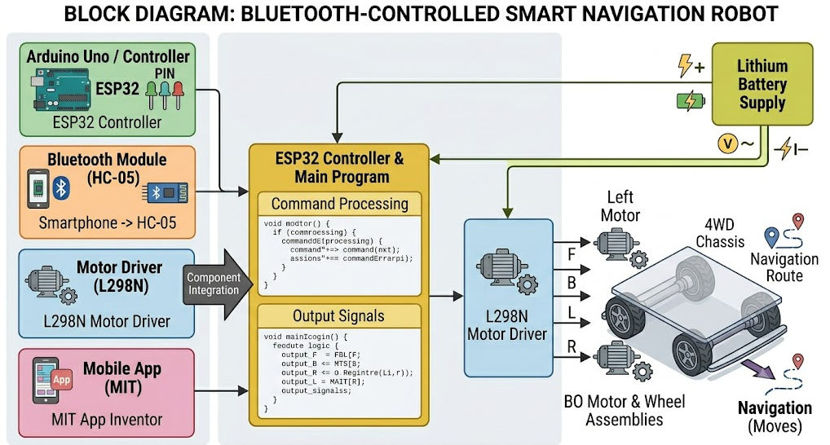
Snapshot 4.2 Block Diagram

4.3 Circuit Diagram
The circuit diagram shows the connections between ESP32, L298N motor driver, motors, and power supply.

ESP32 Connections
ESP32 acts as the main controller and is connected to:
- L298N Motor Driver
- Power Supply
- Bluetooth Communication (built into ESP32)

L298N Motor Driver Connections
The motor driver is connected to:
- ESP32 control pins
- Four BO motors
- Battery power supply
Functions:
- Controls motor direction
- Controls motor speed
- Drives the motors safely
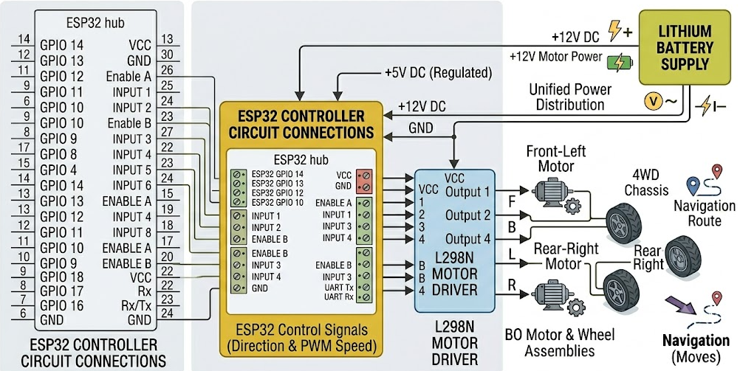

Snapshot 4.4 Circuit Diagram

Motor Connections
The four BO motors are connected to the output terminals of the L298N motor driver.
Functions:
- Forward movement
- Backward movement
- Left movement
- Right movement

Battery Connections
The lithium battery holder supplies power to:
- ESP32
- L298N Motor Driver
- BO Motors
The complete circuit ensures reliable communication and robotic movement.
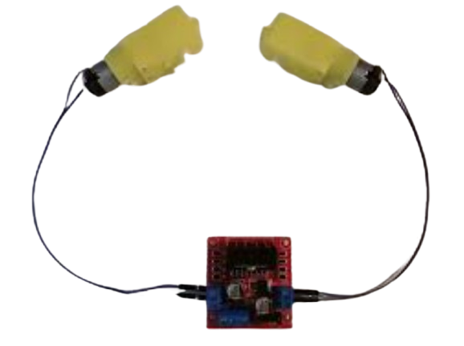

Snapshot 4.3 Motor Connections

4.4 Working Principle
The Bluetooth-Controlled Smart Navigation Robot operates through wireless communication and embedded programming.

Working Process
- The user opens the mobile application developed using MIT App Inventor.
- The smartphone connects to ESP32 through Bluetooth.
- The user selects a movement command or destination.
- The command is transmitted wirelessly to ESP32.
- ESP32 processes the command.
- Control signals are sent to the L298N motor driver.
- The motor driver controls the BO motors.
- The robot moves according to the programmed instructions.
Supported movements include:
- Forward
- Backward
- Left
- Right
- Stop
The robot can also execute predefined navigation sequences for:
- Home
- Hospital
- Office
- School
Thus, the system combines Bluetooth communication, mobile application control, and robotic movement into a single platform.
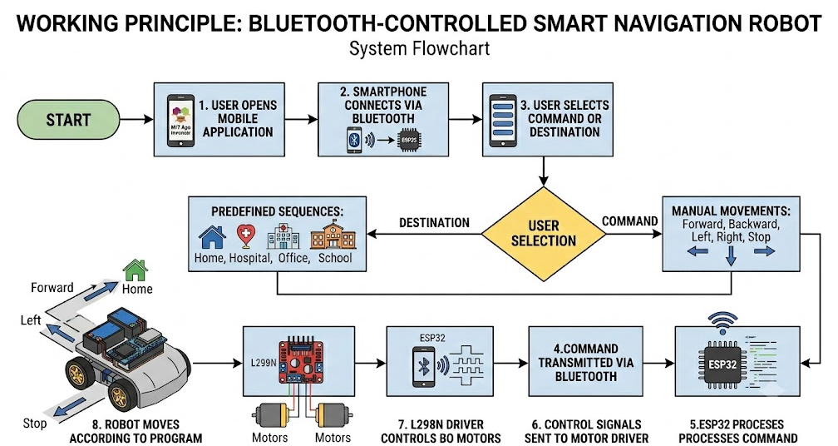
Snapshot 4.5 Working Principal

4.5 MIT App Design
The mobile application is developed using MIT App Inventor.
MIT App Inventor provides a simple drag-and-drop environment for Android application development and enables easy Bluetooth communication with ESP32.

Features of the Mobile Application
The application includes:
- Bluetooth Connect Button
- Bluetooth Disconnect Button
- Forward Button
- Backward Button
- Left Button
- Right Button
- Stop Button
- Home Button
- Hospital Button
- Office Button
- School Button

Application Interface
The application is designed with:
- Simple user interface
- Large control buttons
- Easy Bluetooth connectivity
- Destination navigation options

Application Working
- The user connects the smartphone to ESP32 through Bluetooth.
- The application establishes communication.
- Button presses send command characters to ESP32.
- ESP32 processes the commands.
- The robot performs the required movement.
The mobile application acts as the primary control interface for the robotic system.
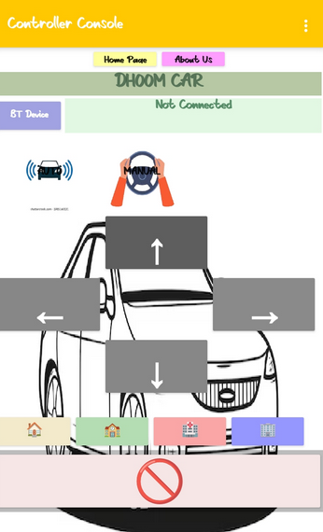

Snapshot 4.6 Working Principal

4.6 Bluetooth Communication
Bluetooth communication is used for wireless control of the robotic vehicle.
The ESP32 contains an inbuilt Bluetooth module, eliminating the need for an external Bluetooth device.

Bluetooth Communication Process
- Smartphone pairs with ESP32.
- The mobile application sends commands.
- ESP32 receives commands wirelessly.
- Commands are processed by the controller.
- Motor control signals are generated.
- The robot performs the selected operation.

Advantages of Bluetooth Communication
- Wireless operation
- Easy smartphone connectivity
- Low power consumption
- Low implementation cost
- Fast response time
- Simple system design
Bluetooth communication enables flexible and efficient robotic control without wired connections.

CHAPTER 5

IMPLEMENTATION

5.1 Hardware Implementation
Hardware implementation is an important stage in the development of the Bluetooth-Controlled Smart Navigation Robot. This phase involves assembling the hardware components, making electrical connections, integrating the control system, and constructing the robotic vehicle.
The major hardware components used in the project are:
- ESP32
- L298N Motor Driver
- BO Motors
- 4WD Chassis
- Lithium Battery Holder and Batteries
- Zero PCB
- Jumper Wires

ESP32 Implementation
ESP32 acts as the main controller of the robotic system. It receives commands from the mobile application through Bluetooth and controls the movement of the robot.
The ESP32 performs:
- Bluetooth communication
- Command processing
- Motor control
- Route navigation execution
ESP32 is programmed using Arduino IDE and Embedded C/C++.
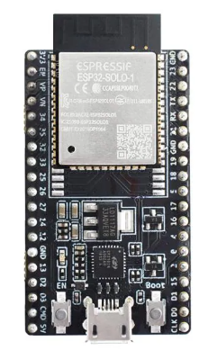

Snapshot 5.1 ESP32

L298N Motor Driver Implementation
The L298N motor driver is used to control the BO motors connected to the robot.
Functions:
- Motor direction control
- Speed control
- Power distribution to motors
- Safe motor operation
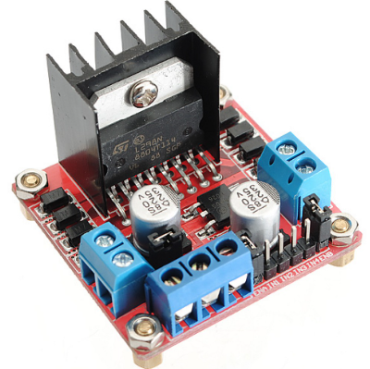
The motor driver acts as an interface between ESP32 and the motors.

Snapshot 5.2 L298N Motor Driver

BO Motor and Wheel Assembly
Four BO motors are mounted on the 4WD chassis.
Functions:
- Forward movement
- Backward movement
- Left turning
- Right turning
The wheel assembly provides stability and smooth movement of the robot.

Battery and Power Supply Implementation
A lithium battery holder with batteries is used to power the system.
The battery powers:
- ESP32
- L298N Motor Driver
- BO Motors
Proper power distribution ensures stable robotic operation.
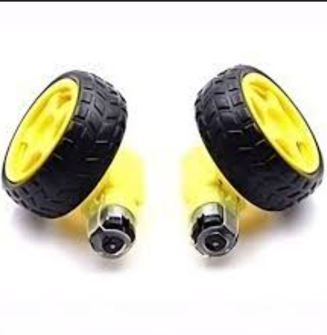

Snapshot 5.3 BO Motors Wheels

Zero PCB Implementation
The Zero PCB is used for mounting and connecting electronic components.
Functions:
- Circuit assembly
- Component mounting
- Reliable electrical connections

Chassis Construction
The 4WD chassis serves as the mechanical structure of the robot.
The chassis supports:
- Motor mounting
- Component arrangement
- Battery placement
- Stable movement
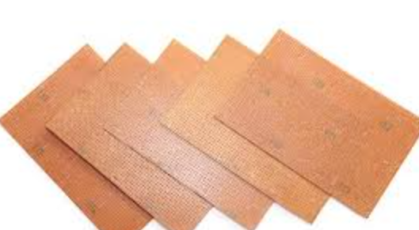
Snapshot 5.4 Zero PCB

5.2 Software Implementation
Software implementation involves developing the embedded program for ESP32 and the Android application using MIT App Inventor.
The major software tools used are:
- Arduino IDE
- MIT App Inventor

ESP32 Programming
ESP32 is programmed using Embedded C/C++ language.
The program controls:
- Bluetooth communication
- Motor operations
- Destination navigation
- Command processing
The code contains:
- Setup function
- Loop function
- Motor control functions
- Bluetooth communication functions
- Route navigation functions

Bluetooth Communication Logic
ESP32 receives commands from the mobile application through Bluetooth communication.
The program:
- Reads Bluetooth commands
- Identifies user instructions
- Executes corresponding movements
Example commands:
- F → Forward
- B → Backward
- L → Left
- R → Right
- S → Stop
Destination commands:
- H → Home
- P → Hospital
- O → Office
- C → School

Motor Control Programming
Motor movement is controlled through the L298N motor driver.
The software controls:
- Forward rotation
- Reverse rotation
- Left turning
- Right turning
- Stop operation
PWM signals may also be used for speed control.

MIT App Development
The mobile application is developed using MIT App Inventor.
The application includes:
- Bluetooth connection button
- Forward button
- Backward button
- Left button
- Right button
- Stop button
- Home button
- Hospital button
- Office button
- School button
The application sends commands wirelessly to ESP32 through Bluetooth.

5.3 ESP32 Source Code
The ESP32 source code is the main program used to control the robotic system. It handles Bluetooth communication, motor control, and predefined route navigation.
The code includes:
- Library declarations
- Pin configuration
- Bluetooth communication setup
- Motor control functions
- Route navigation logic

Example Pin Configuration

int IN1 = 18;
int IN2 = 19;
int IN3 = 21;
int IN4 = 22;

Bluetooth Communication Code

if (SerialBT.available())
{
char cmd = SerialBT.read();
}

Motor Control Function

void moveForward()
{
digitalWrite(IN1, HIGH);
digitalWrite(IN2, LOW);
digitalWrite(IN3, HIGH);
digitalWrite(IN4, LOW);
}

Route Navigation
Predefined routes are programmed in ESP32 for:
- Home
- Hospital
- Office
- School
These routes allow automatic destination-based movement.

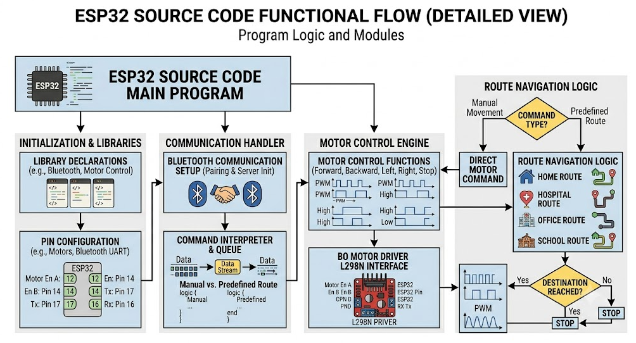
Snapshot 5.4 ESP32 Logic

5.4 MIT App Logic
The MIT App controls the robot by sending commands to ESP32 through Bluetooth.

Bluetooth Connection Steps
- Turn ON Bluetooth on the smartphone
- Select ESP32 device
- Pair the device
- Start communication

Button Control Logic
Each button sends a specific character:
- Forward → F
- Backward → B
- Left → L
- Right → R
- Stop → S

Destination Control Logic
The app also supports destination selection:
- Home → H
- Hospital → P
- Office → O
- School → C
These commands trigger predefined movement sequences in ESP32.

App Interface
The application is designed with:
- Simple layout
- Large buttons
- Easy navigation
- User-friendly control

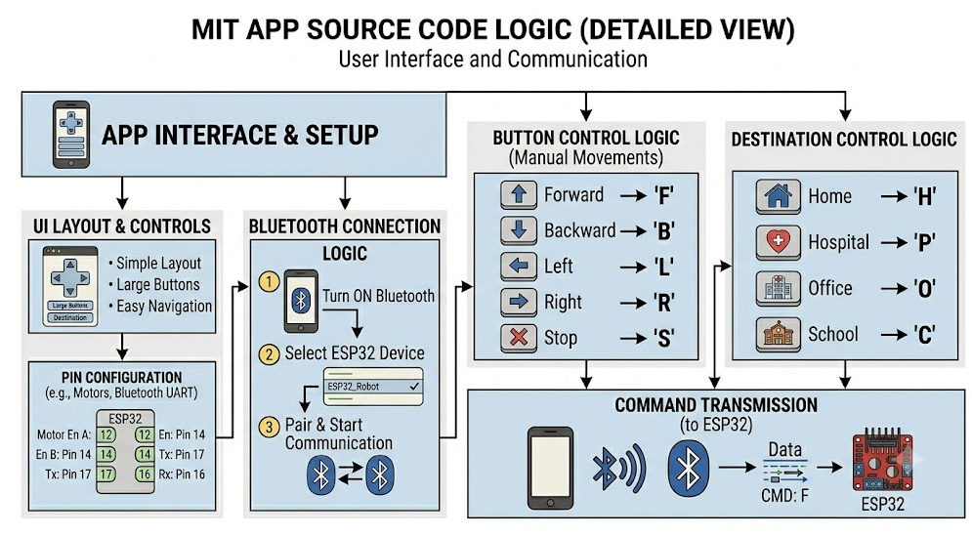

Snapshot 5.5 MIT App Logic

5.5 Testing and Calibration
Testing and calibration ensure proper and stable operation of the robotic system.

Hardware Testing
ESP32 Testing
- Program upload check
- Bluetooth communication test
- Pin functionality verification
Motor Testing
- Forward and reverse direction test
- Rotation check
- Speed verification
Power Testing
- Battery voltage check
- Stability of power supply

Software Testing
- Bluetooth communication testing
- Movement command testing
- Route navigation testing
- Mobile app control testing

Movement Calibration
- Straight line movement adjustment
- Turning accuracy correction
- Speed balancing

Bluetooth Range Testing
- Connection stability check
- Command transmission reliability
- Effective range testing

Final Testing
After full integration, the system is tested for:
- Wireless control
- Movement accuracy
- Bluetooth performance
- Route navigation
- Overall system stability

CHAPTER 6

SYSTEM TESTING

6.1 Test Approach
System testing is a crucial phase in the development of the Smart Multi-Control Robotic Car project. It verifies whether all hardware and software components function correctly according to the system requirements. The main aim is to detect errors in communication, hardware operation, sensor accuracy, and program logic before final deployment.
The testing approach includes both individual module testing and integrated system testing. Each component is tested separately and later combined for overall performance evaluation.
The testing mainly focuses on:
- Bluetooth communication
- Motor movement control
- Future Obstacle detection system
- Autonomous navigation
- Mobile application functionality
- Sensor accuracy
- Route navigation
Initially, the ESP32 was tested using basic programs to verify pin functionality and serial communication. After that, the ESP32 Bluetooth module was tested for wireless communication with the mobile application. The motor driver and BO motors were tested for directional movement. Later, the ultrasonic sensor and servo motor were integrated for Future Obstacle detection and scanning.
Finally, full system testing was performed after integrating all modules. Repeated trials and calibration were done to improve accuracy, stability, and reliability in both manual and autonomous modes.

6.2 Features Tested

6.2.1 Bluetooth Communication Testing
Bluetooth communication was tested between the mobile app and ESP32 module. Parameters tested include pairing, connection stability, command transmission, range, and response time. The system successfully transmitted commands to the ESP32/Arduino.

6.2.2 Motor Movement Testing
Motor testing verified all directional movements:
- Forward
- Backward
- Left
- Right
- Stop
The L293D motor driver correctly controlled BO motors based on received commands.

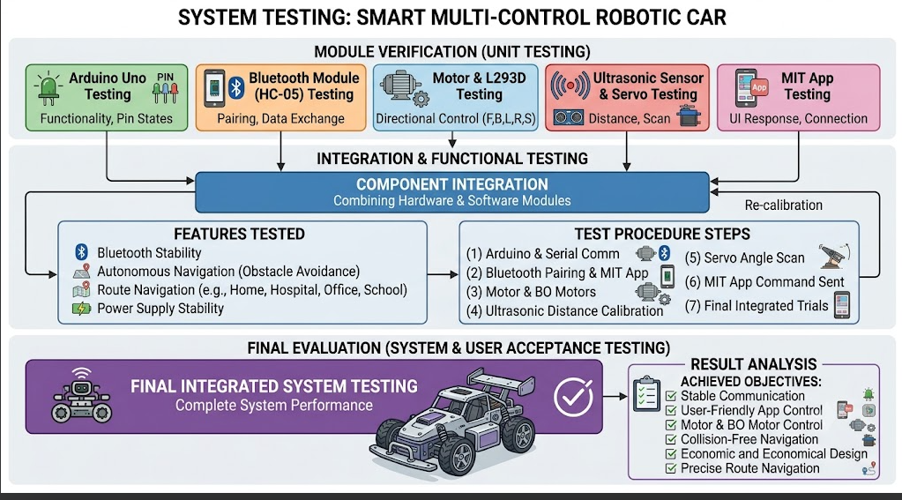
Snapshot 6.1 System Testing

6.2.3 MIT App Testing
The mobile application was tested for:
- Bluetooth connection
- Button controls
- Route navigation
- Autonomous mode
The app successfully controlled the robotic car without delay.

6.2.4 Ultrasonic Sensor Testing
The HC-SR04 sensor was tested for distance measurement and Future Obstacle detection. It accurately detected nearby objects and provided real-time readings.

6.2.5 Servo Motor Testing
The servo motor was tested for proper rotation and scanning functionality. It successfully rotated the ultrasonic sensor for environmental scanning.

6.2.6 Autonomous Navigation Testing
The robot was tested in obstacle environments. It successfully detected obstacles, stopped, scanned surroundings, and changed direction safely.

6.2.7 Route Navigation Testing
Predefined routes were tested:
- Home
- Hospital
- Office
- School
The robot successfully followed programmed movement sequences.

6.2.8 Power Supply Testing
Battery performance was tested for voltage stability and continuous operation. The system successfully powered all components without failure.

6.3 Testing Procedure
The testing procedure was carried out step-by-step to ensure proper functionality of each module.

Step 1: Arduino Testing
ESP32 was tested using basic programs to verify code uploading, serial communication, and pin functionality.

Step 2: Bluetooth Testing
ESP32 was paired with a smartphone and tested using MIT App commands to confirm wireless communication.

Step 3: Motor Testing
Motor driver and BO motors were tested for forward, reverse, left, right, and stop operations.

Step 4: Ultrasonic Sensor Testing
Distance measurement and Future Obstacle detection were verified using different object distances.

Step 5: Servo Motor Testing
Servo rotation and scanning angles were tested for accuracy.

Step 6: MIT App Testing
All app buttons and Bluetooth communication were tested for proper functionality.

Step 7: Autonomous Testing
Robot was tested in obstacle environments to verify automatic movement and collision avoidance.

Step 8: Final System Testing
All modules were integrated and tested together for overall system performance and reliability.

6.4 Result Analysis
The results show that the Smart Multi-Control Robotic Car performed successfully according to the project objectives.
Bluetooth communication provided stable wireless control between the mobile application and robotic system. The MIT App worked smoothly and allowed easy user control.
The motor driver and BO motors responded accurately to all movement commands. The ultrasonic sensor effectively detected obstacles and improved safety by preventing collisions.
The servo motor enhanced scanning capability, improving autonomous navigation. The robot successfully avoided obstacles and selected safe paths during autonomous mode.
Predefined route navigation (Home, Hospital, Office, School) worked correctly with accurate movement sequences.
Overall, the system proved to be:
- Reliable
- Cost-effective
- Efficient
- Suitable for educational and automation purposes
The project successfully demonstrated embedded system design, wireless communication, sensor integration, and mobile-controlled robotics.

CHAPTER 7

RESULT INTERPRETATION AND DISCUSSION

7.1 Project Results
The Smart Multi-Control Robotic Car project was successfully designed, developed, and tested using ESP32/ESP32, ESP32 Bluetooth module, ultrasonic sensor, servo motor, L293D motor driver, and BO motors. The system achieved all objectives related to wireless control, Future Obstacle detection, autonomous navigation, and mobile application integration.
The robotic vehicle responded correctly to commands sent from the MIT App Inventor mobile application through Bluetooth communication. Stable wireless connectivity was achieved between the smartphone and the robot.
The robot successfully performed:
- Forward movement
- Backward movement
- Left turning
- Right turning
- Stop operation
The ultrasonic sensor effectively detected obstacles and helped prevent collisions. The servo motor improved scanning capability by rotating the sensor for environmental detection.
In autonomous mode, the robot successfully detected obstacles and changed direction intelligently. The predefined route navigation system also executed programmed paths (Home, Hospital, Office, School) accurately.
Overall, the system worked reliably and demonstrated effective integration of embedded systems, wireless communication, and robotic automation.

7.2 Advantages
The project offers several advantages:
- Wireless Control The robot is controlled using Bluetooth, eliminating wired connections.
- User-Friendly Operation The MIT App provides simple smartphone-based control.
- Future Obstacle detection Ultrasonic sensor improves safety by detecting obstacles.
- Autonomous Navigation The robot can move automatically without continuous manual control.
- Low Cost System Uses affordable components suitable for students.
- Easy to Build and Maintain Simple hardware and software integration.
- Educational Value Helps understand robotics, embedded systems, sensors, and mobile app development.
- Future Expandability Can be upgraded with IoT, GPS, AI, and camera modules.
- Portable Design Compact and easy to transport.
- Real-Time Automation Demonstrates practical robotic automation concepts.

7.3 Limitations
Despite successful performance, the system has some limitations:
- Limited Bluetooth Range ESP32 works only for short-distance communication.
- Battery Dependency
The system fully depends on battery power.
- Limited Processing Power Microcontroller has limited capability for advanced AI tasks.
- Basic Future Obstacle detection Ultrasonic sensor may not detect all object types accurately.
- No Camera Support No live video or image processing capability.
- Indoor Usage Limitation Bluetooth performance is better in indoor environments.
- Simple AI Logic Autonomous system uses basic decision-making only.
- Surface Dependency Performance varies depending on floor conditions.

7.4 Future Scope
The project has strong future development potential in robotics and automation.
It can be upgraded using:
- Wi-Fi communication
- Internet of Things (IoT)
- GPS navigation
- Camera integration
- Voice control
- Artificial Intelligence (AI)
- Machine Learning (ML)
- Cloud-based monitoring
Future enhancements may include:
- Live video streaming
- Real-time tracking
- Gesture control
- Mobile internet control
- AI-based object detection
- Smart navigation systems
The system can be applied in:
- Industrial automation
- Smart warehouses
- Surveillance systems
- Medical assistance robots
- Rescue operations
- Smart delivery systems
Overall, this project provides a strong foundation for future research in intelligent robotic systems and automation technologies.

CONCLUSION
The Smart Multi-Control Robotic Car project was successfully designed and implemented using ESP32 Bluetooth module, ultrasonic sensor, servo motor, motor driver, and mobile application control. The project demonstrated wireless robotic movement, Future Obstacle detection, autonomous navigation, and predefined route control effectively.
The robotic system successfully responded to commands from the mobile application developed using MIT App Inventor and performed forward, backward, left, right, and stop movements accurately. The ultrasonic sensor and servo motor improved robotic intelligence by detecting obstacles and supporting automatic navigation.
The project provided practical knowledge in embedded systems, robotics, wireless communication, automation technologies, and mobile application development. It also improved problem-solving skills, teamwork, and hardware-software integration understanding.
The Smart Multi-Control Robotic Car project proved to be economical, user-friendly, and suitable for educational and automation applications. The project also provides a strong foundation for future upgrades using IoT, Wi-Fi, GPS, artificial intelligence, and advanced autonomous technologies.
Overall, the project successfully achieved all objectives and demonstrated the practical implementation of intelligent robotic automation systems.

REFERENCES

Books
- Massimo Banzi, Getting Started with Arduino, Maker Media Publications.
- Simon Monk, Programming Arduino: Getting Started with Sketches, McGraw Hill Education.
- John-David Warren, Josh Adams, Harald Molle, Arduino Robotics, Apress Publications.
- Muhammad Ali Mazidi, Sarmad Naimi, Sepehr Naimi, AVR Microcontroller and Embedded Systems Using Arduino, Pearson Publications.
- Rajesh Singh, Robotics for Engineers, Firewall Media Publications.

Websites
- Arduino Official Website https://www.arduino.cc
- MIT App Inventor Official Website https://appinventor.mit.edu
- ESP32 Bluetooth Module Tutorial https://lastminuteengineers.com/hc05-bluetooth-arduino-tutorial/
- Ultrasonic Sensor HC-SR04 Guide https://randomnerdtutorials.com/complete-guide-for-ultrasonic-sensor-hc-sr04/
- Arduino Project Hub https://projecthub.arduino.cc

YouTube References
- Arduino Bluetooth Controlled Car Tutorial https://www.youtube.com/watch?v=BBwEF6WBUQs
- MIT App Inventor Bluetooth Control Tutorial https://www.youtube.com/watch?v=9x8D3r9m0l8
- Arduino Obstacle Avoiding Robot Tutorial https://www.youtube.com/watch?v=1n_KjpMfVT0
- ESP32 Bluetooth Module with Arduino https://www.youtube.com/watch?v=AVyljEwM6sQ
- Arduino Robotics Complete Project Guide https://www.youtube.com/watch?v=5dWQk0DkWm8

