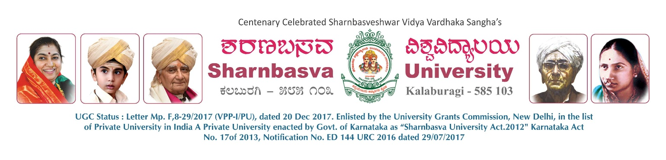A
PROJECT REPORT
ON
“SMART MULTI CONTROL ROBOTIC CAR”
Submitted to
Department of Computer Science & Design
in partial fulfilment of the 6th Semester Mini-Project

Submitted by
BHAGYASHREE PATIL | (SG23CSD007)
CHETANA PATIL | (SG23CSD011)
SHIVANGOUDA MALIPATIL | (SG23CSD040)
SUPRIYA HIREMATH | (SG23CSD049)
Under the Guidance of:
PROF. SOUMYA MITEKAR

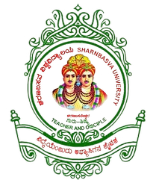

DEPARTMENT OF COMPUTER SCIENCE & DESIGN
FACULTY OF ENGINEERING AND TECHNOLOGY
SHARNBASVA UNIVERSITY,
KALBURAGI
2025-2026


CERTIFICATE

This is to certify that the project titled “SMART MULTI CONTROL ROBOTIC CAR” is a bonafide work carried out by BHAGYASHREE PATIL (SG23CSD007), CHETANA PATIL (SG23CSD011), SHIVANGOUDA MALIPATIL (SG23CSD040) , and SUPRIYA HIREMATH (SG23CSD049) in partial fulfillment of the requirements for the award of the B.Tech. in Computer Science and Design, 6th Semester, under the Faculty of Engineering and Technology, Sharnbasva University, during the academic year 2025–2026

NAME | USN
BHAGYASHREE PATIL | (SG23CSD007)
CHETANA PATIL | (SG23CSD011)
SHIVANGOUDA MALIPATIL | (SG23CSD040)
SUPRIYA HIREMATH | (SG23CSD049)

GUIDE CHAIRPERSON DEAN

Name of the Examiners Signature with date

ACKNOWLEDGEMENT
Any achievement, be it scholastic or otherwise, does not depend solely on individual efforts but also on the guidance, encouragement, and cooperation of intellectuals, elders, and friends. Many individuals, in their own capacities, have contributed to the successful completion of this project work. We take this opportunity to express our sincere gratitude to all of them.
First and foremost, we express our immense gratitude to Dr. Anilkumar Bidve, Vice Chancellor of Sharnbasva University, for his inspiration and support during the tenure of the course.
We also extend our sincere thanks to Dr. Laxmi Patil, Registrar, Sharnbasva University, Kalaburagi.
We also express our sincere thanks to Dr. S. H. Honnalli, Registrar (Evaluation), Sharnbasva University, Kalaburagi.
I express my sincere thanks to Dr. Kiran Maka, Finance Officer, for their constant encouragement and support.
We extend our heartfelt gratitude to Dr. Shivkumar Jawalgi, Dean, Sharnbasva University, Kalaburagi.
We extend our sincere gratitude to Dr. Sachinkumar Veerashetty, Chairperson, Department of Computer Science and Design, Faculty of Engineering and Technology, for his constant encouragement and support.
We would also like to express our heartfelt thanks to our guide, Prof. Soumya Mitekar, Department of Computer Science and Design, Faculty of Engineering and Technology, for valuable guidance, constant encouragement, and support throughout the project work.
Finally, we express our sincere gratitude to all the faculty members of the Department of Computer Science and Design, Faculty of Engineering and Technology, for their encouragement, guidance, and continuous support.
Bhagyashree Patil | (SG23CSD007)
Chetana Patil | (SG23CSD011)
Shivangouda Malipatil | (SG23CSD040)
Supriya Hiremath | (SG23CSD049)

