CHAPTER 1

INTRODUCTION

Nowadays we all use QR code for multiple purposes like making payments, sharing Wi-Fi, etc. Have you ever wished to generate such QR code on your own? We are here with a project for QR code generator using Python. So, follow us to build this Python project.

**About QR Code Generator project :**

* QR Code is a machine-readable matrix barcode that uniquely represents information. With the increase in optical capabilities of smartphones, the use of QR codes started increasing.
* In this project, we will build a QR Code generator using Python Modules.
* To generate QR Code in Python we will be using Tkinter and Qrcode modules in Python to build this project.
* We use the Tkinter module to build the GUI to take text/URL to convert to QR Code.
* Then we generate the QR code from the above inputs and save in the given location using the qrcode module

CHAPTER 2

OBJECTIVES

A QR code (quick response code) is a type of two dimensional (2D) [bar code](https://www.techtarget.com/searcherp/definition/bar-code-or-barcode) that is used to provide easy access to online information through the digital camera on a smartphone or tablet.

A barcode reader in the camera interprets the bar code, which typically contains a link to view a webpage, send an SMS text message or call a phone number. The technology for QR codes was developed by Densa-Wave, a Toyota subsidiary. The codes were originally used for tracking inventory and required a separate reader app, but beginning with iOS 11 and Android 8.0, readers are native to most mobile device cameras.

### Uses of QR codes

QR codes are an inexpensive way to enhance business-to-business (B2B) and business-to-consumer ([B2C](https://www.techtarget.com/searchcustomerexperience/definition/B2C)) communication. Popular uses include:

* Contactless dining - During the COVID-19 pandemic, many restaurants began using QR codes to provide paperless menus.
* Mobile device management - Network administrators can generate a [QR code for device enrollment](https://www.techtarget.com/searchmobilecomputing/tip/What-are-the-benefits-of-QR-code-enrollment) and send it to an end user by email. The QR code's call to action will prompt the end user to download the applications and policies that the managed device requires.
* Point of Sale (POS) - PayPal introduced a feature on its mobile app that [enables people selling goods to accept payments through QR codes](https://www.computerweekly.com/news/252483407/Coronavirus-pandemic-spurs-QR-code-app-upgrade-at-PayPal).
* Making two apps work together - Videxio launched a service that [lets users connect third-party video endpoints to online meetings](https://www.techtarget.com/searchunifiedcommunications/news/252453442/Videxio-MeetingConnect-uses-QR-codes-to-join-meetings) by scanning a QR code.

CHAPTER 3

LANGUAGE SPECIFICATION

**Python :**

Python is a popular programming language. It was created by Guido van Rossum, and released in 1991.

**It is used for:**

* web development (server-side),
* software development,
* mathematics,
* system scripting.

**What can Python do?**

* Python can be used on a server to create web applications.
* Python can be used alongside software to create workflows.
* Python can connect to database systems. It can also read and modify files.
* Python can be used to handle big data and perform complex mathematics.
* Python can be used for rapid prototyping, or for production-ready software development.

**Why Python?**

* Python works on different platforms (Windows, Mac, Linux, Raspberry Pi, etc).
* Python has a simple syntax similar to the English language.
* Python h…

**Python def Keyword :**

* Python def keyword is used to define a function, it is placed before a function name that is provided by the user to create a user-defined function. In python, a function is a logical unit of code containing a sequence of statements indented under a name given using the “def” keyword. In python def keyword is the most used keyword.

**Syntax:**

def function_name:

function definition statements...

**QR code generation using python :**

1. QR code is a machine-readable barcode designed in two-dimensional pixelated form.
2. The QR code can be used to store a range of data.
3. QR in QR code is abbreviated for Quick Response.
4. QR code was invented in the year 1994 by Masahiro Hara, a Japanese engineer from Automobile Manufacturer Denso Wave, in order to track the movement of car parts.
5. The popularity of the QR code has increased in the later 2010s with improvement in optical proficiencies of Mobile Phones and their extensive acceptance.
6. At the moment, QR codes are being utilized for a wide range of applications such as making online payments, checking hotel menus, sharing Wi-Fi passwords, obtaining cost and other information of products, and a lot more.
7. QR codes have become so famous that now every new smartphone comes with a built-in QR code reader.

CHAPTER 4

SYSTEM SPECIFICATION

**SOFTWARE REQUIREMENTS**

Operating system : Windows

Language : Python

**HARDWARE REQUIREMENTS**

Processor : Intel®Core™i5

Hard disk : 500GB

RAM : 2GB

System Type : 64Bit operating system

CHAPTER 5

IMPLEMENTATION

First we will import tkinter and all its sub-modules using the *. Then we will also import messagebox and pyqrcode. Tkinter module helps in creating GUI windows and apps where users can interact with events. We will generate object ws by assigning it with the Tk() constructor. Then we will give this application a title using the ws.title() method and pass "QR CODE GENERATOR" as its string. We can also configure the color of the app using the ws.config().

Then we create a user-defined function named generate_QR() where all our QR code logic will reside. The pyqrcode.create() generates the QR code as it fetches the string through user_input.get() method from the text box.

Also, this function will get executed when the user_input.get() is not equal to 0. Once the qr code gets generated using the pyqrcode.create(), we have to use the BitmapImage() and pass the data = qr.xbm()) along with a scale size (here 10) that will generate a Bitmap image of 10x10. If the user_input.get() is equals to zero, messagebox.showwarning() shows a warning to fill the data in that text box. Then within the try block we call the display_code().

This is another user-defined function that provides the image details as well as the status info that we can see at the bottom of that application.

We have to use the Label(), Entry(), and Button() constructors of the Tkinter module to generate the labels, text box, and buttons that will help programmers create a event-driven program. We will then store these Constructor initialization in three different objects lbl, entry, and button.

Finally, we will use the output.pack() method that is a geometry manager of widgets in rows or columns. Programmers can use options like fill, expand, and side to make changes in this geometry manager or pass it blank without any parameter.

Lastly, the mainloop() is used, which is an infinite loop implemented for running the application, wait for an event to occur and process the event as long as the window does not get closed by the user manually

CHAPTER 6

SOURCE CODE

import qrcode

from tkinter import *

cp = Tk()

cp.title('copyassignment.com')

cp.geometry('700x250')

cp.config(bg='#8facaf')

def generate():

img = qrcode.make(msg.get())

type(img)

img.save(f'{save_name.get()}.png')

Label(cp, text='File Saved!', bg='#e52165' , fg='black', font=('Arial Black', 8)).pack()

def show():

img = qrcode.make(msg.get())

type(img)

img.show()

frame = Frame(cp, bg='#8facaf')

frame.pack(expand=True)

#------------------ENTER THE TEXT OR URL------------------

Label(frame, text='Enter the Text or URL : ', font=('Arial Black', 16),

bg='#8facaf').grid(row=0, column=0, sticky='w')

msg = Entry(frame)

msg.grid(row=0, column=1)

#------------------ENTER THE FILE NAME------------------

Label(frame, text='File Name(Save As) : ', font=('Arial Black', 16),

bg='#8facaf').grid(row=1, column=0, sticky='w')

save_name = Entry(frame)

save_name.grid(row=1, column=1)

#------------------BUTTONS TO SHOW OR SAVE QRCODE------------------

btn = Button(cp, text='Show QR code', bd='5', command=show, width=15)

btn.pack()

btn = Button(cp, text='Save QR code', command=generate, bd='5', width=15)

btn.pack()

cp.mainloop()

CHAPTER 7

RESULTS

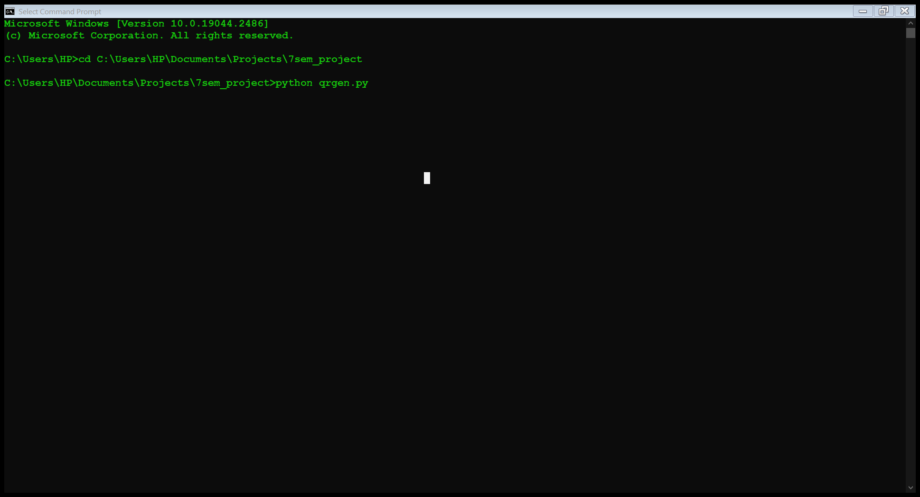

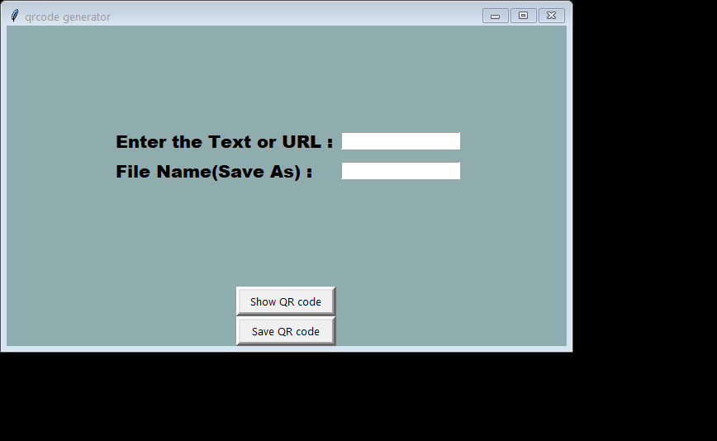

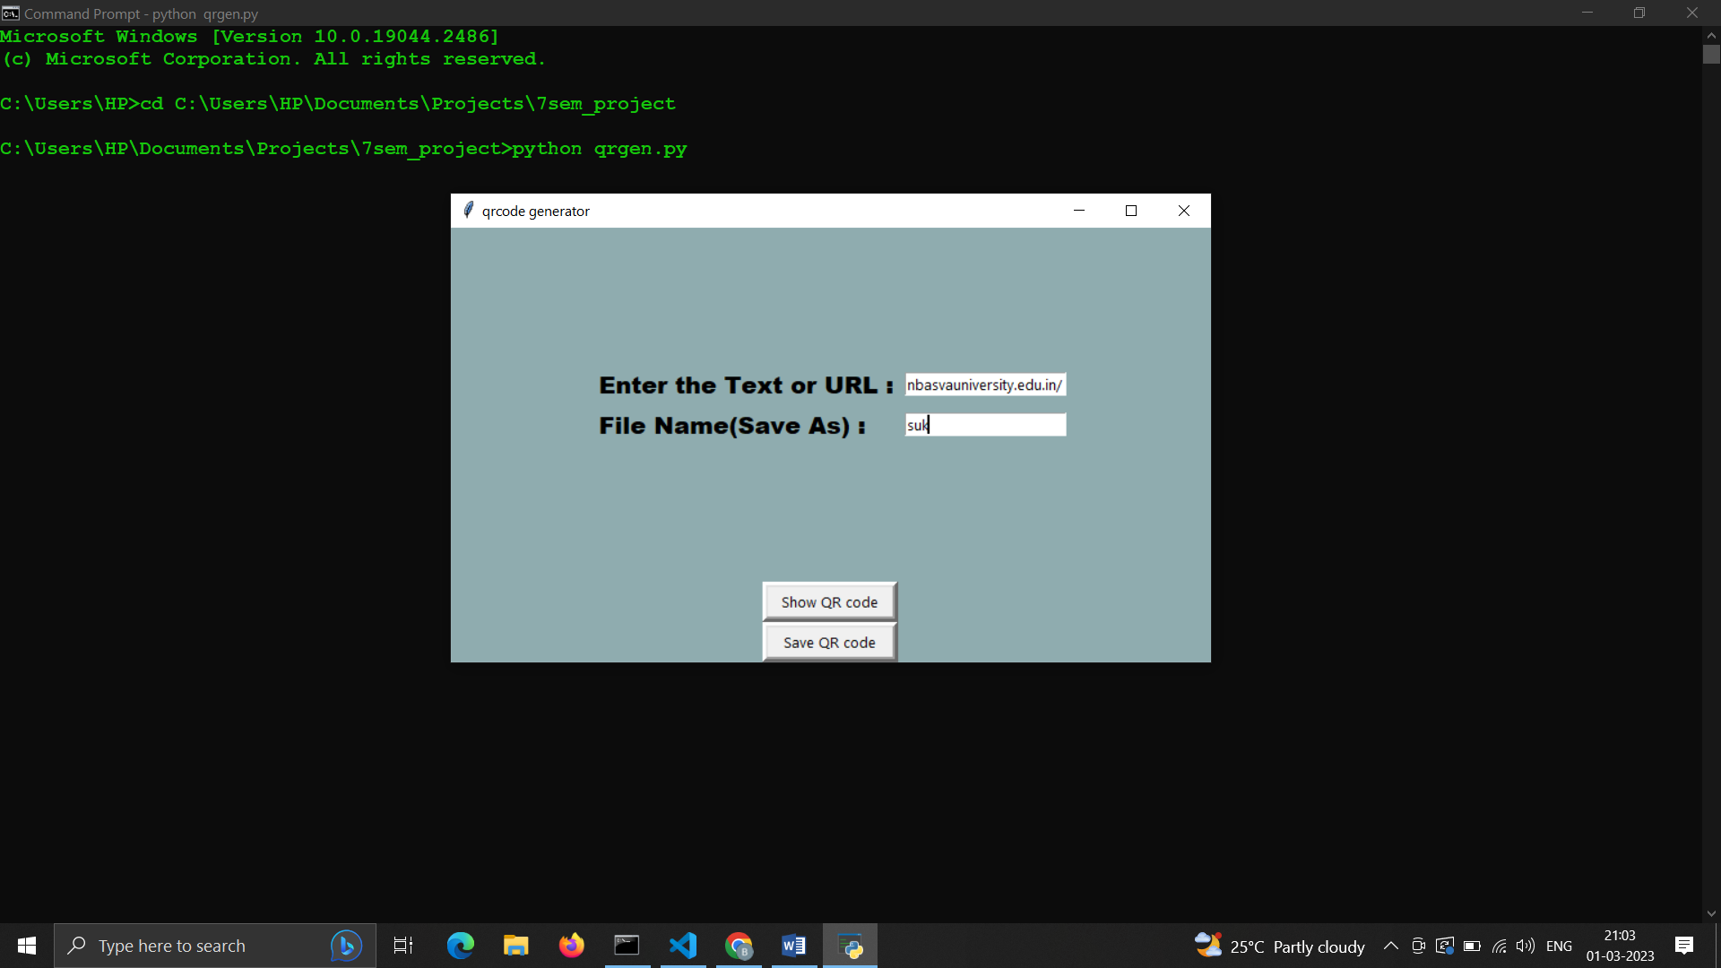

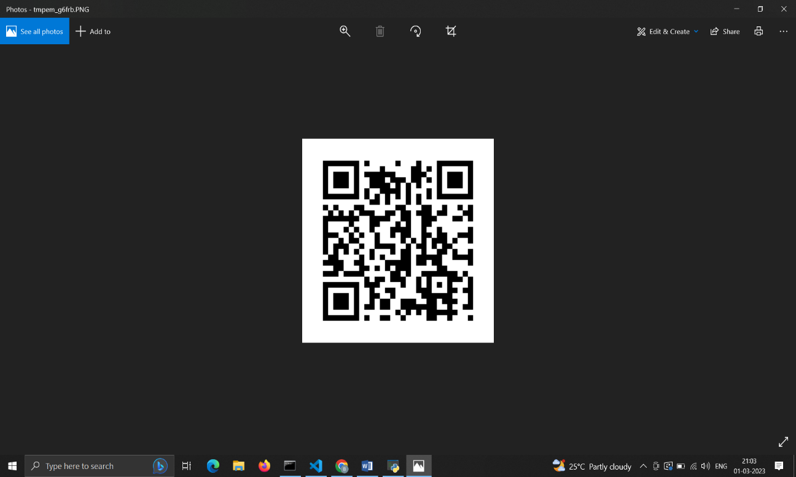

CHAPTER 8

CONCLUSION

In the past decade or so, the application of QR codes in public domains like supermarkets and in educational purposes like book scanning or stationary scanning has been increased rapidly and it will continue to thrive in more fields as the awareness will increase.

The QR code technique is getting popular day by day and at the same time it is becoming increasingly secure as the technology is enhancing. Once, the awareness about these codes increases, it will get a wide spectrum to evaluate its significance.

In near future, this technology will be used in wide public domains. Firstly, QR codes were used to store the information about inventory products but nowadays it is being used in the huge industries like marketing, secure payment systems, advertising, education systems etc.

REFERENCES

[1][www.google.com](http://www.google.com)

[2] [www.wikipedia.com](http://www.wikipedia.com)

[3] <https://docs.python.org/3/library/turtle.html>

[4] [www.w3schools.com](http://www.w3schools.com)