Document Status: Approved
Approved by: Management Representative
Released by : Mentor Labs

Revision / Document History

Ver. | Date | Changed by | Modifications
1 | 12/05/2024 | Adarsh | Initial version
2 | 12/05/2024 | Dhivyaa sankari | Initial version
3 | 12/05/2024 | Bhagyasree | Initial version

List of Abbreviations
DFD Data Flow Diagram
E-R Entity Relationship
RS Requirement Specification

Table of Contents
1. Introduction 3
1.1 Purpose 3
1.2 Scope 3
1.3 Definitions, Acronyms and Abbreviations 3
1.4 References 3
1.5 Coordinators 3
2. Software Requirements 3
2.1 Operational Requirements 3
2.2 Functional Requirements 4
2.3 User Interface Requirements 7
2.4 External Interface Requirements 18
3. Project Execution Related Requirements 18
3.1 Development Environment 18
Technologies to be used for development of the Application: 18
3.2 Design requirements 18
3.3 Coding requirements 18
3.4 Error handling requirements 18
3.5 Resource Requirements 18
Technologies to be used for development of the Application: 18
3.6 Risk management 18
3.7 Training Requirements 18
4. Testing Requirements 18
5. Quality Assurance Activities 19
6. Software Acceptance Criteria 19
7. Deliverables 19
7.1 List of Deliverables 19
7.2 Delivery 19
8. Requirements Acceptance Statement 19

Introduction

Purpose To create a Traffic management system that helps in maintaining offence information and also help RTO to include new vehicle information ,owner information and old/scrapped vehicles by creating a platform.

Scope The scope of this project is limited to offence details would include designing a system to monitor and manage traffic violations.The seized, releasing and scrapped details are out of scope.

Definitions, Acronyms and Abbreviations
Not Applicable

References
Not Applicable

Coordinators
- Adarsh
- Dhivyaa sankari
- Bhagyasree

Software Requirements

Operational Requirements

RTO Officer : Rto officer is allowed to register the new vehicle as well as transferring the vehicle from old owner to new owner. Also Perform crud operations on person data and owner data

Traffic cop : He should be allowed to add a offence details against a vehicle and aslo to clear the offence..

Clerk: He should be allowed to add a offence details against a vehicle and aslo to clear the offence and generate reports and notify the RTO.

Admin : He will be able to create or update logins for the cops, RTO officer and clerk.

Functional Requirements

FIGURE 2.1 USE CASE DIAGRAM FOR TMS
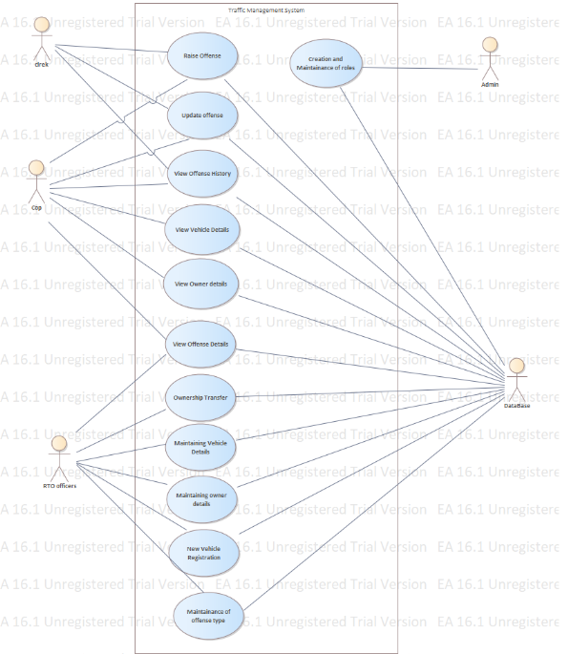

Requirement Tag ID | RS-1-1
Source/Trigger | Traffic cop
Description  Rising the offence | Input | Registration number , vehicle details , type of offence
Description  Rising the offence | Process | he will enter the registration number in the application and he will get the details of that vehicle, owner and the previous offences he made . Then the cop will create a new offence.
Description  Rising the offence | Output | It will send the notification to the vehicle owner that the offence is raised
Validation Method

Requirement Tag ID | RS-1-2
Source/Trigger | Traffic cop
Description  Closing the offence | Input | Registration number
Description  Closing the offence | Process | with the help of the registration number the cop checked the person paid the penalty or not .If yes the cop will close the offence
Description  Closing the offence | Output | offence is closed
Validation Method

Requirement Tag ID | RS-1-3
Source/Trigger | clerk
Description  Rising the offence | Input | Registration number , vehicle details , type of offence
Description  Rising the offence | Process | he will enter the registration number in the application and he will get the details of that vehicle, owner and the previous offences he made . Then the cop will create a new offence.
Description  Rising the offence | Output | It will send the notification to the vehicle owner that the offence is raised
Validation Method

Requirement Tag ID | RS-1-4
Source/Trigger | clerk
Description  Generate reports | Input | Registration number , type of vehicle , offence type , offence date
Description  Generate reports | Process | Based on the registration number or type of vehicle or offence type or offence date the clerk will generate reports and sent to rto
Description  Generate reports | Output | Report is generated and sent to rto
Validation Method

Requirement Tag ID | RS-1-5
Source/Trigger | clerk
Description  closing the offence |  | Registration number
Description  closing the offence |  | with the help of the registration number the cop checked the person paid the penalty or not .If yes the clerk will close the offence
Description  closing the offence |  | offence is closed
Validation Method

Requirement Tag ID | RS-1-6
Source/Trigger | RTO
Description  Registering the new vehicle | Input | Owner details , new vehicle details
Description  Registering the new vehicle | Process | By taking the owner details and the new vehicle details like the colour , engine no., chasis no . With that he will register the vehicle with the owner details.
Description  Registering the new vehicle | Output | Registered the new vehucle
Validation Method

Requirement Tag ID | RS-1-7
Source/Trigger | RTO
Description  Transferring of vehicle | Input | Registration number ,Old vehicle owner details, new vehicle owner details
Description  Transferring of vehicle | Process | By entering the registration number he will check that any offences are pending on that vehicle . if no , he will transfer that vehicle to new owner by registering with his details.If any details found against the vehicle the transfer should not be allowed.
Description  Transferring of vehicle | Output | vehicle is transferred from old owner to new owner
Validation Method

Requirement Tag ID | RS-1-8
Source/Trigger | RTO
Description  CRUD operations | Input | Nature of offfence , type of vehicle , compounding fee
Description  CRUD operations | Process | with the of details of nature of offence , type of vehicle and compounding fee he will do some operations like if the compound fee is increased for the offence he will update that .
Description  CRUD operations | Output | Details are updated.
Validation Method

Requirement Tag ID | RS-1-9
Source/Trigger | Admin clear offense
Description | Input | Vehicle number , personal details
Description | Process | withe the help of Reg id check the offense details and it is cleared display offense cleared
Description | Output | The penalty is Cleared
Validation Method

Requirement Tag ID | RS-1-9
Source/Trigger | Admin Add Offense
Description | Input | Vehicle Number , personal details
Description | Process | with the help of Registartion id he will check the details history if found add to that otherwise add the vehicle number and personal details to the database
Description | Output | Offense Added Successfully
Validation Method

User Interface Requirements

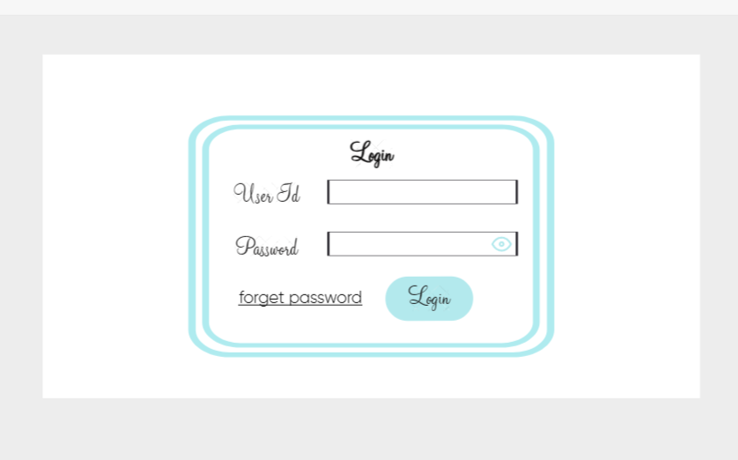
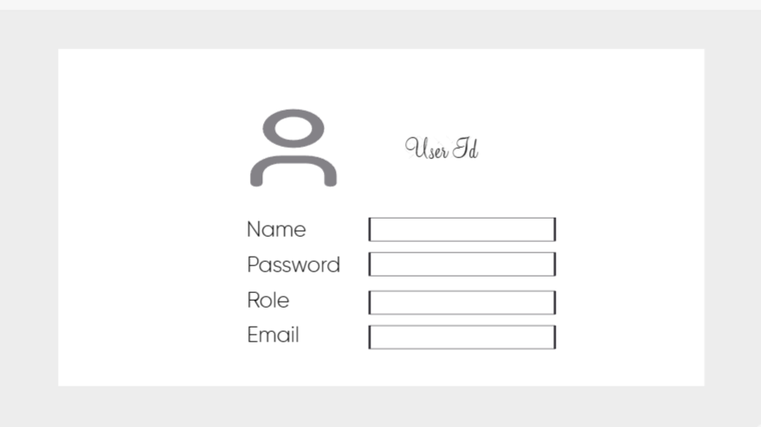

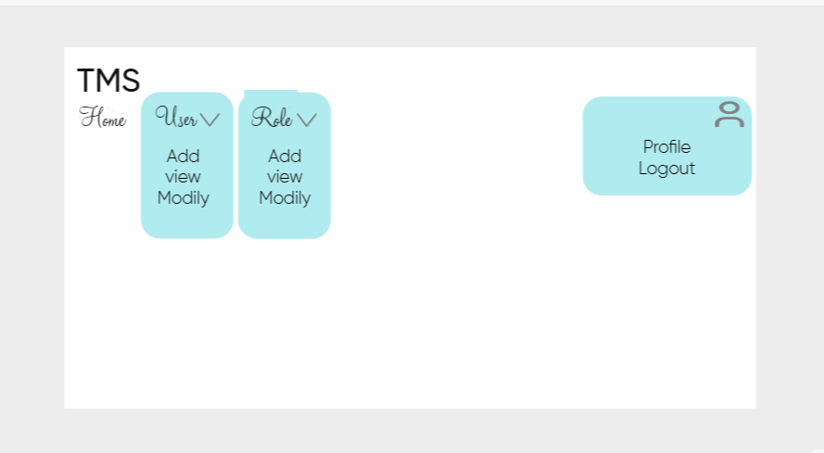

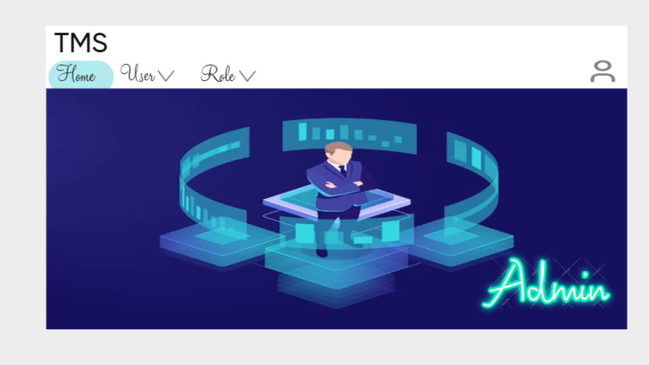

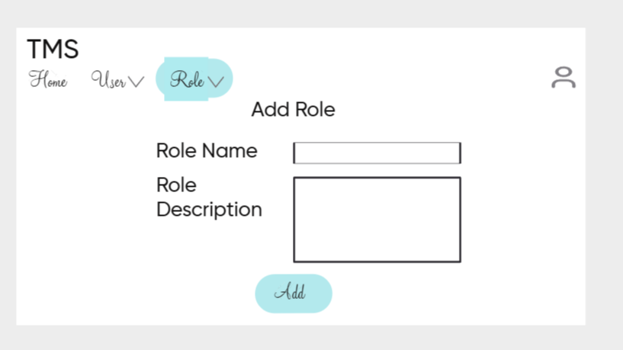
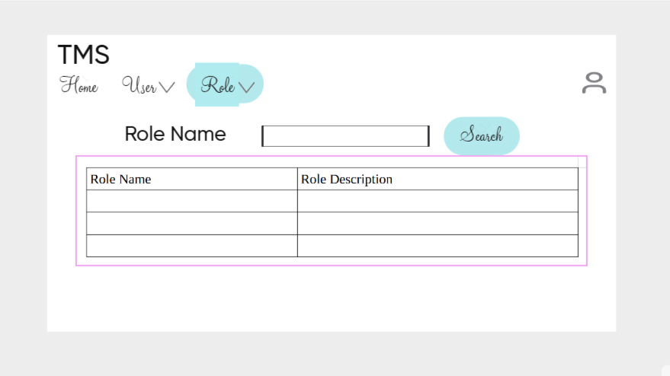

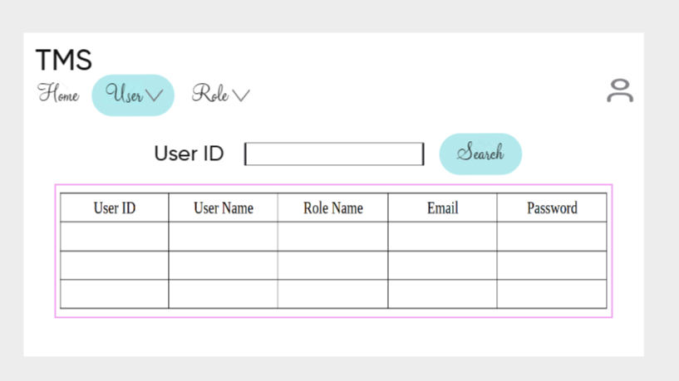

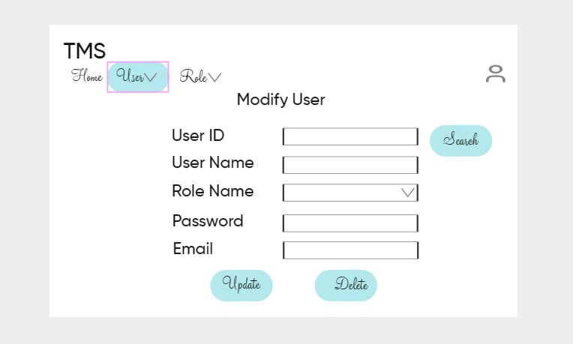

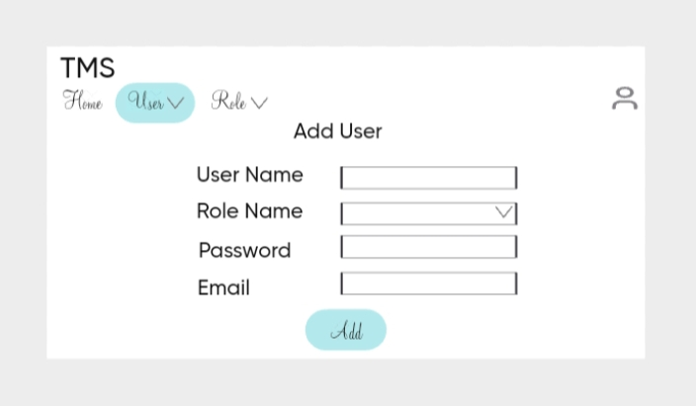

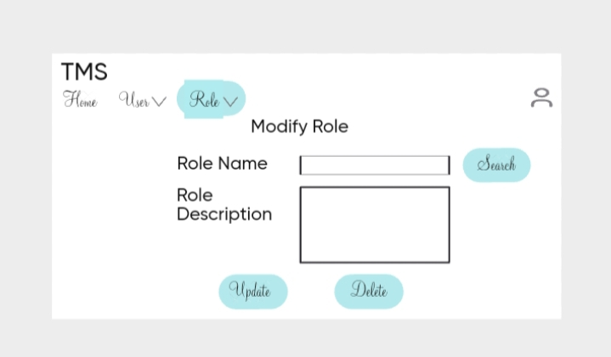

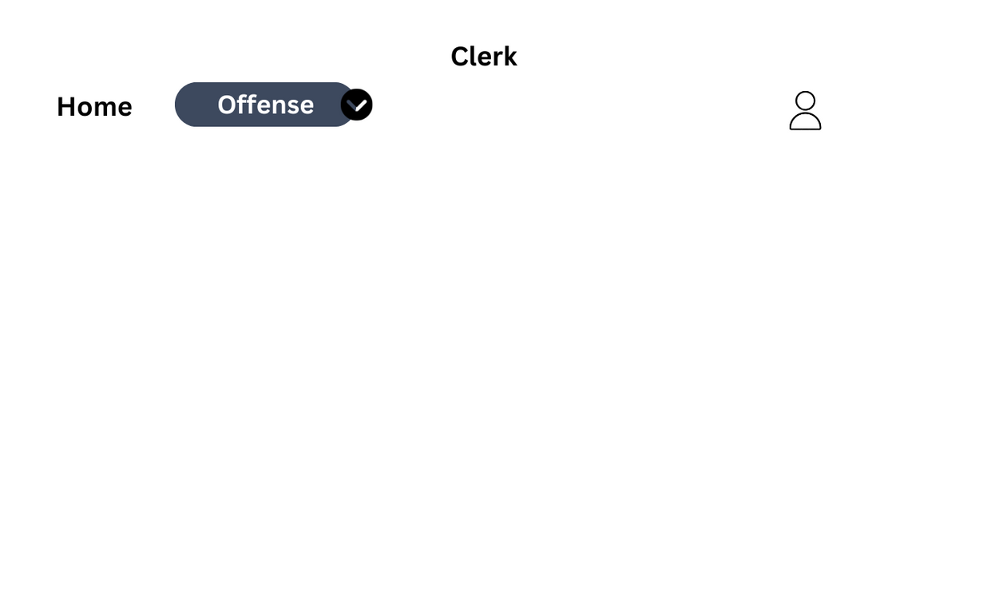

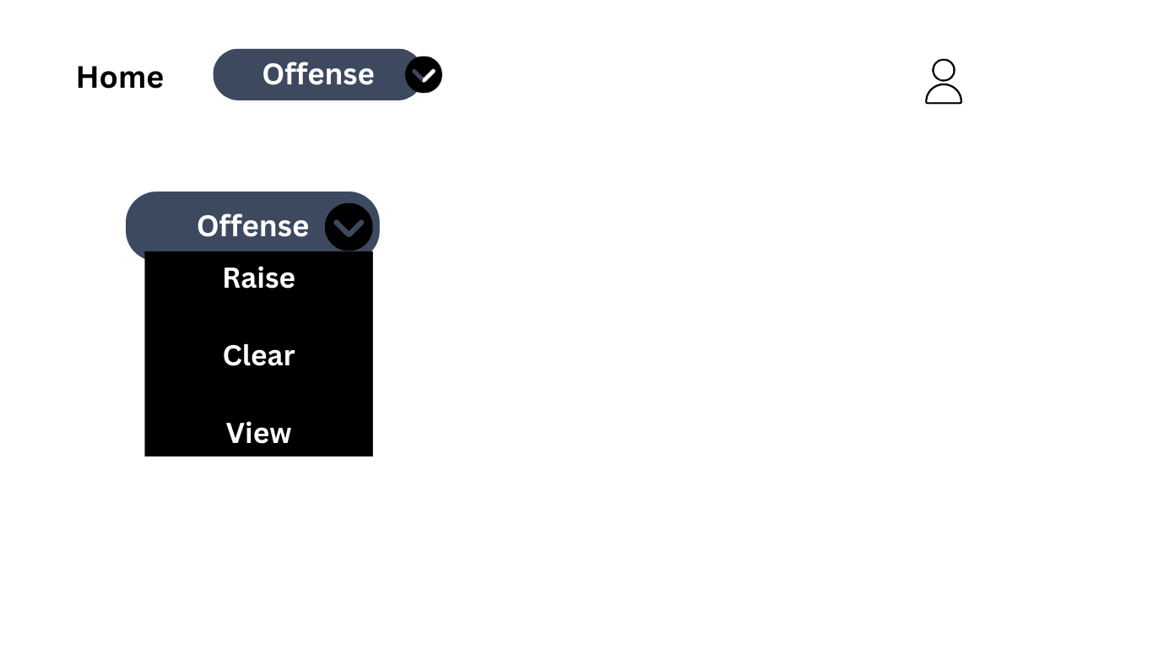

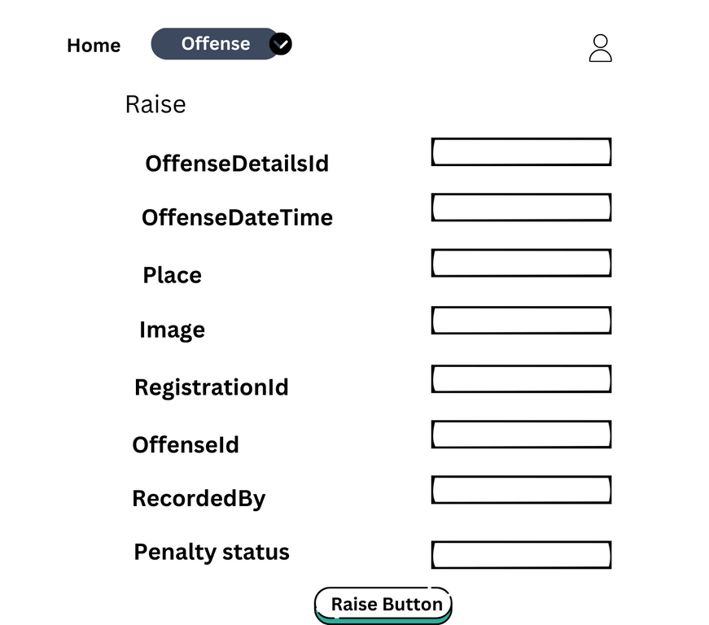

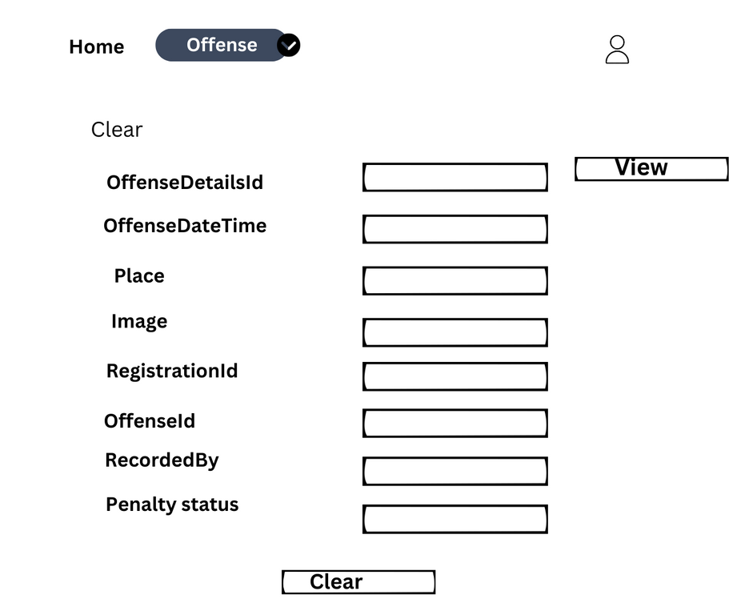

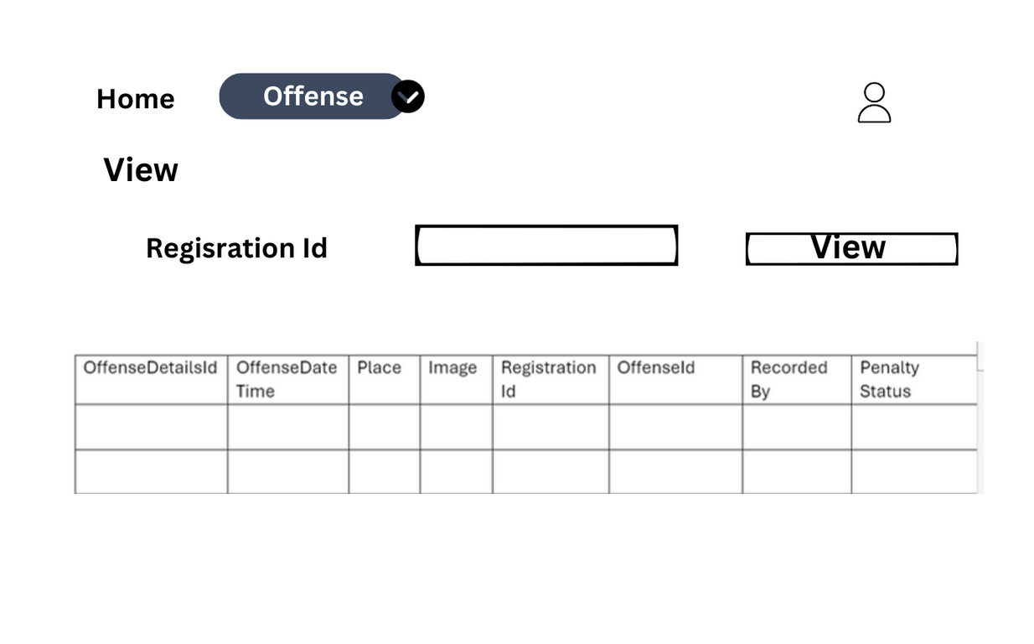
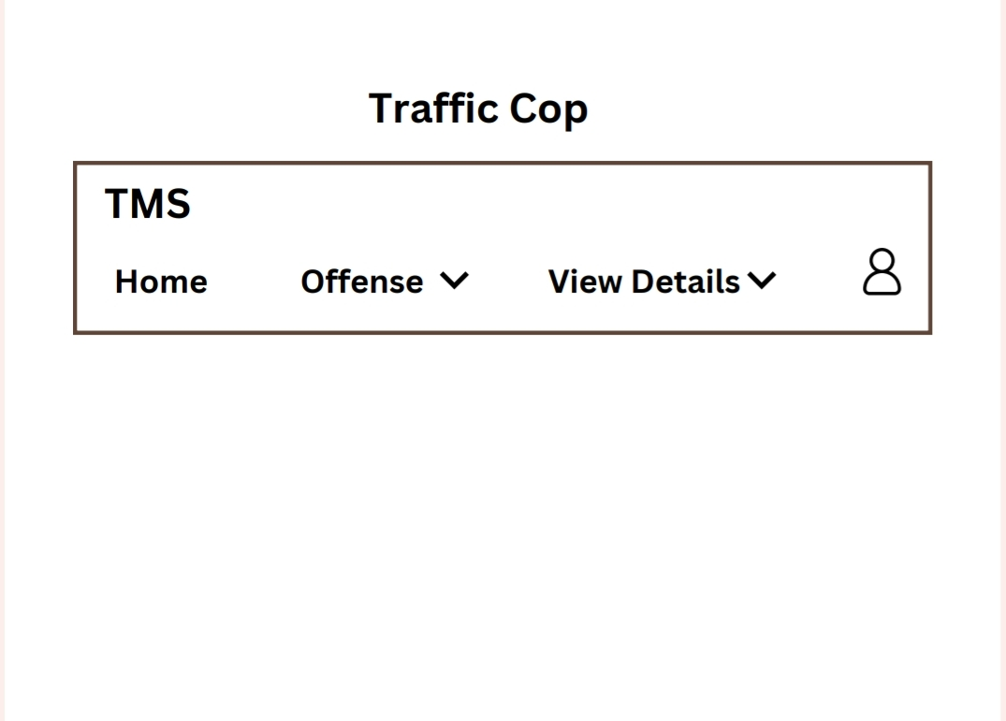
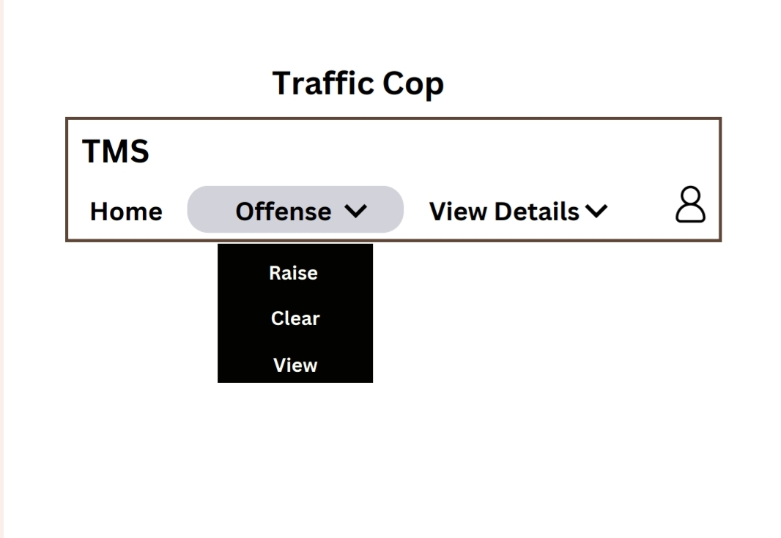

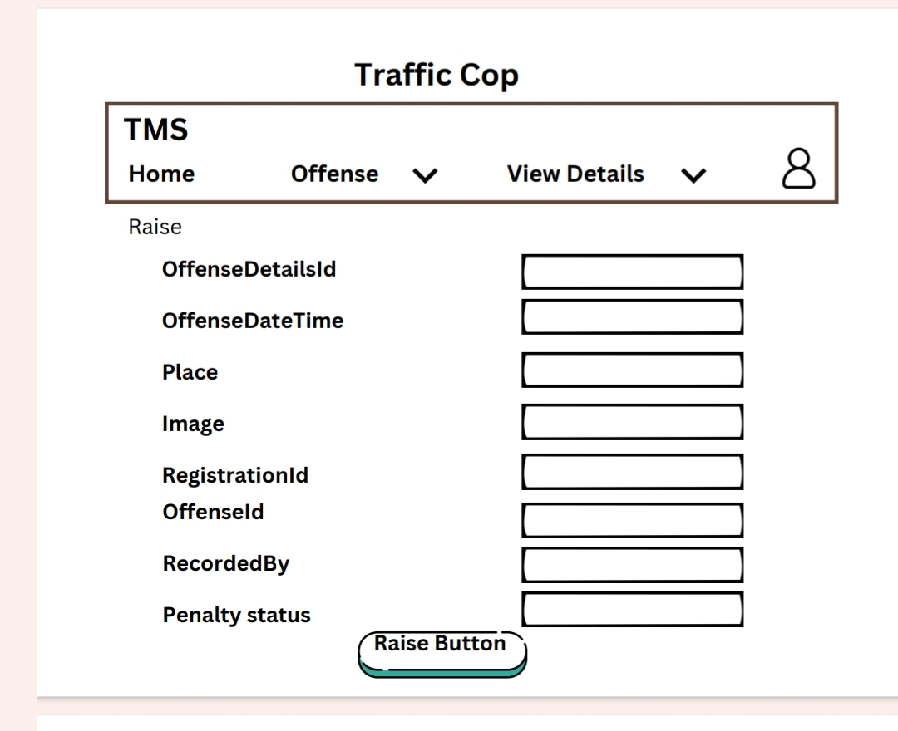
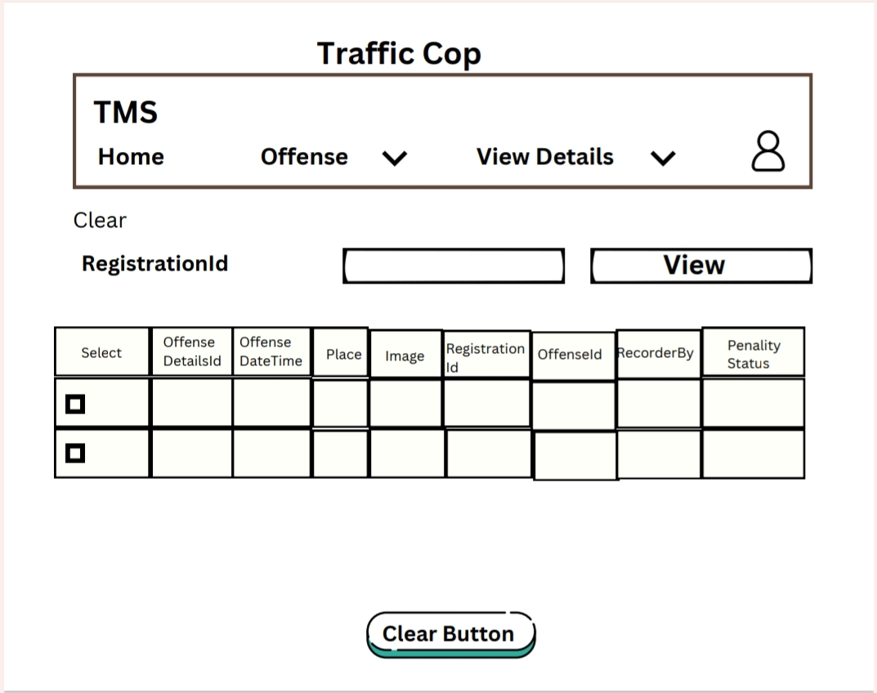
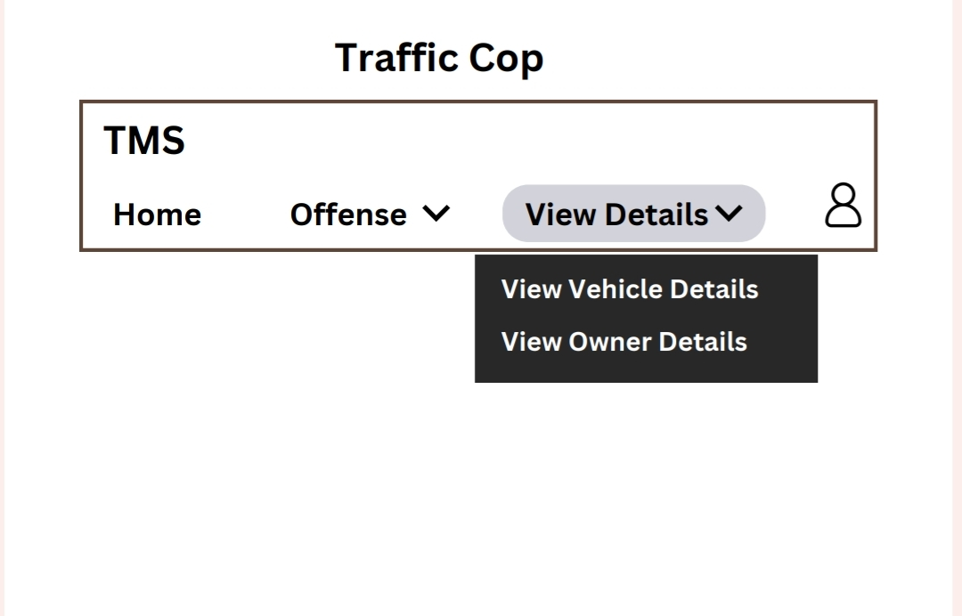
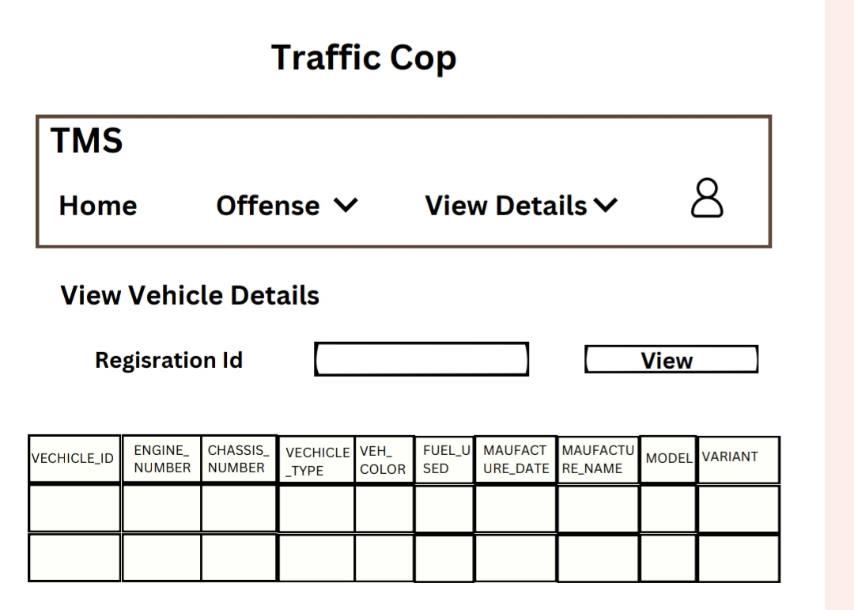

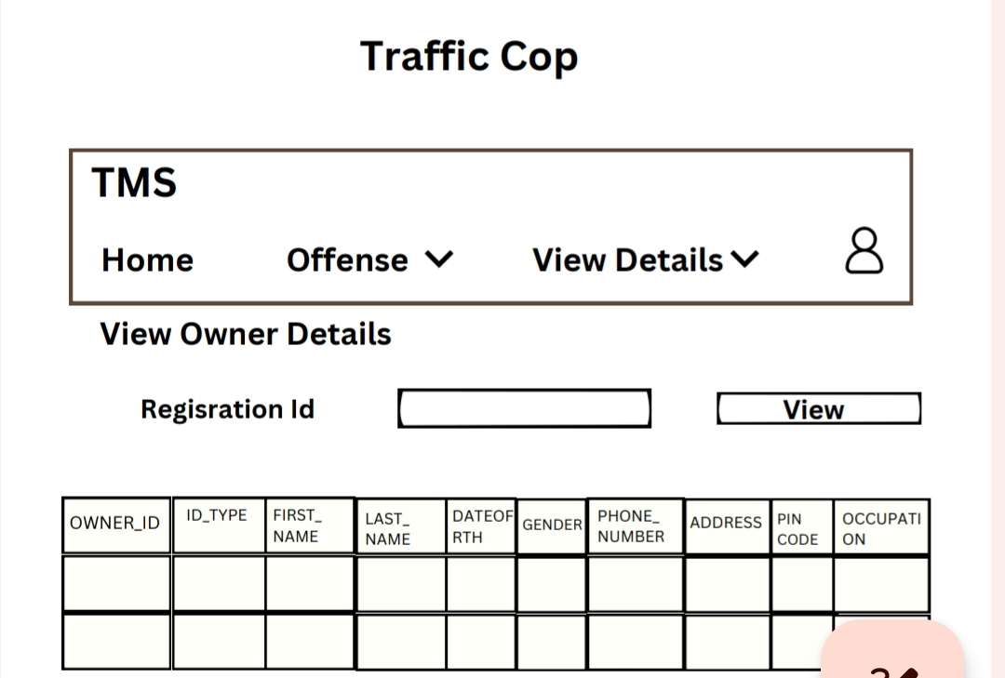

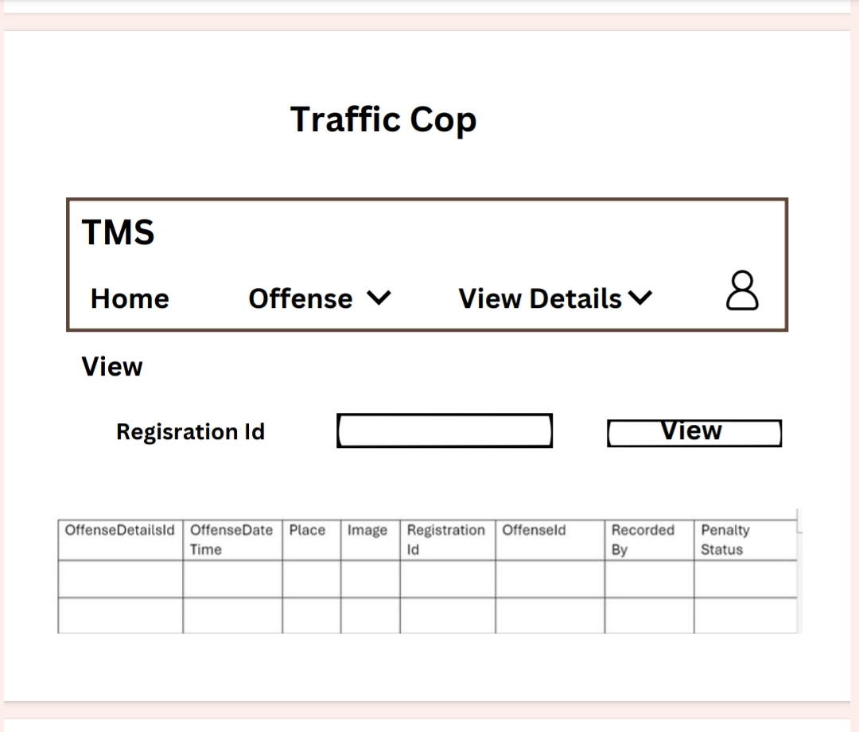

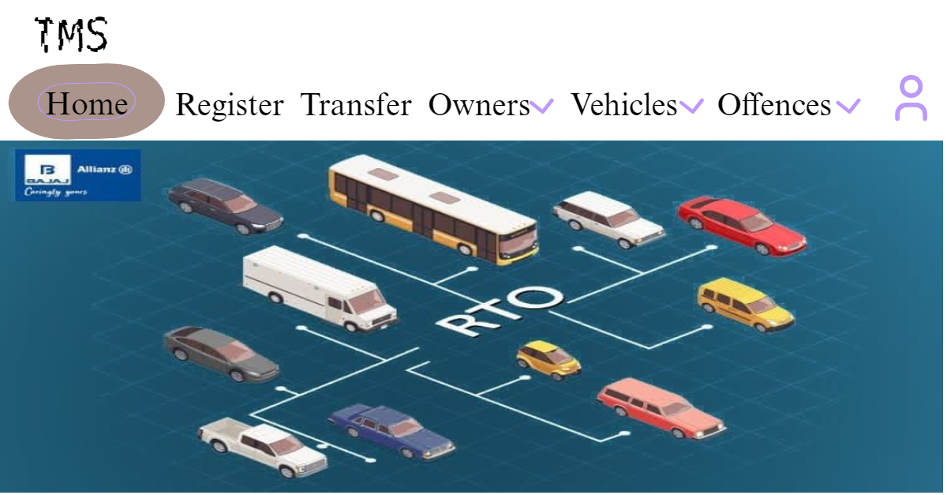

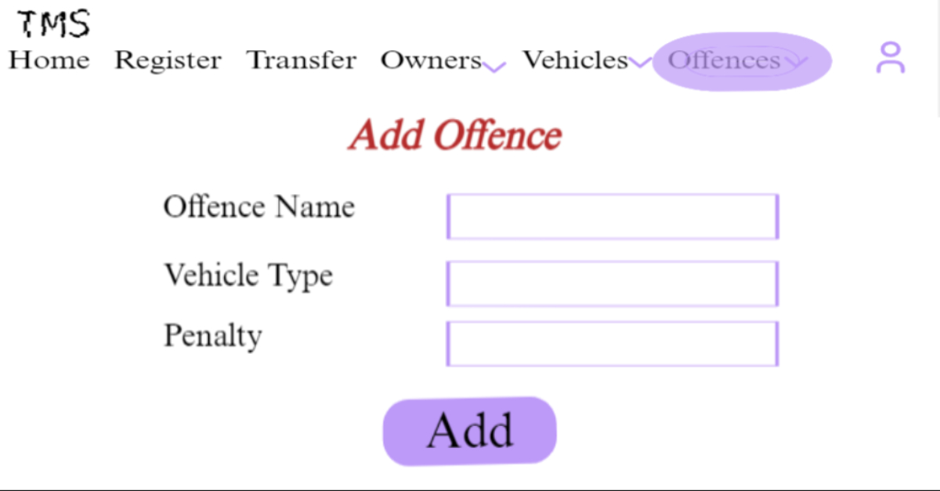

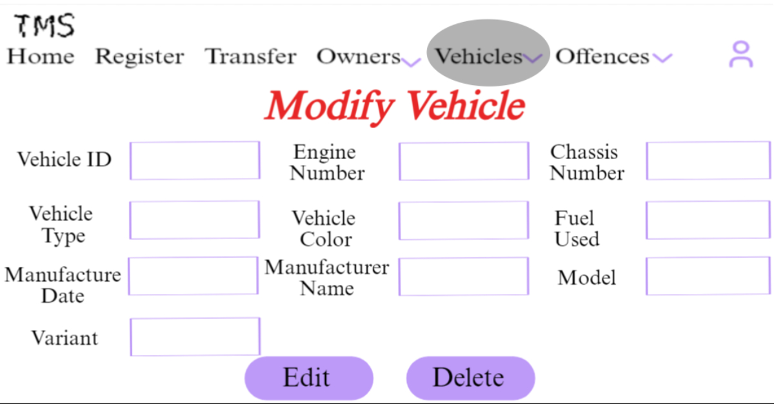

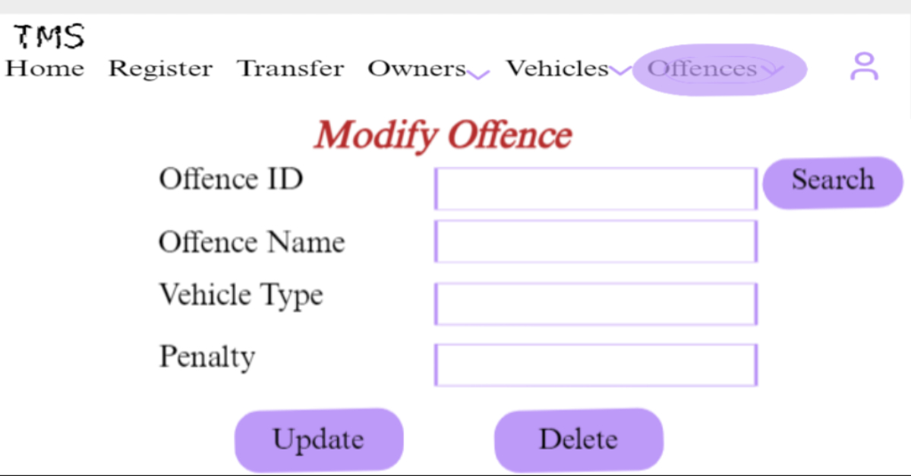
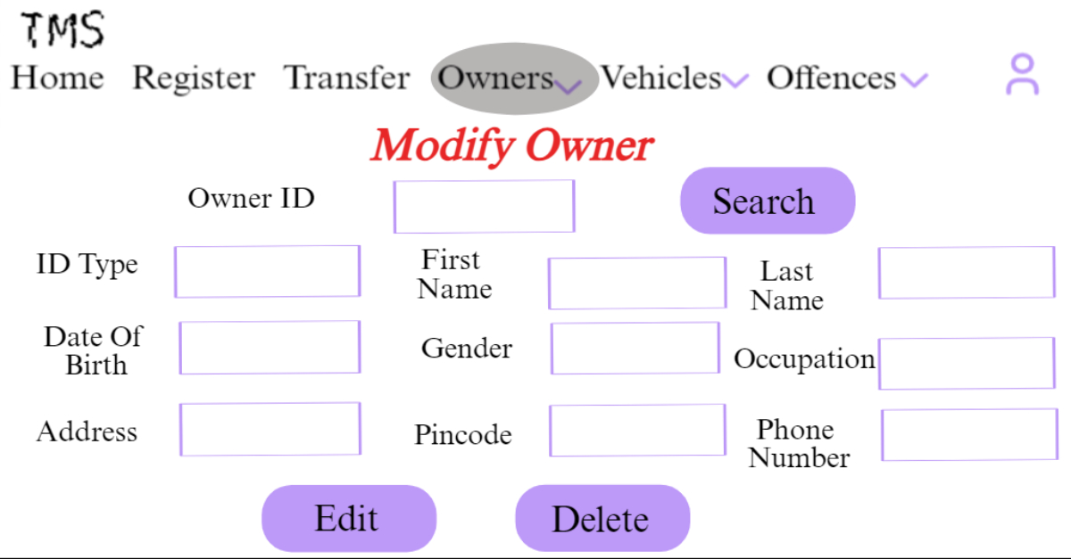
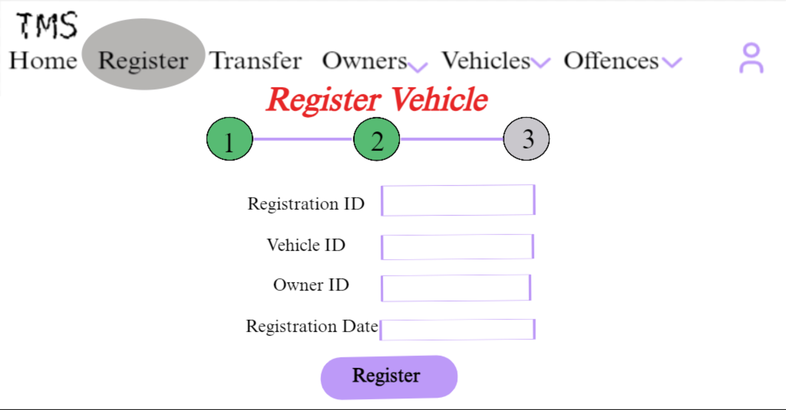
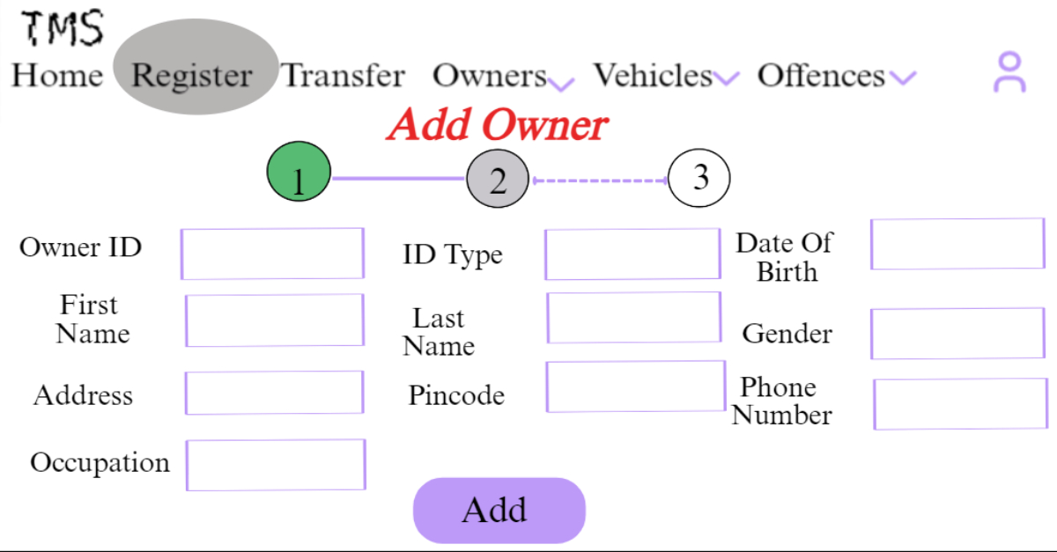

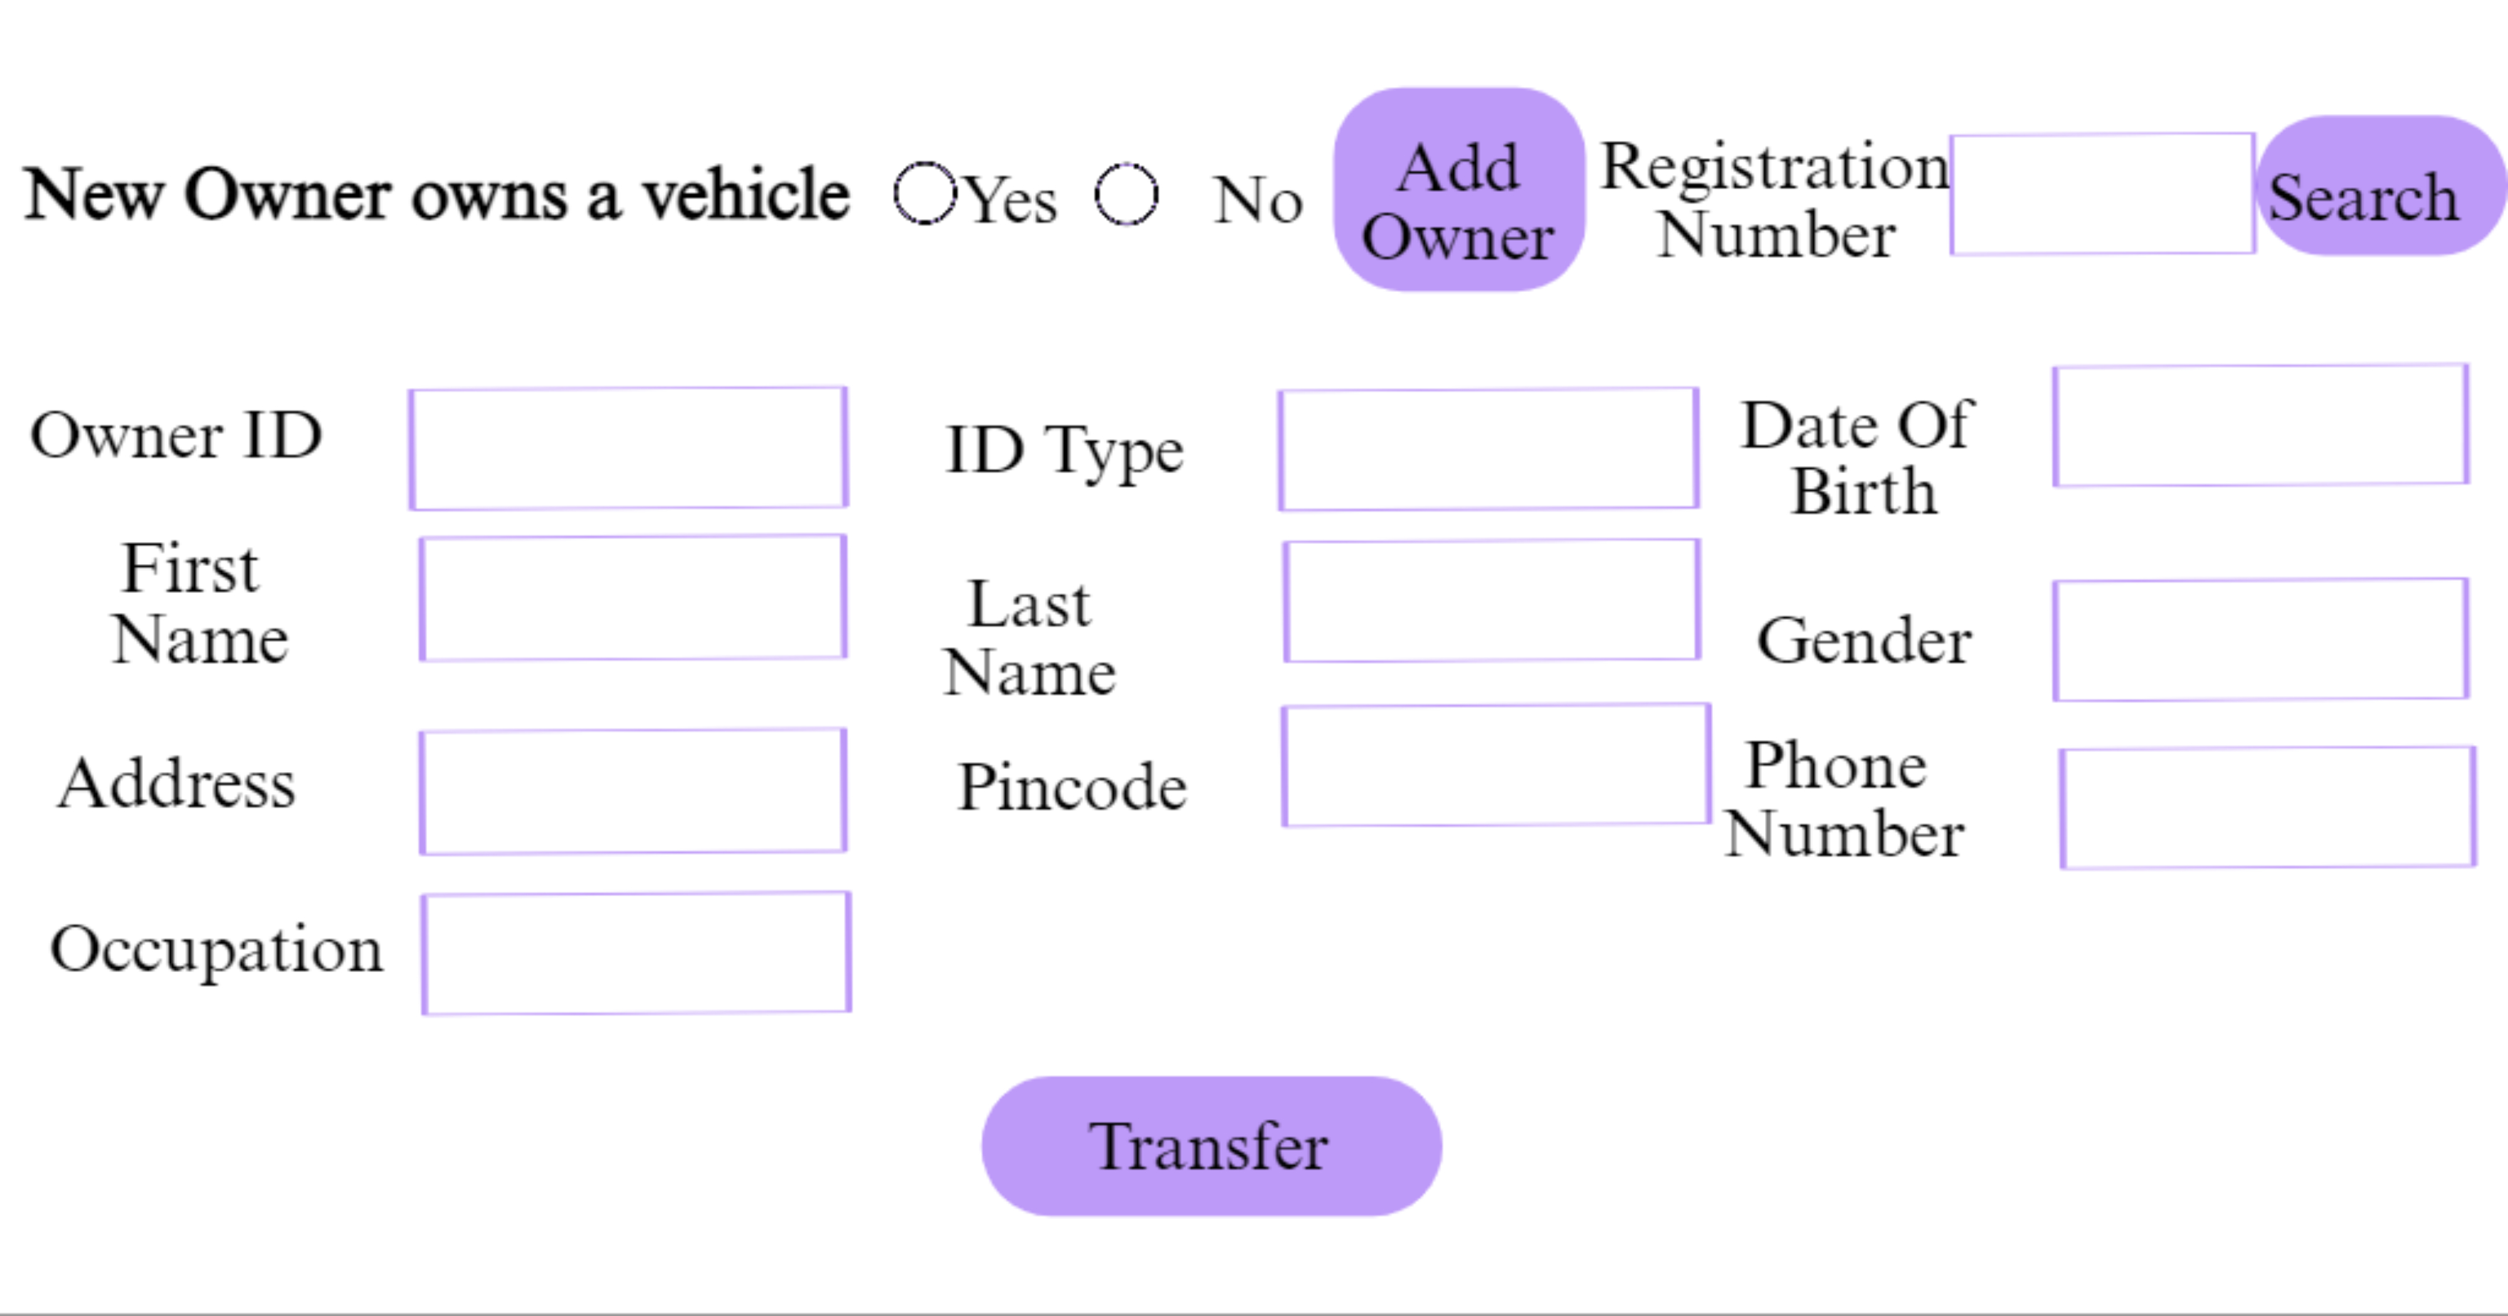
External Interface Requirements
NA

Project Execution Related Requirements

Development Environment

Technologies to be used for development of the Application:

JAVA

Oracle 10g XE Database

Software tools that can be used for development:

NetBeans

sqldeveloper

Enterprise Architecture

Design requirements

Not applicable.

Coding requirements
Since, the entire application is being coded in Java, all the coding standards required by JAVA are certainly applicable here.

Error handling requirements
NA

Resource Requirements

Technologies to be used for development of the Application:

JAVA

Oracle 10g XE Database

Risk management
Not applicable.

Training Requirements
Since the application being developed is greatly dependent on user interaction, the end user should be comfortable with the GUI.

End user should be given a walkthrough of the working of the entire application along. Training should be provided with respect to efficient GUI usage.

Testing Requirements
The testing phase shall include unit testing to validate each individual module of the system, Integration testing to check if the system works according to customer requirements after modules’ integration. This is supported by regression testing for efficient results.
The testing is to be carried out manually following both black box testing as well as white box testing in order to understand the system functionality better.

Quality Assurance Activities
NA

Software Acceptance Criteria
User acceptance test is the sole software acceptance criteria.
In order to fulfill this criterion, the system should be executed and tested. The errors found during system testing should be solved and corrected version of the software should be sent to customer for final Acceptance Testing.

Deliverables

List of Deliverables
Not applicable

Delivery
Not Applicable

Requirements Acceptance Statement
Requirements Acceptance statement consists of agreement to the above mentioned requirements, by the cusomer & supplier.

