Reviewed by:

Approved by:

List of Abbreviations
DFD Data Flow Diagram
ER Entity Relationship
FHD Function Hierarchy Diagram
HLD High Level Design
LLD Low Level Design
GUI Graphical User Interface
IEEE Institute of Electrical and Electronic Engineers
S/W Software
SDL Specification Description Language
StrD Structured
Table of Contents
1. Introduction 4
2. Design Scope 4
3. Design Methodology 4
4. Design Notations 4
5. Design Considerations 4
6. Design Overview 5
7. Decomposition 12
DH-1-1 UserEO 12
DH-1-2 RoleEO 12
DH-1-3 OwnerEO 12
DH-1-4 VehicleEO 12
DH-1-5 RegistartionEO 12
DH-1-6 OffenceDetailEO 12
DH-1-7 OffenceTypeEO 13
DH-1-8 UserDAOImpl 13
DH-1-9 RoleDAOImpl 13
DH-1-10 OwnerDAOImpl 13
DH-1-11 VehicleDAOImpl 13
DH-1-12 RegistrationDAOImpl 13
DH-1-13 OffenceDetailDAOImpl 13
DH-1-14 OffenceTypeDAOImpl 14
DH-1-15 DAOFactory<E> 14
DH-1-16 ResourceManager 16
DH-1-17 Validatior 16
8. Interface Design 16
8.1 User Interface 16
9. Data design 17
9.2 Data structure (data types, arrays, and structures) 18
10. Reusability 18
11. Design Alternatives 18
13. Additional Hardware and Software required 18
14. Testing Strategy 18
15. Traceability Matrix 18
16. References 19

Introduction
The project “Traffic Management System” has be designed so as to ease the work of traffic police by managing the offense committed by the vehicle and RTO by managing the vehicle and owner details.

Design Scope
The scope of this project is limited to offence management.
Traffic police can raise, clear and view the offence details.
RTO can register a vehicle, transfer a vehicle.
Payment of the penalty and scraping of the vehicle is not included in the project.

Design Methodology
Object Oriented Analysis and Design (OOAD) methodology has enabled the project to break down specifications into functionally independent units. This approach facilitates a modular and structured design process, where each unit represents a cohesive and manageable component of the system. By employing OOAD, we ensure that our design is both scalable and maintainable, with clear delineation of responsibilities for each unit.

Design Notations
The design notations adhere to Unified Modelling Language (UML) standards, aligning with the Object-Oriented Analysis and Design (OOAD) methodology employed in this project.

Design Considerations
Not Applicable.

6. Design Overview

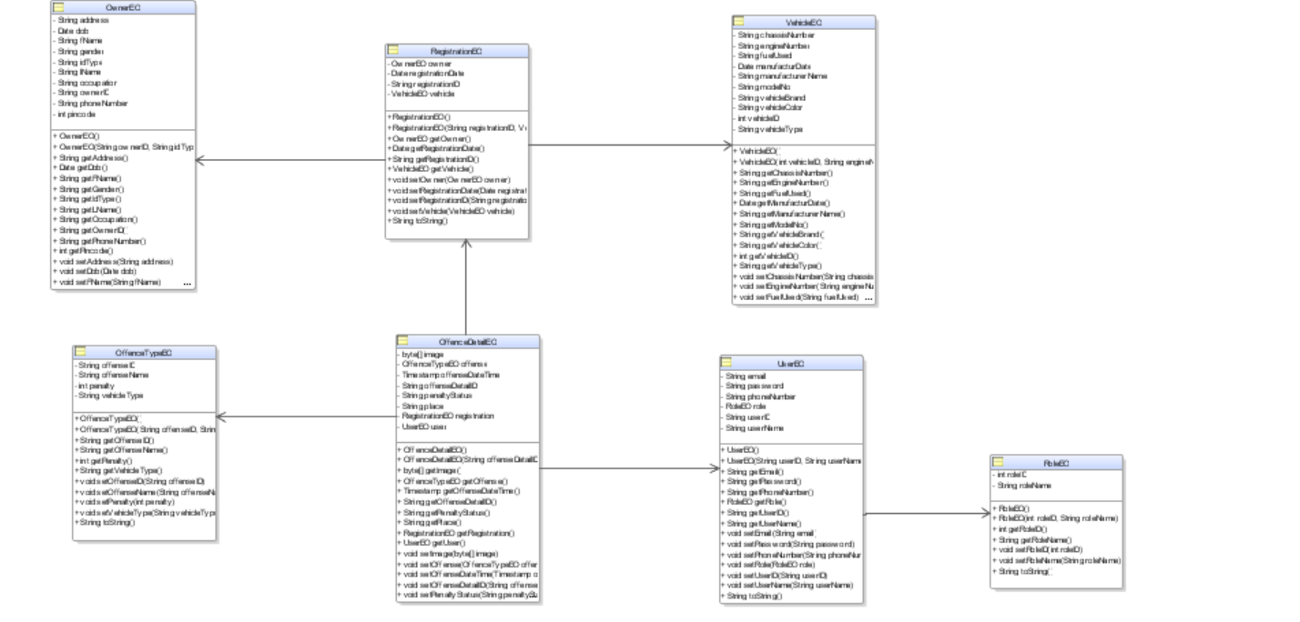
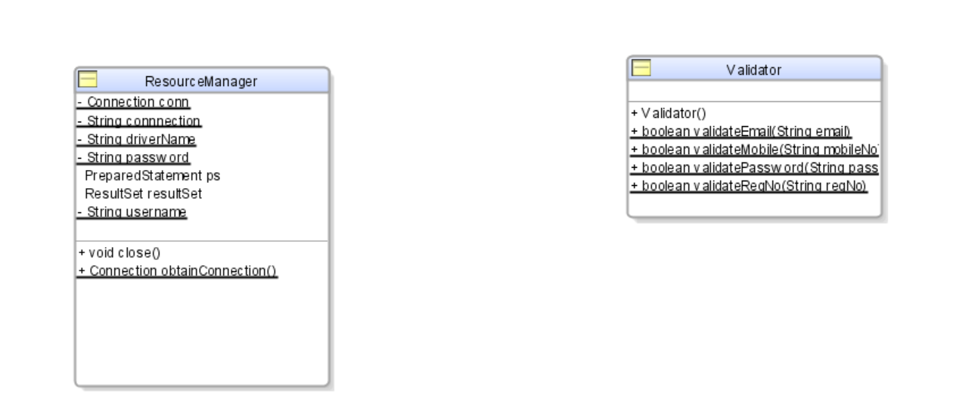

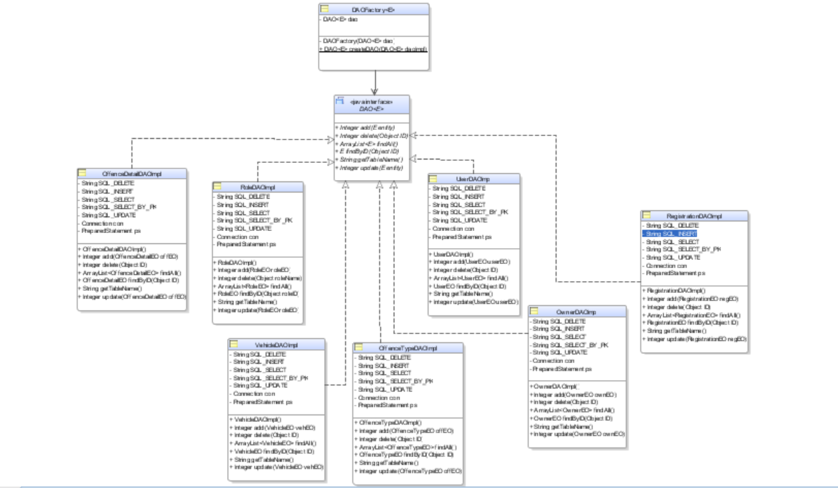
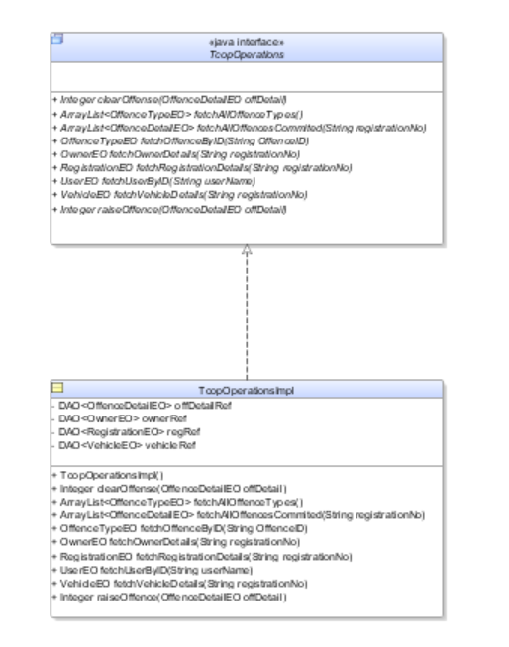

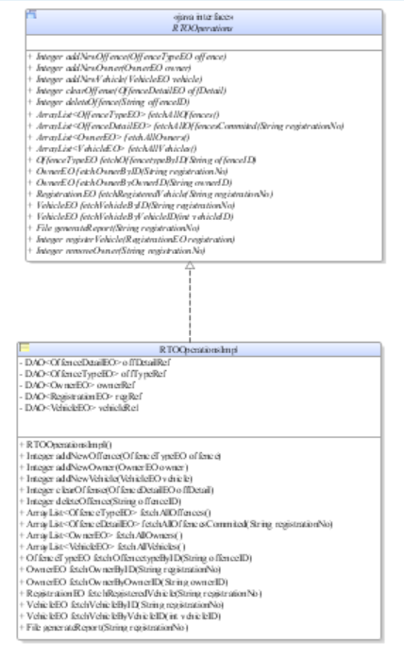

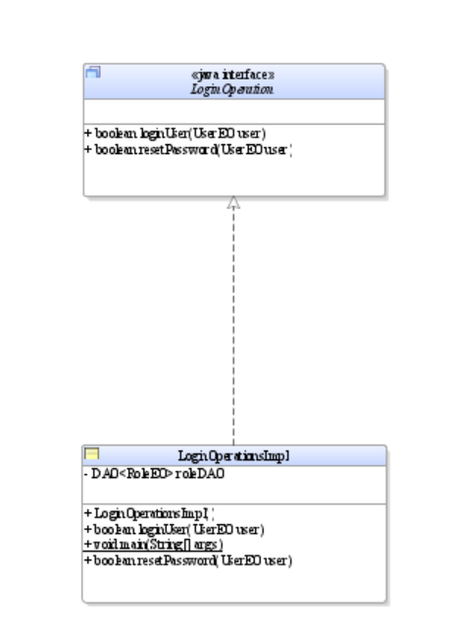
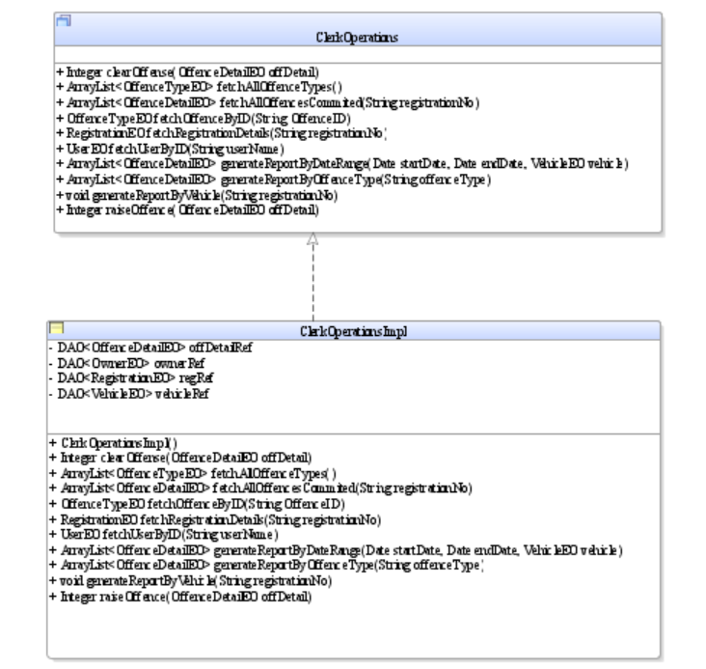

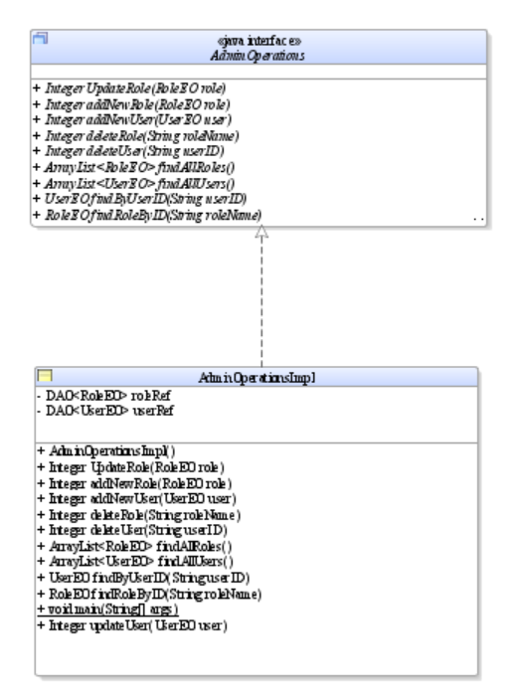

7. Decomposition

DH-1-1 UserEO
Inputs: Sets the user details
Outputs: Gets the user details.
Scope: Specific
This class is a model class for the database table TMS_USERS.

DH-1-2 RoleEO
Inputs: Sets the role details
Outputs: Gets the role details.
Scope: Specific
This class is a model class for the database table TMS_ROLES.

DH-1-3 OwnerEO
Inputs: Sets the owner details
Outputs: Gets the owner details.
Scope: Specific
This class is a model class for the database table TMS_OWNERS.

DH-1-4 VehicleEO
Inputs: Sets the vehicle details
Outputs: Gets the vehicle details.
Scope: Specific
This class is a model class for the database table TMS_VEHICLES.

DH-1-5 RegistrationEO
Inputs: Sets the registration details
Outputs: Gets the registration details.
Scope: Specific
This class is a model class for the database table TMS_REGISTRATIONS.

DH-1-6 OffenceDetailEO
Inputs: Sets the offence details
Outputs: Gets the offence details.
Scope: Specific
This class is a model class for the database table TMS_OFFENSE_DETAILS.

DH-1-7 OffenceTypeEO
Inputs: Sets the offence type details
Outputs: Gets the offence type details.
Scope: Specific
This class is a model class for the database table TMS_OFFENSE_TYPES.

DH-1-8 UserDAOImpl
Inputs: The details to be inserted, updated, selected or deleted.
Outputs: The result of selection, insertion, updating or deletion.
Scope: Specific
This class implements the DAO<UserEO> interface.

DH-1-9 RoleDAOImpl
Inputs: The details to be inserted, updated, selected or deleted.
Outputs: The result of selection, insertion, updating or deletion.
Scope: Specific
This class implements the DAO<RoleEO> interface.

DH-1-10 OwnerDAOImpl
Inputs: The details to be inserted, updated, selected or deleted.
Outputs: The result of selection, insertion, updating or deletion.
Scope: Specific
This class implements the DAO<OwnerEO> interface.

DH-1-11 VehicleDAOImpl
Inputs: The details to be inserted, updated, selected or deleted.
Outputs: The result of selection, insertion, updating or deletion.
Scope: Specific
This class implements the DAO<VehicleEO> interface.

DH-1-12 RegistrationDAOImpl
Inputs: The details to be inserted, updated, selected or deleted.
Outputs: The result of selection, insertion, updating or deletion.
Scope: Specific
This class implements the DAO<RegistrationEO> interface.

DH-1-13 OffenceDetailDAOImpl
Inputs: The details to be inserted, updated, selected or deleted.
Outputs: The result of selection, insertion, updating or deletion.
Scope: Specific
This class implements the DAO<OffenceDetailEO> interface.

DH-1-14 OffenceTypeDAOImpl
Inputs: The details to be inserted, updated, selected or deleted.
Outputs: The result of selection, insertion, updating or deletion.
Scope: Specific
This class implements the DAO<OffenceTypeEO> interface.

DH-1-15 DAOFactory<E>
Inputs: An instance of a DAO implementation class.
Outputs: Returns an instance of the DAO interface/superclass.
Scope: Specific
This Java class DAOFactory<E> is a generic factory for creating instances of DAO implementations.

DH-1-16 ResourceManager
Inputs: NA
Outputs: NA
Scope: Generic
This class is used to handle the connection with database.

DH-1-17 Validatior
Inputs: Information to be validated.
Outputs: Result of validation.
Scope: Generic
This class is used to validate the details furnished by the user.

8. Interface Design

8.1 User Interface

9. Data design

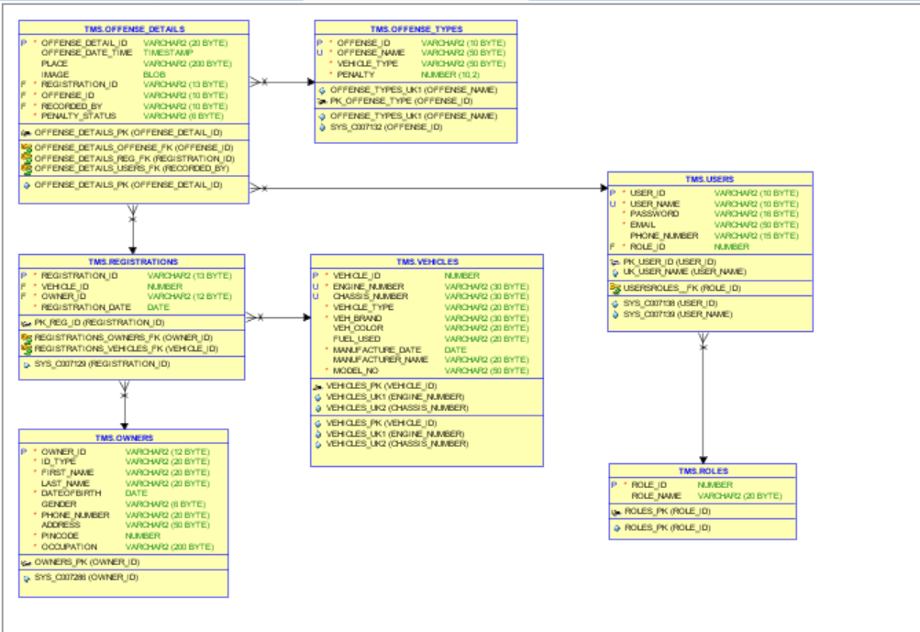

9.2 Data structure (data types, arrays, and structures)
Not applicable.

10. Reusability
NA

11. Design Alternatives
Not applicable.

12. Design Feasibility
We have used the OOAD approach in this project. This methodology has been chosen based on our analogy of the user requirements, feasibility study and based on the experience of the co-ordinators. It has been seen that several other project groups developing similar projects have chosen the same methodology.
The OOAD assures properties such as reusability, modularity, efficiency.

Additional Hardware and Software required
This requirement is based on the future stages of development. Therefore as of now this is not applicable

14. Testing Strategy
The various stages of testing to be followed for our application includes white unit and integration testing.
We will carry out all such testing in a simulated environment only.

15. Traceability Matrix
As per the requirements-HLD tagging shown in the document “Requirement_Traceability.xls” each of the requirements has been mapped to the appropriate classes. Both the requirements and classes have been tagged according to the tag standards.

16. References
List of all external sources of information referenced in this document.

Sl. No. | Description | Date | Vers. | Location
1. | Software Requirements Specification Document | 04/04/2024 | 1.0 | SRS.doc
2.
3.

Description, date, and version shall uniquely identify the information source, and the location shall specify where it is to be found.

