**1.Mobile Sales Dashboard , 2**Energy Consumption Dashboard **& 3.Library Management System**

# **The domain of the Project:**

# G18 SQL & Power BI

# **Name:**

**Ms. Bhagyashree Diwakar Gourkar**

**B.Tech, 4th year Pursuing**

# **Period of the project**

# **MAY 2025 to September 2025**

****Declaration****

The projects titled “**Energy Consumption Dashboard”, “Mobile Sales Dashboard”, and “Library Management System”** have been mentored by **Siddhika Shah**, organised by **SURE Trust**, from **May 2025 to September 2025**, for the benefit of the educated unemployed rural youth in gaining hands-on experience in working on industry-relevant projects that would take them closer to prospective employers.

I, ****Bhagyashree Diwakar Gourkar****, hereby declare that I have successfully worked on these projects individually and enhanced my practical knowledge in the domains of **SQL** and **Power BI**.

**Name:**  
Ms. Bhagyashree Diwakar Gourkar  
B.Tech, 4th Year (Pursuing)

**Mentor:**  
Siddhika Shah  
Software Developer  
TATA Technologies

**Organiser:**  
Prof. Radhakumari  
Executive Director & Founder  
SURE Trust

****Table of contents:****

1. **Executive summary**
2. **Introduction**
3. **Project Objectives**
4. **Methodology & Results**
5. **Social / Industry relevance of the project**
6. **Learning & Reflection**
7. **Future Scope & Conclusion**

****PROJECTS:-****

1. Project 1: Energy Consumption Dashboard (Power BI)
2. Project 2: Mobile Sales Dashboard (Power BI)
3. Project 3: Library Management System (SQL)

# Project 1: Energy Consumption Dashboard (Power BI)

## **Executive Summary:-**

The Energy Consumption Dashboard project was developed to create an interactive Power BI analytics platform that highlights key insights on electricity usage, cost, and renewable energy contribution. This dashboard enables stakeholders to monitor usage, detect peak demand, and promote sustainability.

## Introduction:-

The project was undertaken in response to the global demand for efficient energy monitoring solutions. Traditional monitoring is limited to monthly bills and lacks actionable insights. The dashboard bridges this gap by presenting detailed analysis of usage patterns and renewable integration.

## **Project Objectives:-**

The objectives of the project include: enabling real-time monitoring of energy usage, identifying peak load hours, comparing renewable vs non-renewable energy, and encouraging conservation practices through actionable insights.

## **Methodology & Results:-**

The project followed an ETL approach using Excel data imported into Power BI. Steps included cleaning, modeling, defining DAX measures, and creating visualizations such as KPIs, charts, and trend lines. The final dashboard showcased peak consumption, renewable shares, and cost metrics.

**GITHUB LINK:-**

**<https://github.com/Bhagyashree-web/SQL_POWER-BI-PROJECT_SURE_PROED/tree/main/Energy-Consumption-Dashboard>**

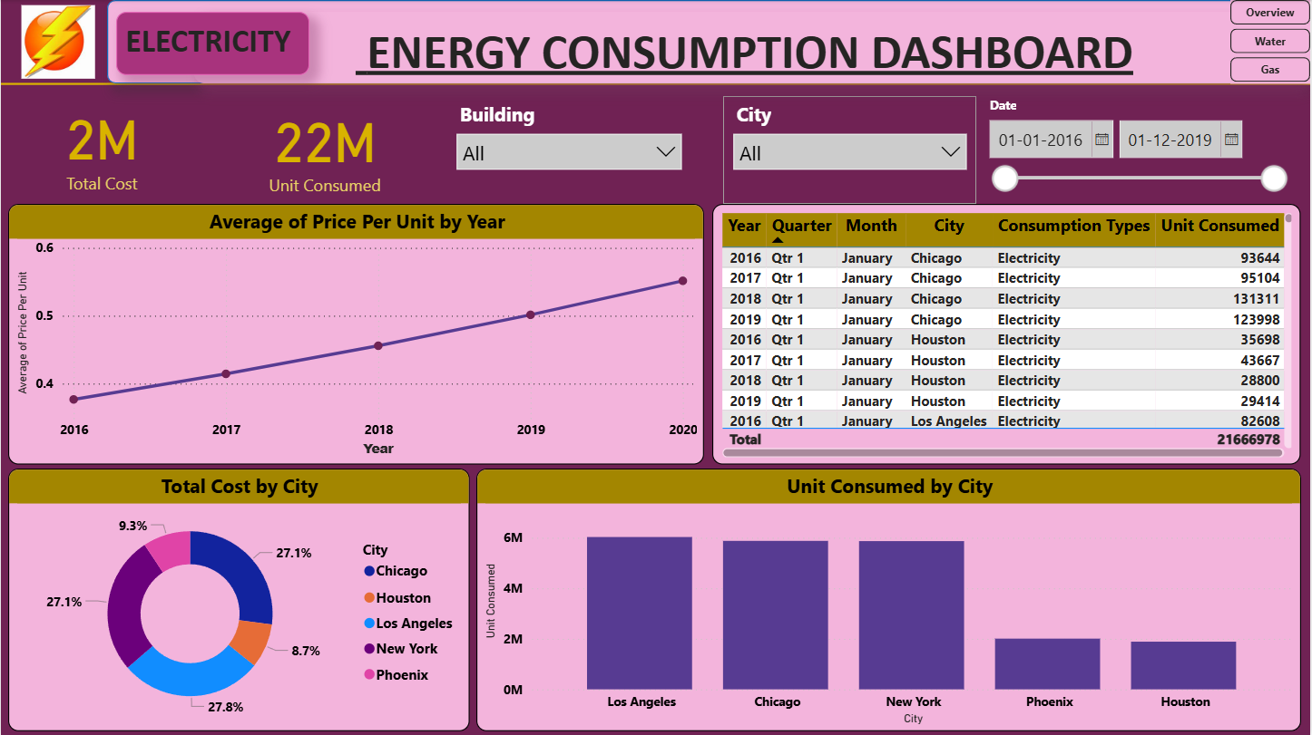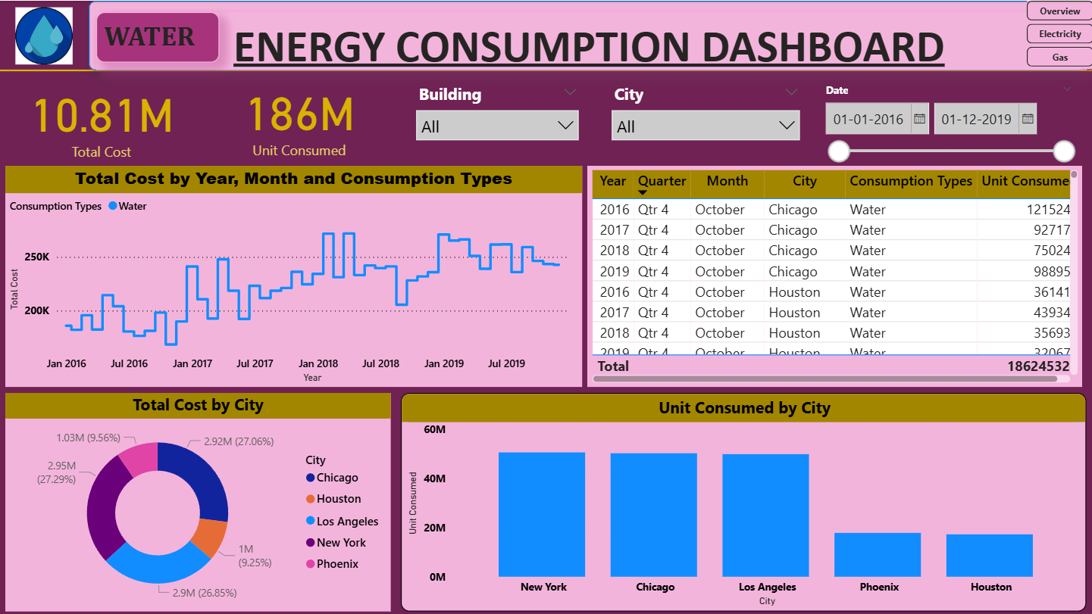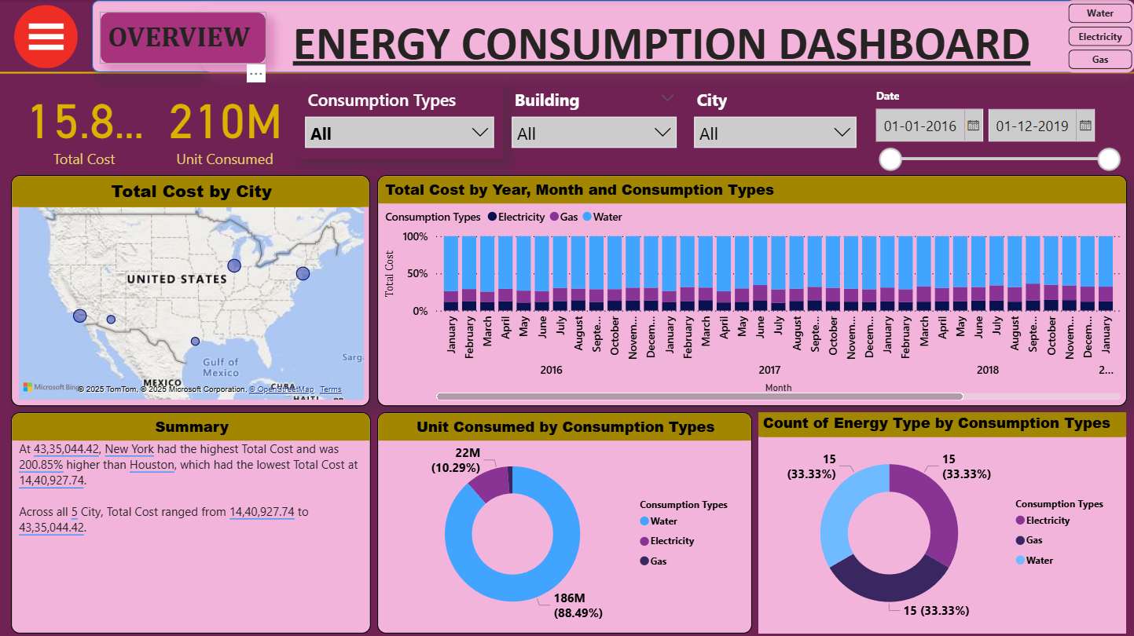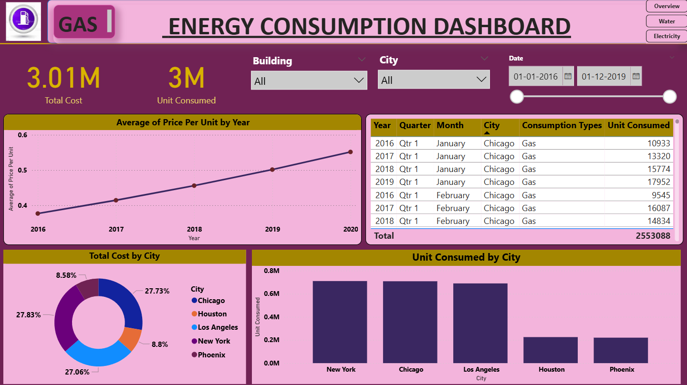

## Social / Industry Relevance of the Project:-

This project holds societal importance by encouraging households to save energy and industrial relevance by enabling organizations to optimize costs and meet sustainability goals.

## Learning & Reflection:-

Key learnings included Power BI data modeling, dashboard design, and sustainability analytics. The project enhanced technical, managerial, and problem-solving skills.

## Future Scope & Conclusion:-

The project objectives were met successfully. Future scope includes integrating IoT data for real-time monitoring and applying predictive analytics for energy forecasting.

# Project 2: Mobile Sales Dashboard (Power BI)

## Executive Summary:-

The Mobile Sales Dashboard project transformed raw sales data into meaningful insights. Built using SQL and Power BI, it provided KPIs such as total sales, quantity, transactions, average price, city-wise sales, brand performance, ratings, and payment preferences. Insights revealed top brands and cities, customer satisfaction trends, and dominant payment methods.

## Introduction:-

In the mobile industry, vast sales data is generated daily, but often underutilized. Static reporting fails to provide dynamic analysis of sales trends, brand contributions, or customer feedback. This dashboard bridges the gap by offering interactive, real-time insights for decision-making.

## Project Objectives:-

The project aimed to design a unified dashboard to analyze sales data effectively. Goals included identifying top-performing brands and cities, studying payment preferences, analyzing ratings, and providing time-based sales trends.

## Methodology & Results:-

The project followed an ETL pipeline. Data was structured using SQL, cleaned, and queried. It was then modeled in Power BI with DAX measures. The dashboard displayed KPIs, charts, maps, and ratings distribution for business insights.

**GITHUB LINK:-**

**<https://github.com/Bhagyashree-web/SQL_POWER-BI-PROJECT_SURE_PROED/tree/main/Mobile-Sales-Dashboard>**

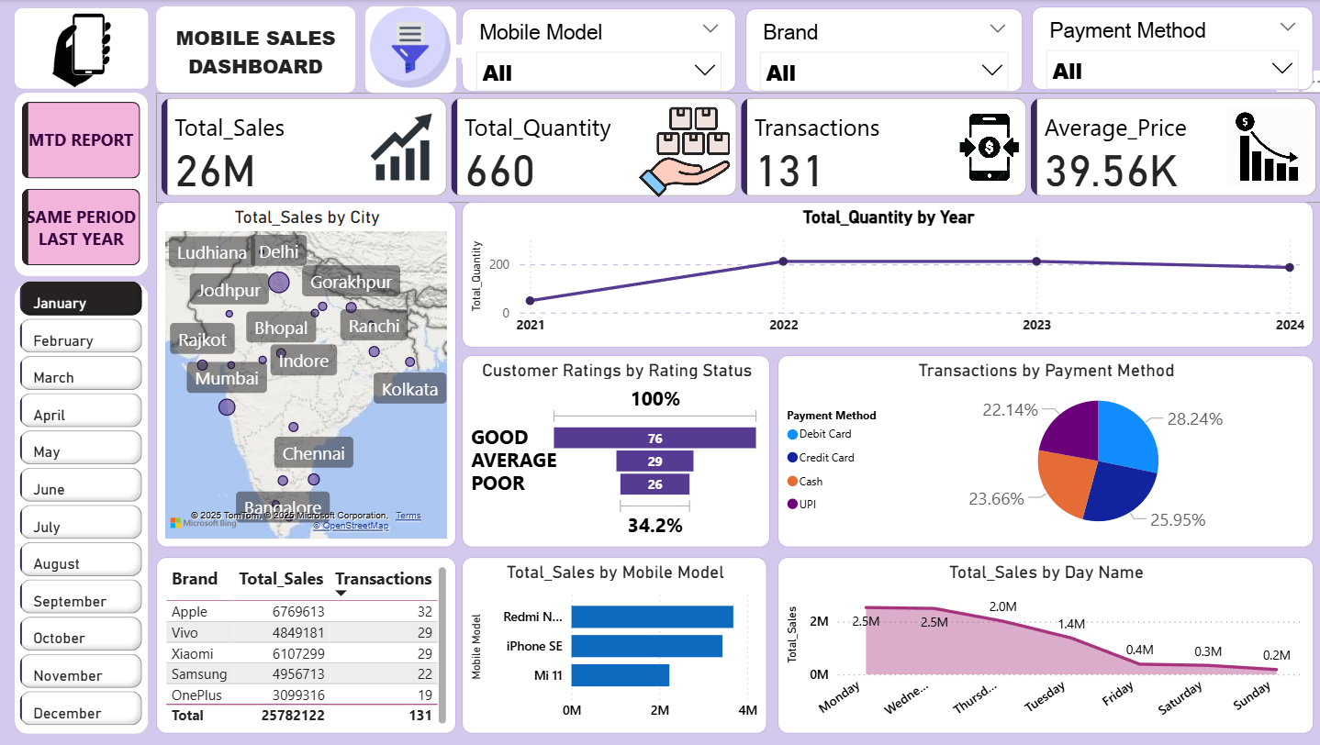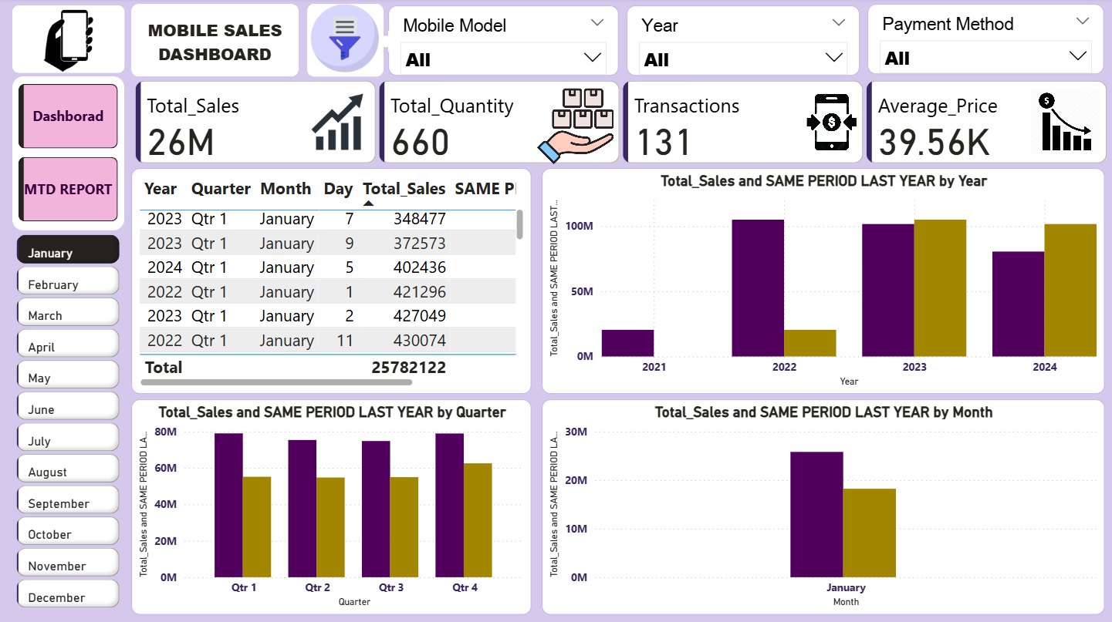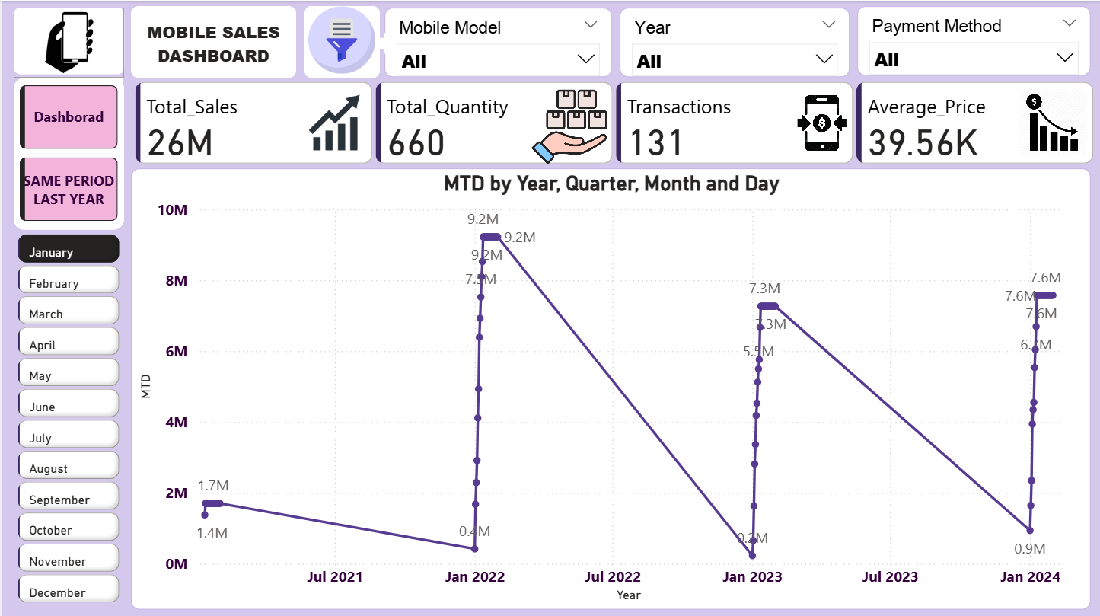

## Social / Industry Relevance of the Project:-

The dashboard benefits the retail industry by identifying profitable markets, tracking performance, and aligning business strategy. For society, it improves customer satisfaction by analyzing feedback and service gaps.

## Learning & Reflection:-

Learnings included SQL data structuring, Power BI visualization, and business analytics skills. The project improved individual problem-solving, data interpretation, and dashboard design expertise.

## Future Scope & Conclusion:-

The dashboard successfully met its objectives, providing decision-makers with clarity. Future scope includes real-time data integration with SQL servers and predictive modeling for sales forecasting.

# Project 3: Library Management System (SQL)

## Executive Summary:-

The Library Management System project automated book records, borrowing, and returning processes. Developed using SQL, it provided a structured database for managing students, books, and transactions. The system improves efficiency by reducing manual errors and supporting automated reporting.

## Introduction:-

Traditional library systems are prone to inefficiency and errors. This project introduced a database-driven solution using SQL to streamline record-keeping, ensuring accurate and accessible information about books and users.

## Project Objectives:-

Objectives included designing an ER model, creating normalized tables, tracking book issuance and returns, and generating reports for librarians.

## Methodology & Results:-

The methodology involved ER diagram design, schema creation, and writing SQL queries, joins, and triggers. The project was implemented on MySQL/SQL Server. Outputs included queries for book search, issue/return, and overdue calculations.

**GITHUB LINK:-**

**[https://github.com/Bhagyashree-web/SQL_POWER-BI-PROJECT_SURE_PROED/tree/main/Library%20Management%20System](https://github.com/Bhagyashree-web/SQL_POWER-BI-PROJECT_SURE_PROED/tree/main/Library Management System)**

**SCHEMA:-**

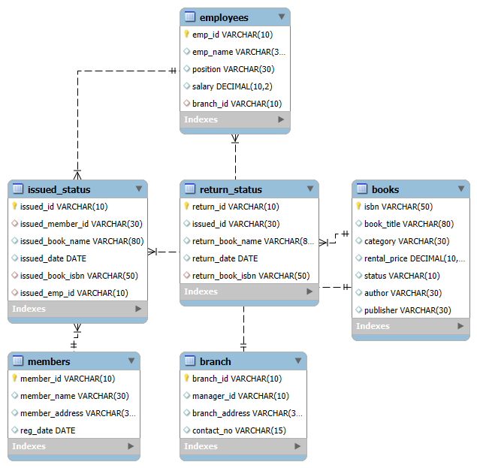

**SOME OUTPUTS:-**

1. List all books that have never been issued.

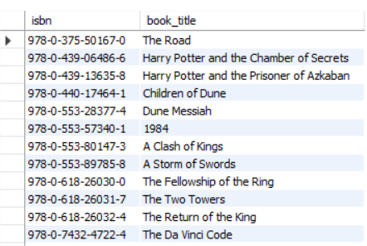

2. Find the total number of members registered in the system.

**Q2**

3. Show all books issued by employee `E106`.

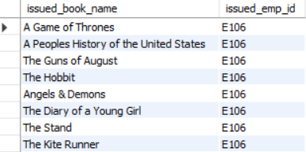

## Social / Industry Relevance of the Project:-

The project has academic relevance by training students in database design and industrial relevance for educational institutions managing large libraries.

## Learning & Reflection:-

Learnings included schema design, normalization, SQL queries, and real-world database handling. It also enhanced systematic thinking and query optimization skills.

## Future Scope & Conclusion:-

The project objectives were achieved with a functional SQL-based LMS. Future scope includes integrating a web interface, mobile app, and cloud deployment for scalability.

**GITHUB LINK OF ENTIRE PROJECT:-**

**<https://github.com/Bhagyashree-web/SQL_POWER-BI-PROJECT_SURE_PROED?tab=readme-ov-file>**