**Creating Developer Account:**

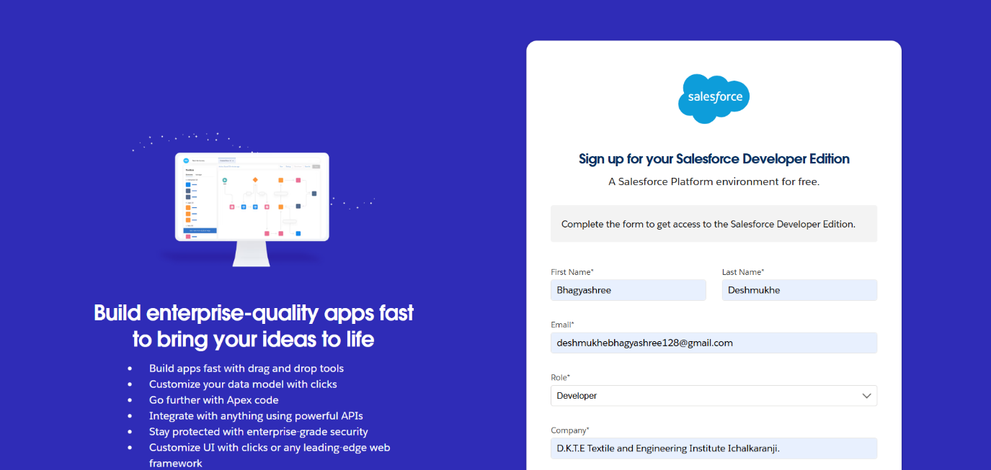

**Account Activation**

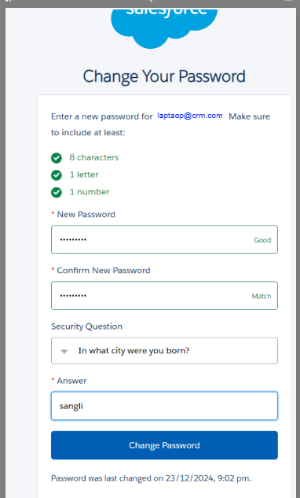

**Creating a Custom Tab**

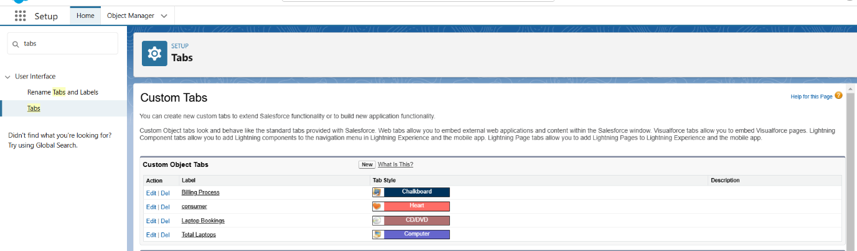

**Create a Lightning App**

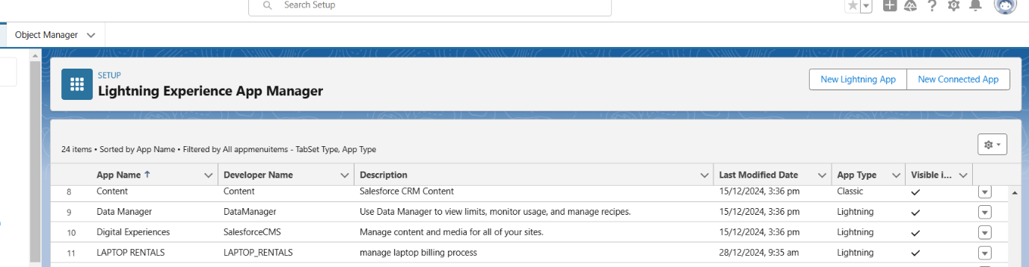

**Creating the field in Laptops Bookings object**

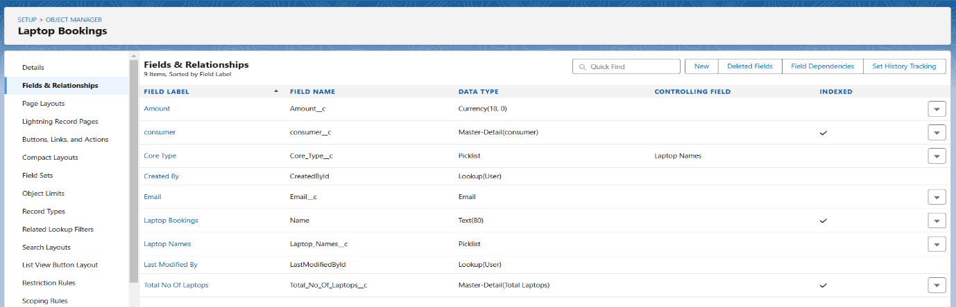

**Creating the field in Total Laptops**

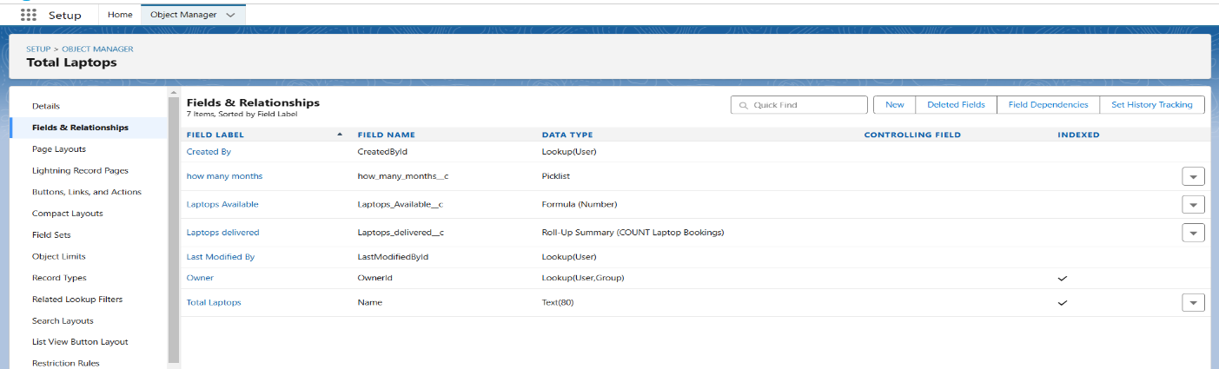

**Creating the field in consumer object**

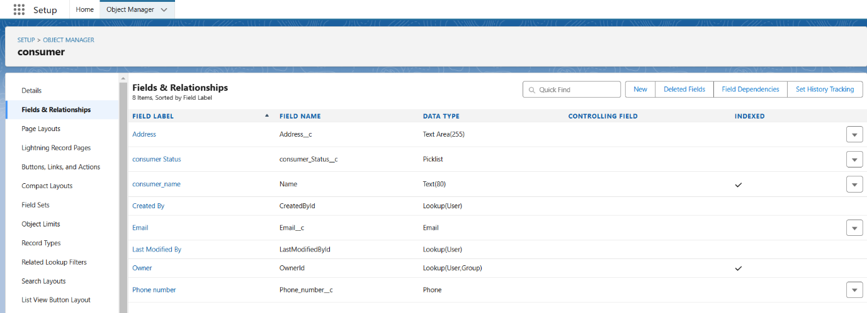

**object Creation of Fields & Relationship for Billing Process Object**

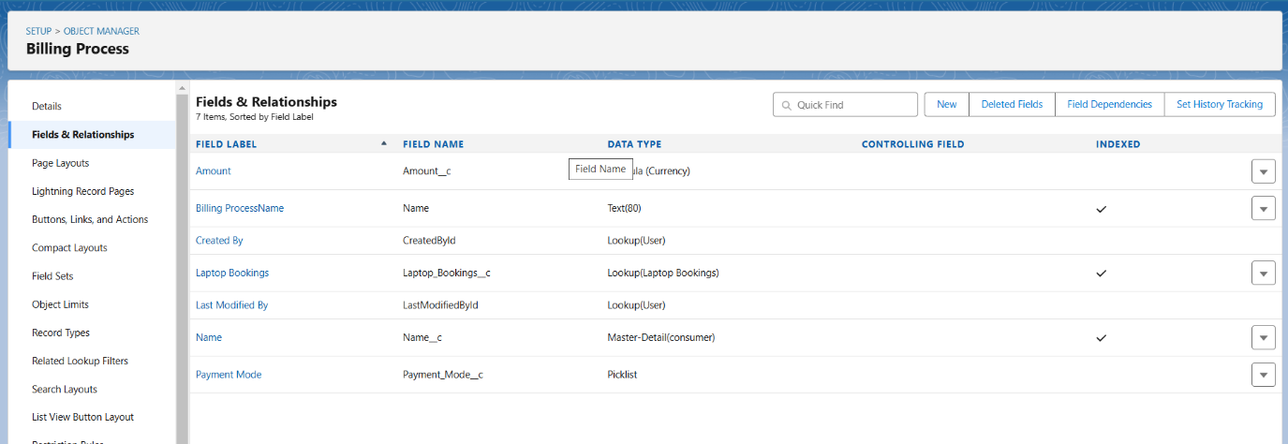

**Creating the validation rule for phone number field in consumer object**

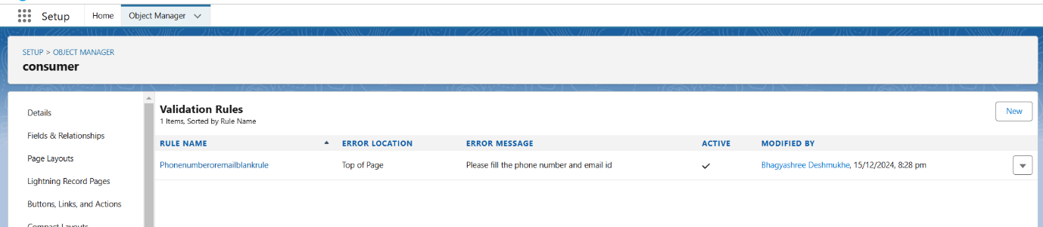

**Agent Profile**  
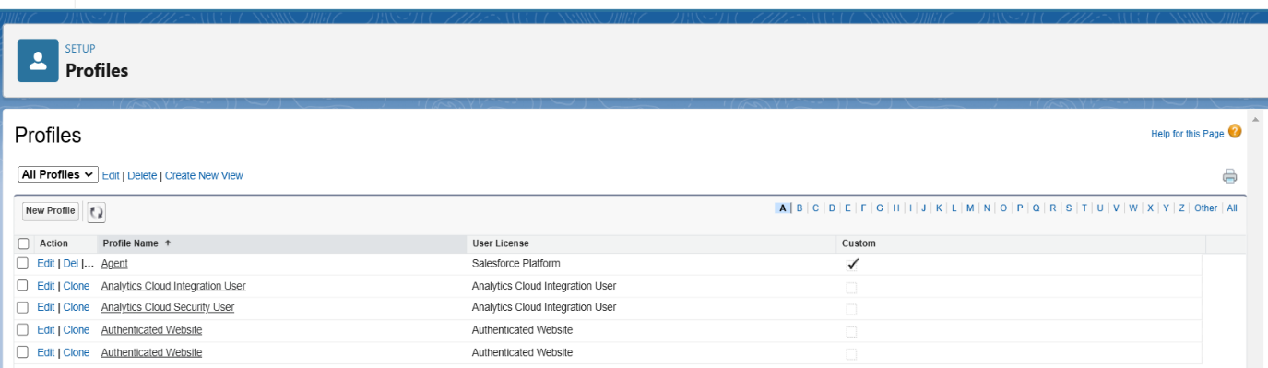

**owner Profile**

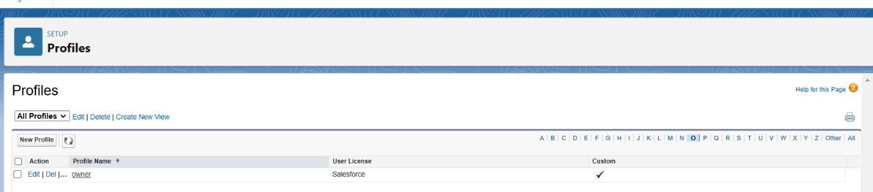

**Creating owner Role**

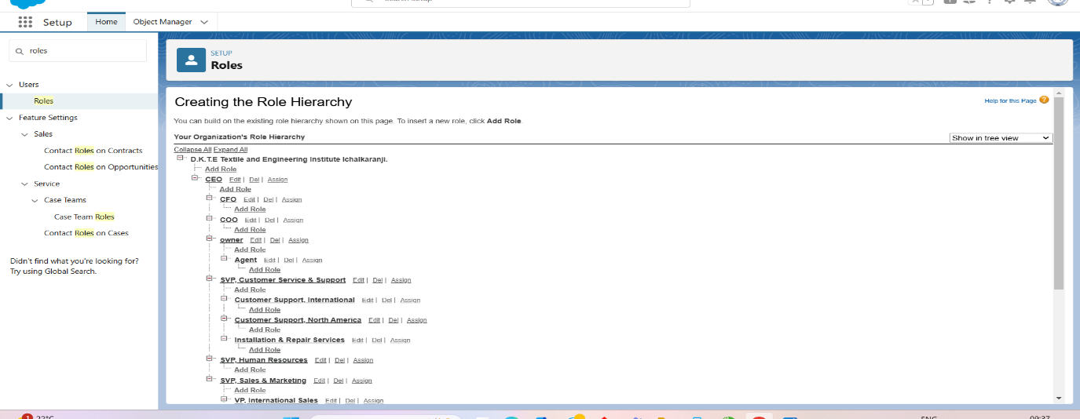

**Create User**

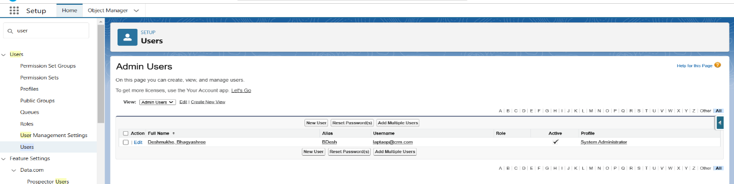

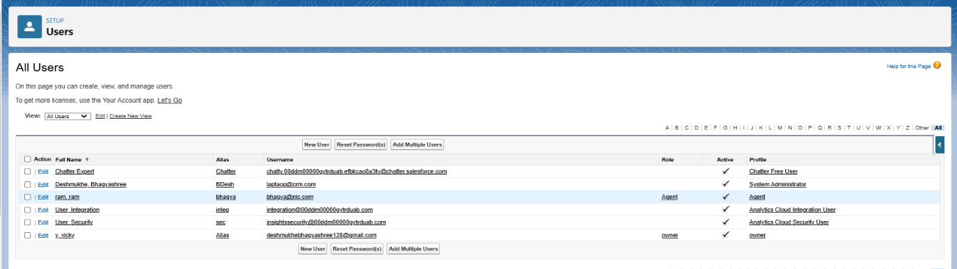

**Create a Flow**

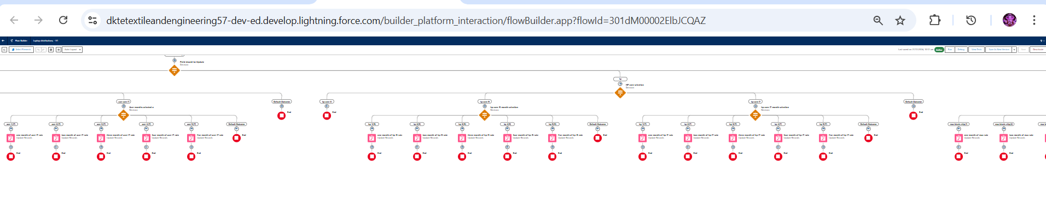

**Apex Trigger and Handler Class**

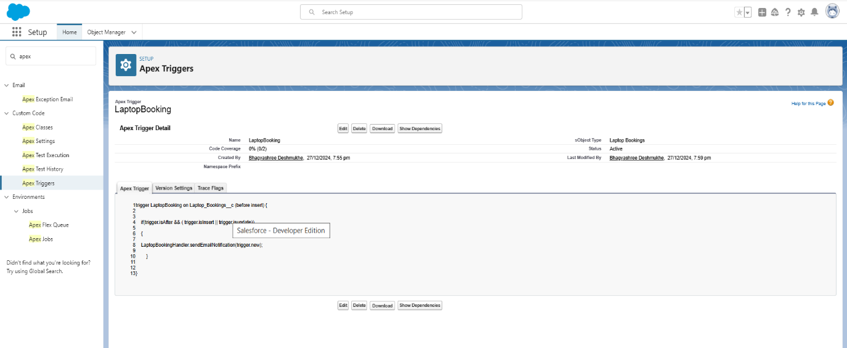

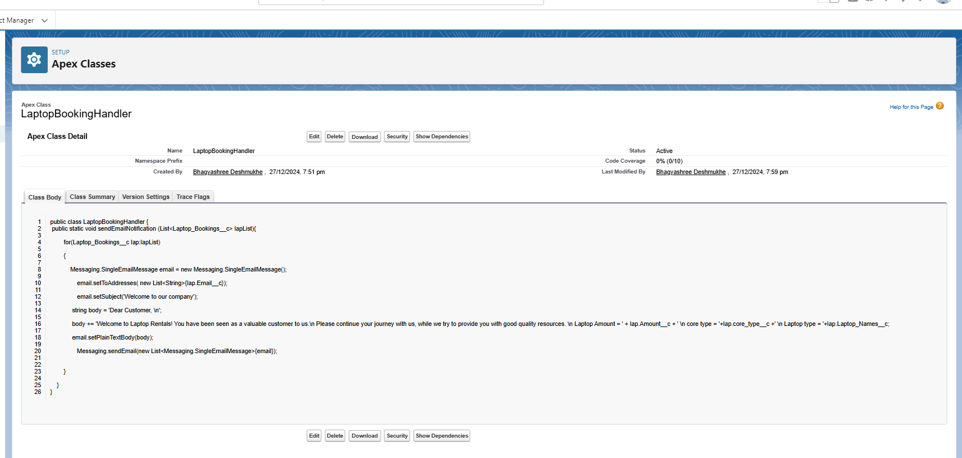

**Create Report**

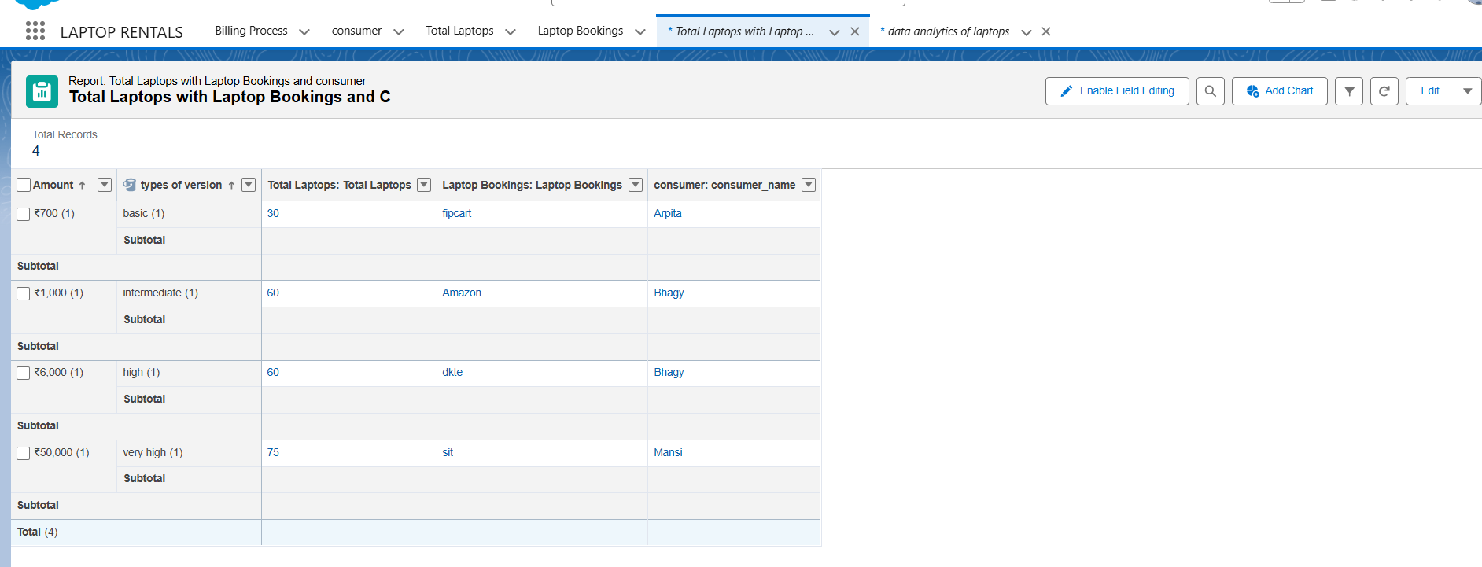

**Create Dashboard**