SearchFix AI — Software Documentation
Interactive 2-Step Extension Architecture (Comment Analysis ➔ Document Selection ➔ PDF Upload ➔ Decision)

Application Type | Chrome Extension Client + Node.js Express REST Web Service API
AI Model & Files API | Gemini 3.5 Flash + @google/genai Files API (PDF native parsing)
Decision Output States | ACCEPTED (Company Error) / DISPUTED (Files Correct) / REVIEW_REQUIRED
Step 1 Endpoint | POST http://localhost:3000/api/searchfix/analyze-comments (application/json)
Step 2 Endpoint | POST http://localhost:3000/api/searchfix/analyze-documents (multipart/form-data)
Security Vault | GEMINI_API_KEY maintained strictly on backend environment (.env)

1. Interactive 2-Step Architecture & Workflow
Step 1 receives comments and returns required file types so the Chrome Extension downloads ONLY requested files. Step 2 receives uploaded PDFs and evaluates ACCEPTED / DISPUTED / REVIEW_REQUIRED decisions.
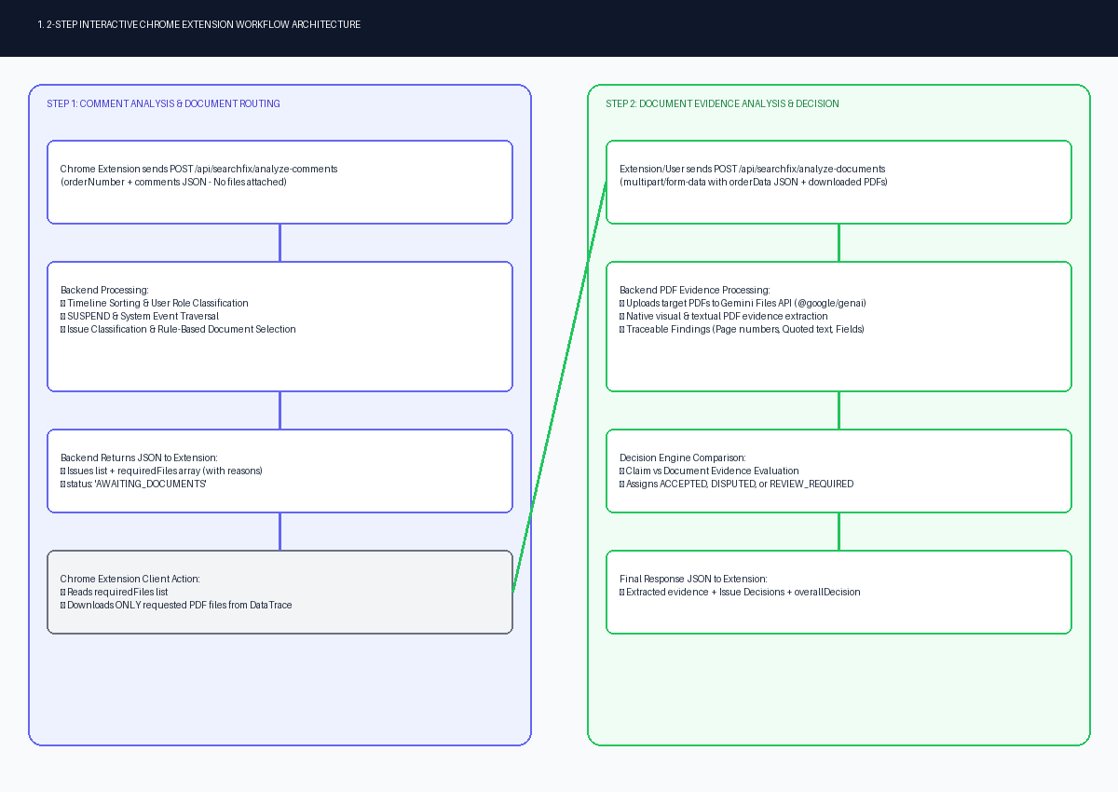

2. Decision Engine Output States
ACCEPTED confirms company error. DISPUTED confirms company files are correct. REVIEW_REQUIRED is returned when required supporting documents were not provided or evidence is inconclusive.
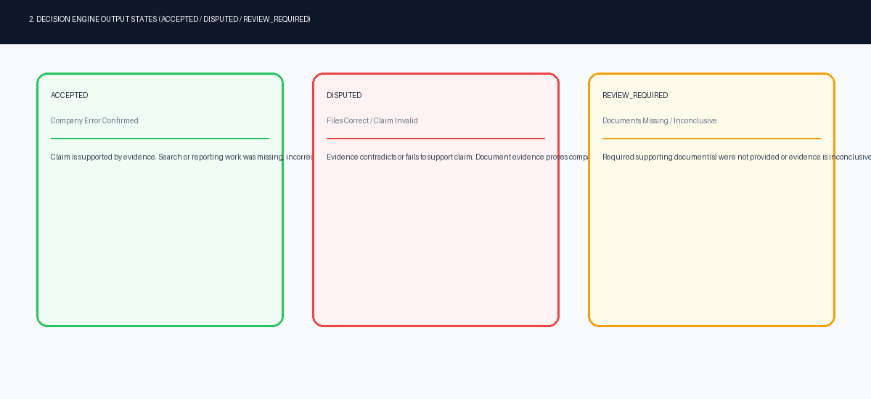

3. Interactive 2-Step Sequence Map
Sequence diagram detailing the 2-step interaction between Chrome Extension, Express Controller, Comment & Routing Engine, Document Analyzer, and Gemini Files API.
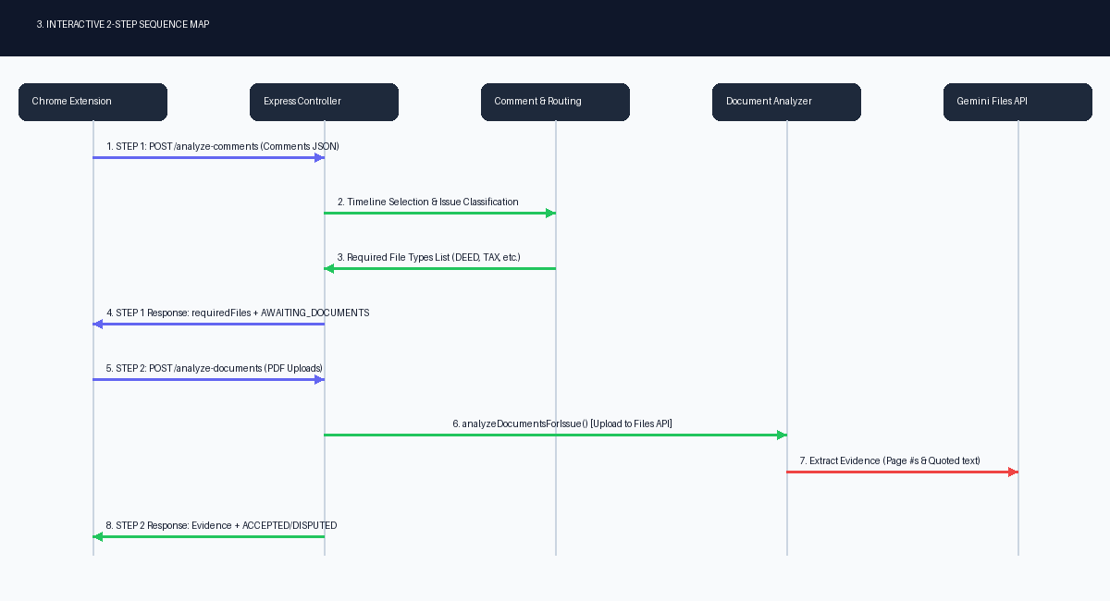

4. Technology Matrix & Endpoint Mapping
Breakdown of Node.js, Express, Multer file upload, Zod schema engine, @google/genai SDK, and endpoints.
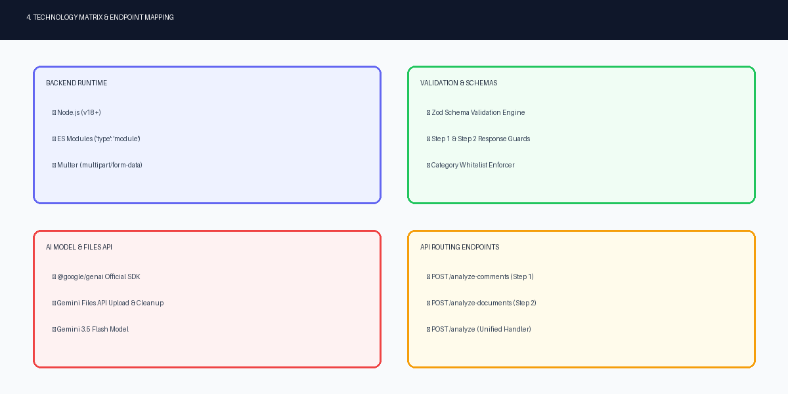

5. Hosting, Endpoints & Deployment Topology
Overview of interactive API routes, test suites (Orders 1-8 regression dataset), and cloud hosting on Render.com.
