MINI PROJECT REPORT
AI-Driven Customer Segmentation for Retail Optimization

Submitted by:
1. Kartik More PRN: RBC24BC036
2. Shreya Nagargoje PRN: RBC24BC038
3. [Team Member 3] PRN: [PRN No]
4. [Team Member 4] PRN: [PRN No]
____________________________________________________________
1. Title of the Project
AI-Driven Customer Segmentation for Retail Optimization
A machine learning system to divide retail shoppers into meaningful groups using K-Means Clustering, enabling smarter, targeted marketing strategies.
2. Problem Statement
In retail, every customer has different income and spending habits. Using a single generic discount strategy for all customers wastes marketing budget and reduces profit. The problem is: How can a retail store automatically identify different types of customers so it can give the right offer to the right customer at the right time?
3. Objectives
- Load and clean the retail customer dataset (200 records).
- Select key features: Annual Income and Spending Score.
- Use the Elbow Method (WCSS) to find the best number of clusters (K = 5).
- Apply K-Means Clustering to group customers into 5 distinct segments.
- Provide clear, actionable retail marketing strategies for each segment.
4. Methodology
Step 1 - Data Collection: Load Mall_Customers.csv containing 200 customer records.
Step 2 - Feature Selection: Pick 'Annual Income (k$)' and 'Spending Score (1-100)' as the most relevant retail behavior indicators.
Step 3 - Elbow Method: Compute WCSS (Within-Cluster Sum of Squares) for K = 1 to 10. The 'elbow' bend in the curve at K = 5 indicates the optimal cluster count.
Step 4 - K-Means Clustering: Train KMeans(n_clusters=5) with k-means++ initialization. The algorithm assigns each customer to their nearest centroid and updates centroids iteratively until convergence.
Step 5 - Visualization & Business Insights: Generate 2D cluster scatter plot and map each cluster to a retail marketing strategy.
5. Dataset, Tools & Technologies Used
Dataset: Mall Customers Dataset
- Records: 200 customers
- Attributes: CustomerID, Gender, Age, Annual Income (k$), Spending Score (1-100)
Programming Language: Python 3.11
Libraries Used:
- pandas : Data loading and manipulation
- numpy : Numerical operations
- scikit-learn: KMeans algorithm and Elbow Method
- matplotlib & seaborn: Data visualization and chart generation
Tools: VS Code / Any Python IDE, Windows OS
6. Implementation
The project is implemented in a single clean Python file: customer_segmentation.py
Key code steps:
A) Load dataset: df = pd.read_csv('Mall_Customers.csv')
B) Extract features: X = df.iloc[:, [3, 4]].values
C) Elbow loop: Fit KMeans for K=1 to 10, store inertia values in wcss[]
D) Train model: KMeans(n_clusters=5, init='k-means++', random_state=42).fit_predict(X)
E) Save outputs: elbow_method.png, customer_clusters.png, segmented_customers.csv
7. Results
The K-Means model successfully identified 5 customer segments from 200 shoppers:

Cluster Name | Count | Avg Income | Avg Spend | Retail Strategy
Target / VIP | 39 | $86.5k | 82/100 | Premium loyalty, VIP perks
Careful Savers | 35 | $88.2k | 17/100 | Bundle discounts, cashback
Standard / Regular | 81 | $55.3k | 50/100 | Festival offers, membership
Careless / Impulsive | 22 | $25.7k | 79/100 | Flash sales, EMI, BNPL
Sensible / Budget | 23 | $26.3k | 21/100 | Clearance sales, essentials

Figure 1: Elbow Method Graph (Optimal K = 5)
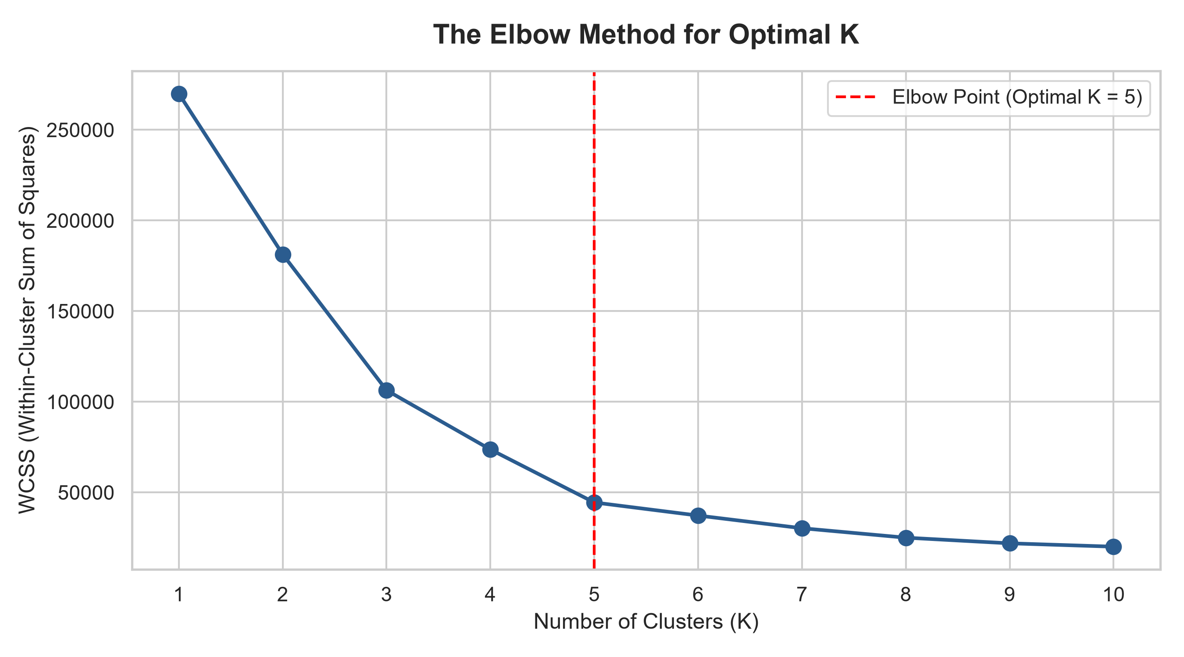

Figure 2: Customer Segmentation Cluster Plot
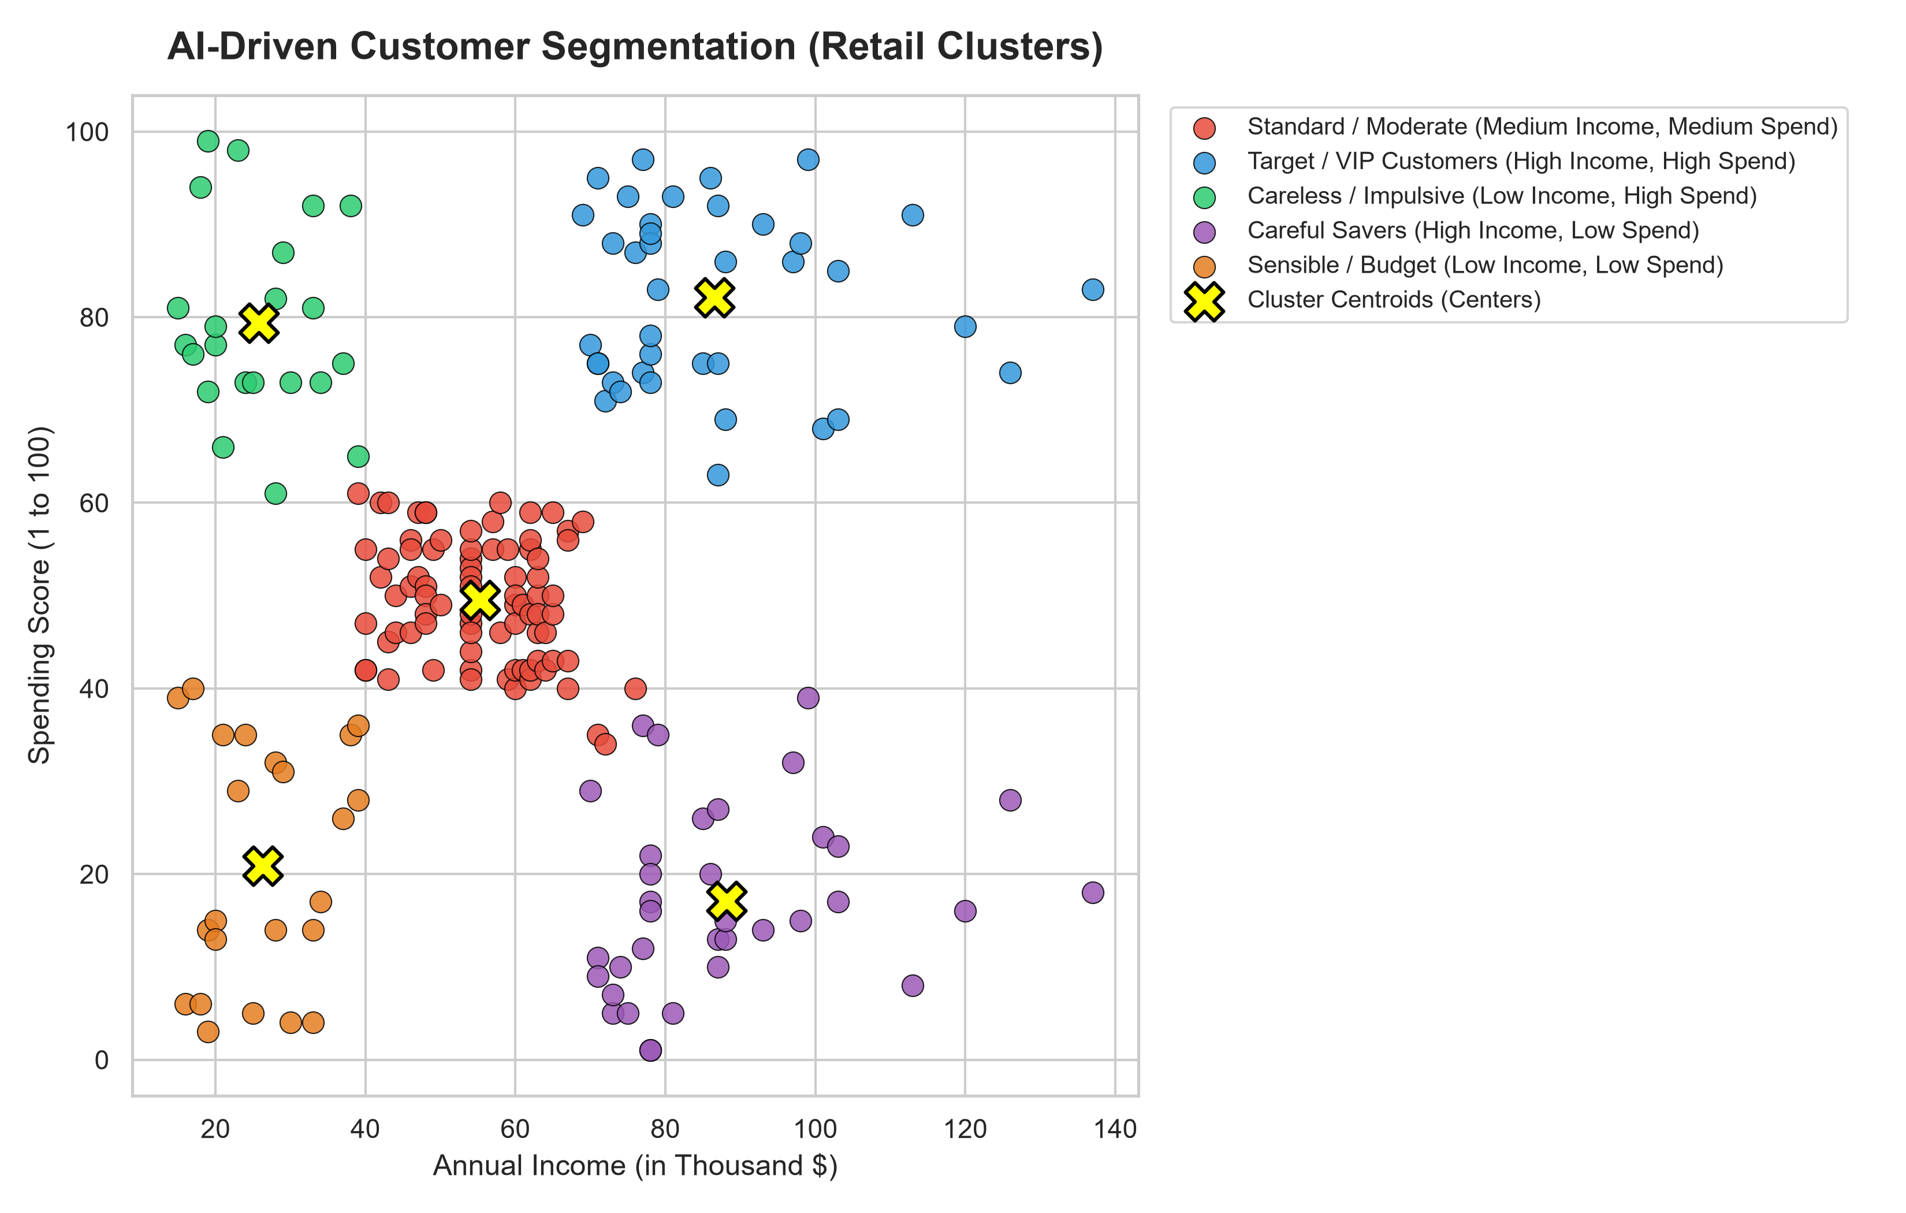
8. Conclusion
This project successfully demonstrates how AI-driven K-Means Clustering can transform raw retail customer data into 5 meaningful business segments. Instead of using generic promotions for all customers, retail stores can now deliver personalized offers — VIP rewards for high spenders, budget deals for low-income shoppers, and trend-driven flash sales for impulsive buyers.
This system reduces marketing costs, increases customer satisfaction, and boosts overall store revenue. It is a practical, scalable, and simple solution that showcases the power of Unsupervised Machine Learning in real-world retail business optimization.

