REACT

**OBJECTIVE-1:-**

Create a new React App “myfirstreact” and display heading

Code:-

import React from 'react';

function App() {

return (

<div>

<h1>Welcome to the first session of React</h1>

</div>

);

}

export default App;

Output:-

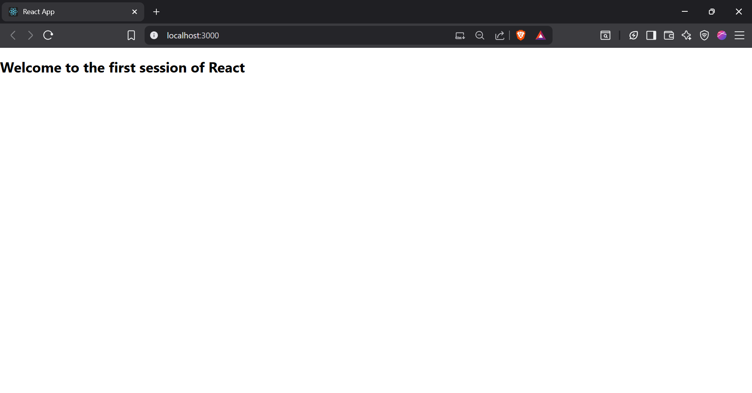

**OBJECTIVE-2:-**

How to create a React App named StudentApp with Home, About, and Contact components and display them together?

Code:-

Home.js:

import React, { Component } from 'react';

class Home extends Component {

render() {

return (

<div>

<h3>Welcome to the Home Page of Student Management Portal</h3>

</div>

);

}

}

export default Home;

About.js:

import React, { Component } from 'react';

class About extends Component {

render() {

return (

<div>

<h3>Welcome to the About Page of Student Management Portal</h3>

</div>

);

}

}

export default About;

Contact.js:

import React, { Component } from 'react';

class Contact extends Component {

render() {

return (

<div>

<h3>Welcome to the Contact Page of Student Management Portal</h3>

</div>

);

}

}

export default Contact;

App.js:

import React from 'react';

import './App.css';

import { Home } from './Components/Home';

import { About } from './Components/About';

import { Contact } from './Components/Contact';

function App() {

return (

<div className="container">

<Home />

<About />

<Contact />

</div>

);

}

export default App;

Output:-

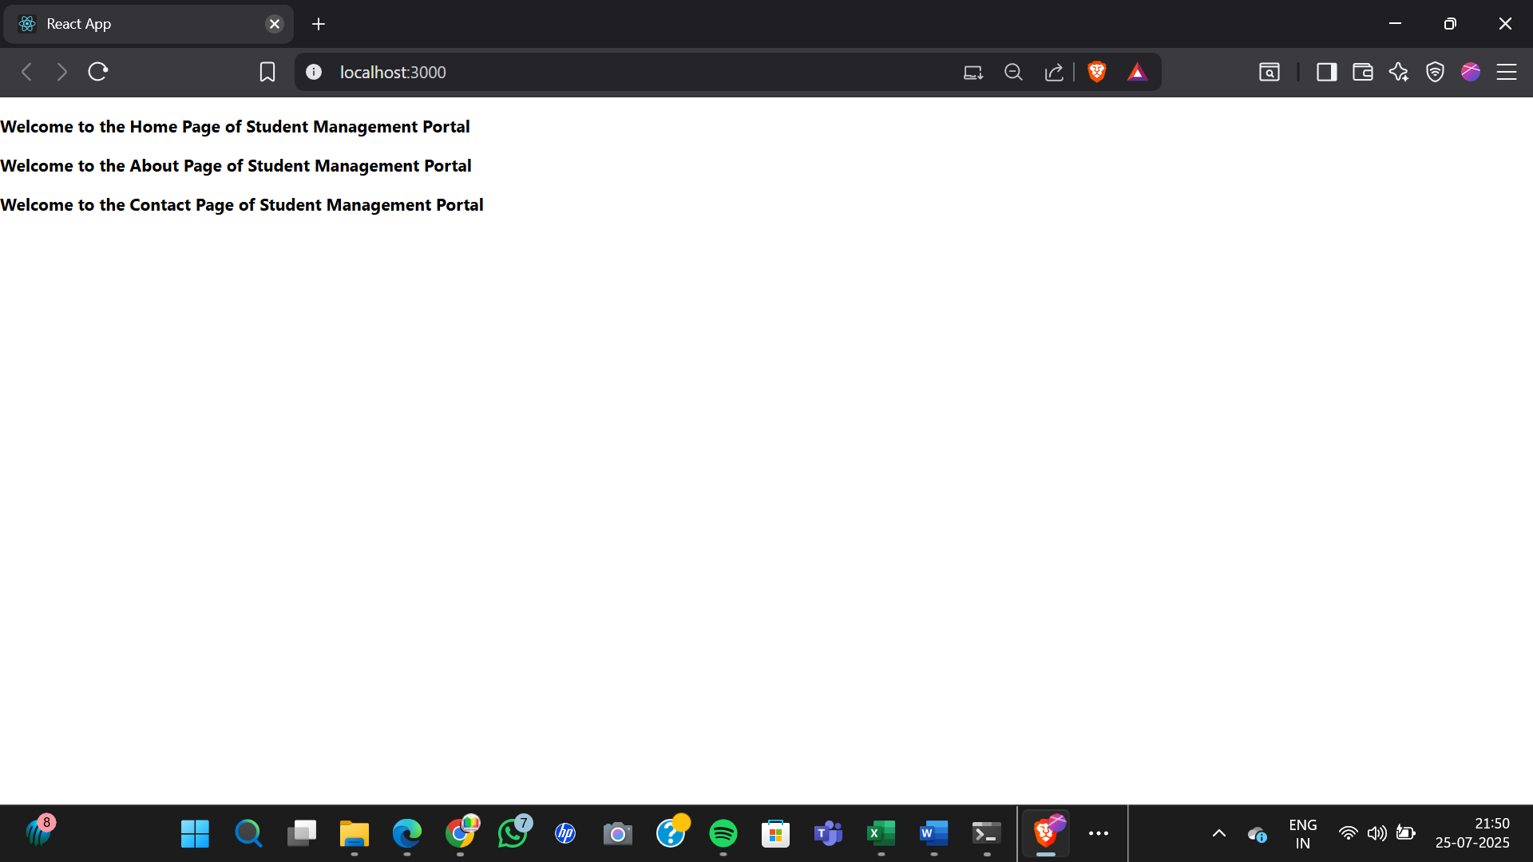

**OBJECTIVE-3:-**

Create a react app for Student Management Portal named scorecalculatorapp and create a function component named “CalculateScore” which will accept Name, School, Total and goal in order to calculate the average score of a student and display the same.

Code:-

CalculateScore.js:

import '../Stylesheets/mystyle.css';

const percentToDecimal = (decimal) => {

return (decimal.toFixed(2) + '%');

}

const calcScore = (total, goal) => {

return percentToDecimal(total / goal);

}

export const CalculateScore = ({ Name, School, total, goal }) => (

<div className="formatstyle">

<h1><font color="Brown">Student Details:</font></h1>

<div className="Name">

<b><span> Name: </span></b>

<span>{Name}</span>

</div>

<div className="School">

<b><span> School: </span></b>

<span>{School}</span>

</div>

<div className="Total">

<b><span>Total:</span></b>

<span>{total}</span>

<span>Marks</span>

</div>

<div className="Score">

<b>Score:</b>

<span>

{calcScore(total, goal)}

</span>

</div>

</div>

);

mystyle.css:

.Name {

font-weight: 300;

color: blue;

}

.School {

color: crimson;

}

.Total {

color: darkmagenta;

}

.formatstyle {

text-align: center;

font-size: large;

}

.Score {

color: forestgreen;

}

App.js:

import { CalculateScore } from './components/CalculateScore';

function App() {

return (

<div>

<CalculateScore

Name={"Steeve"}

School={"DNV Public School"}

total={284}

goal={3}

/>

</div>

);

}

export default App;

Output:-

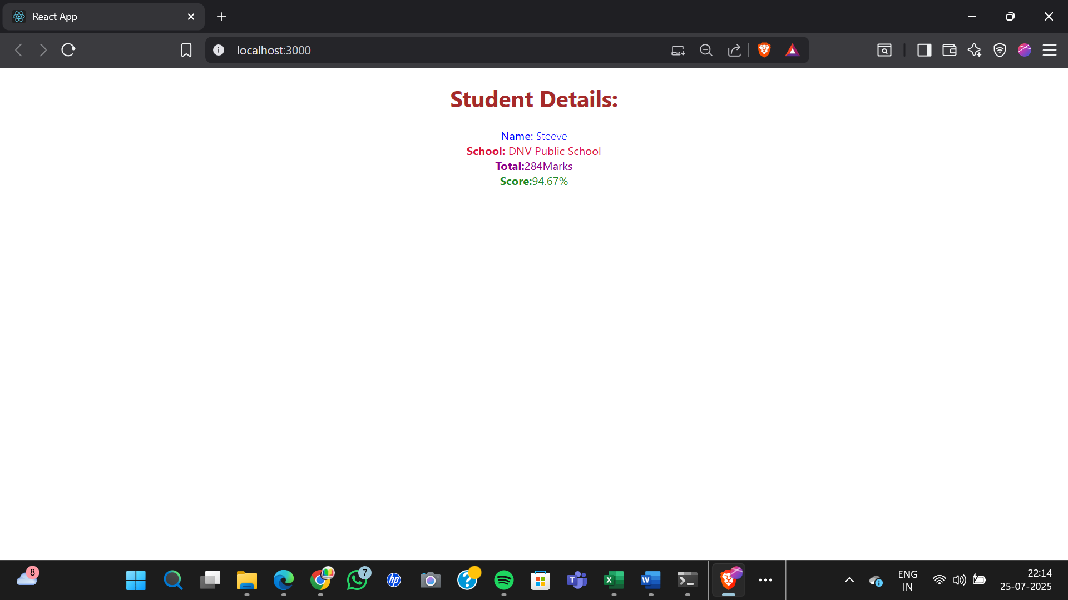

**OBJECTIVE-4:-**

Blogapp:

Post.js:

class Post {

  constructor(id, title, body) {

    this.id = id;

    this.title = title;

    this.body = body;

  }

}

export default Post;

Posts.js:

import React from 'react';

import Post from './Post';

class Posts extends React.Component {

  constructor(props) {

    super(props);

    this.state = { posts: [] };

  }

  loadPosts() {

    fetch('https://jsonplaceholder.typicode.com/posts')

      .then(response => response.json())

      .then(data => {

        const postList = data.map(post => new Post(post.id, post.title, post.body));

        this.setState({ posts: postList });

      });

  }

  componentDidMount() {

    this.loadPosts();

  }

  componentDidCatch(error, info) {

    alert("An error occurred: " + error.message);

  }

  render() {

    return (

      <div>

        <h1>Blog Posts</h1>

        {

          this.state.posts.map(post => (

            <div key={post.id}>

              <h2>{post.title}</h2>

              <p>{post.body}</p>

            </div>

          ))

        }

      </div>

    );

  }

}

export default Posts;

App.js:

import React from 'react';

import Posts from './Posts';

function App() {

  return (

    <div>

      <Posts />

    </div>

  );

}

export default App;

Output:-

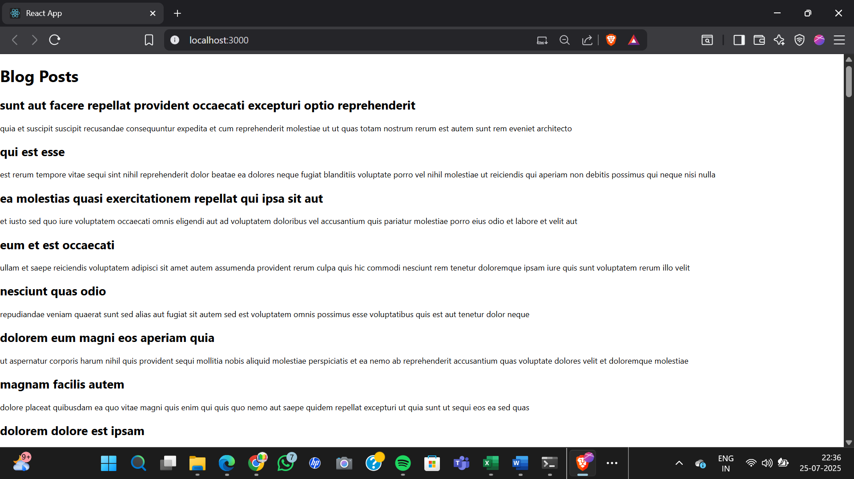

**OBJECTIVE-5:-**

My Academy team at Cognizant want to create a dashboard containing the details of ongoing and completed cohorts. A react application is created which displays the detail of the cohorts using react component. You are assigned the task of styling these react components.

CODE:-

CohortDetails.jsx:

import React from 'react';

import styles from './CohortDetails.module.css';

const CohortDetails = ({ cohorts }) => {

  return (

    <div>

      <h2>Cohorts Details</h2>

      {cohorts.map((cohort, index) => (

        <div key={index} className={styles.box}>

          <h3 className={

            cohort.status === 'Ongoing' ? styles.greenText : styles.blueText

          }>

            {cohort.id} - {cohort.name}

          </h3>

          <dl>

            <dt>Started On</dt>

            <dd>{cohort.startedOn}</dd>

            <dt>Current Status</dt>

            <dd>{cohort.status}</dd>

            <dt>Coach</dt>

            <dd>{cohort.coach}</dd>

            <dt>Trainer</dt>

            <dd>{cohort.trainer}</dd>

          </dl>

        </div>

      ))}

    </div>

  );

};

export default CohortDetails;

App.js:

import React from 'react';

import CohortDetails from './components/CohortDetails';

const cohorts = [

  {

    id: 'INTADMDF10',

    name: '.NET FSD',

    startedOn: '22-Feb-2022',

    status: 'Scheduled',

    coach: 'Jathma',

    trainer: 'Jojo Jose'

  },

  {

    id: 'ADM21JF014',

    name: 'Java FSD',

    startedOn: '10-Sep-2021',

    status: 'Ongoing',

    coach: 'Apoorv',

    trainer: 'Elisa Smith'

  },

  {

    id: 'CDBJF21025',

    name: 'Java FSD',

    startedOn: '24-Dec-2021',

    status: 'Ongoing',

    coach: 'Jathma',

    trainer: 'John Doe'

  }

];

function App() {

  return (

    <div>

      <CohortDetails cohorts={cohorts} />

    </div>

  );

}

export default App;

CohortDetails.module.css:

.box {

  width: 300px;

  display: inline-block;

  margin: 10px;

  padding: 10px 20px;

  border: 1px solid black;

  border-radius: 10px;

}

dt {

  font-weight: 500;

}

.greenText {

  color: green;

}

.blueText {

  color: blue;

}

Output:-

