**REACT(PART-2)**

OBJECTIVE-1:-

Create a React Application named “cricketapp” with the following components:-

CODE:-

import React from "react";

const ListofPlayers = () => {

const players = [

{ name: "Virat", score: 92 },

{ name: "Rohit", score: 81 },

{ name: "Dhoni", score: 65 },

{ name: "Rahul", score: 74 },

{ name: "Shikhar", score: 55 },

{ name: "Jadeja", score: 38 },

{ name: "Bumrah", score: 47 },

{ name: "Shami", score: 90 },

{ name: "Ashwin", score: 82 },

{ name: "Pant", score: 66 },

{ name: "Kohli", score: 70 },

];

const lowScorers = players.filter(player => player.score < 70);

return (

<div>

<h2>All Players</h2>

{players.map((p, i) => (

<p key={i}>{p.name}: {p.score}</p>

))}

<h2>Players Scored Below 70</h2>

{lowScorers.map((p, i) => (

<p key={i}>{p.name}: {p.score}</p>

))}

</div>

);

};

const IndianPlayers = () => {

const oddTeam = ["Virat", "Rahul", "Jadeja", "Ashwin", "Pant"];

const evenTeam = ["Rohit", "Dhoni", "Shikhar", "Bumrah", "Shami", "Kohli"];

const [a, b, c, d, e] = oddTeam;

const [f, g, h, i, j, k] = evenTeam;

const T20 = ["Rohit", "Virat", "Pant"];

const Ranji = ["Rahane", "Pujara", "Iyer"];

const merged = [...T20, ...Ranji];

return (

<div>

<h2>Odd Team Players</h2>

{[a, b, c, d, e].map((p, i) => (

<p key={i}>{p}</p>

))}

<h2>Even Team Players</h2>

{[f, g, h, i, j, k].map((p, i) => (

<p key={i}>{p}</p>

))}

<h2>Merged Players</h2>

{merged.map((p, i) => (

<p key={i}>{p}</p>

))}

</div>

);

};

const App = () => {

const flag = true;

return (

<div>

<h1>🏏 Welcome to Cricket App 🏏</h1>

{flag ? <ListofPlayers /> : <IndianPlayers />}

</div>

);

};

export default App;

OUTPUT:-

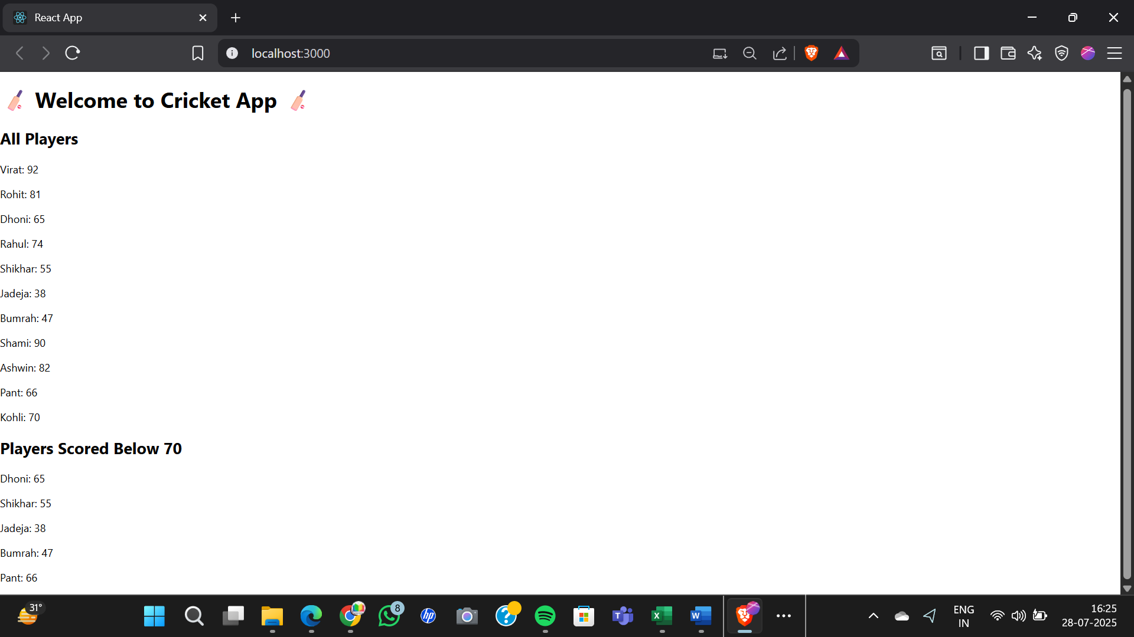

import React from "react";

const ListofPlayers = () => {

const players = [

{ name: "Virat", score: 92 },

{ name: "Rohit", score: 81 },

{ name: "Dhoni", score: 65 },

{ name: "Rahul", score: 74 },

{ name: "Shikhar", score: 55 },

{ name: "Jadeja", score: 38 },

{ name: "Bumrah", score: 47 },

{ name: "Shami", score: 90 },

{ name: "Ashwin", score: 82 },

{ name: "Pant", score: 66 },

{ name: "Kohli", score: 70 },

];

const lowScorers = players.filter(player => player.score < 70);

return (

<div>

<h2>All Players</h2>

{players.map((p, i) => (

<p key={i}>{p.name}: {p.score}</p>

))}

<h2>Players Scored Below 70</h2>

{lowScorers.map((p, i) => (

<p key={i}>{p.name}: {p.score}</p>

))}

</div>

);

};

const IndianPlayers = () => {

const oddTeam = ["Virat", "Rahul", "Jadeja", "Ashwin", "Pant"];

const evenTeam = ["Rohit", "Dhoni", "Shikhar", "Bumrah", "Shami", "Kohli"];

const [a, b, c, d, e] = oddTeam;

const [f, g, h, i, j, k] = evenTeam;

const T20 = ["Rohit", "Virat", "Pant"];

const Ranji = ["Rahane", "Pujara", "Iyer"];

const merged = [...T20, ...Ranji];

return (

<div>

<h2>Odd Team Players</h2>

{[a, b, c, d, e].map((p, i) => (

<p key={i}>{p}</p>

))}

<h2>Even Team Players</h2>

{[f, g, h, i, j, k].map((p, i) => (

<p key={i}>{p}</p>

))}

<h2>Merged Players</h2>

{merged.map((p, i) => (

<p key={i}>{p}</p>

))}

</div>

);

};

const App = () => {

const flag = false;

return (

<div>

<h1>🏏 Welcome to Cricket App 🏏</h1>

{flag ? <ListofPlayers /> : <IndianPlayers />}

</div>

);

};

export default App;

OUTPUT:-

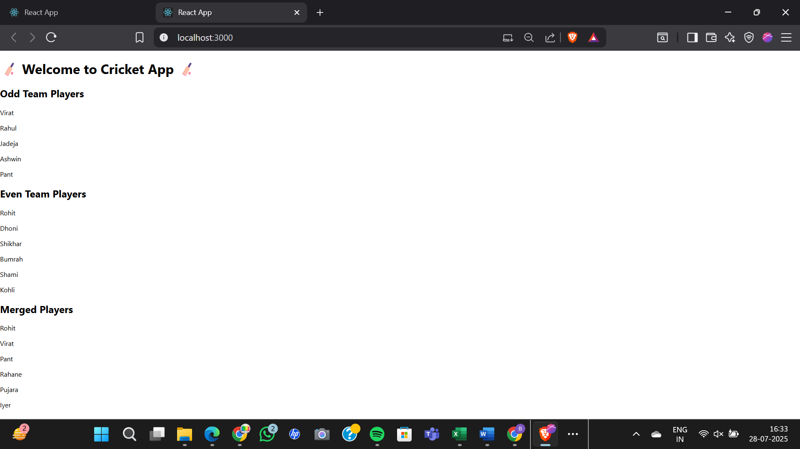

OBJECTIVE-2:-

Create a React Application named “officespacerentalapp” which uses React JSX to create elements, attributes and renders DOM to display the page.

CODE:-

import React from "react";

const App = () => {

const officeList = [

{

name: "WeWork Bengaluru",

rent: 55000,

address: "MG Road, Bengaluru",

image: "https://via.placeholder.com/300x200?text=WeWork+Bengaluru"

},

{

name: "Regus Mumbai",

rent: 65000,

address: "Bandra, Mumbai",

image: "https://via.placeholder.com/300x200?text=Regus+Mumbai"

},

{

name: "Smartworks Noida",

rent: 50000,

address: "Sector 62, Noida",

image: "https://via.placeholder.com/300x200?text=Smartworks+Noida"

}

];

return (

<div>

<h1>🏢 Office Space Rentals 🏢</h1>

{officeList.map((office, index) => (

<div key={index} style={{ marginBottom: "20px" }}>

<img src={office.image} alt={office.name} width="300" height="200" />

<h2>{office.name}</h2>

<p><strong>Address:</strong> {office.address}</p>

<p style={{ color: office.rent < 60000 ? "red" : "green" }}>

<strong>Rent:</strong> ₹{office.rent}

</p>

</div>

))}

</div>

);

};

export default App;

OUTPUT:-

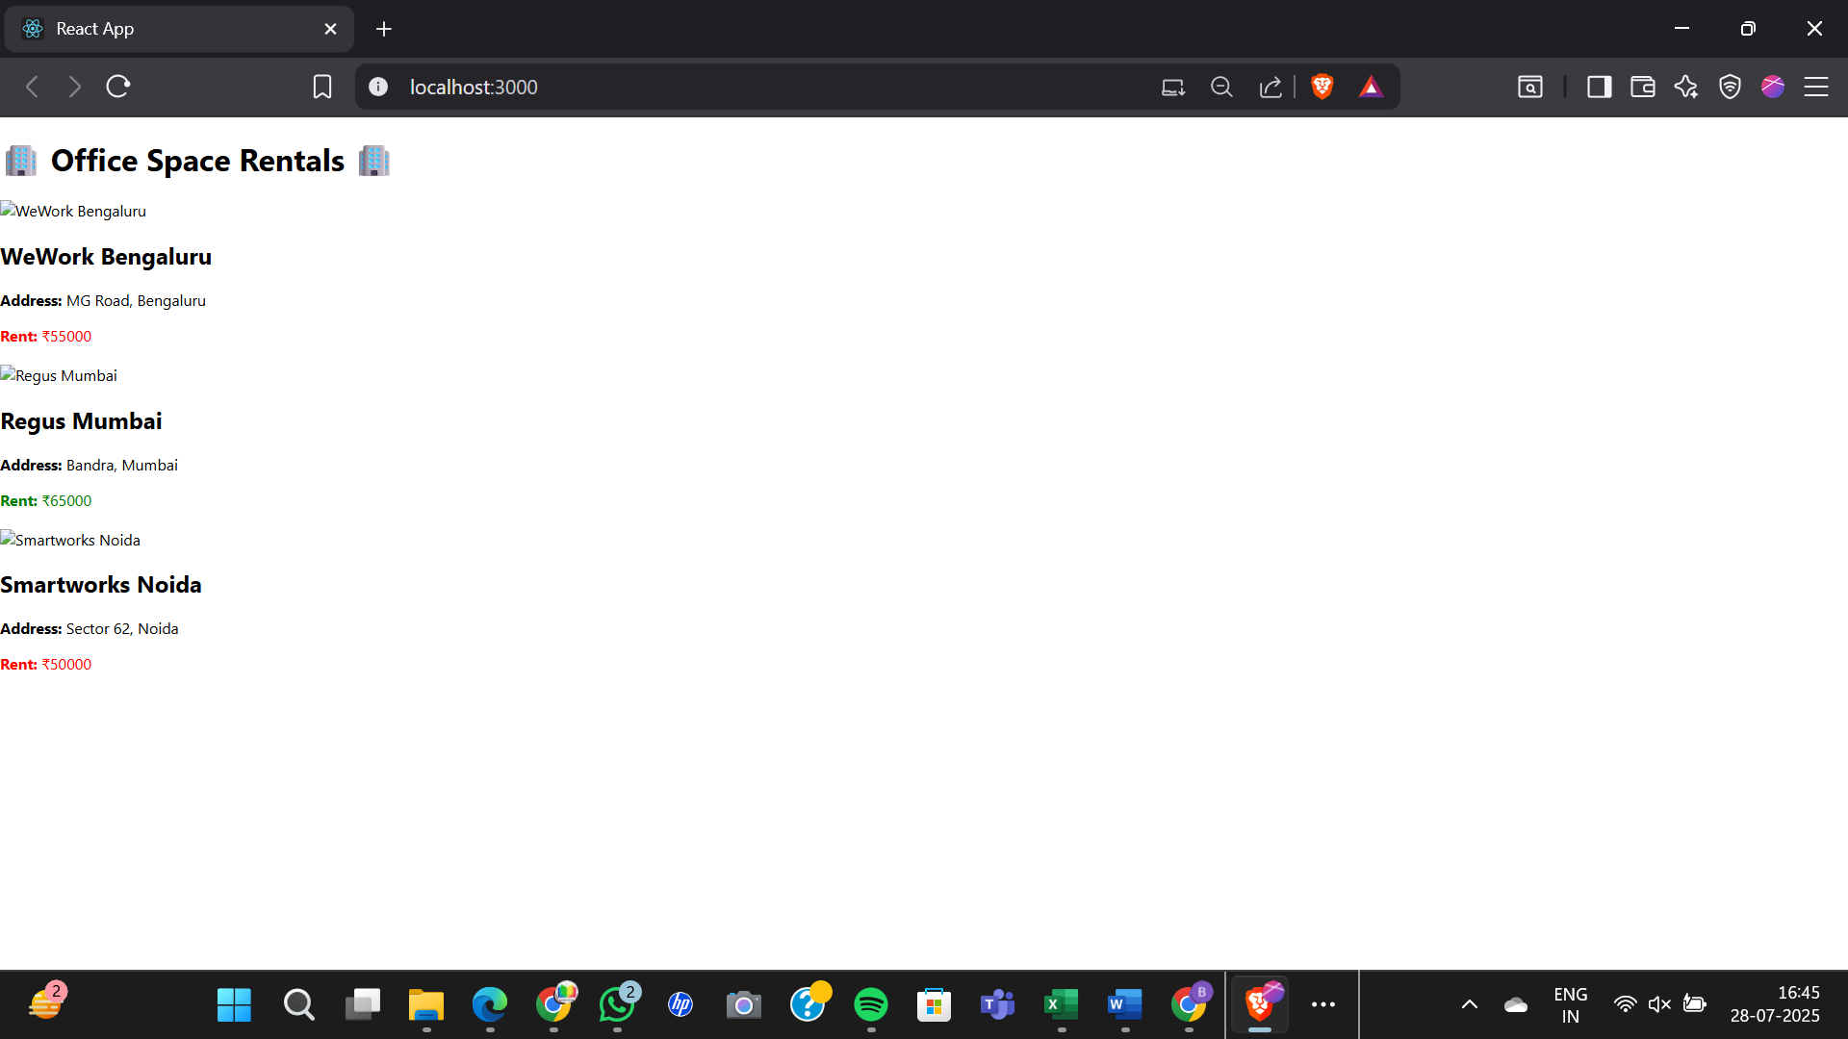

OBJECTIVE-3:-

Create a React Application called **eventexamplesapp** to:-

CODE:-

import React, { Component } from "react";

class CurrencyConvertor extends Component {

constructor(props) {

super(props);

this.state = {

rupees: "",

euro: null,

};

}

handleChange = (e) => {

this.setState({ rupees: e.target.value });

};

handleSubmit = (e) => {

e.preventDefault();

const euro = (this.state.rupees / 90).toFixed(2);

this.setState({ euro });

};

render() {

return (

<div>

<h2>Currency Convertor</h2>

<input

type="number"

value={this.state.rupees}

onChange={this.handleChange}

placeholder="Enter amount in ₹"

/>

<button onClick={this.handleSubmit}>Convert</button>

{this.state.euro && <p>€ {this.state.euro}</p>}

</div>

);

}

}

class App extends Component {

constructor() {

super();

this.state = {

count: 0,

message: "",

syntheticText: "",

};

}

increment = () => {

this.setState({ count: this.state.count + 1 });

this.sayHello();

};

sayHello = () => {

this.setState({ message: "Hello from React!" });

};

decrement = () => {

this.setState({ count: this.state.count - 1 });

};

sayWelcome = (msg) => {

this.setState({ message: msg });

};

handleSyntheticEvent = (e) => {

this.setState({ syntheticText: "I was clicked" });

};

render() {

return (

<div style={{ padding: "20px" }}>

<h1>React Event Handling</h1>

<h2>Counter: {this.state.count}</h2>

<button onClick={this.increment}>Increment</button>

<button onClick={this.decrement}>Decrement</button>

<h2>{this.state.message}</h2>

<button onClick={() => this.sayWelcome("Welcome to Events!")}>

Say Welcome

</button>

<button onClick={this.handleSyntheticEvent}>Click Me</button>

<h3>{this.state.syntheticText}</h3>

<CurrencyConvertor />

</div>

);

}

}

export default App;

OUTPUT:-

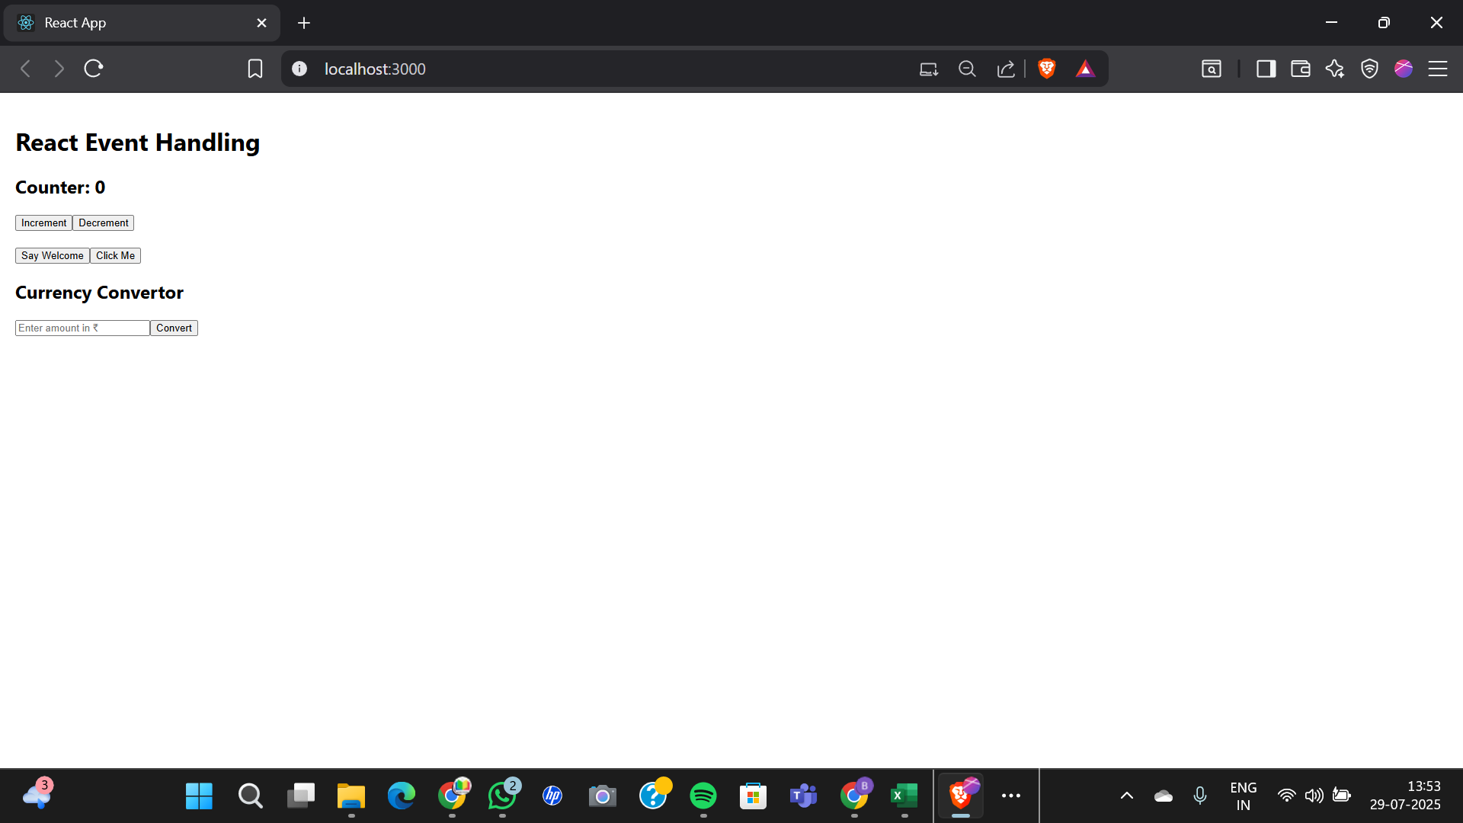

OBJECTIVE-4:-

Create a React Application named “ticketbookingapp” where:-

CODE:-

GuestPage.js:

import React from 'react';

function GuestPage() {

return (

<div>

<h2>Welcome Guest!</h2>

<p>Browse available flight details below.</p>

</div>

);

}

export default GuestPage;

UserPage.js:

import React from 'react';

function UserPage() {

return (

<div>

<h2>Welcome User!</h2>

<p>You can now book your flight tickets.</p>

</div>

);

}

export default UserPage;

App.js:

import React, { useState } from 'react';

import GuestPage from './components/GuestPage';

import UserPage from './components/UserPage';

function App() {

  const [isLoggedIn, setIsLoggedIn] = useState(false);

  const handleLogin = () => setIsLoggedIn(true);

  const handleLogout = () => setIsLoggedIn(false);

  return (

    <div>

      <h1>✈️ Ticket Booking App</h1>

      {isLoggedIn ? (

        <>

          <button onClick={handleLogout}>Logout</button>

          <UserPage />

        </>

      ) : (

        <>

          <button onClick={handleLogin}>Login</button>

          <GuestPage />

        </>

      )}

    </div>

  );

}

export default App;

OUTPUT:-

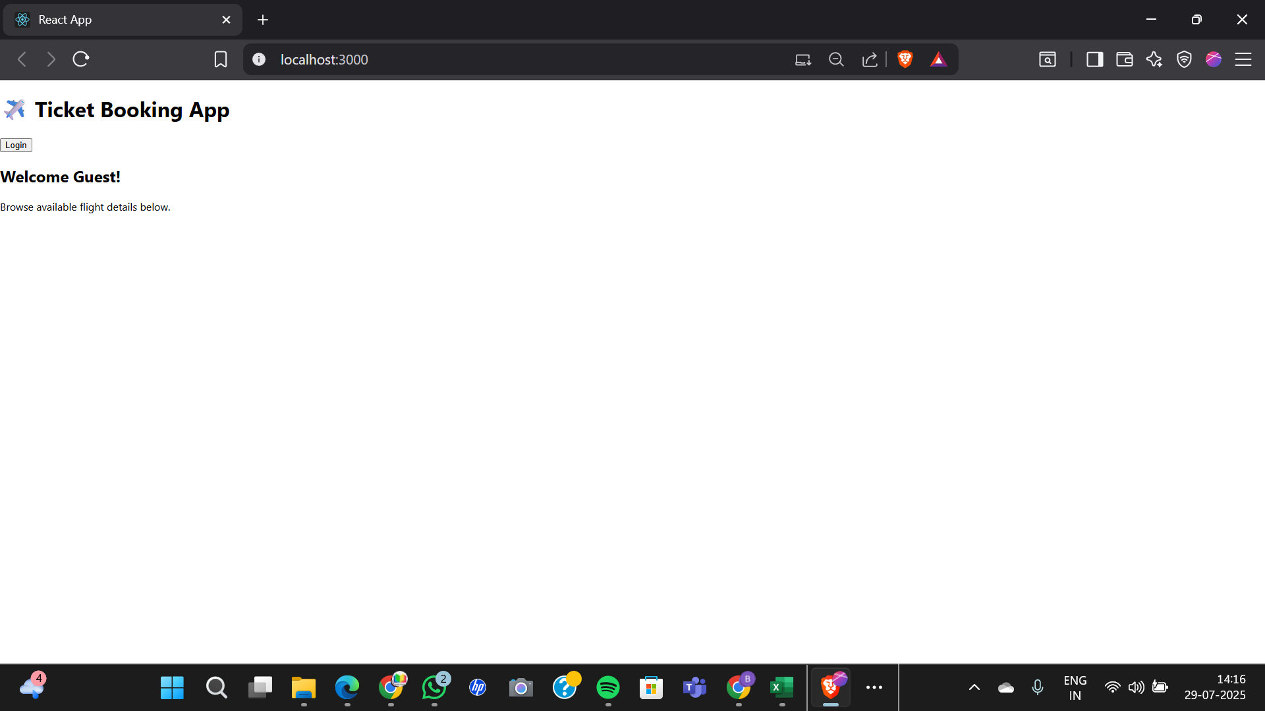

OBJECTIVE-5:-

Create a React App named **“bloggerapp”** with the following 3 components:-

CODE:-

BookDetails.js:

function BookDetails() {

return <div><h2>📚 Book Details</h2><p>This is book content.</p></div>;

}

export default BookDetails;

BlogDetails.js:

function BlogDetails() {

return <div><h2>📝 Blog Details</h2><p>This is blog content.</p></div>;

}

export default BlogDetails;

CourseDetails.js:

function CourseDetails() {

return <div><h2>🎓 Course Details</h2><p>This is course content.</p></div>;

}

export default CourseDetails;

App.js:

import React, { useState } from 'react';

import BookDetails from './components/BookDetails';

import BlogDetails from './components/BlogDetails';

import CourseDetails from './components/CourseDetails';

function App() {

const [selected, setSelected] = useState("book");

// 1. Using if-else statement

let displayComponent;

if (selected === "book") {

displayComponent = <BookDetails />;

} else if (selected === "blog") {

displayComponent = <BlogDetails />;

} else {

displayComponent = <CourseDetails />;

}

return (

<div>

<h1>📖 BloggerApp</h1>

<button onClick={() => setSelected("book")}>Show Book</button>

<button onClick={() => setSelected("blog")}>Show Blog</button>

<button onClick={() => setSelected("course")}>Show Course</button>

<hr />

{/* Method 1: If-Else assigned above */}

{displayComponent}

{/* Method 2: Ternary Operator */}

{/* {selected === "book" ? <BookDetails /> : <CourseDetails />} */}

{/* Method 3: Logical && Operator */}

{/* {selected === "blog" && <BlogDetails />} */}

{/*Method 4: Switch Case (via helper function or inline) - skipped here for brevity */}

</div>

);

}

export default App;

OUTPUT:-

